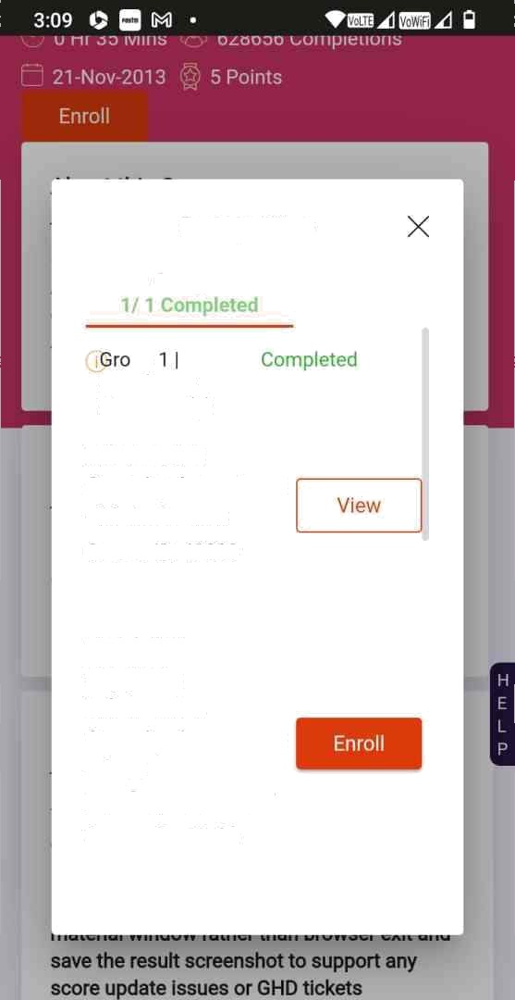

Prerequlslles

Group 1

up Mandatory Elements (J)

lnformatlon

Security Awareness

- Main Course

Course ID: 43893

Third Party Suppliers Information Securlty Awareness

- Core

Brlefing LCS WBT

Course iD: 55703



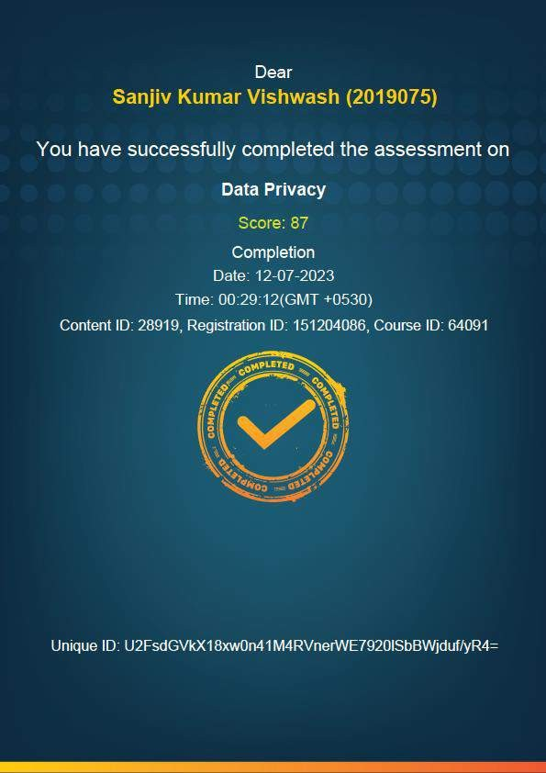

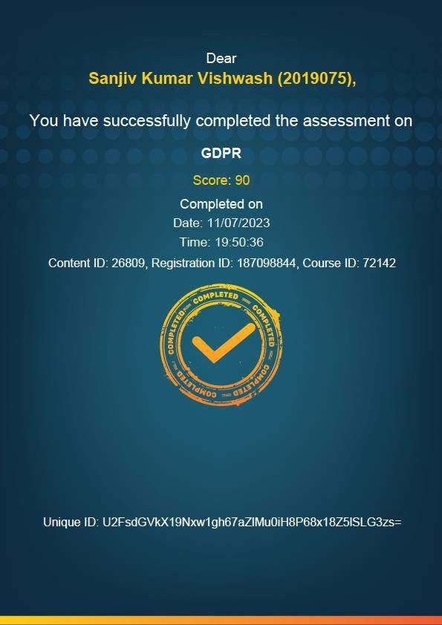



_ IEvqlve

@

0 . 0

My Learnings

Exolore

### Course Content

Web Ba sed Train i no

### Information Security Awareness - An Introducllon

English

0.00



## “. “ !”.” ! i! ”

0

Completed



## Informatlon Security Awareness - An

Introduction

English

000

0

Completed

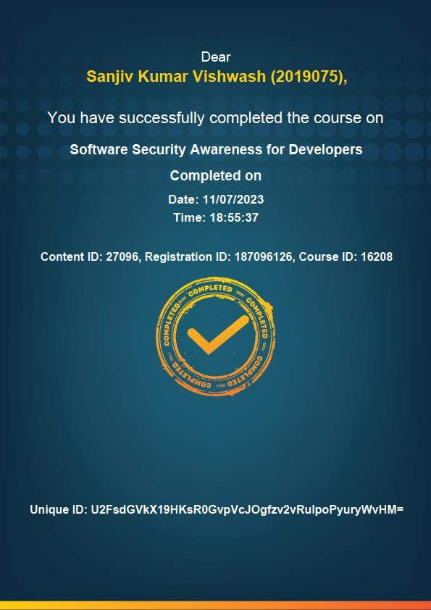



9:41 * * @

@

& eng.ultimatix.net

.

iEVo Ve

My Leamlngs

Explore

C.ourses

In Fro s‹ess Completed



### i- ›‹”. .›•

Information Security Awareness - Maln Co...

Course ID: 43893

5 Points 12-Jul-2023

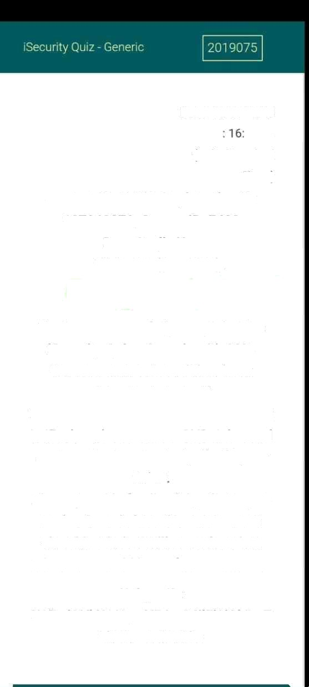

Date: 11707/2023

Time 07:12

{India Standard

Time)

# Content ID:11373, Registration ID:

## 187063870, Course ID: 740B

Dear Sanjlv Kumar

Vishwash(2019075),

Congratulations!

You have successfully completed the

isecurity Quiz - Generic with 8O°a. Your assessment result has been downloaded as pdf

In case your score does not get updated

In iEvolve, please raise a ‹sHD ticket and enclose the downloaded pdf with your ticket

Please provide feedback by clicking on End quiz and close the assessment else this window will auto close in 3 minutes to avoid loss of your progress.

Unique ID: U2FsdGVkX1/OywVPJmO4ilFl2iAkBw7 1kOtFuSwBBNk=