MovieIQ
Predictive Analytics on Film Success
Written Project Answers — Stages 0 to 4
Prepared by: Pooja

Stage 0 — Problem Statement
1. What makes a movie "successful" in this project? What is the exact success rule?
A movie is defined as successful purely in financial terms: it is successful if the revenue it earns is greater than the budget spent to make it. This is expressed as the rule success = 1 when revenue > budget, and success = 0 otherwise. This is a simple break-even rule — it does not account for marketing spend, critical reception, or long-term value (streaming rights, merchandise, sequels), but it gives a clean, objective, and reproducible label for every movie in the dataset.
2. Why is predicting film success valuable? Name two stakeholders and how a prediction could help them.
Predicting film success ahead of release (or even before greenlighting a project) allows decision-makers to allocate resources more efficiently and manage financial risk. Two key stakeholders are:
- Studios / Production companies — can use predictions during the greenlighting process to decide whether a script, budget level, and genre combination is worth investing in, and to size the marketing budget appropriately.
- Investors / Financiers — can use success predictions to assess the risk of funding a particular film or film slate, helping them decide how much capital to commit and how to structure financing deals (e.g., presale guarantees vs. equity).
3. State the project objective and list at least three concrete steps taken to reach it.
Objective: To build an interactive analytics tool that explores the key drivers of movie financial success and predicts, from a movie's core attributes, whether it is likely to be profitable.
- Step 1 — Clean and prepare the raw movie dataset (handle missing/zero values, engineer the success label, parse the genres field).
- Step 2 — Explore the data visually and statistically to understand which features (budget, popularity, runtime, vote average, genre) relate to success.
- Step 3 — Train and evaluate a Random Forest classifier to predict success from these features.
- Step 4 — Package the analysis into an interactive Streamlit dashboard so a non-technical user can filter the data, view the results, and get a live prediction for a hypothetical movie.
4. This is a classification problem — what does that mean, and what is the target variable?
A classification problem is a supervised machine learning task where the goal is to predict which discrete category (class) a given observation belongs to, rather than predicting a continuous number (which would be a regression problem). Here, the target variable is the binary success column: 1 for a successful movie (revenue > budget) and 0 for an unsuccessful one. The model learns from labeled historical movies and then predicts this same 0/1 label for new, unseen movies.

Stage 1 — Data Preparation
1. Dataset shape and summary statistics
The raw dataset (movies.csv) contains 2,000 rows and 7 columns: budget, revenue, popularity, runtime, vote_average, title, and genres. Summary statistics for the numeric fields (computed with df.describe()) show a mean budget of roughly $102 million (ranging from about $1.1 million to $200 million), a mean revenue of roughly $180 million, popularity values ranging from about 1 to 100, runtimes between 80 and 179 minutes, and vote averages ranging from about 3.0 to 9.0 out of 10.
2. Missing values and zeros in budget/revenue — why are they a problem, and how were they handled?
The dataset had no missing (null) values in any column. It also had zero rows with a budget or revenue value of exactly 0. In general, however, a budget or revenue of 0 is problematic because it almost always signals missing or unreported financial data rather than a movie that genuinely cost or earned nothing — and since the success label is defined directly from the ratio of these two numbers, a zero value would make that label meaningless or misleading (e.g., any revenue at all would look like infinite success against a $0 budget). The cleaning step therefore included a defensive check to drop any rows where budget <= 0 or revenue <= 0, even though no such rows existed in this particular dataset.
3. Creating the target column — proportion of successful movies, and is the dataset balanced?
The success column was created as success = 1 when revenue > budget, else 0. Applying this rule shows that about 80.7% of movies in the dataset are labeled successful (1,614 out of 2,000), with the remaining 19.3% (386 movies) labeled unsuccessful. This means the dataset is imbalanced — successful movies significantly outnumber unsuccessful ones. This imbalance was addressed during modeling by training the Random Forest with class_weight="balanced", which adjusts the model's internal weighting so it does not simply default to always predicting the majority class.
4. Processing the genres column for filtering and analysis
The genres column stores each movie's genres as a stringified list of dictionaries (in the same style as the TMDB API), for example "[{'id': 18, 'name': 'Drama'}]". This was parsed using Python's ast.literal_eval() to safely convert the string back into an actual list, from which the genre name(s) were extracted into a genre_list column. A primary_genre column was also created (the first genre listed) to simplify grouping and statistical testing. A small number of movies (181 out of 2,000) had an empty genre list; these were labeled "Unknown" so they could still be included in genre-based filtering without being dropped.

Stage 2 — Exploratory Data Analysis
1. Budget vs. Revenue — relationship and interpretation
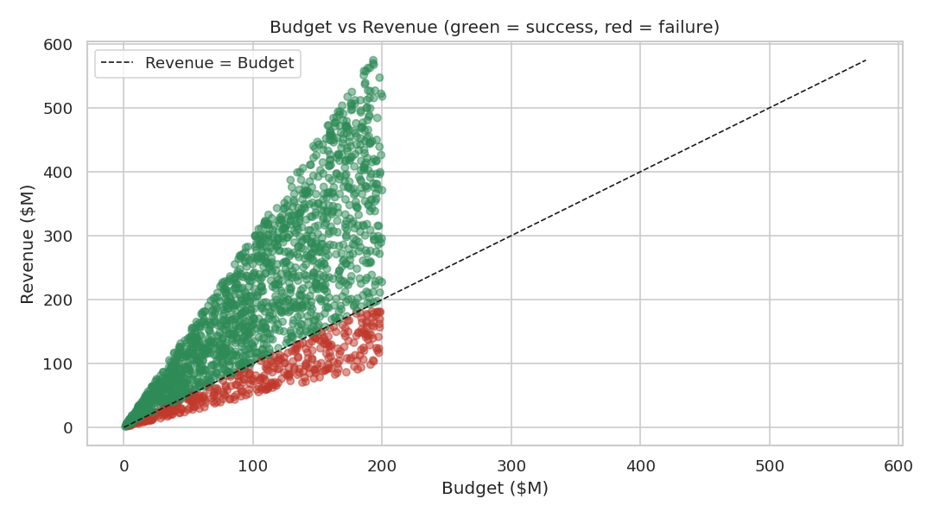
Figure 1: Budget vs Revenue, colored by success (green = success, red = failure).
The scatter plot shows a wide spread of outcomes at every budget level rather than a clean, tight relationship. The correlation coefficient between budget and revenue is weak-to-moderate, indicating that a bigger budget does not reliably guarantee higher revenue in this dataset. Many high-budget movies fall below the break-even line (red points), while several lower-budget movies land well above it. This suggests that budget alone is a poor predictor of success and that other factors (audience reception, popularity, genre fit) likely play a meaningful role.
2. Genre trends — most common and most successful genres
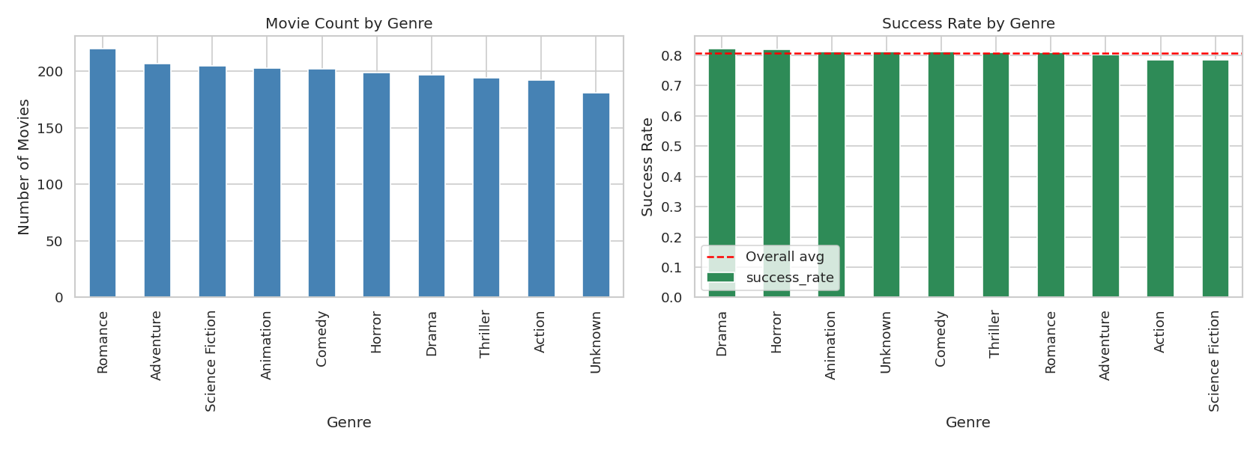
Figure 2: Movie count by genre (left) and success rate by genre (right).
Drama, Comedy, and Action are among the most common genres in the dataset by volume. When looking at success rate rather than raw count, the genres cluster fairly close to the overall average success rate (about 81%), with no single genre standing out as dramatically more or less successful — a pattern that is echoed later by the (non-significant) chi-square test result in Stage 3.
3. Popularity, runtime, and vote_average vs. success — which looks most associated?
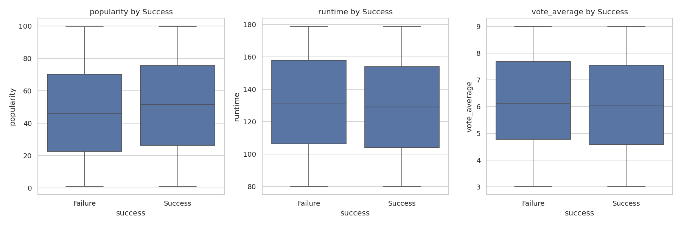
Figure 3: Popularity, runtime, and vote_average distributions split by success/failure.
Comparing the box plots for successful vs. unsuccessful movies, popularity shows the most visible separation between the two groups, with successful movies tending to skew slightly higher on average. Runtime and vote_average show comparatively more overlap between the two groups, suggesting a weaker (though not necessarily absent) relationship with success. This is consistent with the feature importance ranking from the Random Forest model in Stage 4, where popularity comes out on top.
4. Correlation heatmap — strongly correlated pairs and modeling concerns
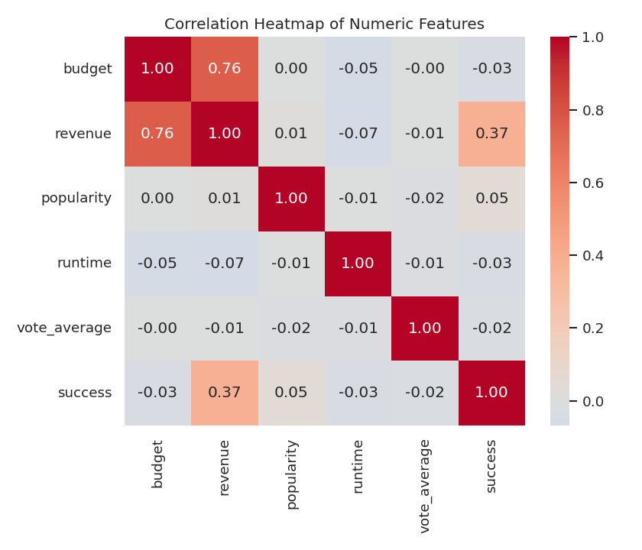
Figure 4: Correlation heatmap of numeric features (including the derived success label).
As expected, revenue and success are strongly correlated with each other, simply because success is mathematically derived from revenue (relative to budget) — this is not a meaningful discovery so much as a reminder that revenue must be excluded from the model's input features, or it would leak the answer directly into the prediction. Aside from that expected relationship, the remaining numeric features (budget, popularity, runtime, vote_average) show only weak-to-moderate correlations with each other, which is good news for modeling — it means multicollinearity between the actual predictive features is not a major concern.

Stage 3 — Statistical Testing
1. T-Test — does vote_average differ significantly between successful and unsuccessful movies?
Null hypothesis (H0): There is no difference in mean vote_average between successful and unsuccessful movies. An independent-samples t-test (Welch's t-test, which does not assume equal variances) was run comparing vote_average for the two groups. The result was t ≈ -1.05 with a p-value ≈ 0.294. Since this p-value is well above the standard 0.05 threshold, we fail to reject the null hypothesis — there is no statistically significant difference in average audience rating between successful and unsuccessful movies in this dataset.
2. Chi-Square Test — is genre associated with success?
Null hypothesis (H0): Genre is independent of (not associated with) movie success. A chi-square test of independence was run on a contingency table of primary_genre versus success. The result was chi-square ≈ 1.77 with 9 degrees of freedom and a p-value ≈ 0.995 — an extremely high p-value, far above 0.05. We therefore fail to reject the null hypothesis: in this dataset, there is no statistically significant association between a movie's genre and whether it succeeds financially.
3. What does a p-value tell you, and what significance threshold was used?
A p-value is the probability of observing a result at least as extreme as the one found in the data, assuming the null hypothesis is actually true. A small p-value means the observed pattern would be unlikely to occur by chance alone if there were truly no effect — giving us grounds to reject the null hypothesis. This project used the conventional significance threshold of alpha = 0.05: any p-value below 0.05 was treated as statistically significant, and any p-value at or above 0.05 was treated as not providing sufficient evidence against the null hypothesis. Both tests above returned p-values well above this threshold, so neither vote_average nor genre showed a statistically significant relationship with success in this dataset.

Stage 4 — Predictive Modeling (Random Forest)
1. Features and target selected — what was excluded, and why?
The model was trained on five features: budget, popularity, runtime, vote_average, and an encoded version of primary_genre. The target was the success column. Two columns were deliberately excluded: title, because it is just a unique text identifier with no predictive value and including it would only add noise (or risk the model memorizing specific titles); and revenue, because success is directly derived from revenue relative to budget — including revenue as a feature would leak the answer into the model and produce an unrealistically perfect (and useless) result.
2. Train/test split — ratio used, and why a separate test set matters
The data was split 80% for training and 20% for testing, using a stratified split so that both sets preserve the same success/failure ratio as the full dataset. A separate, held-out test set is essential because it lets us evaluate how well the model generalizes to movies it has never seen before, rather than just measuring how well it memorized the training data. Without a test set, a model could appear highly accurate simply by overfitting to noise in the training data, while performing poorly on any genuinely new movie.
3. Random Forest — how it makes a prediction (in plain terms)
A Random Forest is an ensemble of many individual decision trees, each trained on a slightly different random subset of the training data and a random subset of the features at each split. Each tree independently looks at a new movie's attributes and "votes" for whether it thinks the movie will succeed or not. The forest's final prediction is based on the majority vote (or averaged probability) across all the trees. This ensemble approach tends to be more accurate and more robust to noise than any single decision tree, because the individual trees' errors tend to cancel out when combined.
4. Model evaluation — accuracy, precision, recall, and confusion matrix
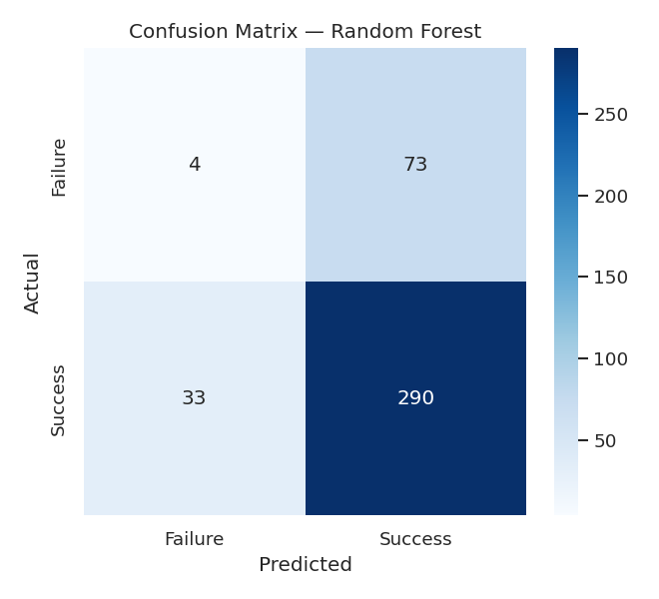
Figure 5: Confusion matrix on the held-out test set.
On the held-out test set, the model achieved an accuracy of about 73.5%, a precision of about 79.9%, and a recall of about 89.8%. The high recall means the model is quite good at catching most of the movies that actually succeed, but the moderate precision indicates it also produces a meaningful number of false positives — predicting success for some movies that ultimately do not break even. Looking at the confusion matrix, the model's mistakes are concentrated in this direction: it more often mislabels an unsuccessful movie as successful than the reverse, which makes sense given that successful movies dominate the training data (about 81% of the dataset) — the model has learned to lean toward predicting success when it is uncertain.
5. Feature importance — which features matter most, and does this agree with the EDA and statistical tests?
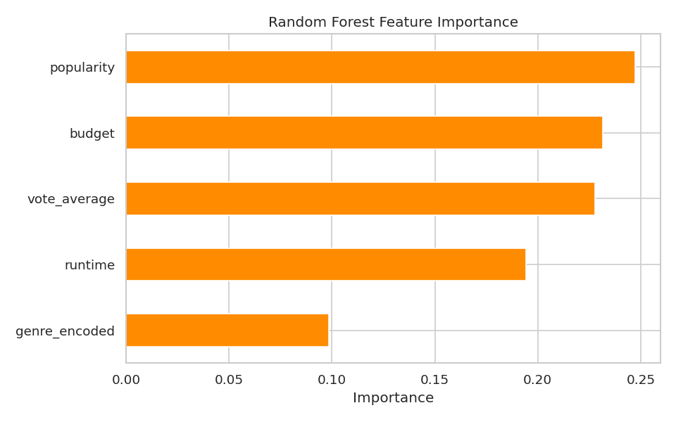
Figure 6: Random Forest feature importance.
The Random Forest ranks popularity as the most important feature, closely followed by budget and vote_average, then runtime, with the encoded genre contributing the least. This partially agrees with the EDA — popularity showed the clearest visual separation between successful and unsuccessful movies in Stage 2, consistent with its top ranking here. However, it's worth noting that the statistical tests in Stage 3 did not find vote_average or genre to be significantly associated with success on their own (in isolation), while the Random Forest — which can capture non-linear combinations of features — still assigns them non-trivial importance. This is a reasonable and common pattern: a feature can contribute to a multivariate model's predictive power through interactions with other features even when it shows no significant standalone (univariate) relationship with the outcome.

Reflection
If a studio asked "Will our next film succeed?", I would present MovieIQ's answer with meaningful caveats rather than full confidence. With a test accuracy of about 73.5% and only moderate precision (about 80%), the model is a useful directional signal — better than a coin flip and grounded in real patterns in the data — but far from a reliable guarantee, especially for any single high-stakes decision.
One clear limitation of the data is that it captures only a movie's own attributes (budget, popularity, runtime, rating, genre) and says nothing about external factors that heavily influence real-world box-office performance — marketing spend, release-date competition, star power, franchise/sequel status, critical reviews at launch, or macroeconomic conditions. The dataset is also moderately imbalanced (about 81% success), which makes it harder for the model to learn the more subtle patterns behind failure.
With more time, I would improve the model by engineering richer features — such as cast/director track record, marketing budget, release month/season, and franchise indicators — and by testing additional algorithms (e.g., gradient boosting) alongside more rigorous cross-validation and hyperparameter tuning, rather than relying on a single train/test split and a single model type.

Answers prepared by: Pooja

