A mobile app where any person (who must register previously) will report an irregularity of a public service and each complaint will be forming a database that will compile all the information requested when uploading the complaint to the platform, to order and systematize it. It will generate a map that will geolocate each complaint indicating whether it has been attended or not by the authorities, by means of colors in the symbol that indicates the location of the complaint; as well as a statistic that can be consulted by users. It is hoped that the operation of the App is as follows:

1. **User Registration:** User needs to sign up by providing the required details as shown below:

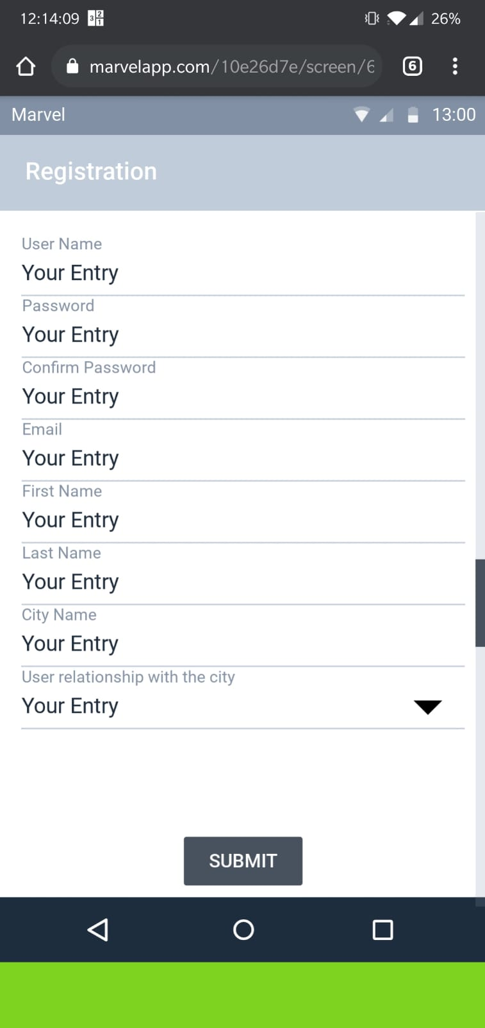

1. **User Login** (restricted access to the application only of registered users):

* Register with Email or with Google/Facebook/Twitter.

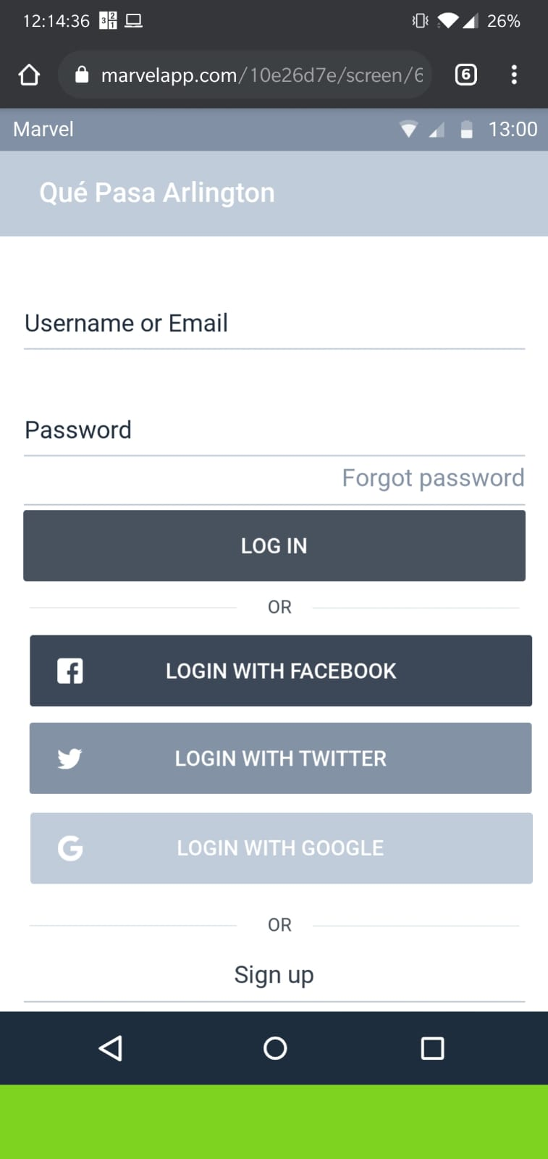

2. **Home screen:**

* There are two options- New Request, Check complaint.

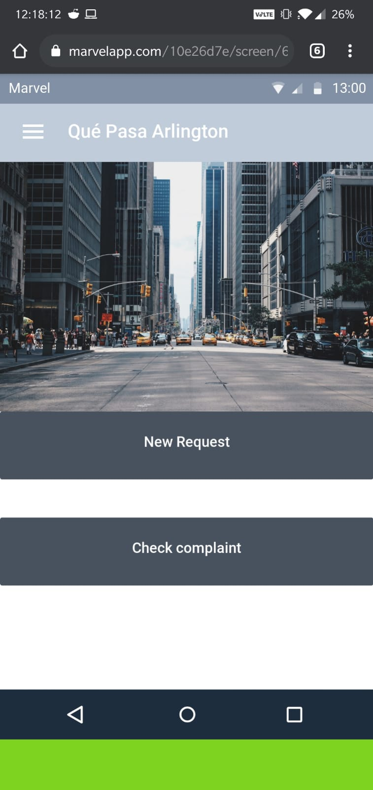

* It displays the following results on a split screen:
  + Map of geolocated complaints identified with colors as they were attended or not by the authorities. (gray = not reported to the authorities; red = reported without response; yellow = reported in process; green = complaint resolved)- colors to be changed later, as this is just the prototype

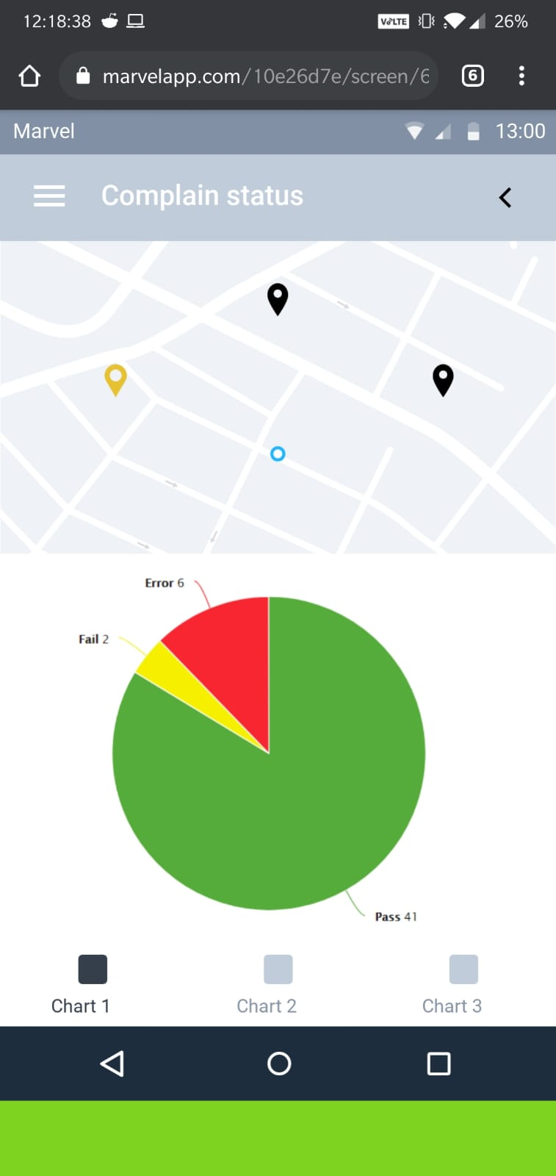

* Statistics through graphics:
  + Pie chart of the Total percentage of complaints without response = red; complaint pending = yellow and complaint resolved = green.
  + Pie chart discriminated by subjects (*) of unanswered complaints = red; complaint pending = yellow and complaint resolved = green.
  + Pie chart of the Total percentage of complaints discriminated by subjects. (use color by theme).
* Proposed solutions for each complaint. Initiatives are generated from the result of the “Proposed Solution to Complaint” field, discriminated by themes and location (**)
* “Report” button to be present on central axis of the app
* Report Module: Pressing the “Report” button will redirect to the screen that will contain:
  + Simple Selection of Subject (*) to which the complaint corresponds, from the following list:

1. Municipal Taxes

2. Economic Activity

3. Formal Employment

4. Informal Employment

5. Education

6. Electric Service

7. Environment

8. Emergency and fire response

9. Government-citizen relationship

10. Health

11. Recreation and Entertainment

12. Security

13. Public Order and Citizen Coexistence

14. Urban planning

15. Solid waste

16. Telecommunications and innovation services

17. Roads

18. Transportation

19. Wastewater

20. Drains

21. Drinking Water Service

22. Domestic Gas Service

23. Infrastructure

24. Housing

25. Sports

26. Culture, Traditions and Identity

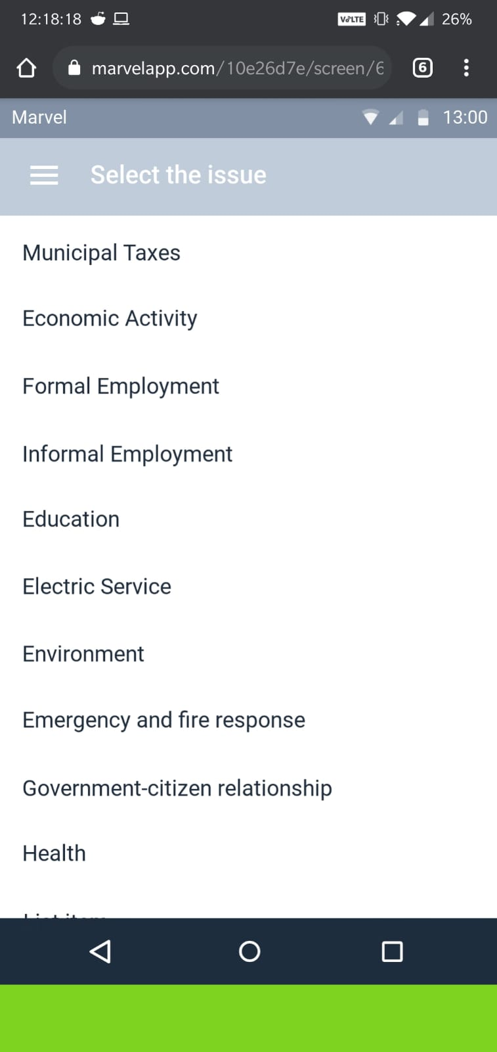

* Complaint:
  + Table for Description of the complaint (same number of limited Instagram characters - mandatory filling).
  + Table for Proposal of Solution to the Complaint with limited number of characters in the same amount of Instagram (optional filling).
  + Annexes / Supports: (optional filling), space to upload any of the following: Documents, Audios, Photos or Videos. (set size and weight limits)  
    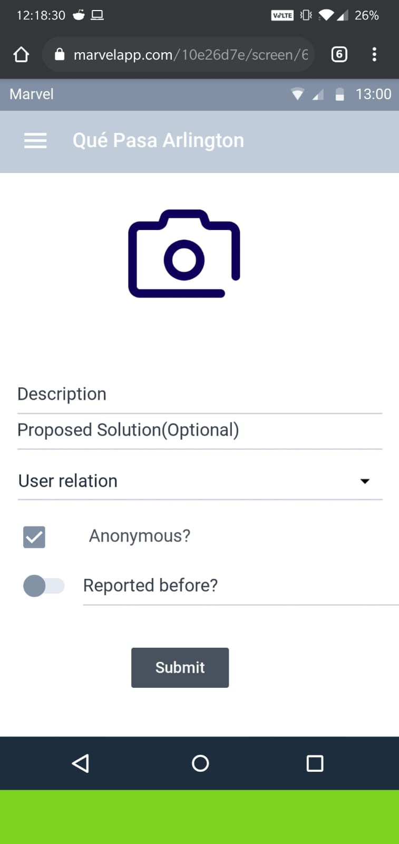
* Closed questions:
  + Was it reported / reported? If not
  + If the answer is negative.
  + Why not? – It is because of distrust in the system or in the capacity of government solution, cumbersome process, expensive, fear/retaliation /persecution or Other
* Geographic location of the complaint: It can be in 2 ways -Location in real time or -Locate on the map

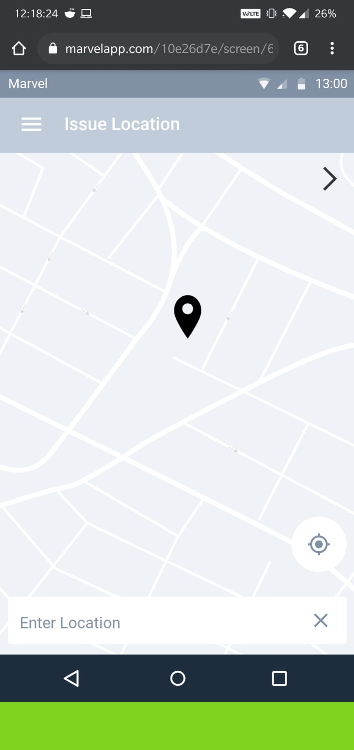

**Result/Utility of the App:**

The information collected is required to be processed as follows:

* Geolocation on the map of the complaints identifying them with colors according to whether they were attended or not by the authorities. (gray = not reported; red = reported without response; yellow = reported in process; green = complaint resolved). (home map)
* Statistics generation: (access only app administrator)
  + Registered user count
  + Complaint Count
  + Count of complaints by location (city, state, country)
  + Counting and graphing of complaints issues & counting and graphs of situations reported to organizations
  + Counting and graphs of situation denounced before organizations without governmental response
  + Counting and graphs of situation denounced before organizations in process
  + Counting and graphs of situation denounced before resolved bodies
  + Counting and situation graphs NOT reported to agencies for distrust in the government system / solution.
  + Counting and situation graphs NOT reported to agencies by cumbersome, long, expensive process.
  + Counting and situation graphs NOT reported to organizations by Fear/retaliation/persecution.
  + Counting and situation graphs NOT reported to organizations by Others.
* **Report Generation:** (Only administrator of the application)
* Processing of the text received in the “Description of Complaints” field will be carried out based on the data reduction methodology, accounting and coding common words, terms and/or phrases for their repetition.
* Processing of the suggestions to generate the section "People gives solutions ..." that will be made from the generation of a list of proposals that are acquired by the repetition of common words, terms and / or phrases. (data reduction methodology).
* Generation of a follow-up alarm about the status of the complaint process by sending notification to the registered email with a link that allows updating the status of the complaint in the App.
* This applies to those complaints that they have obtained within their YES responses to the “reported” or “reported to the agencies” question. The frequency of this notification must be monthly.