**Full Stack Ecommerce Website Development Using React, Spring Boot, MySql And Payment Gatway**

**Technologies Used:** **React, Spring Boot, MySQL, And Payment Gateway (RazorPay)**

**frontEnd : react , Backend : SpringBoot , Payment gateway : Razor Pay**

**Customer**

* Carousel
* sorting feature,
* pagination,
* filter,
* add to cart,
* buy,
* payment gateway,
* track order,
* review and rate product

**Admin**

* admin panel,
* add product,
* manage order,
* change order status

**Create React App Using :** *npx create-react-app project_name or we can use npx create-react-app . (. Is used to current folder makes our project ) if we want to create new projet folder we can use npx create-react-app project_name this fomat*

**Downloads :**

**react alice carousel (2.7.1)**

**Mui :** *npm install @mui/material @emotion/react @emotion/styled*

**Mui – icon :** *npm install @mui/icons-material @mui/material @emotion/styled @emotion/react*

**Tailwand css :**

* + - *npm install -D tailwindcss@3*
    - *npx tailwindcss init :* ***Created Tailwind CSS config file: tailwind.config.js***

**tailwind.config.js**

*/** @type {import('tailwindcss').Config} */*

*module.exports = {*

*content: [*

*"./src/**/*.{js,jsx,ts,tsx}",*

*],*

*theme: {*

*extend: {},*

*},*

*plugins: [],*

*}*

Add This code In **tailwind.config.js** file

**index.css**

*@tailwind base;*

*@tailwind components;*

*@tailwind utilities;*

Add This code In **index.css** file

**Now You can Start Your Project Using :** *npm start*

*30/4/25*

**\src\customer\components\navigation\Navigation.jsx**

**Navigation.jsx**

**Navigation Bar :** [*https://tailwindcss.com/plus/ui-blocks/ecommerce/components/store-navigation*](https://tailwindcss.com/plus/ui-blocks/ecommerce/components/store-navigation)

(Use This link To get readyMade Navbar From Tailwind Doc )

### *npm install @heroicons/react :* ( Icons for UI This library provides SVG-based icons (like shopping carts, chevrons, user profiles, etc.) that you can use directly in React components.)

### *npm install @headlessui/react :* ***(***Accessible UI components (without styles)

This library gives you interactive components like:

* Dialogs (modals)
* Dropdowns
* Tabs
* Menus
* Disclosures (accordions)

But without any built-in styling, you can fully customize them (usually with Tailwind CSS).

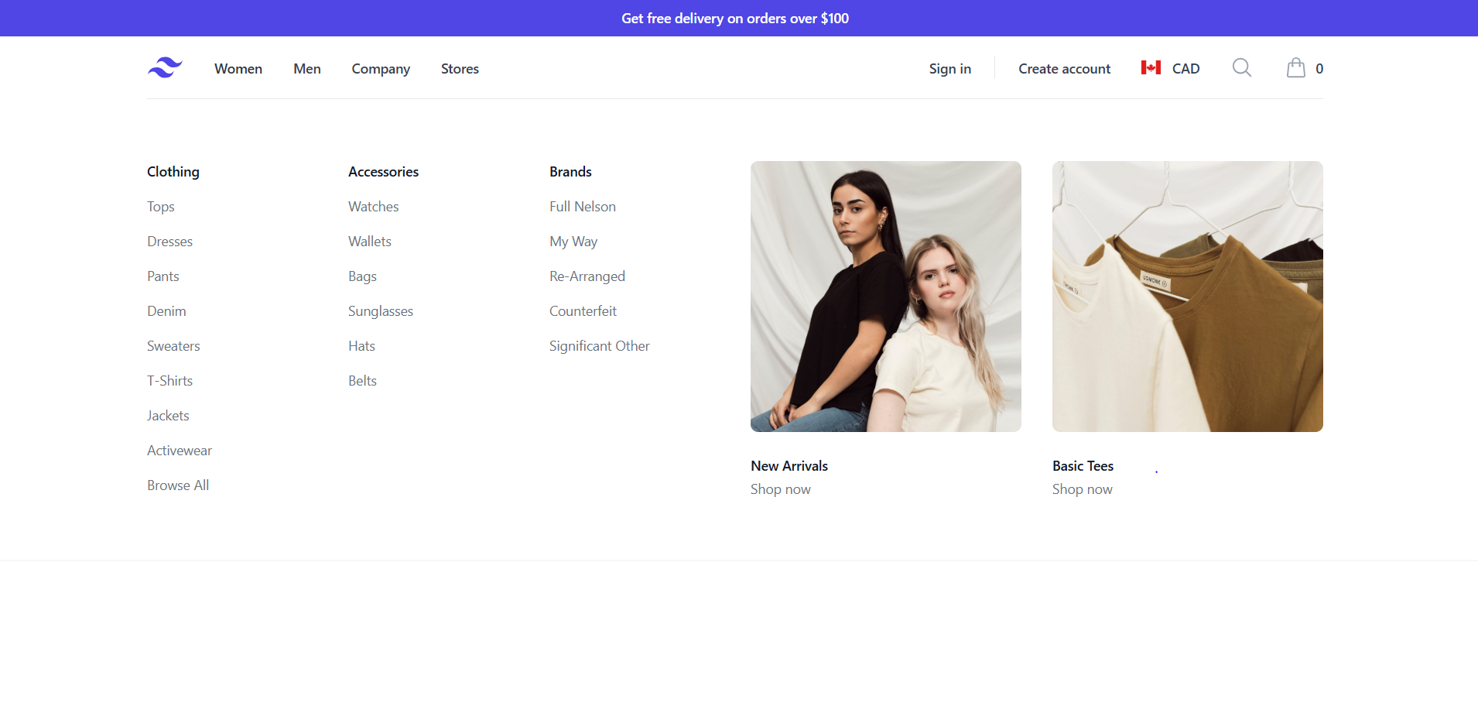

So Navbar look like this

Home Section :

*react-alice-carousel* : is a React carousel/slider library used to create image sliders, carousels, or galleries in React applications.

**Key Features :**

Responsive — works across devices and screen sizes

* Touch-friendly — supports swipe/drag gestures on mobile
* Autoplay support
* Infinite loop
* Custom buttons/dots
* Lightweight and easy to integrate

**Download Templete :** <https://maxmarinich.github.io/react-alice-carousel/#basic>

\src\customer\components\HomeCarousel\MainCarousel.jsx

Add this template code in -> **MainCarousel.jsx**

\src\customer\Pages\HomePage\HomePage.jsx

**HomePage.jsx :** importing **MainCarousel.jsx** in **HomePage.jsx** AndAfter import **HomePage.jsx** in **App.js**

\src\customer\components\HomeCarousel\ MainCarouselData.js

const items = mainCarouselData.map((item) => <img className='cursor-pointer' role='presentation' src = {item.image} alt = "" />)

Iterating in **MainCarousel.jsx** so The images present in that file will display on Home Page And Using Carousel it will Auomatically slide.When We Set some properties in this .like autoplay , autoplayInterval etc.



**Creating Home Section Card :**

\src\customer\components\HomeSectionCard\**HomeSectionCard.jsx**

**Creating Carousel**

\src\customer\components\HomeSectionCarousel\**HomeSectionCarousel.jsx**

Importing **HomeSectionCard.jsx** in **HomeSectionCarousel.jsx** and Then It will imported in Main **HomePage.jsx**

Some Problem with **HomeSectionCarousel** The slide is not working properly

**Data Files**

\src\Data\mens_kurta.js