Activity 2:

Create Cloud SQL (MySQL) 2nd generation instance and database related operations

Complexity: Easy

Task:

* Create MySQL 2nd generation instance:
* **gcloud sql instances create mynewsq-ints1 --tier =db-n1-standard-2 --region=europe-west2**
* Set Root user password

**gcloud sql users set-password root % --instance mynewsq-ints1 --password test12 –host=HOST**

* Describe the created instance

Command:

**gcloud sql instances describe mysqldemo1**

O/P:

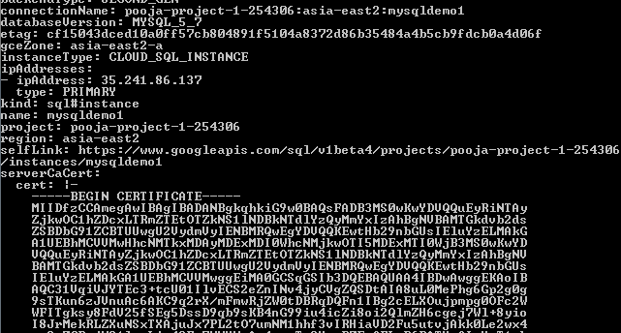

* Create new database

**gcloud sql connect mysqldemo1 –user=root**

**Create database Customer;**

* List the available databases

**Show databases;**

* Import CSV file into the Database table
* Check the import status

<Command and Output>

* Export data to the dump file

1. gsutil mb –p pooja-project1-254306 –l asia-east1 gs://bucketsql1
2. gcloud sql instances describe mysqldemo1
3. gsutil acl ch -u p983091810473-8o07wq@gcp-sa-cloud-sql.iam.gserviceaccount.com:W gs://bucketsql1
4. gcloud sql export sql mysqldemo1 gs://bucketsql1/sqldumpfile.gz \ --database= customer

* Export data to the CSV file

1. gsutil mb –p pooja-project1-254306 –l asia-east1 gs://bucketsql2
2. gcloud sql instances describe mysqldemo1
3. gsutil acl ch -u p983091810473-8o07wq@gcp-sa-cloud-sql.iam.gserviceaccount.com:W gs://bucketsql2

gcloud sql export csv mysqldemo1 gs://bucketsql2/testcsv1 \--database=customer -–query=select * from profiles

* Check the Export status

<Command and Output>

* Delete the database

**Truncate databases <database name>**

* Delete the instance

gcloud sql instances delete mynewsq-ints1

p983091810473-8o07wq@gcp-sa-cloud-sql.iam.gserviceaccount.com