**STORAGE:**

* Google has different kinds of products for storing different kind of data.

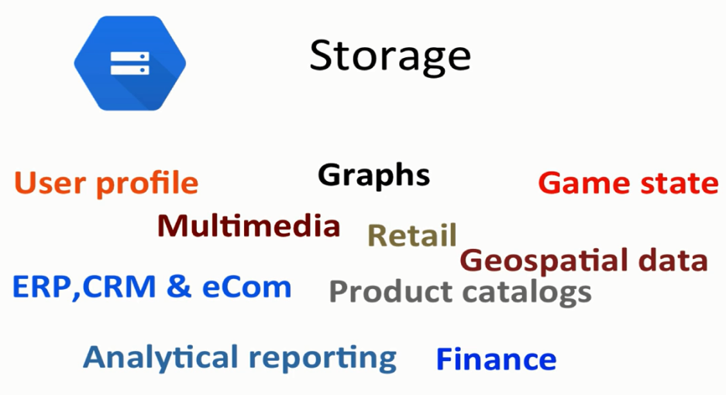

* How to choose what system to go for:

Structured data :data that follows structure eg: oracle, mysql etc

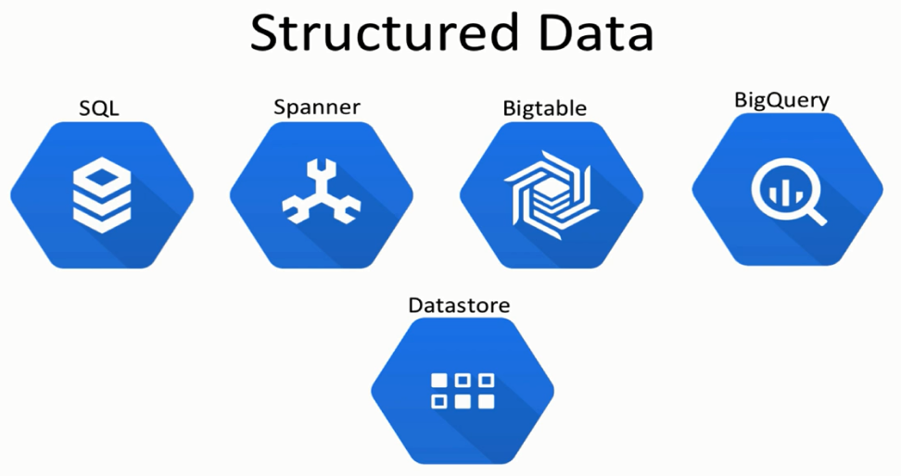

* Unstructured data: photos,ppts,xray-images etc
* Google data storage options: https://cloud.google.com/storage-options/

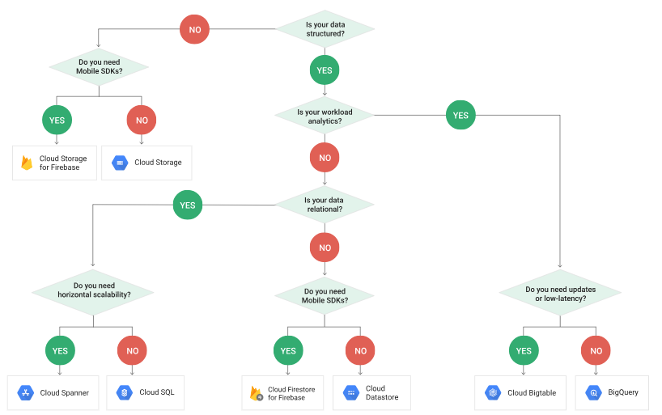

* CLOUD SQL:

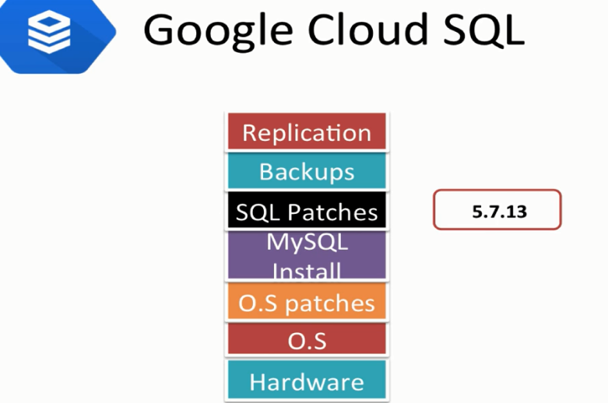

* Encryption:

External encryption: SSl or cloud sql proxy

Internal encryption on network ,tables, backup files etc.

256 bit-AES -256



* Automatic storage increase:

50GB/25= 2 round of 2 +5=7, at 43 reached threshold will add 7 again

* Cloud SQL proxy once installed in local or any server starts encryption automatically.

Backups and restore

* BACKUP: Automatic backup(7 backup retains), can take manual backup which will incure come cost.

HIGH AVAILABILTY:

High availability is only for mysql and comes into picture when we create a failover replica

MYSQL- High availability.

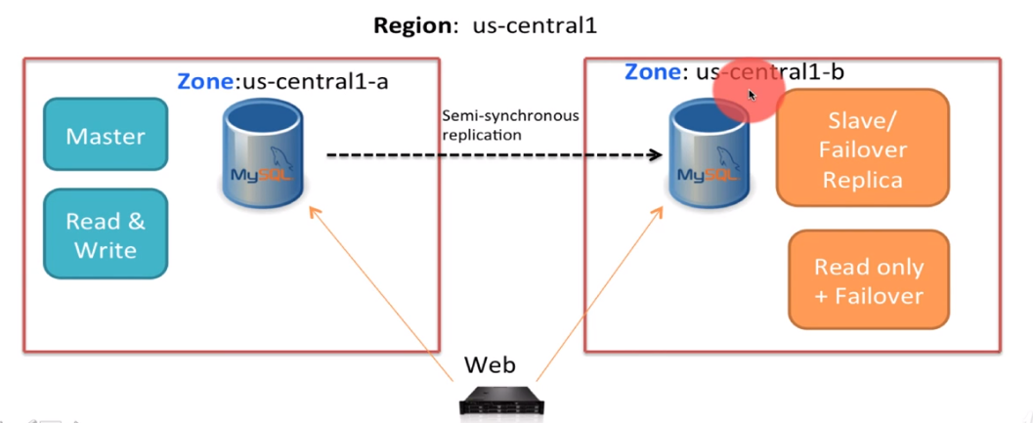

When failover happens: whne there is a zone outage.

To control failover there is a failover API by google .

What happens during failover ?

* No IP changes required.
* Application experiences an outage.
* Existing connections are closed
* Master moves to slave and slave moves to some other zone.

DATASTORE:

* No SQL concept
* Built for high availability, scalability, durability

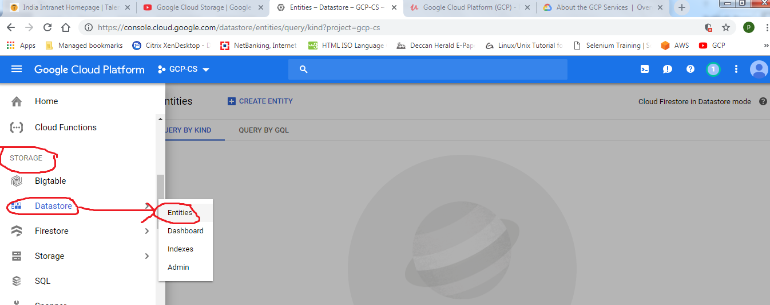

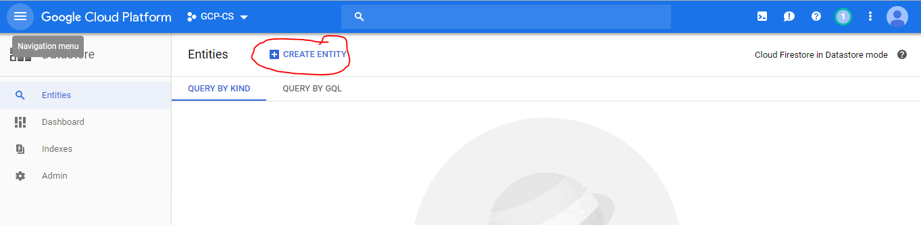

SPANNER:

Is a fully managed relational database service

* Strong horizontal scaling
* Consistency on global scale
* Schema model , queries automatic.
* Combines both advantages of relational database structures with non-relational scales.
* Synchronous replication for high availability.

Why spanner was created:



Mysql had risk of failover and replication leading to loss of data and downtime.

INSTANCE IN REGION:

1 node -2 terra bytes of data. Total 3 nodes

SPANNER ARCHITECTURE:

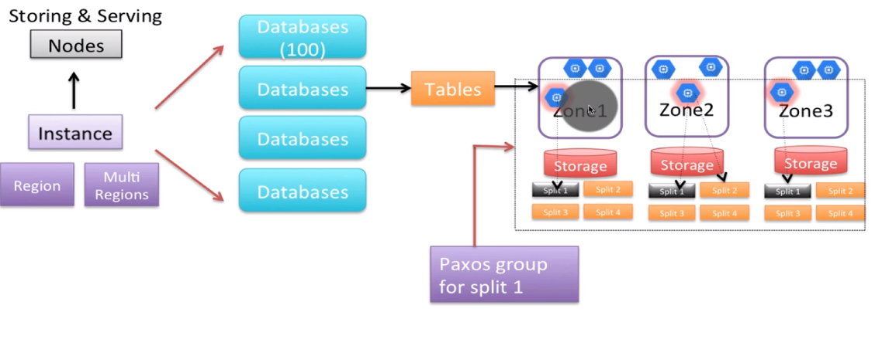

Spanner assigns particular split to each node. And they form a paxos group

When split grows in data then spanner assigns to node to a different split this way horizontal scaling.

MULTI REGIONAL SPANNER ARCHITECTURE:

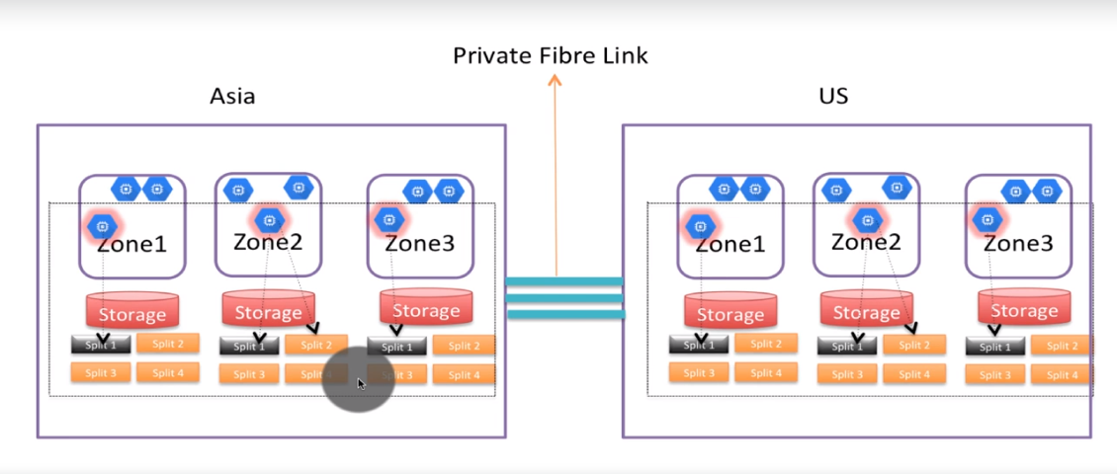

Private fibre link for transfer of data with security and high performance.

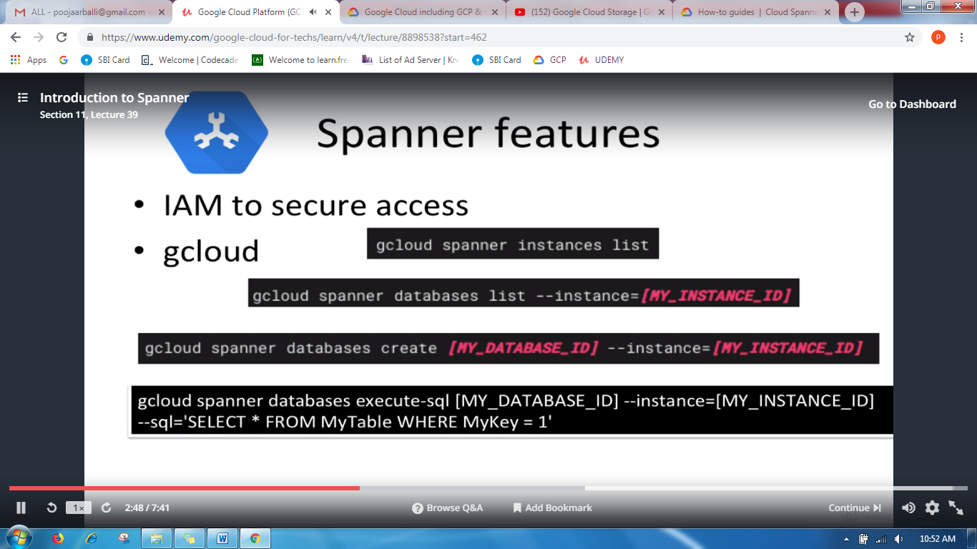

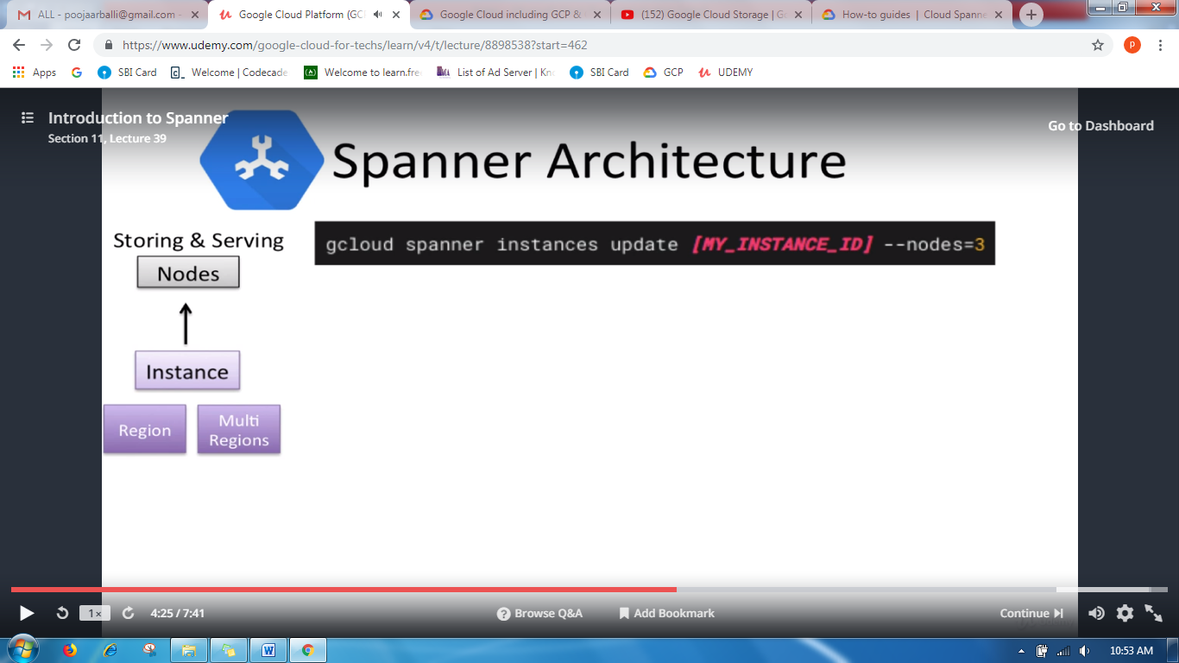

SPANER is based on a new storage model called RESI

Data in spanner is strongly typed:

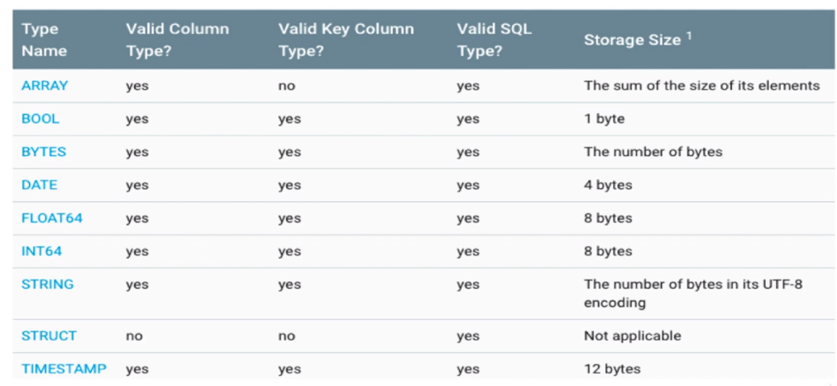

How long does the schema update takes;

1. It depends on how much time spanner needs to recheck the existing data to update the data.
2. Eg: if one wants to update a particular column as not null then it has to check for all the null columns in the previous data and then update all the coulmns.
3. If data has to be made indexed the spanner has to back fill all the existing data which is time taking for update.

HOTSPOT:

If the primary key column is monotonically increasing by time then single server will have all the load because spanner devides data in the form of spilts with reference to primary key

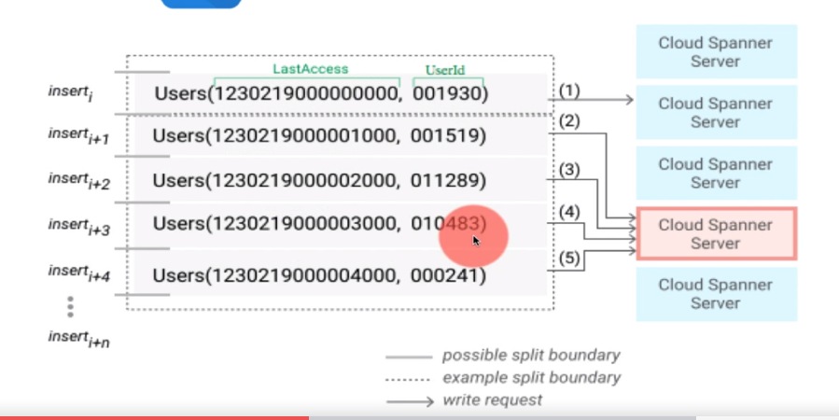

Solution is to hash the key and then to spread the rights.

INTERLEAVED TABLES:

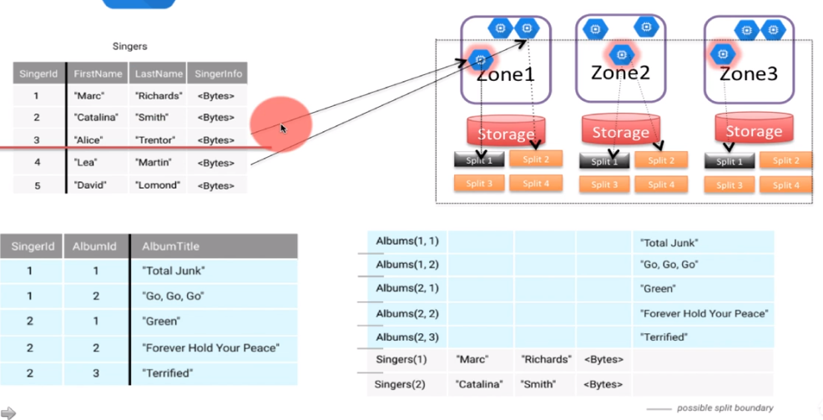

It leads to read latency.

Interleaved tables:

Allows you to pre-join the tables which allows you to access the related tables with very less disk access.

Creation: define the table as the child of the parent table.

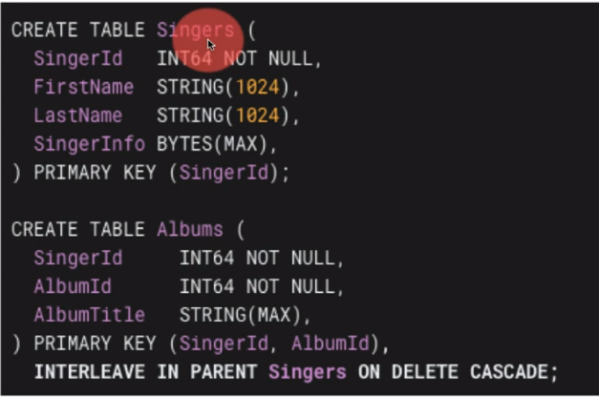

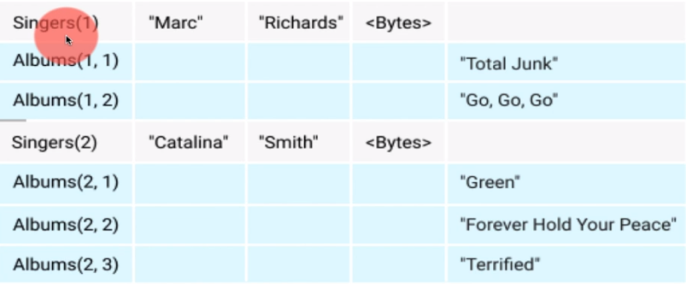

1. Go to search bar and then Spanner:

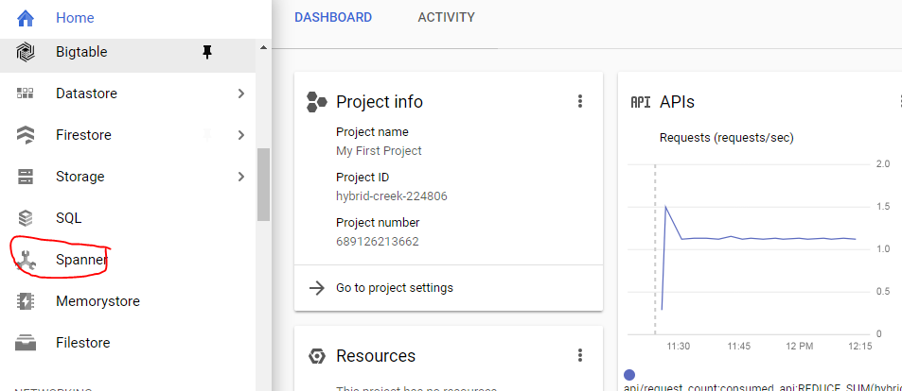

1. Spanner window opens, Create a new instance.

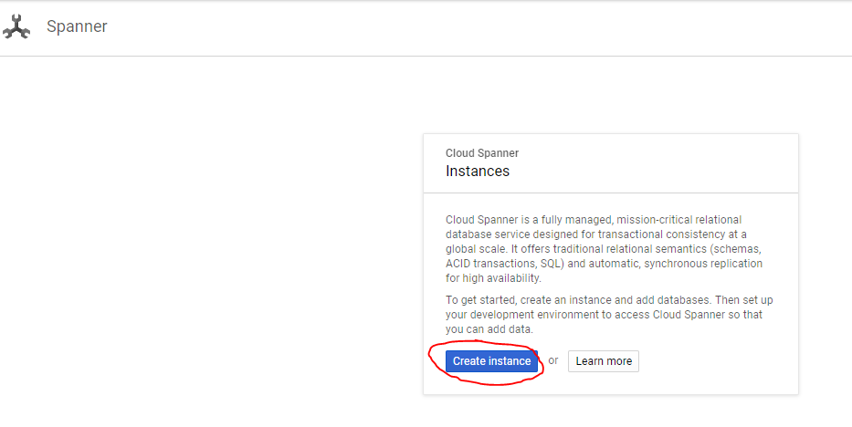

1. Fill in the instance name and other details:

