Week4- Day1- create Jsonl file for using fine tuning concept

- Execute program and generate JSONL file format.
- Open Leaftaps project in VS
- Open converter folder-> add input dir-> location of input file
- Add output dir-> add location of output file where want to store jsonl file
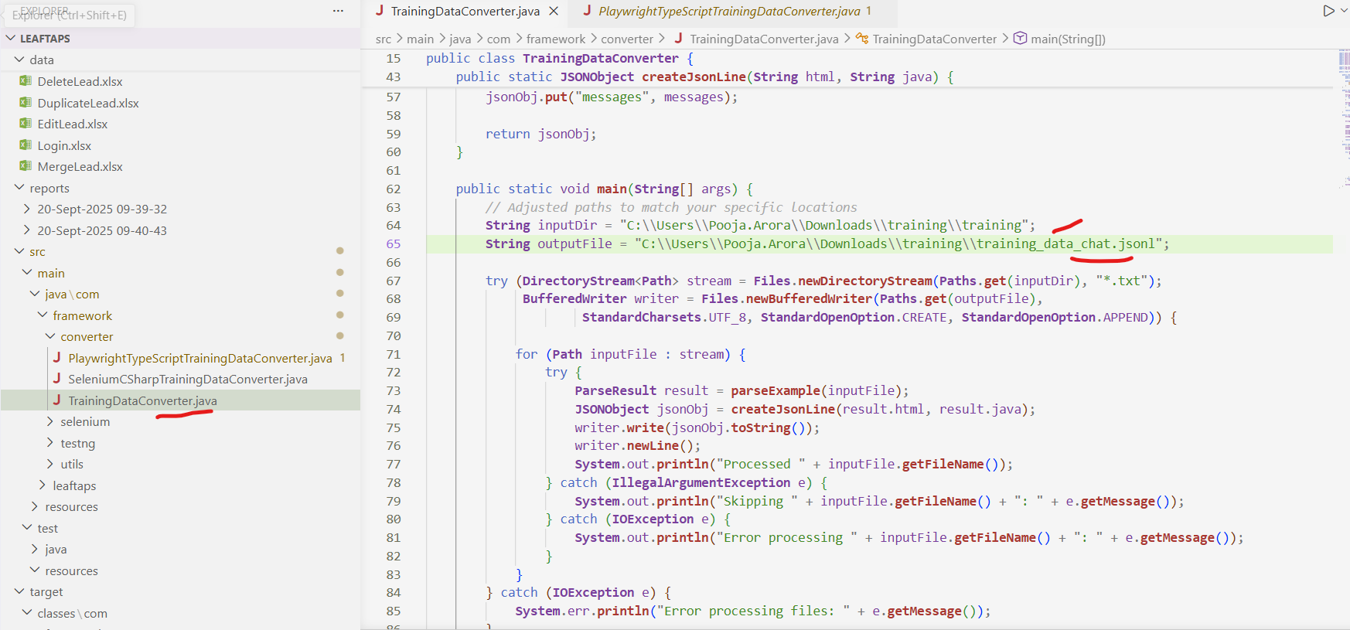

- In training folder under inputDir, store input file in which DOM code and Java code.
- Run the function and jsonl file is created under outputfile folder
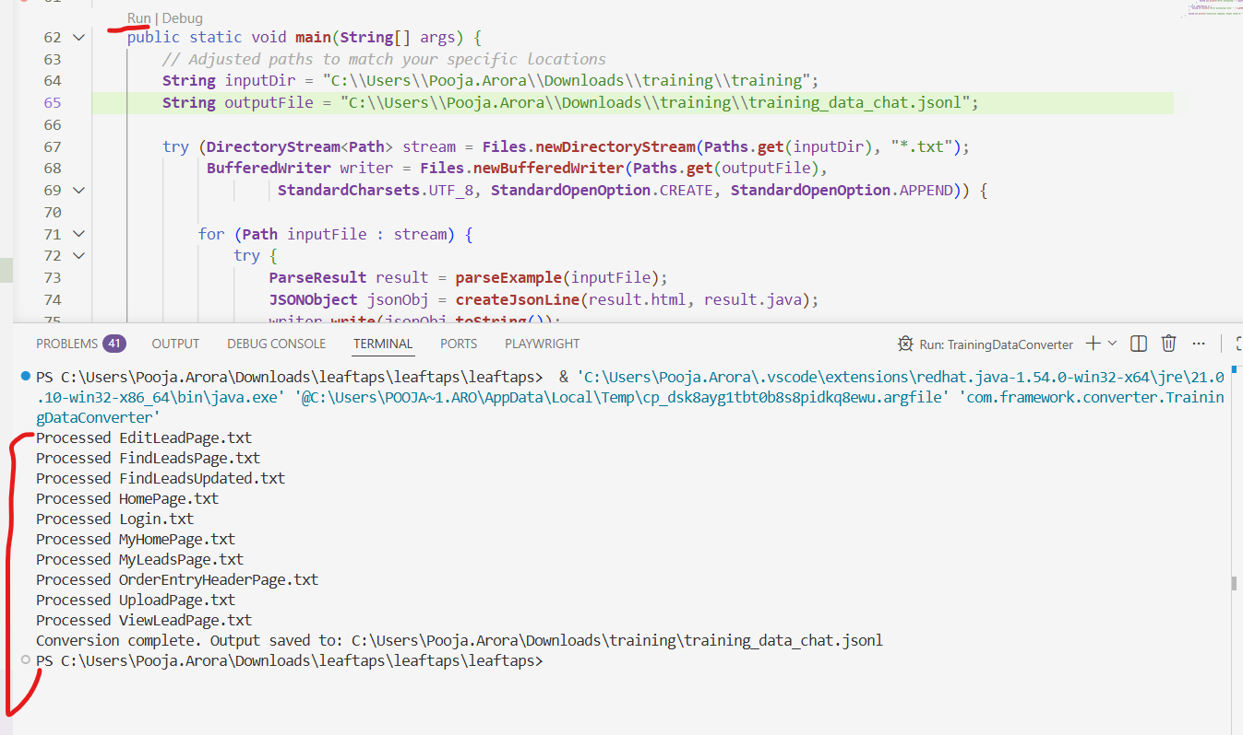

- open api.testleaf.com and login it
- click on fine tuning page and click on create button
- upload jsonl file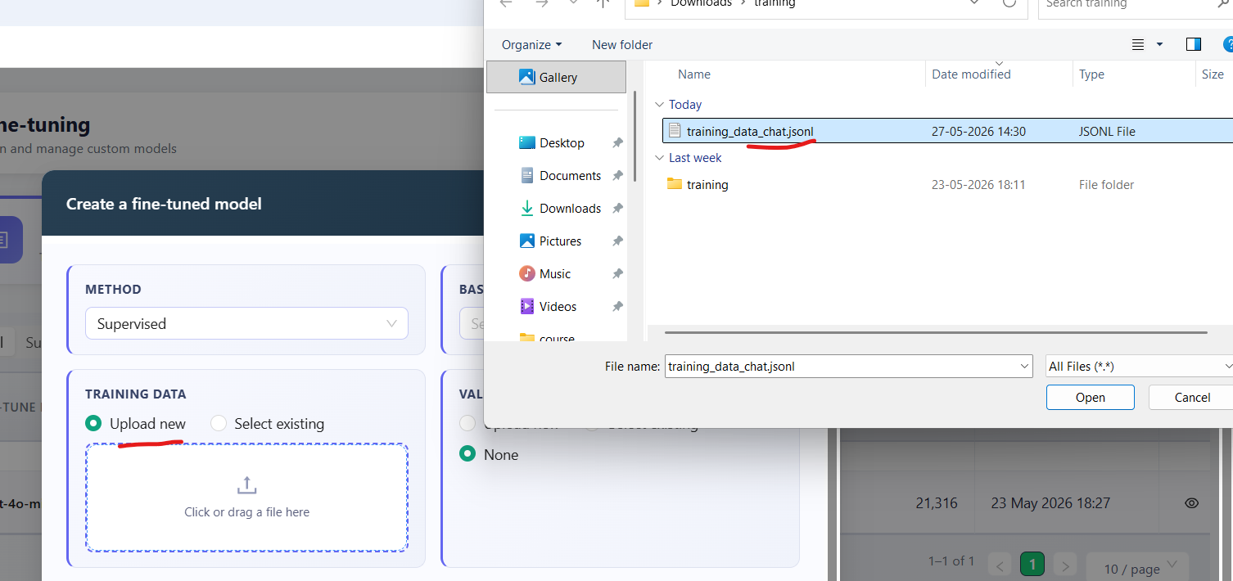

- select and enter parameters of fine tuning and click on create model button.
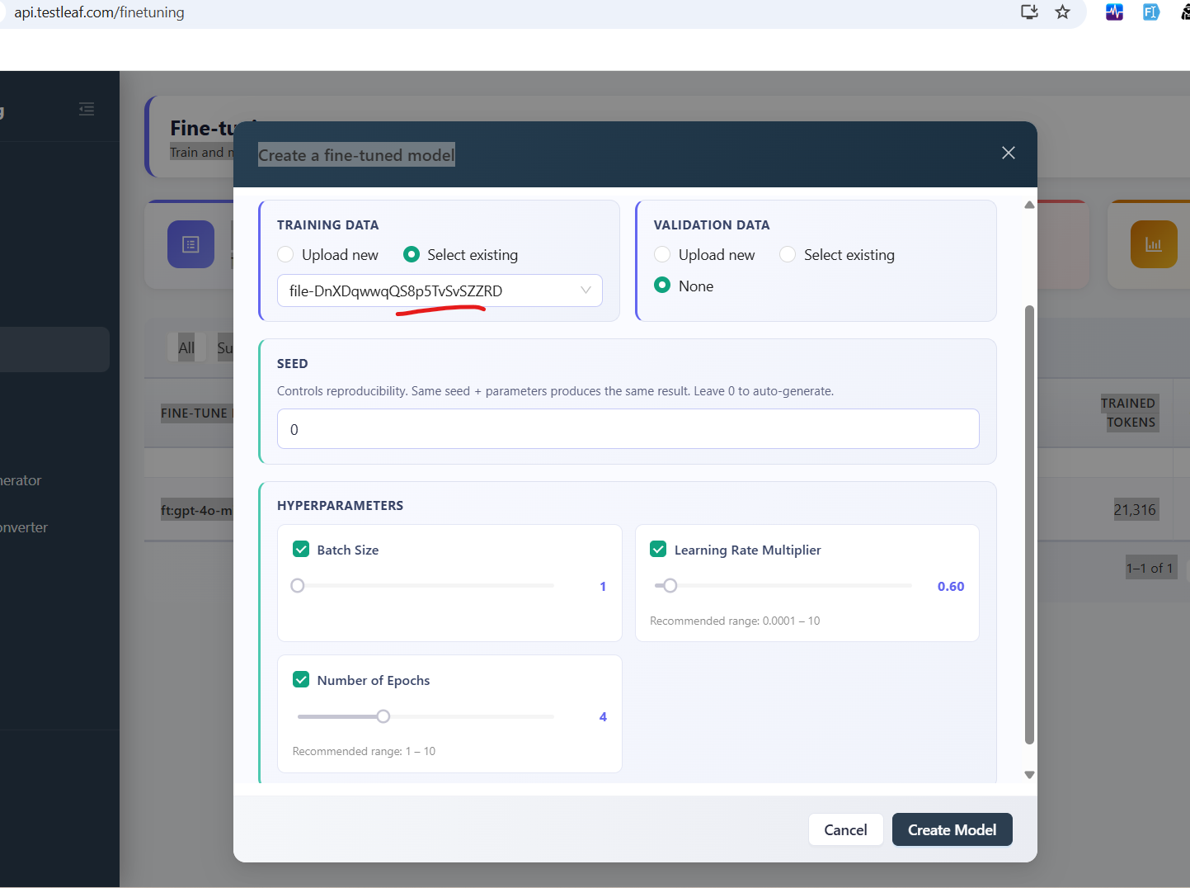

- model creation takes around 20 minutes
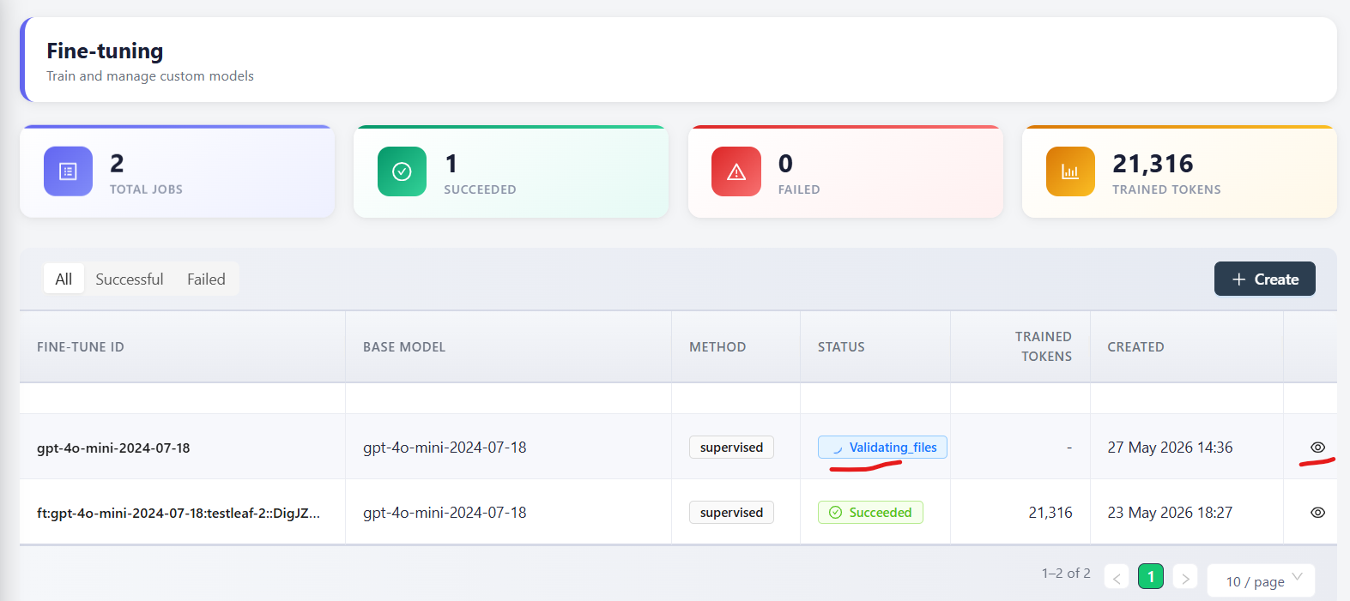

- after completed then copy id and paste into popup.js file.
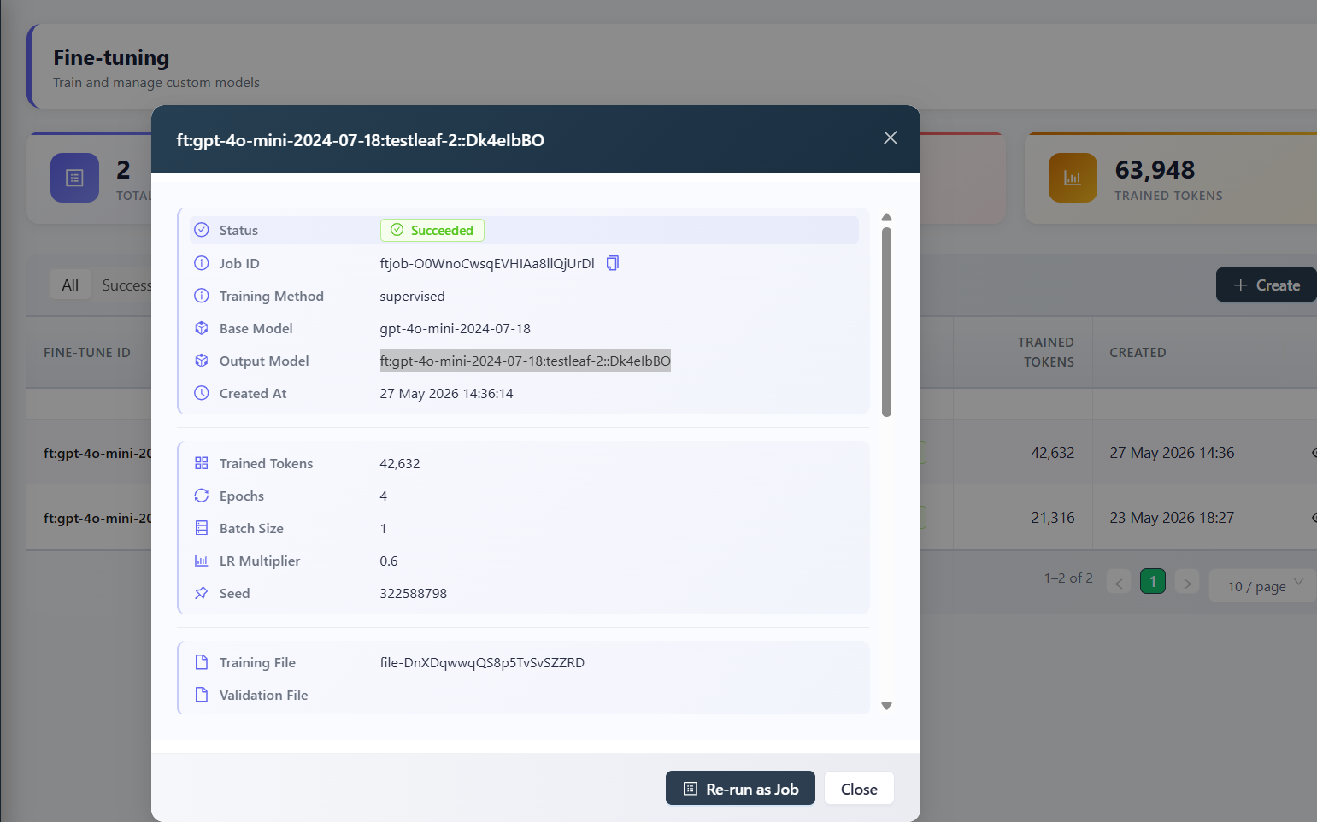

- open popup.js file in AI-extension and add model id in it.
- Add fine tune id in popup.js file and save it.
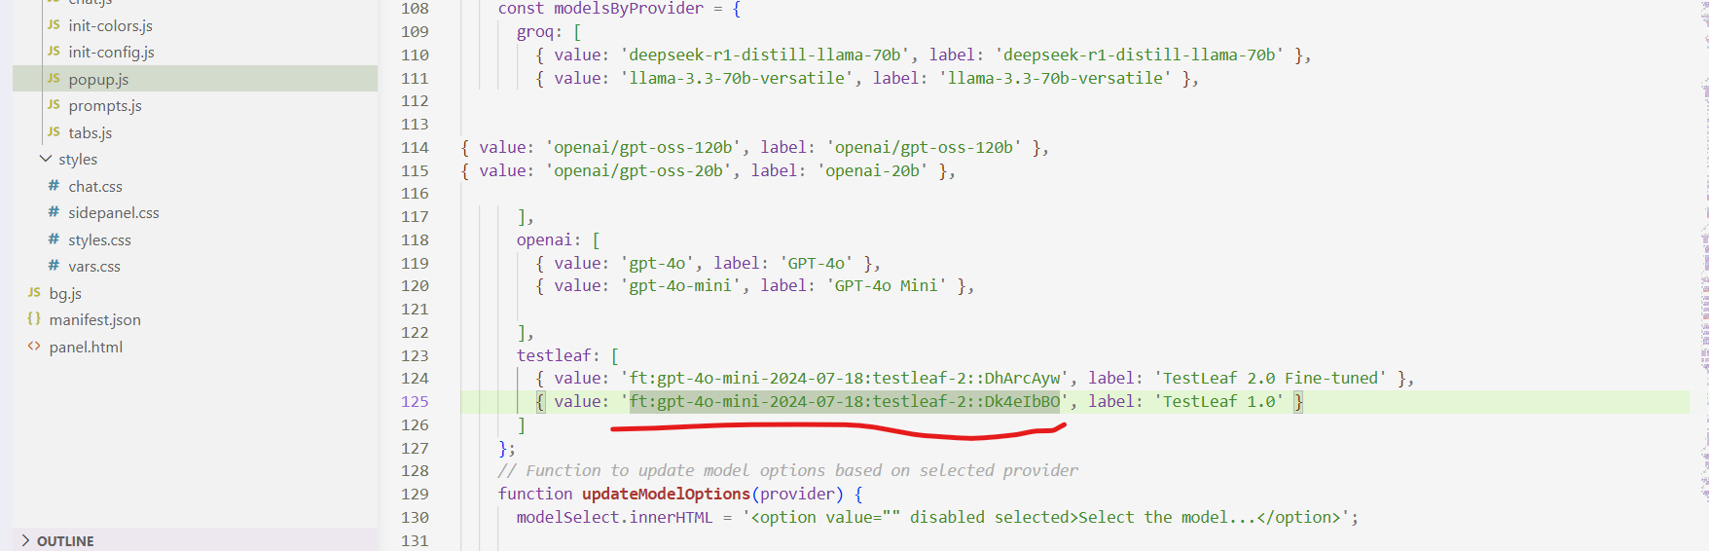

- generate api key after click on API keys button
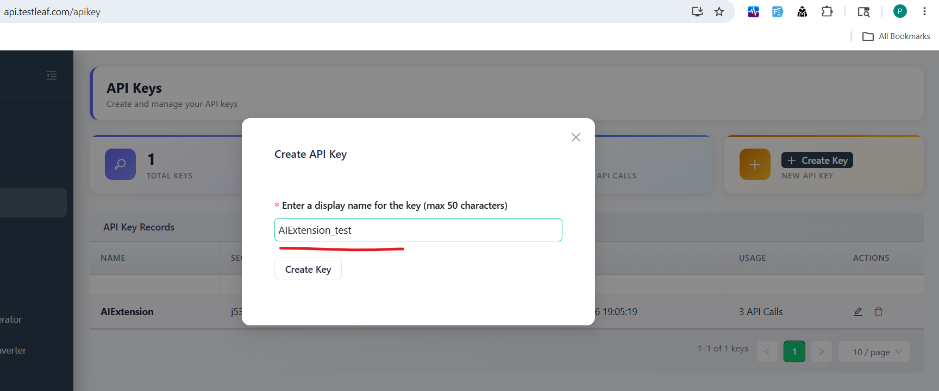
- enter name of api key and click on createkey button
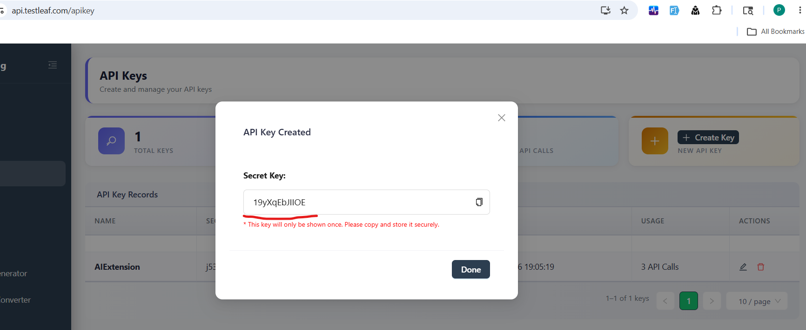
- Save it and open chrome extension and add ai-extension in it
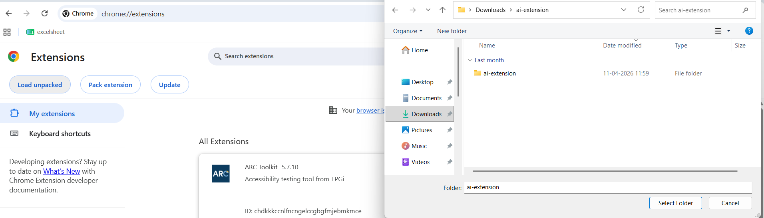
- Extension is loaded
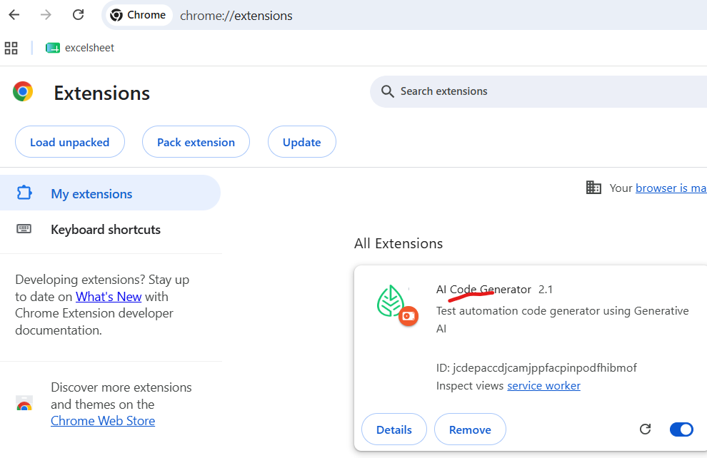
- Go to setting and add api key and select model TestLeaf
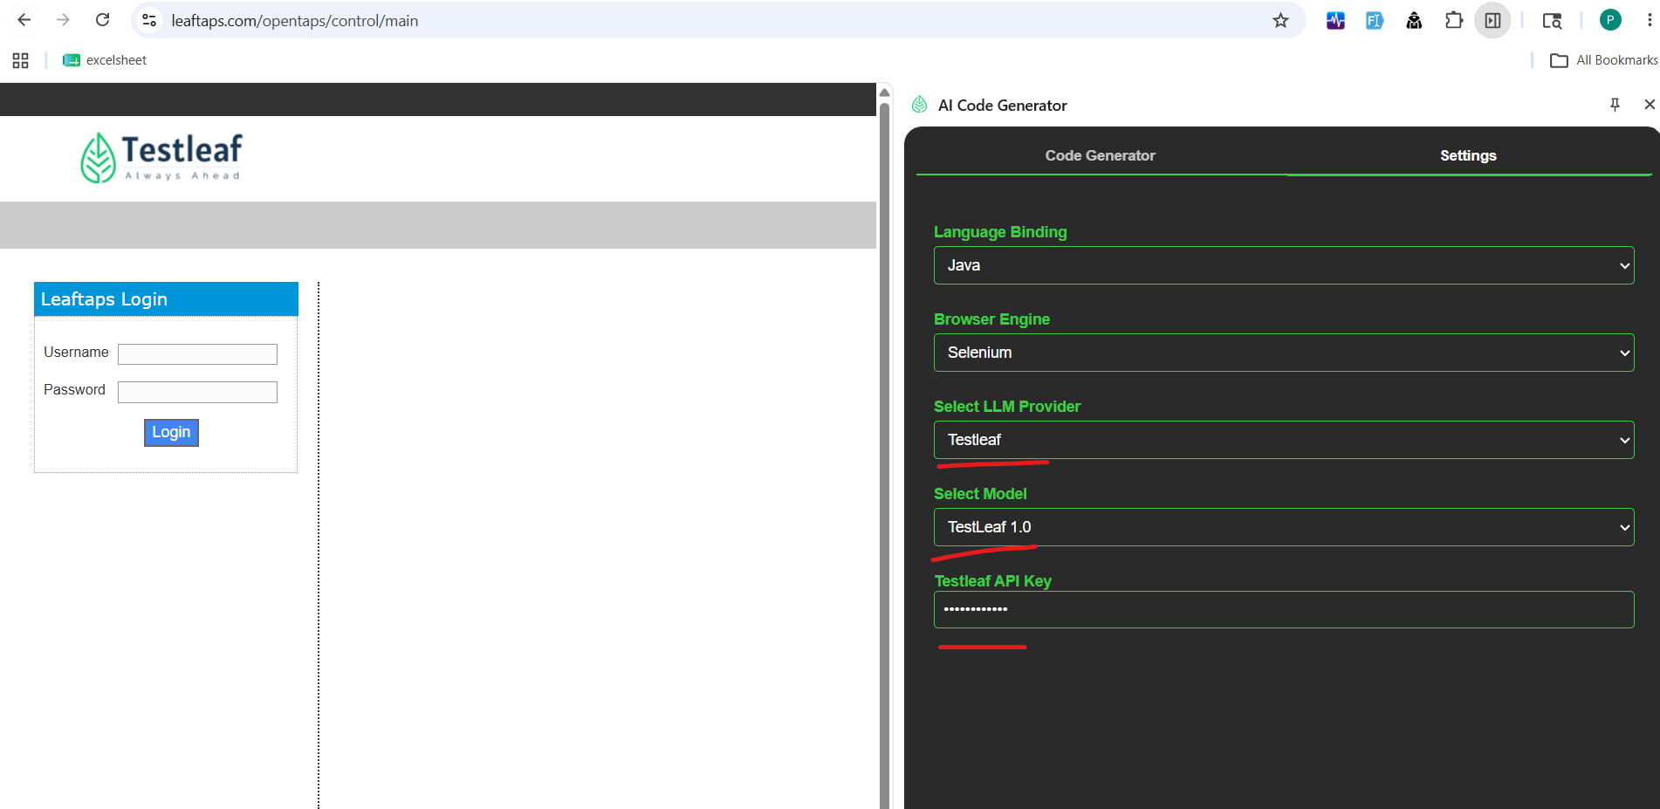
- Open any login page then inspect and generate
- Generate the code
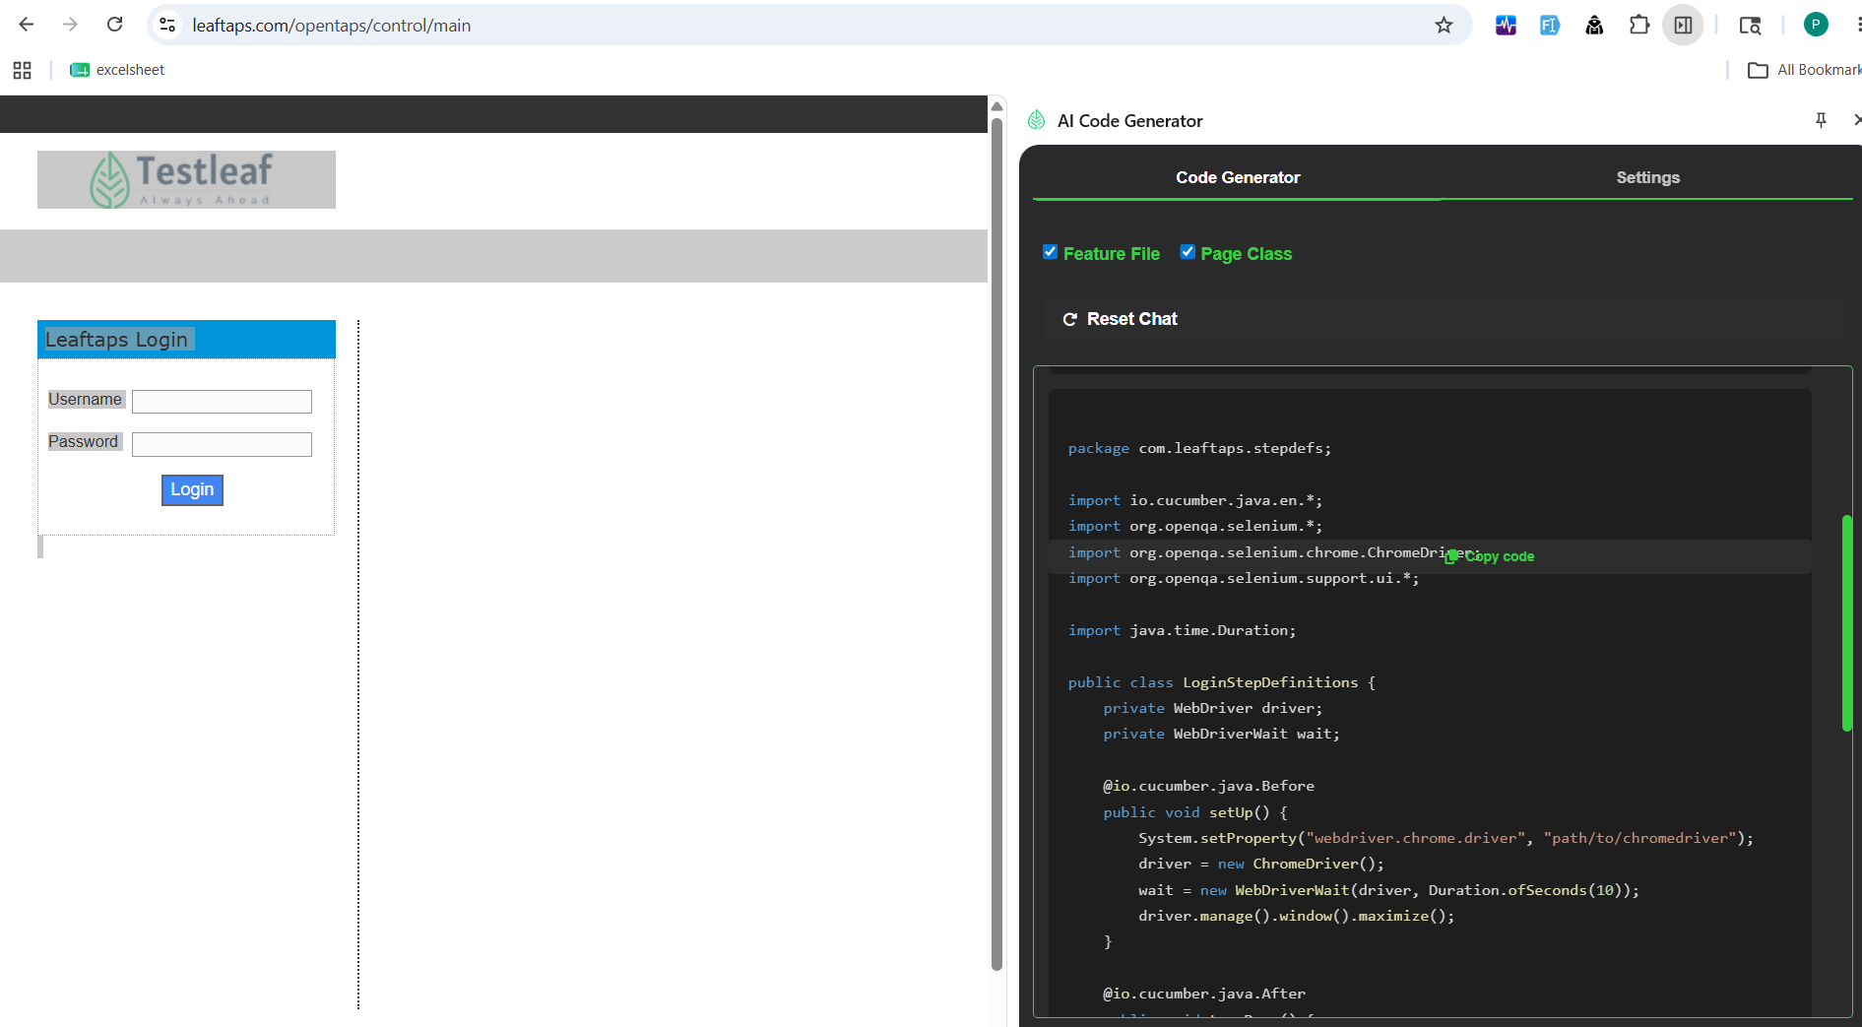
Feature: Login to OpenTaps

Scenario Outline: Successful login with valid credentials
Given I open the login page
When I type "<username>" into the Username field
And I type "<password>" into the Password field
And I click the Login button
Then I should be logged in successfully

Examples:
| username | password |
| "admin" | "admin123"|
| "user1" | "password1"|
| "user2" | "password2"|

package com.leaftaps.stepdefs;

import io.cucumber.java.en.*;
import org.openqa.selenium.*;
import org.openqa.selenium.chrome.ChromeDriver;
import org.openqa.selenium.support.ui.*;

import java.time.Duration;

public class LoginStepDefinitions {
private WebDriver driver;
private WebDriverWait wait;

@io.cucumber.java.Before
public void setUp() {
System.setProperty("webdriver.chrome.driver", "path/to/chromedriver");
driver = new ChromeDriver();
wait = new WebDriverWait(driver, Duration.ofSeconds(10));
driver.manage().window().maximize();
}

@io.cucumber.java.After
public void tearDown() {
if (driver != null) driver.quit();
}

@Given("I open the login page")
public void openLoginPage() {
driver.get("https://leaftaps.com/opentaps/control/main");
}

@When("I type {string} into the Username field")
public void enterUsername(String username) {
WebElement el = wait.until(ExpectedConditions.elementToBeClickable(By.id("username")));
el.sendKeys(username);
}

@When("I type {string} into the Password field")
public void enterPassword(String password) {
WebElement el = wait.until(ExpectedConditions.elementToBeClickable(By.id("password")));
el.sendKeys(password);
}

@When("I click the Login button")
public void clickLogin() {
driver.findElement(By.className("decorativeSubmit")).click();
}

@Then("I should be logged in successfully")
public void verifyLogin() {
WebElement success = wait.until(ExpectedConditions.visibilityOfElementLocated(By.className("success")));
assert success.isDisplayed();
}
}

