Week3-Day-2

Assignment: Open the code base in VS Code and Deployment ,Generate Testcases and Debugging
1)Unzip the useuser-story-to-tests folder and extract
2)Copy the folder path where you have package.json
3)Open the project in VSCode
--File menu- Open Folder ---paste the folder path from step 2
4)In .env file of the roor folder add your groq Key and groq model copied from groq playground and save it.
5)Right click on the backend folder --Click on the option Open in Integrated Terminal
6) Run the below command in the terminal
npm install
7)Simultaneously right click on the frontend folder --Click on the option Open in Integrated Terminal (new terminal)
8) Run the below command in teh terminal
npm install
9) Now your backend and frontend are opened in 2 separate terminals and installation will be inprogress
10) Wait till the installation is completed for both backend and fronend
11) Now click on the backend terminal and run the command
npm run dev
12) Click on the front end terminal abd run the command
npm run dev
13) Check the console of backend --All set if the below is displayed
Environment variables loaded:
PORT: 8090
CORS_ORIGIN: http://localhost:5173
groq_API_BASE: https://api.groq.com/openai/v1
groq_API_KEY: SET
groq_MODEL: openai/gpt-oss-120b
🚀 Backend server running on port 8090
📡 API available at http://localhost:8090/api
🔍 Health check at http://localhost:8090/api/health
14)Check the console of the frontend terminal ,all set if the below is displayed

➜ Local: http://localhost:5173/
➜ Network: http://192.168.1.4:5173/
➜ press h + enter to show help

15) Copy the local host url from the console and open in the browser

16) Once the page is loaded give the user story details and click on generate button to generate the testcases

17) Testcases will be displayed for the given user stories

Generated Test Cases
10 test case(s) generated • Model: openai/gpt-oss-120b • Tokens: 2264
Test Case ID | Title | Category | Expected Result
▶TC-001 | Verify insurance eligibility for a covered radiology test without pre-authorization | Positive | System calls insurance eligibility API receives a positive coverage response, and schedules the test without requiring pre-authorization. No error messages are displayed.
▶TC-002 | Verify insurance eligibility and store pre-authorization details for a test that requires authorization | Positive | System calls eligibility API, receives coverage confirmation requiring pre-authorization, automatically sends pre-authorization request, receives authorization ID and approval date, stores them in the billing record, and schedules the test.
▶TC-003 | Handle insurance API timeout error during eligibility check | Negative | System displays an error message "Unable to verify insurance at this time. Please try again later." and does not schedule the test.
▶TC-004 | Notify coordinator and patient when test is not covered by insurance | Negative | System receives a not-covered response, shows notification to coordinator "Procedure not covered", sends an automated email/SMS to the patient offering alternative payment options, and does not schedule the test.
▶TC-005 | Select primary insurance when patient has multiple plans | Edge | System uses the primary insurance (Plan A) for eligibility check, receives covered response, and schedules the test without involving the secondary plan.
▶TC-006 | Prevent scheduling when user lacks authorization role | Authorization | System denies access, displays message "You do not have permission to schedule radiology tests", and does not invoke insurance API.
▶TC-007 | Validate system performance: insurance eligibility API response within acceptable time | Non-Functional | System receives eligibility response in ≤2 seconds, proceeds to schedule or display appropriate message. Performance metric logged.
▶TC-008 | Handle invalid patient identifier during scheduling | Negative | System validates input, shows error "Invalid patient identifier", and aborts the scheduling workflow without calling the insurance API.
▶TC-009 | Manage pending pre-authorization status | Edge | System records the pending status, displays message "Pre-authorization pending. Test cannot be scheduled until approval is received," and does not schedule the test.
▶TC-010 | Concurrent scheduling of multiple tests triggers separate insurance checks | Edge | System makes two independent insurance eligibility API calls, each receives correct responses, and both tests are scheduled (or handled according to each response) without cross-interference.

Assignment: Add Feature button and generate feature file for this and also integrated with JIRA

Fetch US from JIRA
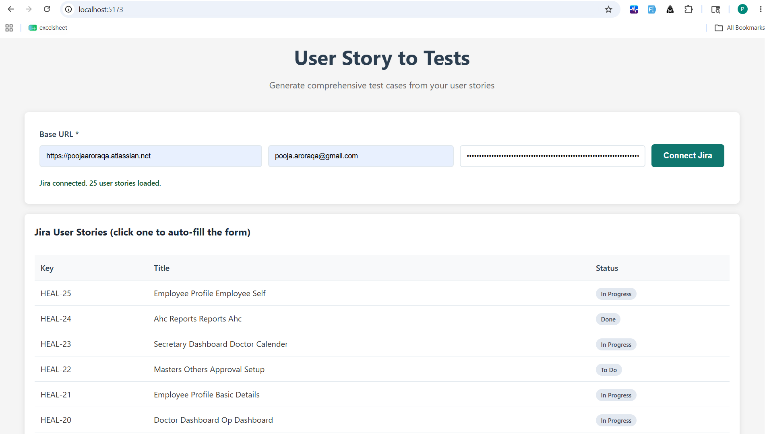

Get one US in below fields
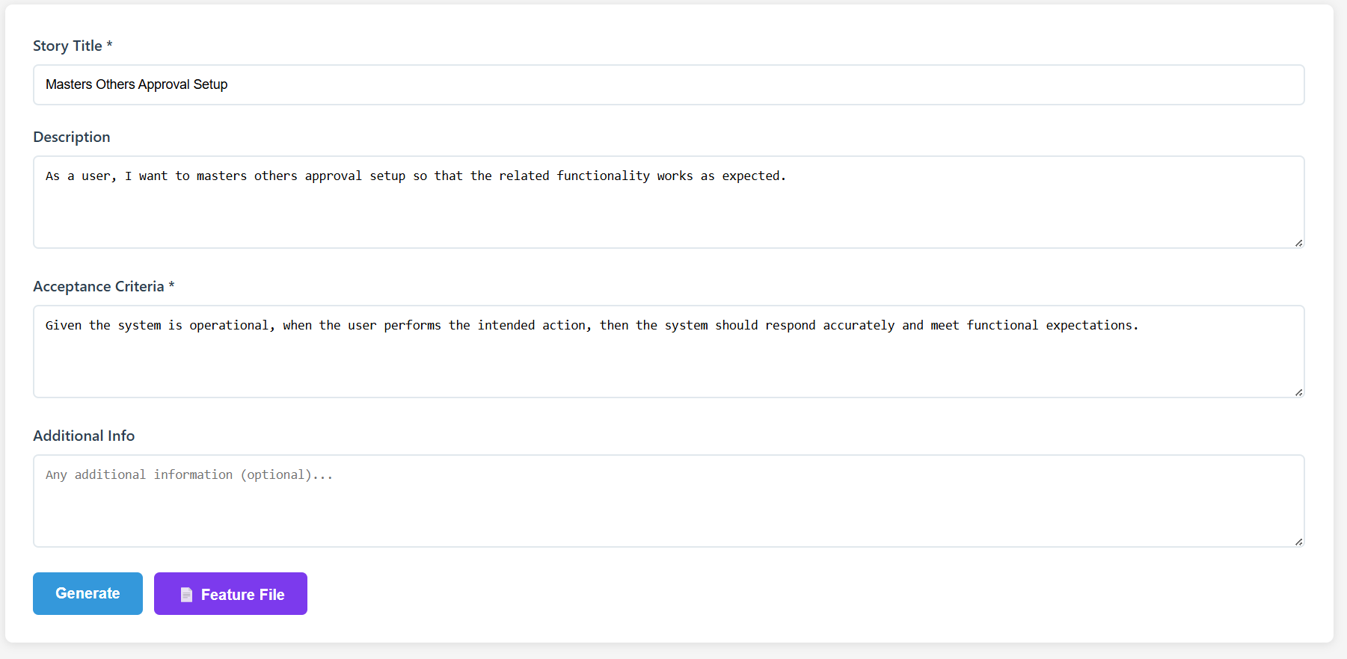

Generate feature file after click on Feature button
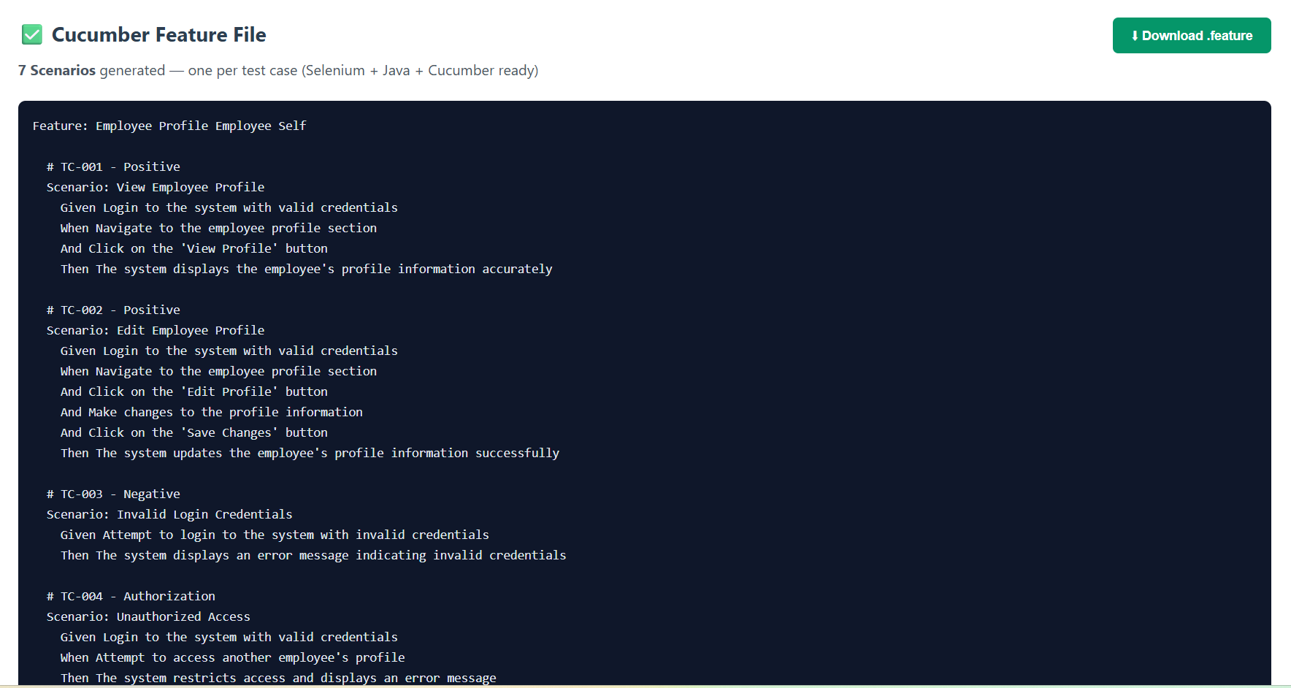

Generate test cases after click on generate button: 