Web chat application
with webcam
Web Development

ABSTRACT
● | A web chat is a system that allows users to communicate in real time using easily accessible web interfaces.
● | It is a type of internet online chat distinguished by its simplicity and accessibility to users who do not wish to take the time to install and learn to use specialized chat software.
● | It is an application which will help to communicate with friends using internet.
● | In this system there is our wish entity namely user. User need to get the link and they have to enter only name as a identification. After receiving text message, it will not disappear.
● | User ‘s can share screen and they can also click pictures with webcam.
INTRODUCTION

- Communication is a mean for people to exchange messages. It has started since the beginning of human creation.
- Distant communication began as early as 1800 century with the introduction of television, telegraph and then telephony.
- Interestingly enough, telephone communication stands out as the fastest growing technology, from fixed line to mobile wireless, from voice call to data transfer.
- The emergence of computer network and telecommunication technologies bears the same objective that is to allow people to communicate.
- All this while, much efforts has been drawn towards consolidating the device into one and therefore indiscriminate the services.
- Chatting is a method of using technology to bring people and ideas together despite of the geographical barriers.
★
The "Web Chat Application with Webcam" has been developed to override the problems
prevailing in the practicing manual system.
★
This is supported to eliminate and in some cases reduce the hardships faced by this
existing system.
★
The application is reduced as much as possible to avoid errors while entering the data.
★
It also provides error message while entering invalid data.
★
No formal knowledge is needed for the user to use this system. Thus by this all it proves
it is user
-
friendly.
★
It can lead to error free, secure, reliable and fast management system.
★
It can assist the user to concentrate on their other activities rather to concentrate on the
record keeping.

PROBLEM DEFINITION

❏ This project is to create a chat application with a server and users to enable the users to chat with each others.
❏ To develop an instant messaging solution to enable users to seamlessly communicate with each other. The project should be very easy to use enabling even a novice person to use it.
EXISTING SYSTEM
⮚
Lack of security of data.
⮚
More man power.
⮚
Time consuming.
⮚
Consumes large volume of
pare work.
⮚
Needs manual calculations.
⮚
No direct role for the higher
officials.
DISADVANTAGES
●
Data need to be entered properly otherwise, outcome may won’t be accurate.
●
This application requires active internet connection.
●
User needs to put correct data or else it behaves abnormally.

PROPOSED SYSTEM
⮚
Lack of security of data.
⮚
More man power.
⮚
Time consuming.
⮚
Consumes large volume of
pare work.
⮚
Needs manual calculations.
⮚
No direct role for the higher
officials.
ADVANTAGES
●
We can have one
-
on
-
one chatting.
●
It helps to connect long distance people.
●
It helps to maintain safety of chat.

DEVELOPMENT
ENVIRONMENT

HARDWARE REQUIREMENT
⮚
i3 Processor Based Computer or higher
⮚
Memory: 1 GB
⮚
Hard Drive: 50 GB

SOFTWARE REQUIREMENT
⮚
Windows 7 or higher
⮚
XAMPP Server
⮚
PHP
⮚
JavaScript
⮚
Notepad++
⮚
MySQL 5.6

UML DIAGRAMS

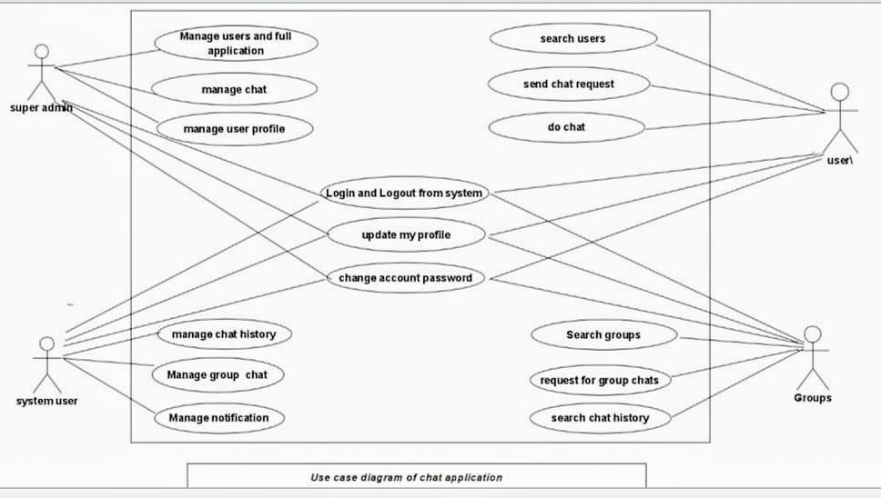
USE CASE DIAGRAM

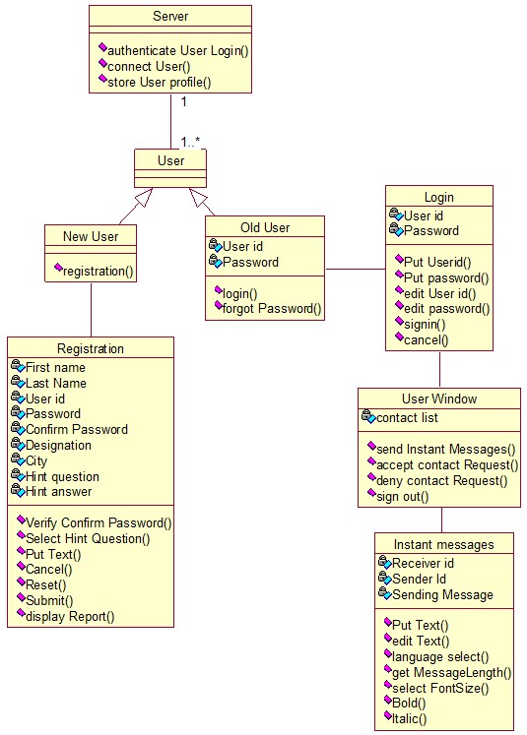
CLASS
DIAGRAM

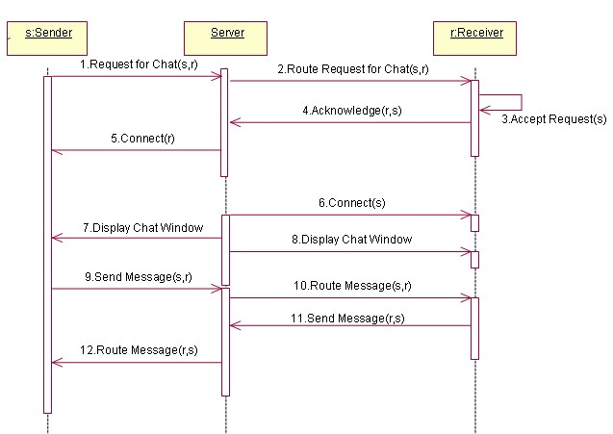
SEQUENCE
DIAGRAM

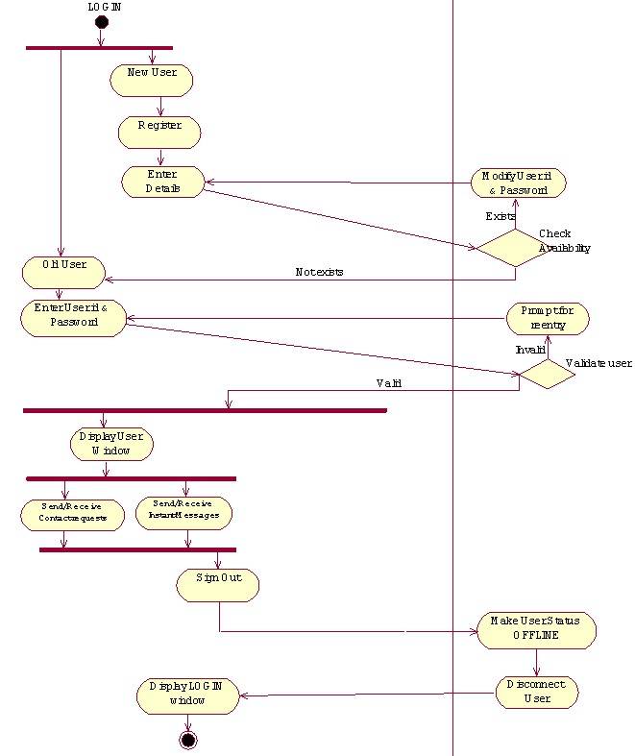
ACTIVITY
DIAGRAM

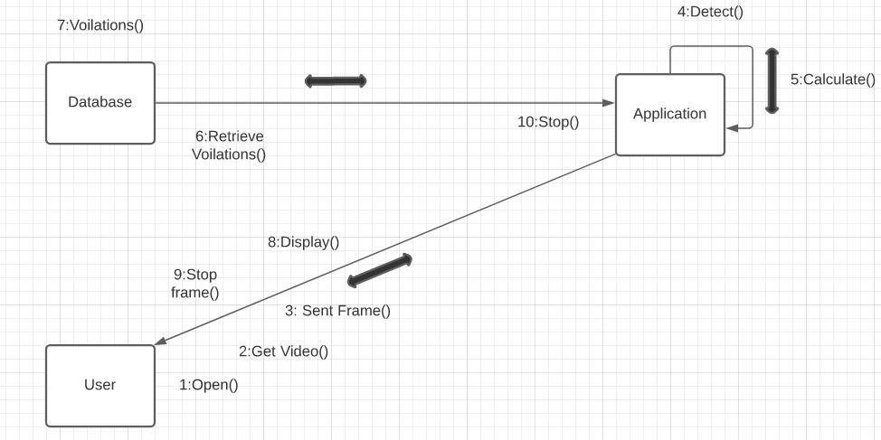
COLLABORATION
DIAGRAM

ER DIAGRAM

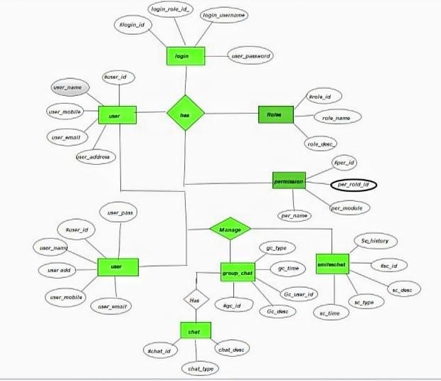
ER DIAGRAM

DFD DIAGRAM

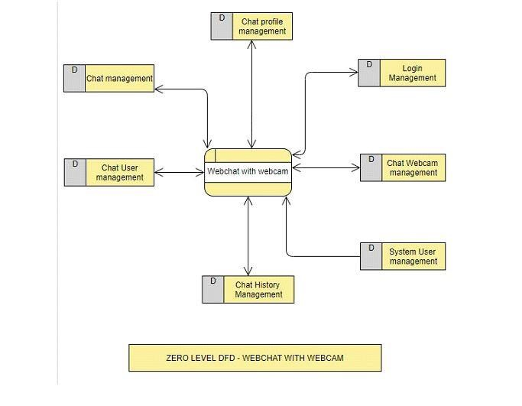
DFD LEVEL 0

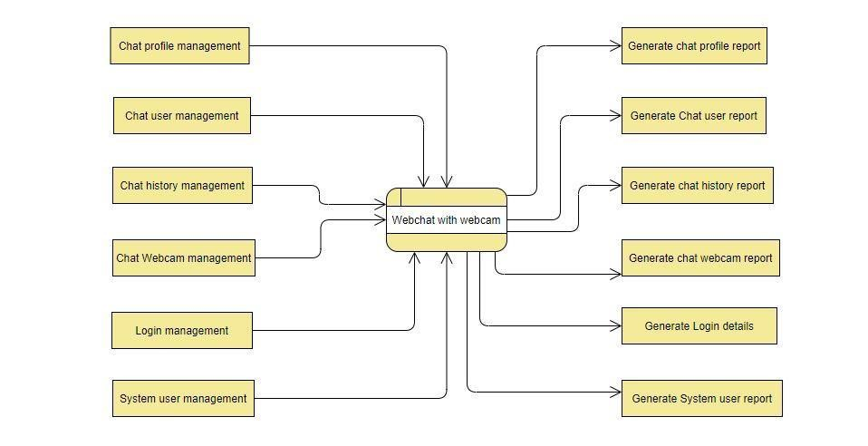
DFD LEVEL 1

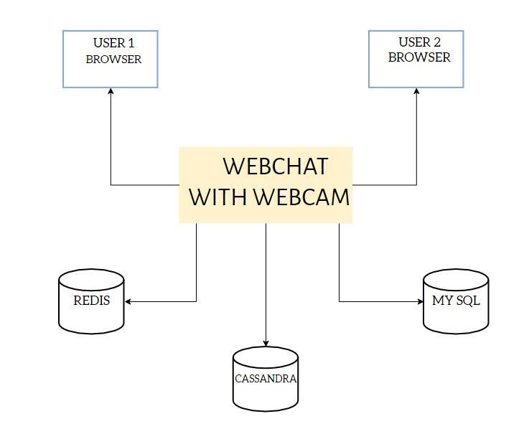
ARCHITECTURE DIAGRAM

MODULES
❖
Web chat profile
❖
Chat history
❖
Login
❖
Users
❖
Registration
❖
Add Friend
❖
Chat webcam

MODULE DESCRIPTION
❖
Web chat profile:
Used for managing the chat
profile details
❖
Chat history :
Used for managing the chat
history details.
❖
Login :
Used for managing the login details.
❖
Users:
Used for managing the users of the
system.
❖
Registration:
User can register and obtain
credentials.
❖
Add Friend:
User can search and add new
friends.
❖
Chat webcam :
while chatting user can set time,
share image and click picture by webcam.

SYSTEM TESTING

TEST CASES & REPORTS
Testing is vital for the success of any software, no system design is ever perfect. Testing is also carried in two phases. First phase is during the module creation. Second phase is after the completion of software. This is system testing which verifies that the whole set of programs handed together.
UNIT TESTING:
- Functionality of the entire module.
- Validations for user input.
- Checking of the Coding standards to be maintained during coding.
- Testing the module with all the possible test data

INTEGRATION TESTING:
- It aims at constructing the program structure while at the same constructing tests to uncover errors associated with interfacing the modules. Modules are integrated by using the top down approach.
VALIDATION TESTING
- Validation testing was performed to ensure that all the functional and performance requirements are met.
SYSTEM TESTING
- It is executing programs to check logical changes made in it with intention of finding errors. A system is tested for online response, recovery from failure etc,. System testing is done to ensure that the system satisfies all the user requirements.
SCREENSHOTS

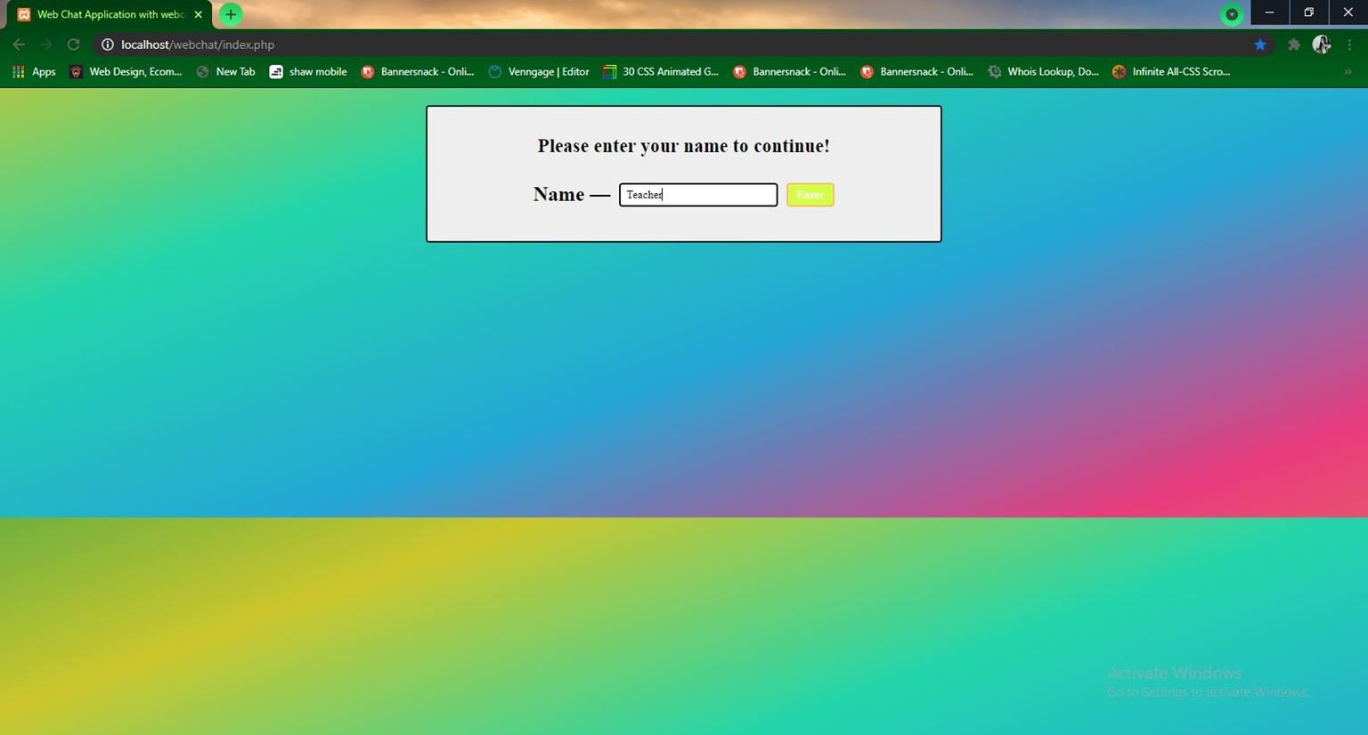
User entry with their name

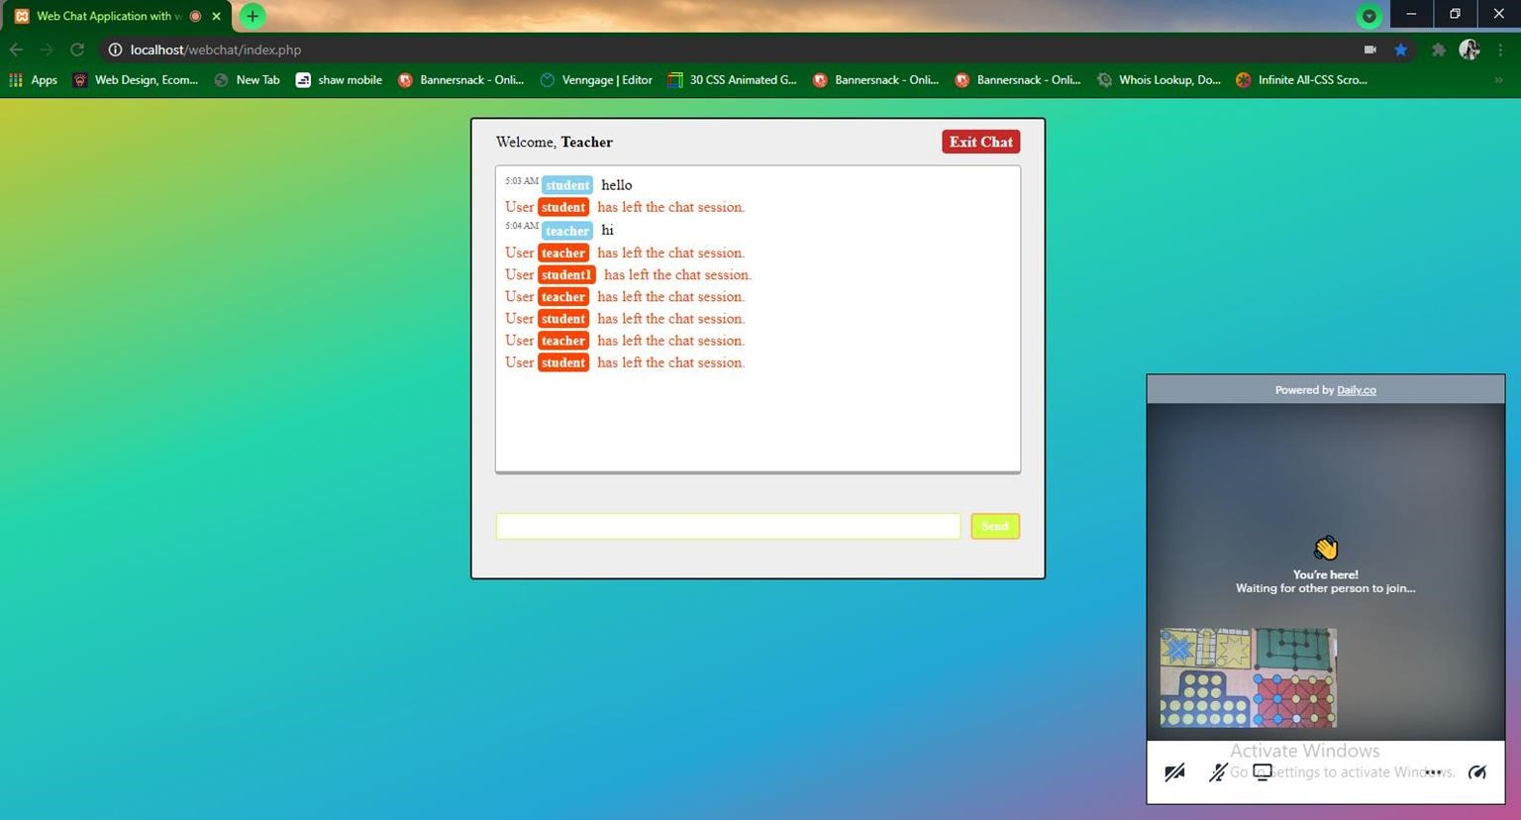
Web chat with video and microphone
allowed

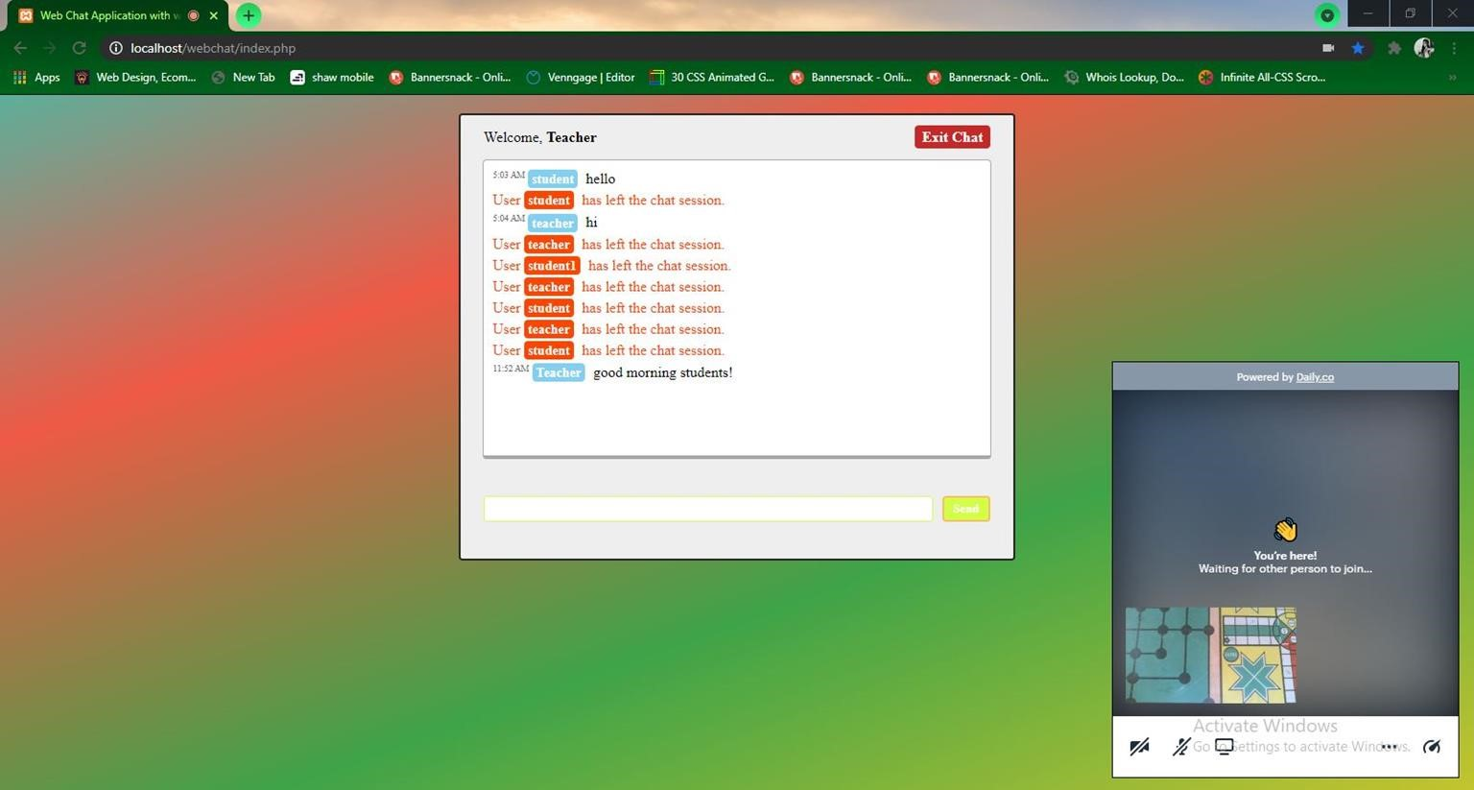
User sent Message

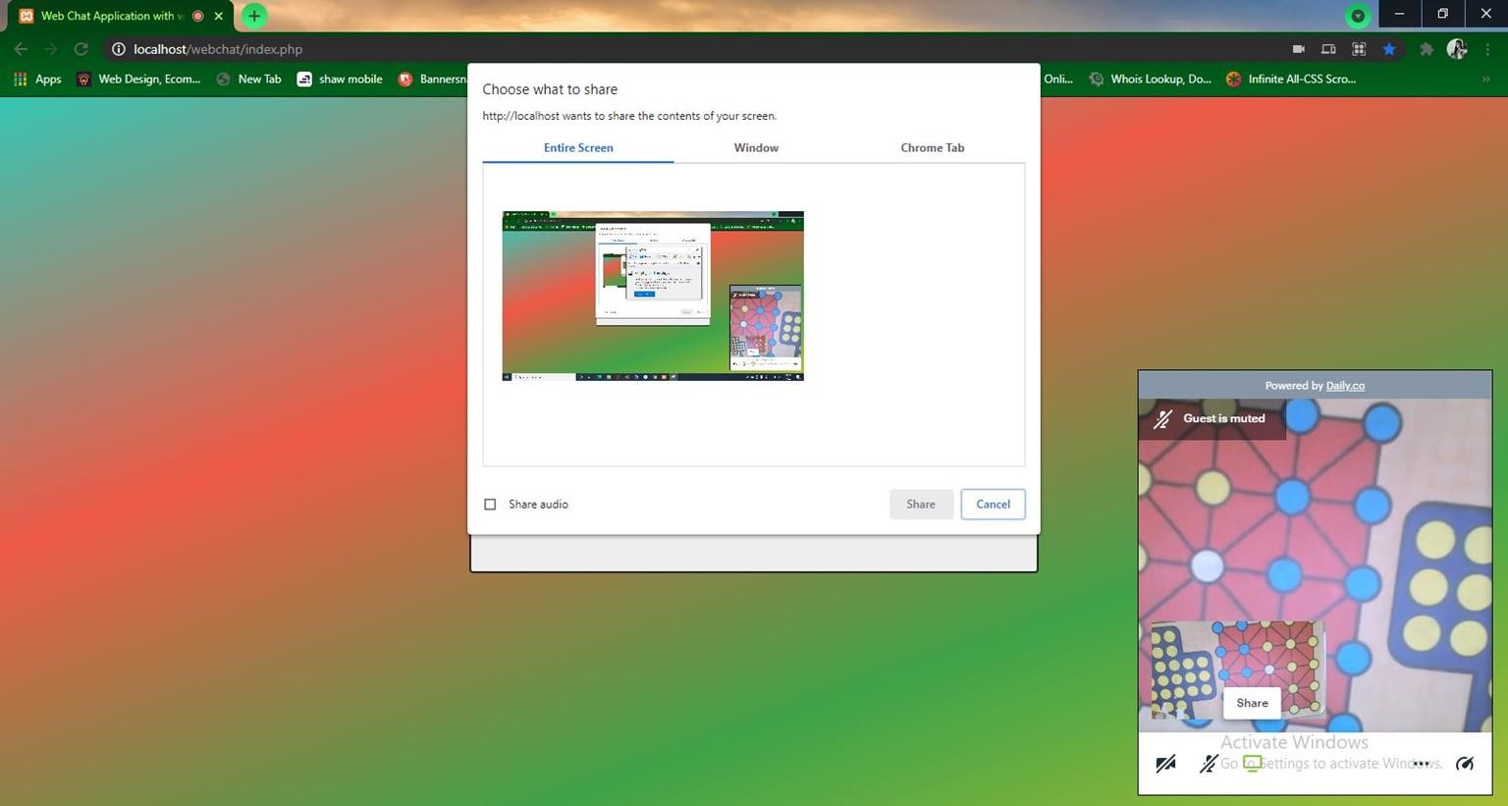
Sharing screen option with entire tab

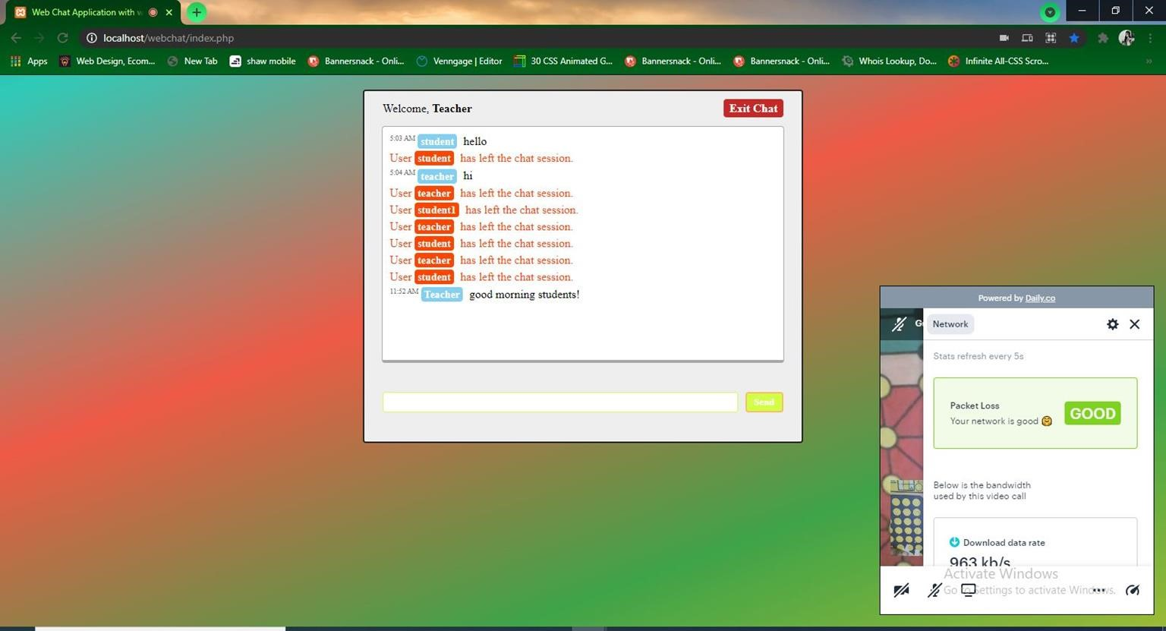
Users network speed status

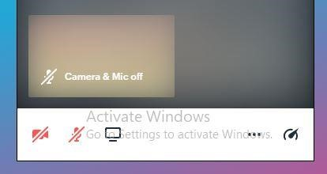
Webcam with video off option

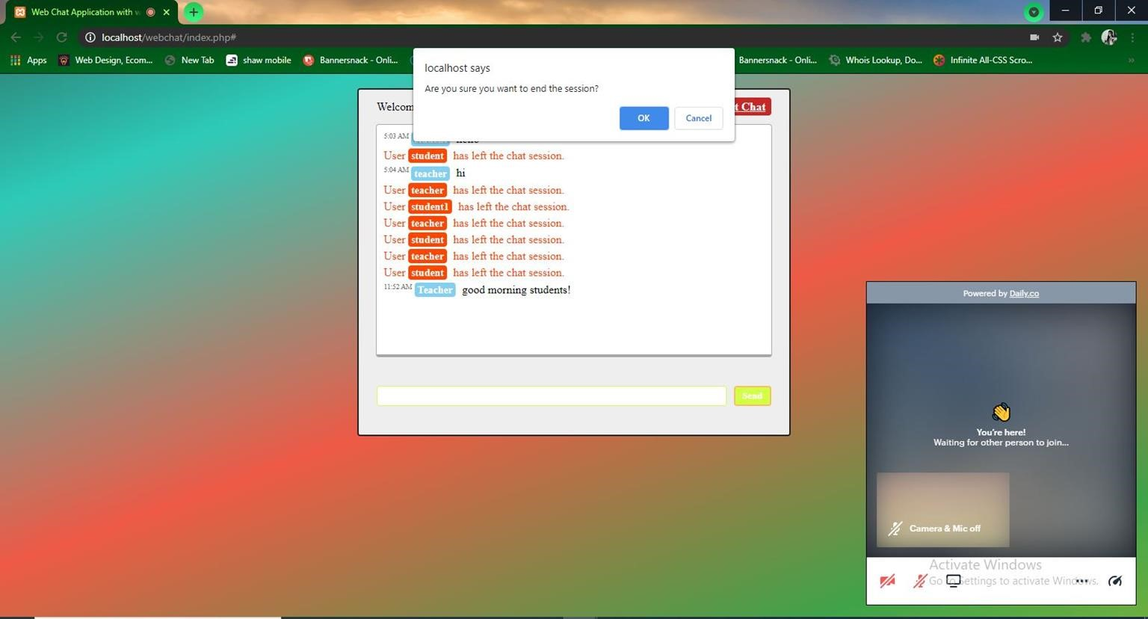
Exit page

CONCLUSION

CONCLUSION
- Our Project is only a humble venture to satisfy the needs to manage their project work.
- Several user friendly coding have also adopted. This package shall prove to be a powerful package in satisfying all the requirements.
- The objective of software planning is to provide a framework that enable to make reasonable estimates made within a limited time framE of the beginning of the application

FUTURE ENHANCEMENTS
- Can add printer in future.
- Shall host the platform on online servers to make it accessible worldwide.
- Integrate multiple load balancers to distribute the loads of the system
- Create the master and slave database structure to reduce the overload of the database queries.
- Implement the backup mechanism for taking backup of codebase and database on regular basis on different servers.

 | REFERENCES
● | “Scaling secret: Real-time chat.” https://medium.com/always-be-coding/ scaling-secret-realtime-chat-d8589f8f0c9b#.m5jigxq6x, may 2015. Accessed: 2016-10-18.
● | D. T. Andrew Hunt, The Pragmatic Programmer: From Journeyman to Master. Addison-  Wesley Professional, first ed., october 1999.
● | “Css is fine, it’s just really hard.” https://medium.com/@jdan/ css-is-fine-its-just-really-hard638da7a3dce0, mar 2017. Accessed: 2017-04-14.
● | “User stories: An agile introduction.” http://www.agilemodeling.com/ artifacts/userStory.htm. Accessed: 2016-10-20.
THANK YOU

