Interaction Between Components in React
React applications are built using multiple components.
Components communicate with each other using:
- Props (Parent → Child)
- Callback Functions (Child → Parent)
- State Lifting (Sharing data between components)
- Context API (Global Communication)
Component Communication Flow
Parent Component
|
| Props
↓
Child Component

Child Component
|
| Callback Function
↑
Parent Component

App.js
import logo from './logo.svg';
import './App.css';
import { useState } from "react";
import Student from "./Student";

function App() {

const [selectedStudent, setSelectedStudent] =
useState("");

const getStudentName = (name) => {
setSelectedStudent(name);
};

return (
<div>

<h1>Student Management System</h1>

<h2>
Selected Student :
{selectedStudent}
</h2>

<Student
id="101"
name="Pooja"
course="React"
sendStudent={getStudentName}
/>

<Student
id="102"
name="Rahul"
course="Angular"
sendStudent={getStudentName}
/>

</div>
);
}

export default App;

Child.js
function Student(props) {
return (
<div
style={{
border: "1px solid black",
margin: "10px",
padding: "10px"
}}
>
<h3>Student Details</h3>

<p>ID : {props.id}</p>
<p>Name : {props.name}</p>
<p>Course : {props.course}</p>

<button
onClick={() => props.sendStudent(props.name)}
>
Select Student
</button>
</div>
);
}

export default Student;

C. Sharing Data Between Siblings
Sibling components cannot communicate directly. Use Common Parent. In real projects, any component can be a parent.
Scenario: Course Selection System
App
|
└── CoursePortal (Parent)
|
├── CourseList (Sibling 1)
|
└── CourseDetails (Sibling 2)
Requirement
- User clicks a course in CourseList
- Selected course should appear in CourseDetails
- Siblings cannot communicate directly
- Parent component (CoursePortal) will manage the data

App.js
import logo from './logo.svg';
import './App.css';

import { useState } from "react";
import CoursePortal from './CoursePortal';
////Sharing Data between Siblings(Child to child communication)
function App()
{

return(
<div>
<CoursePortal></CoursePortal>
</div>

)
}

export default App;

CoursePortal.js
import { useState } from "react";
import CourseList from "./CourseList";
import CourseDetails from "./CourseDetails";

function CoursePortal() {

const[selectedCourse,setSelectedCourse]=useState("") //react

return (
<div>
<h1>Course Portal</h1>
<CourseList updateCourse={setSelectedCourse}></CourseList>
<hr></hr>
<CourseDetails course={selectedCourse}></CourseDetails>
</div>
);
}

export default CoursePortal;

CourseDetails.js
function CourseDetails(props) {

return (
<div>
<h1>Inside CourseDetails-Child2</h1>
<h2>Selected Course(Coming from Another child)</h2>
<h3 style={{color:"red"}}>Course :{props.course}</h3>
</div>
);
}

export default CourseDetails;

CourseList.js
function CourseList(props) {

return (
<div>
<h1>Inside CourseList-Child1</h1>
<button onClick={()=> props.updateCourse("React")}>React</button>
<button onClick={()=> props.updateCourse("Ang")}>Ang</button>
<button onClick={()=> props.updateCourse("Springboot")}>Springboot</button>
</div>
);
}

export default CourseList;

Events:
Event handling in React
An event is an action performed by the user
e.g click, double click, key press, mouse hover, form submit, change input.
event name should be written in Camel case in react
e.g onClick,onChange,onSubmit

Forms
A form is used to collect information from users.
Examples:
- Registration form
- Login form
- Product entry form
- Feedback form
- Job application form
- Order form
- Search form
In normal HTML, form elements maintain their values inside the DOM. In React, we usually store and manage those values using state.
A form generally contains:
<form>
<input />
<textarea />
<select>
<option></option>
</select>
<button type="submit">Submit</button>
</form>
The usual React form workflow is:
User enters data
↓
onChange event executes
↓
State is updated
↓
Component renders updated value
↓
User submits the form
↓
onSubmit event executes

2. Controlled Components
Theory
A controlled component is a form element whose current value is controlled by React state.
For a controlled text input, we normally use:
- useState() to store the value
- value to connect the input to state
- onChange to update the state
- const [name, setName] = useState("");
- <input
- type="text"
- value={name}
- onChange={(event) => setName(event.target.value)}
- />

Why use controlled components?
Controlled components make it easier to:
- Validate input
- Display error messages
- Enable or disable buttons
- Transform entered data
- Reset form fields
- Submit collected information
- Display live previews
- Apply conditional logic
CourseRegistration.js
import React, { useState } from "react";

function CourseRegistration() {
const [studentName, setStudentName] = useState("");
const [email, setEmail] = useState("");
const [course, setCourse] = useState("React");
const [submittedData, setSubmittedData] = useState(null);
const [message, setMessage] = useState("");

const handleSubmit = (event) => {
event.preventDefault();

if (studentName.trim() === "" || email.trim() === "") {
setMessage("Please enter the student name and email.");
setSubmittedData(null);
return;
}

const registration = {
studentName,
email,
course,
};

setSubmittedData(registration);
setMessage("Registration completed successfully.");

setStudentName("");
setEmail("");
setCourse("React");
};

return (
<div>
<h1>Course Registration</h1>

<form onSubmit={handleSubmit}>
<div>
<label htmlFor="studentName">Student Name</label>
<input
id="studentName"
type="text"
value={studentName}
onChange={(event) => setStudentName(event.target.value)}
placeholder="Enter student name"
/><br></br><br></br>
</div>

<div>
<label htmlFor="email">Email Address</label>
<input
id="email"
type="email"
value={email}
onChange={(event) => setEmail(event.target.value)}
placeholder="Enter email address"
/><br></br><br></br>
</div>

<div>
<label htmlFor="course">Select Course</label>
<select
id="course"
value={course}
onChange={(event) => setCourse(event.target.value)}
>
<option value="React">React</option>
<option value="Java">Java</option>
<option value="Spring Boot">Spring Boot</option>
<option value="Oracle SQL">Oracle SQL</option>
</select><br></br><br></br>
</div>

<button type="submit">Register</button>
</form>

{message && <p>{message}</p>}

{submittedData && (
<div>
<h2>Registration Details</h2>
<p>Name: {submittedData.studentName}</p>
<p>Email: {submittedData.email}</p>
<p>Course: {submittedData.course}</p>
</div>
)}
</div>
);
}

export default CourseRegistration;
3. The textarea Tag
Theory
A textarea is used when the user needs to enter multiple lines of text.
Examples:
- Product description
- Feedback
- Address
- Comments
- Project summary
- Complaint details
In React, the content of a controlled textarea is supplied using the value property.
ProductFeedback.js
import React, { useState } from "react";

function ProductFeedback() {
const [feedback, setFeedback] = useState("");
const [submittedFeedback, setSubmittedFeedback] = useState("");

const handleSubmit = (e) => {
e.preventDefault();

if (feedback.trim() === "") {
alert("Please enter feedback");
return; //stop further execution if this validation fails
}

setSubmittedFeedback(feedback);
setFeedback("");
};

return (
<div>
<h1>Feedback Form</h1>

<form onSubmit={handleSubmit}>
<label>Feedback:</label>
<br />

<textarea
rows="4"
cols="40"
value={feedback}
onChange={(e) => setFeedback(e.target.value)}
placeholder="Enter your feedback"
/>

<br />
<br />

<button type="submit">Submit</button>
</form>

{/* Conditional Rendering in forms
Show the below section only if feedback exists.
*/}
{submittedFeedback && (
<div>
<h2>Submitted Feedback</h2>
<p>{submittedFeedback}</p>
</div>
)}
</div>
);
}

export default ProductFeedback;

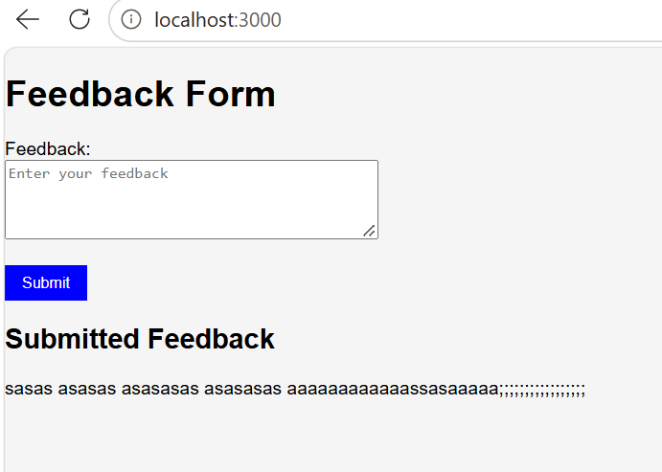
4. The select Tag
Theory
The select tag creates a drop-down list.
It can be used to select:
- Course
- Department
- City
- Product category
- Payment method
A controlled select uses value and onChange.
CategoryForm.js
import React, { useState } from "react";

function CategoryForm() {
const [toyName, setToyName] = useState("");
const [category, setCategory] = useState("");
const [result, setResult] = useState(null);

const handleSubmit = (event) => {
event.preventDefault();

if (!toyName || !category) {
alert("Enter toy name and select category");
return;
}

setResult({ toyName, category });
};

return (
<div>
<h2>Toy Category Form</h2>

<form onSubmit={handleSubmit}>
<input
type="text"
placeholder="Enter toy name"
value={toyName}
onChange={(event) => setToyName(event.target.value)}
/>

<br />
<br />

<select
value={category}
onChange={(event) => setCategory(event.target.value)}
>
<option value="">Select Category</option>
<option value="Educational">Educational</option>
<option value="Electronic">Electronic</option>
<option value="Outdoor">Outdoor</option>
<option value="Soft Toy">Soft Toy</option>
</select>

<br />
<br />

<button type="submit">Save</button>
</form>

{result && (
<p>
{result.toyName} belongs to the {result.category} category.
</p>
)}
</div>
);
}

export default CategoryForm;

5. The File Input Tag
Theory
A file input allows the user to select a file from their device.
It can be used to upload:
- Profile image
- Resume
- Product image
- Assignment
- PDF document
The selected file is available through:
event.target.files[0]
Useful file properties are:
file.name
file.type
file.size
ImageUpload.js
import React, { useState } from "react";

function ImageUpload() {
const [file, setFile] = useState(null);
const [preview, setPreview] = useState("");

const handleFileChange = (event) => {
const selectedFile = event.target.files[0];

if (!selectedFile) {
return;
}

if (!selectedFile.type.startsWith("image/")) {
alert("Please select an image file");
return;
}

setFile(selectedFile);
setPreview(URL.createObjectURL(selectedFile));
};

return (
<div>
<h2>Toy Image Upload</h2>

<input
type="file"
accept="image/*"
onChange={handleFileChange}
/>

{file && (
<div>
<p>File Name: {file.name}</p>
<p>File Type: {file.type}</p>

<img
src={preview}
alt="Toy preview"
width="200"
/>
</div>
)}
</div>
);
}

export default ImageUpload;

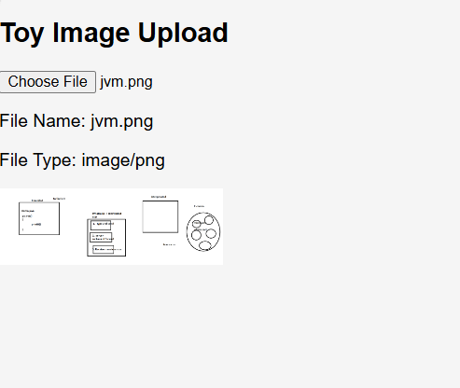

6. Handling Multiple Inputs
Theory
A form may contain several fields, such as:
- Name
- Email
- Price
- Category
- Availability
Instead of creating a separate state variable for every input, we can store all form values in one object.
import React, { useState } from "react";

function ToyOrderForm() {
const [order, setOrder] = useState({
customerName: "",
toyName: "",
quantity: 1,
giftWrap: false,
});

const [submittedOrder, setSubmittedOrder] = useState(null);

const handleChange = (event) => {
const { name, value, type, checked } = event.target;

setOrder({
...order,
[name]: type === "checkbox" ? checked : value,
});
};

const handleSubmit = (event) => {
event.preventDefault();
setSubmittedOrder(order);
};

return (
<div>
<h2>Toy Order Form</h2>

<form onSubmit={handleSubmit}>
<input
name="customerName"
placeholder="Customer name"
value={order.customerName}
onChange={handleChange}
/>

<br />
<br />

<input
name="toyName"
placeholder="Toy name"
value={order.toyName}
onChange={handleChange}
/>

<br />
<br />

<input
type="number"
name="quantity"
min="1"
value={order.quantity}
onChange={handleChange}
/>

<br />
<br />

<label>
<input
type="checkbox"
name="giftWrap"
checked={order.giftWrap}
onChange={handleChange}
/>
Gift Wrapping
</label>

<br />
<br />

<button type="submit">Place Order</button>
</form>

{submittedOrder && (
<div>
<h3>Order Summary</h3>
<p>Customer: {submittedOrder.customerName}</p>
<p>Toy: {submittedOrder.toyName}</p>
<p>Quantity: {submittedOrder.quantity}</p>
<p>
Gift Wrap:{" "}
{submittedOrder.giftWrap ? "Yes" : "No"}
</p>
</div>
)}
</div>
);
}

export default ToyOrderForm;

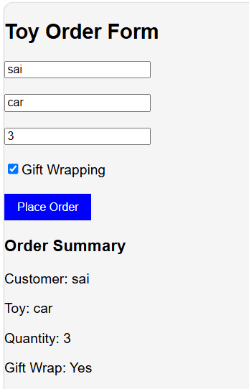

7. Controlled Input Null Value
Theory
A controlled text input should receive a string value.
Correct initialization:
Const[name,setName]= useState(“”);
InCorrect initialization:
Const[name,setName]= useState(null);
8. Alternatives to Controlled Components
Theory
An uncontrolled component stores its current value in the DOM rather than React state.
Its value can be read using:
- useRef
- FormData
Controlled vs Uncontrolled
Controlled component
const [name, setName] = useState("");
<input
value={name}
onChange={(event) => setName(event.target.value)}
/>
React state stores the current value.
Uncontrolled component
React state stores the current value.
Uncontrolled component
const nameReference = useRef();
<input ref={nameReference} />

When to use controlled components
Use controlled components when you need:
- Live validation
- Dynamic error messages
- Live previews
- Conditional buttons
- Complete control over entered data
When to use uncontrolled components
Use uncontrolled components when:
- The form is small
- Values are needed only after submission
- Live validation is not required
- You are working with file inputs
- You want to integrate with non-React code
- import React, { useRef, useState } from "react";

- function ToySearch() {
- const toyReference = useRef();
- const priceReference = useRef();

- const [result, setResult] = useState(null);

- const handleSubmit = (event) => {
- event.preventDefault();

- setResult({
- toyName: toyReference.current.value,
- maximumPrice: priceReference.current.value,
- });
- };

- return (
- <div>
- <h2>Search Toys</h2>

- <form onSubmit={handleSubmit}>
- <input
- ref={toyReference}
- type="text"
- placeholder="Toy name"
- />

- <br />
- <br />

- <input
- ref={priceReference}
- type="number"
- placeholder="Maximum price"
- />

- <br />
- <br />

- <button type="submit">Search</button>
- </form>

- {result && (
- <p>
- Searching for {result.toyName} below ₹
- {result.maximumPrice}
- </p>
- )}
- </div>
- );
- }

- export default ToySearch;

10. 10. Styling in React
React applications can be styled using several approaches:
- Inline styling
- External CSS stylesheet
- CSS Modules
- Conditional classes
- Styling libraries
- CSS-in-JS libraries

11. Inline Styling

Theory
- Inline styles are written as JavaScript objects.
<h1 style={{ color: "white", backgroundColor: "purple" }}>
Happy Toys
</h1>

Important differences from CSS
Normal CSS:
background-color: purple;
font-size: 30px;

React inline object:
{
backgroundColor: "purple",
fontSize: "30px"
}

Example: Toy Shop
function ToyHeader() {
const headerStyle = {
backgroundColor: "#6c3fc5",
color: "white",
padding: "20px",
textAlign: "center",
borderRadius: "10px",
marginBottom: "20px",
};

return (
<header style={headerStyle}>
<h1 style={{ margin: 0 }}>Happy Toys Shop</h1>

<p
style={{
marginTop: "8px",
color: "#f1eaff",
}}
>
Add and manage toys using React components
</p>
</header>
);
}

export default ToyHeader;

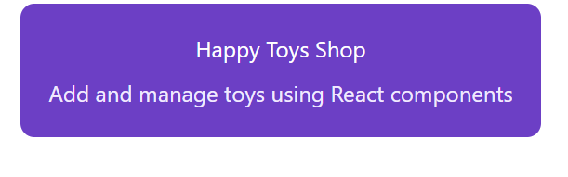
When to use inline styling
Use it for:
- One or two small styles
- Dynamic values
- Conditional styling
- Styles used only in one place

12. CSS Stylesheet
Theory
An external CSS file keeps design separate from JSX.
App.jsx

13. Complete Toy Shop Application
This application demonstrates:
- React components
- Controlled inputs
- Text input
- Number input
- textarea
- select
- Radio buttons
- Checkbox
- File input
- Multiple input handling
- Validation
- Form submission
- Resetting the form
- Conditional rendering
- Passing data from child to parent
- Rendering a list with map()
- Inline styling
- External CSS
Project structure
src/
├── App.jsx
├── App.css
├── components/
│ ├── Header.jsx
│ ├── ToyForm.jsx
│ └── ToyList.jsx
└── main.jsx
import { useState } from "react";
import Header from "./components/Header";
import ToyForm from "./components/ToyForm";
import ToyList from "./components/ToyList";
import "./App.css";
function App() {
const [toys, setToys] = useState([
{
id: 1,
toyName: "Building Blocks",
category: "Educational",
ageGroup: "6-8 Years",
price: 799,
quantity: 5,
description: "Colourful blocks for creative construction.",
available: true,
imageUrl: "",
},
]);
const addToy = (newToy) => {
const toyWithId = {
...newToy,
id: Date.now(),
};
setToys((previousToys) => [
...previousToys,
toyWithId,
]);
};
const deleteToy = (toyId) => {
setToys((previousToys) =>
previousToys.filter((toy) => toy.id !== toyId)
);
};
return (
<div className="app-container">
<Header />
<main className="shop-layout">
<ToyForm onAddToy={addToy} />
<ToyList
toys={toys}
onDeleteToy={deleteToy}
/>
</main>
</div>
);
}
export default App;

Building Toy Shop Application using React Components.
App.js
import { useState } from "react";
import Header from "./Header";
import ToyForm from "./ToyForm";
import ToyList from "./ToyList";
import buildingBlocksImage from "./assests/BB.jpg";
import "./App.css";

function App() {
const [toys, setToys] = useState([
{
id: 1,
toyName: "Building Blocks",
category: "Educational",
ageGroup: "6-8 Years",
price: 799,
quantity: 5,
description: "Colourful blocks for creative construction.",
available: true,
imageUrl: buildingBlocksImage,
},
]);

const addToy = (newToy) => {
const toyWithId = {
...newToy,
id: Date.now(),
};

setToys((previousToys) => [
...previousToys,
toyWithId,
]);
};

const deleteToy = (toyId) => {
setToys((previousToys) =>
previousToys.filter((toy) => toy.id !== toyId)
);
};

return (
<div className="app-container">
<Header />

<main className="shop-layout">
<ToyForm onAddToy={addToy} />

<ToyList
toys={toys}
onDeleteToy={deleteToy}
/>
</main>
</div>
);
}

export default App;

Header.js
function Header() {
const headerStyle = {
backgroundColor: "#6c3fc5",
color: "white",
padding: "24px",
textAlign: "center",
borderRadius: "14px",
boxShadow: "0 5px 14px rgba(0, 0, 0, 0.15)",
};

return (
<header style={headerStyle}>
<h1 style={{ margin: 0 }}>
Happy Toys Shop
</h1>

<p
style={{
marginBottom: 0,
color: "#f1eaff",
}}
>
Toy Inventory Management System
</p>
</header>
);
}

export default Header;

ToyForm.js
import { useEffect, useState } from "react";

const initialFormData = {
toyName: "",
category: "",
ageGroup: "3-5 Years",
price: "",
quantity: "1",
description: "",
available: true,
};

function ToyForm({ onAddToy }) {
const [formData, setFormData] = useState(initialFormData);
const [selectedFile, setSelectedFile] = useState(null);
const [imageUrl, setImageUrl] = useState("");
const [error, setError] = useState("");

const handleChange = (event) => {
const { name, value, type, checked } = event.target;

setFormData((previousData) => ({
...previousData,
[name]: type === "checkbox" ? checked : value,
}));
};

const handleFileChange = (event) => {
const file = event.target.files[0];

if (!file) {
setSelectedFile(null);
setImageUrl("");
return;
}

if (!file.type.startsWith("image/")) {
setError("Please select a valid image.");
event.target.value = "";
return;
}

if (file.size > 2 * 1024 * 1024) {
setError("Image must be smaller than 2 MB.");
event.target.value = "";
return;
}

setError("");
setSelectedFile(file);
setImageUrl(URL.createObjectURL(file));
};

useEffect(() => {
return () => {
if (imageUrl) {
URL.revokeObjectURL(imageUrl);
}
};
}, [imageUrl]);

const validateForm = () => {
if (formData.toyName.trim() === "") {
return "Toy name is required.";
}

if (formData.category === "") {
return "Please select a toy category.";
}

if (Number(formData.price) <= 0) {
return "Price must be greater than zero.";
}

if (Number(formData.quantity) < 1) {
return "Quantity must be at least one.";
}

if (formData.description.trim().length < 10) {
return "Description must contain at least 10 characters.";
}

return "";
};

const resetForm = () => {
setFormData(initialFormData);
setSelectedFile(null);
setImageUrl("");
setError("");
};

const handleSubmit = (event) => {
event.preventDefault();

const validationMessage = validateForm();

if (validationMessage) {
setError(validationMessage);
return;
}

const newToy = {
...formData,
price: Number(formData.price),
quantity: Number(formData.quantity),
imageUrl: imageUrl,
fileName: selectedFile ? selectedFile.name : "No image",
};

onAddToy(newToy);
resetForm();

/*
Clearing React state does not always clear
the browser's file input display.
*/
event.target.reset();
};

return (
<section className="form-section">
<h2>Add New Toy</h2>

{error && <p className="error-message">{error}</p>}

<form onSubmit={handleSubmit}>
<div className="form-group">
<label htmlFor="toyName">Toy Name</label>

<input
id="toyName"
type="text"
name="toyName"
value={formData.toyName}
onChange={handleChange}
placeholder="Enter toy name"
/>
</div>

<div className="form-group">
<label htmlFor="category">Category</label>

<select
id="category"
name="category"
value={formData.category}
onChange={handleChange}
>
<option value="">Select Category</option>
<option value="Educational">Educational</option>
<option value="Electronic">Electronic</option>
<option value="Outdoor">Outdoor</option>
<option value="Soft Toy">Soft Toy</option>
<option value="Vehicle">Vehicle</option>
</select>
</div>

<fieldset className="form-group">
<legend>Age Group</legend>

<label className="radio-label">
<input
type="radio"
name="ageGroup"
value="3-5 Years"
checked={formData.ageGroup === "3-5 Years"}
onChange={handleChange}
/>
3-5 Years
</label>

<label className="radio-label">
<input
type="radio"
name="ageGroup"
value="6-8 Years"
checked={formData.ageGroup === "6-8 Years"}
onChange={handleChange}
/>
6-8 Years
</label>

<label className="radio-label">
<input
type="radio"
name="ageGroup"
value="9+ Years"
checked={formData.ageGroup === "9+ Years"}
onChange={handleChange}
/>
9+ Years
</label>
</fieldset>

<div className="row">
<div className="form-group">
<label htmlFor="price">Price</label>

<input
id="price"
type="number"
name="price"
min="1"
value={formData.price}
onChange={handleChange}
placeholder="Price"
/>
</div>

<div className="form-group">
<label htmlFor="quantity">Quantity</label>

<input
id="quantity"
type="number"
name="quantity"
min="1"
value={formData.quantity}
onChange={handleChange}
/>
</div>
</div>

<div className="form-group">
<label htmlFor="description">Description</label>

<textarea
id="description"
name="description"
rows="4"
maxLength="150"
value={formData.description}
onChange={handleChange}
placeholder="Enter toy description"
/>

<small>
{formData.description.length}/150 characters
</small>
</div>

<div className="form-group">
<label htmlFor="toyImage">Toy Image</label>

<input
id="toyImage"
type="file"
accept="image/*"
onChange={handleFileChange}
/>

{selectedFile && (
<p className="file-name">
Selected: {selectedFile.name}
</p>
)}

{imageUrl && (
<img
src={imageUrl}
alt="Toy preview"
className="image-preview"
/>
)}
</div>

<label className="checkbox-label">
<input
type="checkbox"
name="available"
checked={formData.available}
onChange={handleChange}
/>
Toy is available
</label>

<div className="button-group">
<button type="submit" className="primary-button">
Add Toy
</button>

<button
type="button"
className="secondary-button"
onClick={resetForm}
>
Reset
</button>
</div>
</form>
</section>
);
}

export default ToyForm;

ToyList.js
function ToyList({ toys, onDeleteToy }) {
return (
<section className="list-section">
<div className="list-heading">
<h2>Toy Inventory</h2>
<span className="toy-count">
Total Toys: {toys.length}
</span>
</div>

{toys.length === 0 ? (
<p className="empty-message">
No toys are available. Add the first toy.
</p>
) : (
<div className="toy-grid">
{toys.map((toy) => (
<article className="toy-card" key={toy.id}>
{toy.imageUrl ? (
<img
src={toy.imageUrl}
alt={toy.toyName}
className="toy-image"
/>
) : (
<div className="image-placeholder">
No Image
</div>
)}

<h3>{toy.toyName}</h3>

<p>
<strong>Category:</strong> {toy.category}
</p>

<p>
<strong>Age Group:</strong> {toy.ageGroup}
</p>

<p>
<strong>Price:</strong> ₹{toy.price}
</p>

<p>
<strong>Quantity:</strong> {toy.quantity}
</p>

<p>
<strong>Status:</strong>{" "}
<span
className={
toy.available
? "available"
: "not-available"
}
>
{toy.available
? "Available"
: "Not Available"}
</span>
</p>

<p>{toy.description}</p>

<button
className="delete-button"
onClick={() => onDeleteToy(toy.id)}
>
Delete
</button>
</article>
))}
</div>
)}
</section>
);
}

export default ToyList;

