React Router DOM - Detailed Theory + Practical Examples
1. What is React Router?
React Router is a popular library used in React applications to implement client-side routing.
Normally, in traditional websites:
- Every URL change sends a request to the server.
- Entire page reloads.
In React applications:
- Only the required component changes.
- Page reload is avoided.
- Fast navigation is achieved.
Installation
npm install react-router-dom
Verify:
npm list react-router-dom
o/p:
react-router-dom@7.x.x

2. Features of React Router
1. Client-Side Routing
Changes components without reloading the page.
Example:
/home /about /contact
Each URL shows different component.
2. Dynamic Routing
Create dynamic URLs using parameters.
e.g
/employee/101
/employee/102
Different employee details can be displayed.
3. Nested Routing
Route inside another route.
Example:
/dashboard/profile
/dashboard/settings
/dashboard/reports
4. Lazy Loading Support
Components can be loaded only when needed.
Improves performance.
5. Navigation Guards
Can restrict pages for unauthorized users.
Example:
Login Required
Admin Only Pages
6. URL Parameters
Pass values directly through URL.
Example:
/product/1001
Retrieve value:
const { id } = useParams();
7. 404 Page Support
Display custom page when route is invalid.
Example:
http://localhost:3000/abcxyz
Shows:
Page Not Found
3. Configuration of Routing using React Router
Project Structure
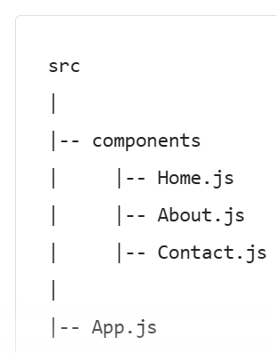
Home.js
function Home() {
return (
<div>
<h2>Home Page</h2>
<p>Welcome to React Router Training.</p>
</div>
);
}
export default Home;
About.js
function About() {
return (
<div>
<h2>About Page</h2>
<p>Learn React Router Concepts.</p>
</div>
);
}
export default About;

Contact.js
function Contact() {
return (
<div>
<h2>Contact Page</h2>
<p>Email : trainer@react.com</p>
</div>
);
}
export default Contact;

App,js
import { BrowserRouter, Routes, Route } from "react-router-dom";
import Home from "./components/Home";
import About from "./components/About";
import Contact from "./components/Contact";
function App() {
return (
<BrowserRouter>
<Routes>
<Route path="/" element={<Home />} />
<Route path="/about" element={<About />} />
<Route path="/contact" element={<Contact />} />
<Route path="*" element={<NotFound />} />
</Routes>
</BrowserRouter>
);
}
export default App;

4. Navigation using Link
Why Link?
Avoids page refresh.
E.g
<Link to="/about">About</Link>
App.js
import { BrowserRouter, Routes, Route, Link } from "react-router-dom";
import Home from "./components/Home";
import About from "./components/About";
import Contact from "./components/Contact";
function App() {
return (
<BrowserRouter>
<nav>
<Link to="/">Home</Link>
{" | "}
<Link to="/about">About</Link>
{" | "}
<Link to="/contact">Contact</Link>
</nav>
<hr />
<Routes>
<Route path="/" element={<Home />} />
<Route path="/about" element={<About />} />
<Route path="/contact" element={<Contact />} />
</Routes>
</BrowserRouter>
);
}
export default App;

Home, About and Contact pages are same as previous program
5. 404 Page (Not Found Page)
Theory
If user enters invalid URL:
localhost:3000/abc
React should display custom error page.
App.js
import { BrowserRouter, Routes, Route } from "react-router-dom";
import Home from "./components/Home";
import About from "./components/About";
import Contact from "./components/Contact";
import NotFound from "./components/NotFound";
function App() {
return (
<BrowserRouter>
<Routes>
<Route path="/" element={<Home />} />
<Route path="/about" element={<About />} />
<Route path="/contact" element={<Contact />} />
<Route path="*" element={<NotFound />} />
</Routes>
</BrowserRouter>
);
}
export default App;

NotFound.js
function NotFound() {
return (
<div>
<h1>404 Error</h1>
<h2>Page Not Found</h2>
<p>Please check the URL.</p>
</div>
);
}
export default NotFound;
<Route path="*" .../> (the catch-all/NotFound route) to the end — it must come last, otherwise it matches every URL before the more specific routes get a chance, including / and /student/:id.
* Means:
Any Route Not Matched
6. URL Parameters
Theory
URL Parameters help pass values dynamically.
Example:
/student/101
/student/102
/student/103
App.js
import { BrowserRouter, Routes, Route,Link } from "react-router-dom";
import Home from "./components/Home";
import About from "./components/About";
import Contact from "./components/Contact";
import NotFound from "./components/NotFound";
import Student from "./components/Student";
function App() {
return (
<BrowserRouter>
<Link to="/student/101">Student 101</Link>
<br />
<Link to="/student/102">Student 102</Link>
<Routes>
<Route path="/" element={<Home />} />
<Route path="/about" element={<About />} />
<Route path="/contact" element={<Contact />} />
<Route path="/student/:id" element={<Student />} />
<Route path="*" element={<NotFound />} />
</Routes>
</BrowserRouter>
);
}
export default App;
Student.js
import { useParams } from "react-router-dom";

function Student() {
const { id } = useParams();

return (
<div>
<h2>Student Details</h2>

<h3>Student Id : {id}</h3>
</div>
);
}
export default Student;
7. Nested Routes
Theory
Route inside another route.
URL Structure:
/dashboard/profile
/dashboard/reports
/dashboard/settings
src
|
|-- components
| |
| |-- Home.js
| |-- About.js
| |
| |-- Dashboard
| |
| |-- Dashboard.js
| |-- Profile.js
| |-- Reports.js
| |-- Settings.js
|
|-- App.js

Dashboard Folder
|
|-- Dashboard.js (Parent Component)
|-- Profile.js (Child Component)
|-- Reports.js (Child Component)
|-- Settings.js (Child Component)

App.js
import { BrowserRouter, Routes, Route, Link } from "react-router-dom";

import Home from "./components/Home";
import About from "./components/About";

import Dashboard from "./components/Dashboard/Dashboard";
import Profile from "./components/Dashboard/Profile";
import Reports from "./components/Dashboard/Reports";
import Settings from "./components/Dashboard/Settings";

function App() {
return (
<BrowserRouter>

<h1>React Router Demo</h1>

<Link to="/">Home</Link>

{" | "}

<Link to="/about">About</Link>

{" | "}

<Link to="/dashboard">Dashboard</Link>

<hr />

<Routes>

<Route path="/" element={<Home />} />

<Route path="/about" element={<About />} />

<Route path="/dashboard" element={<Dashboard />}>

<Route index element={<Reports />} />

<Route path="profile" element={<Profile />} />

<Route path="reports" element={<Reports />} />

<Route path="settings" element={<Settings />} />

</Route>

</Routes>

</BrowserRouter>
);
}
export default App;

Dashboard.js
import { Link, Outlet } from "react-router-dom";

function Dashboard() {
return (
<div>
<h1>Dashboard Page</h1>

<Link to="profile">Profile</Link>

{" | "}

<Link to="reports">Reports</Link>

{" | "}

<Link to="settings">Settings</Link>
<hr />
<Outlet />
</div>
);
}
export default Dashboard;
Profile.js
function Profile() {
return (
<div>
<h2>Profile Page</h2>
<p>Name : Pooja</p>
</div>
);
}

export default Profile;

Reports.js
function Reports() {
return (
<div>
<h2>Reports Page</h2>
<p>No reports available.</p>
</div>
);
}

export default Reports;
Settings.js
function Settings() {
return (
<div>
<h2>Settings Page</h2>

<button>Change Password</button>
</div>
);
}

export default Settings;
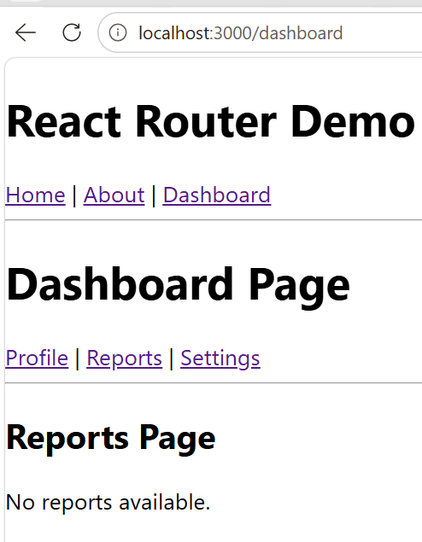
8. Implementing Styles using NavLink
Theory
Link only navigates.
NavLink navigates and also knows:
Current Active Route
This helps highlight active menu.
E.g
<NavLink to="/">Home</NavLink>
<NavLink to="/about">About</NavLink>
<NavLink to="/contact">Contact</NavLink>
App.js
import { BrowserRouter, Routes, Route } from "react-router-dom";

import Home from "./components/Home";
import About from "./components/About";
import Contact from "./components/Contact";
import Menu from "./components/Menu";

function App() {
return (
<BrowserRouter>

<h1>React Router Navigation Demo</h1>

{/* Navigation Bar */}
<Menu />

<hr />

{/* Route Configuration */}
<Routes>

<Route path="/" element={<Home />} />

<Route path="/about" element={<About />} />

<Route path="/contact" element={<Contact />} />

</Routes>

</BrowserRouter>
);
}

export default App;

Menu.js
import { NavLink } from "react-router-dom";

function Menu() {
return (
<div>

<NavLink
to="/"
style={({ isActive }) => ({
backgroundColor: isActive ? "green" : "gray",
color: "white",
padding: "10px",
margin: "5px",
textDecoration: "none"
})}
>
Home
</NavLink>

<NavLink
to="/about"
style={({ isActive }) => ({
backgroundColor: isActive ? "green" : "gray",
color: "white",
padding: "10px",
margin: "5px",
textDecoration: "none"
})}
>
About
</NavLink>

<NavLink
to="/contact"
style={({ isActive }) => ({
backgroundColor: isActive ? "green" : "gray",
color: "white",
padding: "10px",
margin: "5px",
textDecoration: "none"
})}
>
Contact
</NavLink>

</div>
);
}

export default Menu;

