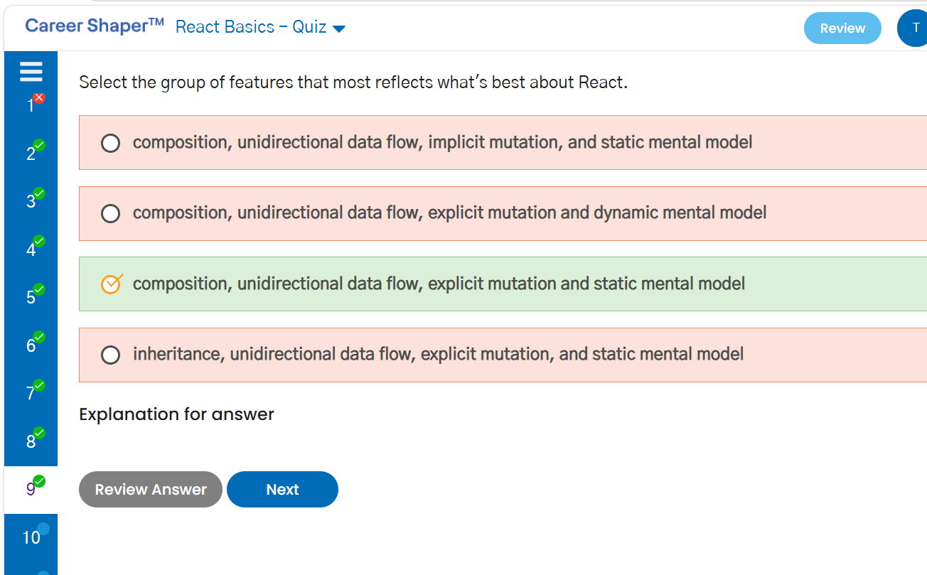
React Basics
1.React - Hello World
App.js
import React from 'react';
import './App.css';

class App extends React.Component {
render(){
return (
<div className="App">
<div id="header">
<h2>Hello World</h2>

</div>
</div>
);
}
}
export default App;

2. Celebration Invitation
import React from "react";
import "./App.css";
function App() {
const chiefGuest = "MR K.KAMAL";
return (
<div className="App">
<div id="invitation">
<p>The Students, Staff and Principal</p>
<p>of</p>
<h3>SVL SR. SEC SCHOOL</h3>
<p>invite you on the</p>
<h1>SILVER JUBILEE CELEBRATIONS</h1>
<p>of their school</p>
<p>on</p>
<p>SUNDAY, THE 26th AUGUST 20XX</p>
<p>at 10 a.m in the School Auditorium</p>
<h2>{chiefGuest}</h2>
<p>A Public Speaker</p>
<p>has kindly consented to be the Chief Guest</p>
<p>and to give away prizes</p>
</div>
</div>
);
}
export default App;

3. Home Essentials
App.js
import React from "react";
import "./App.css";

function App() {

const kitchenItemsPurchased = [
'Paper Towel Holder',
'Cups',
'Drawer Organizers',
'Water Filtration',
'Placemats',
'Cutting Board',
'Shelf Liners'
];

const utilityItemsPurchased = [
'Light Bulbs',
'Extension Cords',
'Batteries',
'First Aid Kit',
'Flashlights',
'Candles',
'Matches'
];

const homeDecortemsPurchased = [
'Toss Pillows',
'Slipcovers',
'Picture Frames',
'Wall Art',
'Door Mats',
'Lighting',
'Wall Hanging Kits'
];

const bedroomItemsPurchased = [
'Mattress Pad',
'Mattress Protector',
'Air Mattress',
'Pillow Protectors',
'Pillows',
'Blankets',
'Quilts'
];

let kitchenList = [];
for (let i = 0; i < kitchenItemsPurchased.length; i++) {
kitchenList.push(
<li key={i} id={`kitchenItems${i + 1}`}>
{kitchenItemsPurchased[i]}
</li>
);
}

let utilityList = [];
for (let i = 0; i < utilityItemsPurchased.length; i++) {
utilityList.push(
<li key={i} id={`utilityItems${i + 1}`}>
{utilityItemsPurchased[i]}
</li>
);
}

let decorList = [];
for (let i = 0; i < homeDecortemsPurchased.length; i++) {
decorList.push(
<li key={i} id={`homeDecorationsItems${i + 1}`}>
{homeDecortemsPurchased[i]}
</li>
);
}

let bedroomList = [];
for (let i = 0; i < bedroomItemsPurchased.length; i++) {
bedroomList.push(
<li key={i} id={`bedroomItems${i + 1}`}>
{bedroomItemsPurchased[i]}
</li>
);
}

return (
<div className="App">
<h1>Home Essentials</h1>

<div className="item-row">

<div className="item-col">
<h3 id="kitchen-items">Kitchen Essentials</h3>
<ul>
{kitchenList}
</ul>
</div>

<div className="item-col">
<h3 id="utility-items">Utility</h3>
<ul>
{utilityList}
</ul>
</div>

<div className="item-col">
<h3 id="decorative-items">Decorative Items</h3>
<ul>
{decorList}
</ul>
</div>

<div className="item-col">
<h3 id="bedroom-items">Bedroom Essential</h3>
<ul>
{bedroomList}
</ul>
</div>

</div>
</div>
);
}

export default App;

App.css
.App {
text-align: center;
}

h1 {
margin-bottom: 30px;
}

.item-row {
display: flex;
justify-content: space-around;
text-align: left;
}

.item-col {
padding: 10px;
}

ul {
padding-left: 20px;
}

