node –version
npm –version
What is npm?
npm (Node Package Manager) is the default package manager for Node.js. It helps developers:
- Install libraries/packages
- Manage project dependencies
- Run scripts and build commands
- Update or remove packages
- Share reusable code through the npm registry
Diffrence between var,let,const?
Difference between null and undefined?
function demo()
{
let x=null;
let y;
console.log("x = "+typeof(x))
console.log("y= "+typeof(y))
}
demo();
function demo()
{
let arr= [1,2,3];
const emp={id:101,name:"ravi"};

console.log("arr = "+arr)
console.log("emp = "+JSON.stringify(emp))
console.log("emp = "+emp.id)
}
demo();
Arrow function
const demo =(a,b) =>
{
console.log("add = "+(a+b))
console.log("sub = "+(a-b))
}
demo(13,5);
const greet =() =>{
return "welcome"
}
console.log("hello = "+greet());
OR
const greet =() => "welcome1"
console.log("hello = "+greet());
//1.Arrow fun used for callback functions
let arr=[3,1,14,5,3,5,8]
console.log(arr.map(a => a*2))
console.log(arr.filter(b => b>5))
//2.callback fun
function greet(name)
{
console.log("hello = "+name)
}
function demo(callback)
{
callback("pooja")
}
demo(greet) //greet is called as callback function,bcz it is passed as an argument here

4.Template literal
const pname ="pooja"
console.log(`welcome ${pname}`);

```- backticks

What is a Linter?
A linter is a tool that analyzes your source code and detects:
- Syntax mistakes
- Unused variables
- Coding standard violations
- Potential bugs
- Code quality issues
Think of it as a grammar checker for code.
For example:
let name = "Pooja";
let age = 25; // never used
A linter will warn:
'age' is assigned a value but never used

ESLint vs Oxlint
Feature | ESLint | Oxlint
Popularity | Most popular linter | Newer linter
Language | JavaScript (Node.js) | Rust
Speed | Slower | Much faster
Ecosystem | Huge plugin support | Limited plugin support
React Support | Excellent | Good
Community | Very large | Growing
Enterprise Projects | Widely used | Less common

Creating React Projects
1. Create React App (CRA)
npx create-react-app first_react_demo
To run the app -> npm start
Change to:
"scripts": {
"start": "set NODE_OPTIONS=--openssl-legacy-provider && react-scripts start",
"build": "set NODE_OPTIONS=--openssl-legacy-provider && react-scripts build",
}
Check the version of React on the same path where you have created the project
npm list react
Creating project with older version
npm install react@18 react-dom@18
Check:
npm list react react-dom

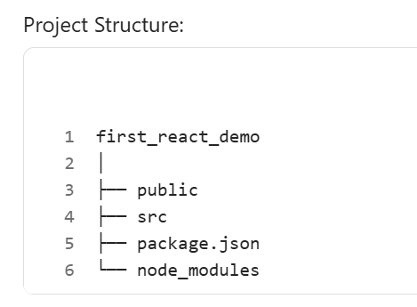
Drawbacks
- Slow startup
- Slow build times
- Large dependencies
- React team has deprecated CRA for new projects
1. package.json
This is the heart of a React project.
Purpose
- Stores project information
- Lists dependencies/packages
- Defines npm commands

2. package-lock.json
- Purpose
- Records the exact versions of installed packages.

3. public Folder
Contains static files.
- public
- │
- ├── index.html
- ├── favicon.ico

Purpose
- Files in this folder are sent directly to the browser.
Typical contents:
- Images
- Logos
- Icons
- Static HTML

4. src Folder
Most important folder.
src
│
├── App.js
├── App.css
├── index.js
├── index.css
├── logo.svg
├── serviceWorker.js
├── setupTests.js
5. App.js
Main component.
function App() {
return (
<div>
<h1>Hello React</h1>
</div>
);
}
export default App;

Purpose
Acts as the parent component.
Hierarchy:
App
├── Header
├── Menu
├── Content
└── Footer
Most components are rendered inside App.
6. App.css
CSS specific to App component.
Example:
h1{
color:blue;
}
Imported inside App.js
import './App.css';
7. index.js/ main.jsx(using vite)
Starting point of React Application.
Also called:
Entry Point
import React from 'react';
import ReactDOM from 'react-dom/client';
import App from './App';

const root = ReactDOM.createRoot(
document.getElementById('root')
);

root.render(<App />);

Process
Browser
↓
index.html
↓
index.js
↓
App.js
↓
Other Components

8. index.css
Global CSS.
Example:
body{
margin:0;
font-family:Arial;
}
Purpose
Styles entire application.
10. serviceWorker.js
What is a Service Worker?
A Service Worker is a JavaScript file that runs in the background, separate from your React application.
It acts like a middleman between the browser and the internet.
User
↓
Browser
↓
Service Worker
↓
Internet / Server
Why Do We Need Service Workers?
Normally:
Browser → Server → Get Data
If internet is unavailable:
Application won't work.
With Service Worker:
Browser
↓
Service Worker
↓
Cache
Previously stored files can still be used.
Result:
✅ Faster loading
✅ Offline support
✅ Reduced network requests
✅ Better user experience
Where is serviceWorker.js Used?
Used heavily in:
- Gmail
- Twitter
- Spotify
- Uber
- Starbucks PWA
These applications continue working even with poor internet connectivity.

11. setupTests.js
Used for Jest and React Testing Library.
Example:
import '@testing-library/jest-dom';
Purpose:
Unit Testing Setup
Whenever you write:
npm test
this setup file runs first.
12. jest.config.json
Configuration file for Jest Testing Framework.
Purpose:
Test Configuration
Coverage Settings
Test Environment
Setup Files

2. Vite
npm create vite@latest second-react-app -- --template react
what is the difference between both the commnads to create react app
To run the app -> npm run dev
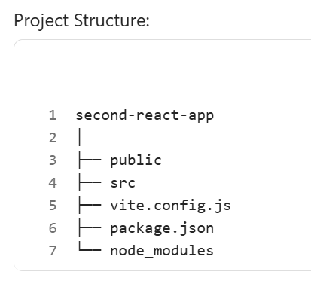
1. node_modules
Contains all installed packages and dependencies.
2. public Folder
Stores static files.
images
icons
logo
pdf
audio
video
3. src Folder
Contains application source code.
Inside it we normally keep:
src/
│
├── assets
├── components
├── App.jsx
├── main.jsx
├── App.css
└── index.css
4. main.jsx
Entry Point of React Application
This is the first file executed.
Responsibilities
✅ Loads React
✅ Loads App Component
✅ Renders application
Flow
main.jsx
↓
App.jsx
↓
Other Components
``
5. App.jsx
src/App.jsx
Root Component
Main component of the application.
Real World Example
App
│
├── Header
├── Menu
├── Products
└── Footer
6. assets Folder
src/assets/
Purpose
Stores project-specific resources.
E,g
images
svg
fonts
icons
7. index.css
src/index.css
Purpose
Global styles.
Example:
body {
margin: 0;
font-family: Arial;
}
Applied throughout the application.
8. App.css
src/App.css
Purpose
Styles specific to App Component.
Example:
h1{
color:red;
}
9. package.json
Most Important Configuration File
Contains project details.
Example:
{
"name": "second-react-app",
"version": "0.0.0"
}
Dependencies Section
"dependencies": {
"react": "^19.2.0",
"react-dom": "^19.2.0"
}
10. package-lock.json
package-lock.json
s

1. What is React?
React is an open-source JavaScript library developed by Meta (Facebook) for building interactive User Interfaces (UI), especially Single Page Applications (SPAs). It allows developers to create reusable UI components and efficiently update the browser when data changes.
What is Jest?
Jest is a JavaScript testing framework that helps developers automatically test their code to ensure it works correctly. It was originally developed by Facebook (Meta) and is widely used with React, Node.js, and general JavaScript applications. [jestjs.io], [jestjs.io]
Your organization's training material also describes Jest as a JavaScript testing framework that provides a test runner, assertion library, and mocking capabilities out of the box

Example
Instead of writing:
<h1>Welcome Pooja</h1>
In React:
function Welcome() {
return <h1>Welcome Pooja</h1>;
}
Here, Welcome is a reusable component.
2. Why React?
Before React, developers manipulated the DOM manually.
Problems with Traditional JavaScript
document.getElementById("name").innerHTML = "Pooja";
`As applications grow:
- Code becomes difficult to maintain
- UI updates become complex
- Performance decreases
- React Solves This
- ✅ Reusable Components
- ✅ Faster updates using Virtual DOM
- ✅ Easy state management
- ✅ Large community support
- ✅ Suitable for enterprise projects
- ✅ Used by Facebook, Instagram, Netflix, etc.

Real-World Example
- Instead of creating 100 product cards manually:
- <ProductCard />
- <ProductCard />
- <ProductCard />
Create one component:
<ProductCard product={product1}/>
<ProductCard product={product2}/>
3. SPA (Single Page Application)
SPA stands for Single Page Application. React is primarily used for building SPAs
Traditional Website
Home.html About.html Contact.html
Every page click:
Browser → Server → Reload Entire Page
React SPA
Home Component
About Component
Contact Component
Only the needed component changes.
Browser → Update Only Changed Part
Example
When using React Router:
<Route path="/" element={<Home />} />
<Route path="/about" element={<About />} />
The URL changes:
localhost:5173/about
but the page does not fully reload.
Advantages
- Faster navigation
- Better user experience
- Reduced server requests

4. React Architecture
- React follows a Component-Based Architecture
Components communicate using:
- Props
- State
- Context API
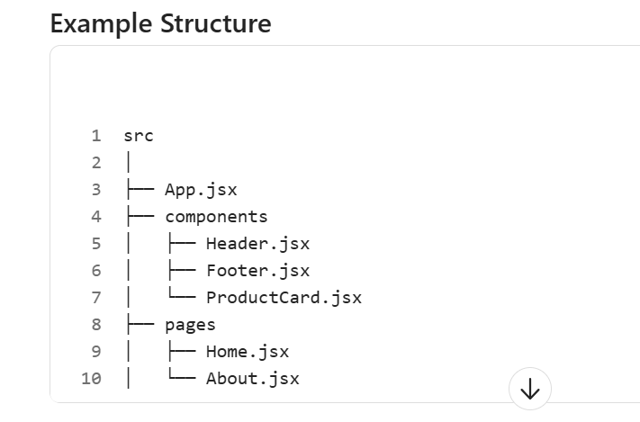
Components communicate using:
- Props
- State
- Context API

Creating First React Hello Wordl App
-we can change the name App component but all the components should be start from uppercase only so that it differs from html tags
-if we are writing multiple lines in components return() function then that code must be enclose/wrap inside <div>
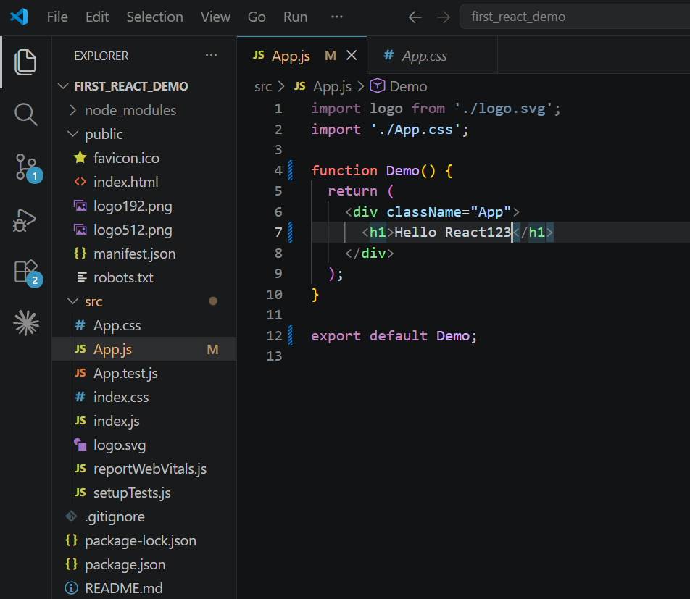Creating new file/component in src : Header
Framework is having its own structure, whereas in library we can define the structure
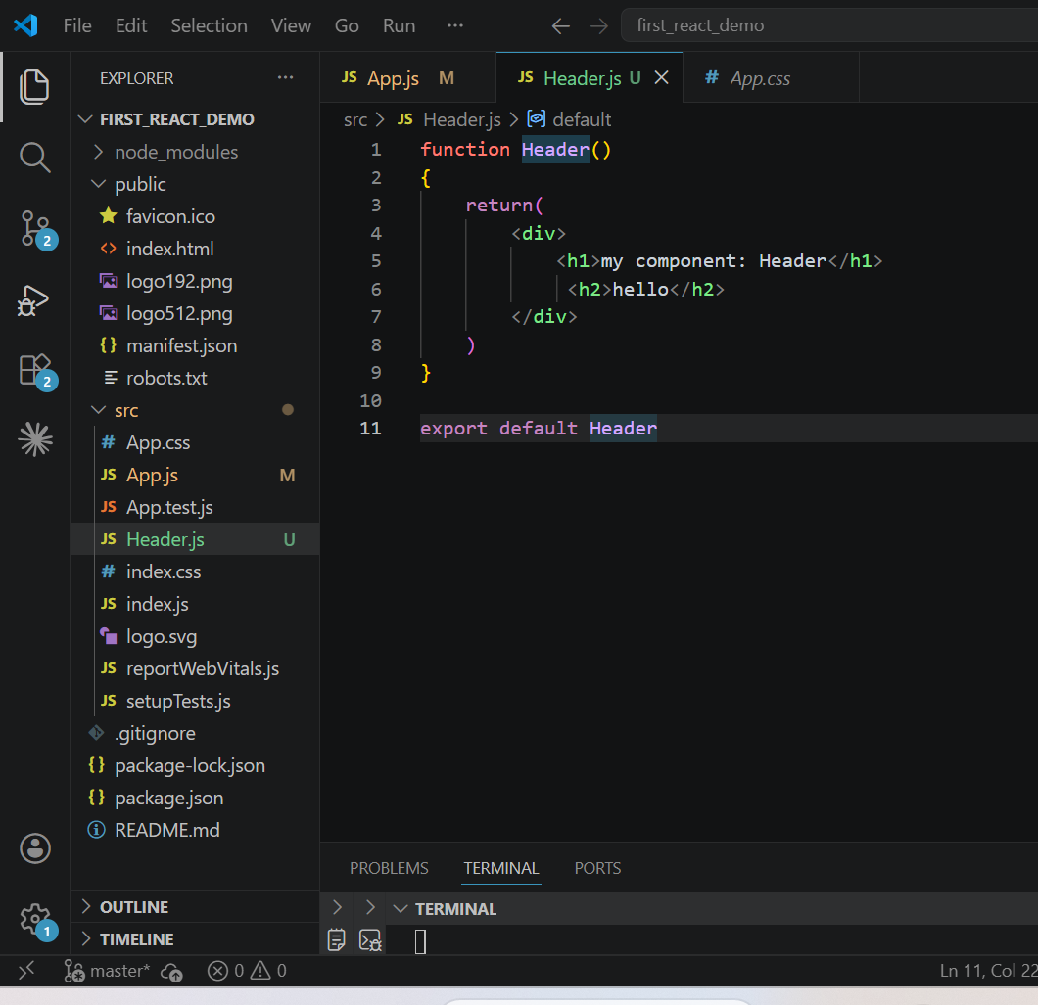
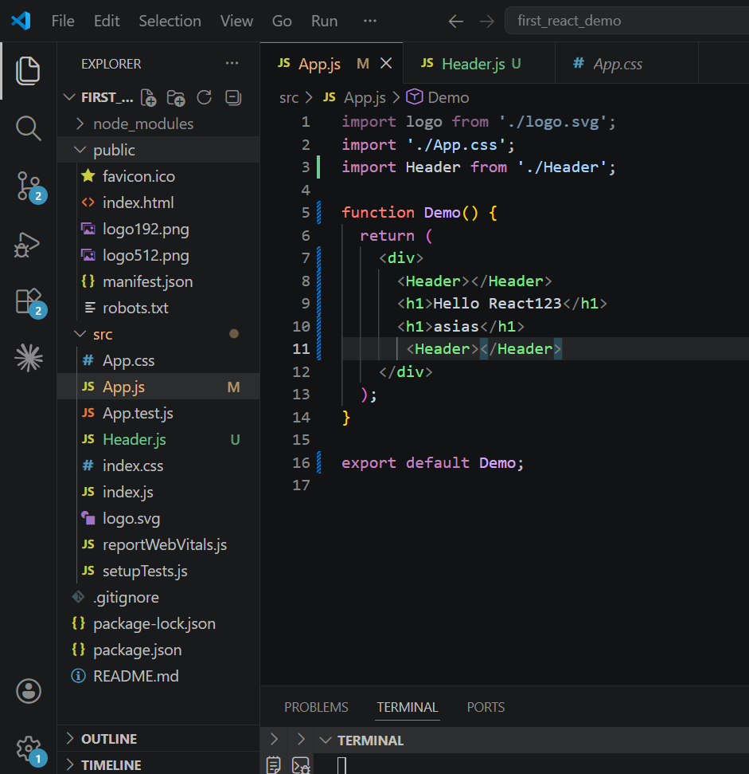
JSX

What is DOM?
- DOM (Document Object Model) is a tree-like representation of an HTML document created by the browser.
<body>
<div>
<h1>Hello React</h1>
<button>Click Me</button>
</div>
</body>

DOM Tree:

Body └── Div ├── H1 └── Button

Why does a browser create a DOM for every HTML document?

A browser cannot directly understand and manipulate raw HTML text efficiently. Therefore, it converts the HTML document into a structured object model called the DOM (Document Object Model).

Why is DOM Needed?

1. To Display the Web Page

HTML is just text.

The browser must understand:

This is a heading

Font size should be large

It should appear on screen

DOM provides this structured representation.

2. To Allow JavaScript Interaction

Without DOM, JavaScript cannot access HTML elements.

Example:

document.getElementById("heading")

The browser searches the DOM tree and returns the element.

Without DOM:

JavaScript cannot find elements.

3. To Handle User Events

When the button is clicked:

Browser locates button in DOM

Browser triggers event

JavaScript function executes

DOM makes event handling possible.

What Happens Internally?

When a browser receives an HTML file:

Step 1

Reads HTML

Step 2

Parses HTML

Step 3

Creates DOM Tree

Step 4

Combines DOM + CSS

Step 5

Creates Render Tree

Step 6

Displays UI

Why does the browser create a DOM for every HTML document?

The browser creates a DOM because HTML is only markup text. DOM converts HTML into a tree of JavaScript objects that the browser and JavaScript can understand, manipulate, style, and respond to user events. Without the DOM, dynamic updates, event handling, and rendering of web pages would not be possible.

5. Virtual DOM

The Virtual DOM (VDOM) is a lightweight, in-memory JavaScript representation of the Real DOM. React keeps this virtual copy and updates it first when state or props change. Then React compares the new Virtual DOM with the previous one and updates only the changed elements in the Real DOM. This process is called Reconciliation

What is DOM?
- DOM = Document Object Model
Example HTML:
<h1>Hello</h1>
Browser creates:
Document
|
h1
Problem with Real DOM
Suppose:
<h1>Pooja</h1>
changes to:
<h1>Bhavsar Pooja</h1>
Browser updates the actual DOM.
Doing this repeatedly is expensive.
React Solution: Virtual DOM
React creates a lightweight copy.
Real DOM
|
Virtual DOM

Characteristics of Virtual DOM
1. Lightweight Representation
Virtual DOM is not an actual browser DOM.
It is just JavaScript objects in memory.
Example:
{
type: "h1",
props: {
children: "Hello React"
}
}
2. In-Memory Structure
Virtual DOM exists in memory and not on the browser screen.
Because memory operations are faster than DOM operations.
3. Diffing Algorithm
React compares:
Old Virtual DOM VS New Virtual DOM
to identify changes.
4. Reconciliation
After finding differences, React updates only affected DOM nodes
5. Efficient Updates
Instead of:
Update Entire Page
React performs:
Update Only Changed Elements
6. Faster Rendering
Since fewer real DOM operations are performed, rendering becomes much faster.
Real DOM vs Virtual DOM
Feature | Real DOM | Virtual DOM
Definition | Actual browser DOM | Lightweight copy of DOM
Update Speed | Slower | Faster
Memory Location | Browser | Memory (JavaScript Objects)
Re-rendering | Entire DOM subtree may update | Only changed nodes update
Performance | Lower for frequent updates | Higher
Manipulation Cost | Expensive | Cheap
User Experience | Less responsive in large apps | More responsive
Used By | Vanilla JS | React, Vue, Preact

Data flow implementation of ReactJS is ___________?
React follows a Unidirectional Data Flow/ one way data flow model.
How it works?
Data flows only in one direction:
Parent Component ↓ (props) Child Component ↓ Grandchild Component

Which helps React for keeping their data unidirectional?
Options:
- Props
- JSX
- ✅ Flux
- DOM

Why is the answer Flux?
React follows Unidirectional (One-Way) Data Flow, meaning data moves in only one direction:
Flux is an architectural pattern introduced by Facebook that enforces this one-way flow of data.
Why Not Props?
props are only a mechanism for passing data from a parent component to a child component.

React Feature’s
1. Component-Based Architecture
2. Virtual DOM
3. JSX (JavaScript XML)
4. One-Way Data Binding
5. Props
6. State
7. High Performance
8. SPA (Single Page Application) Support

Components
1. What is a Component?
A Component is an independent, reusable piece of UI. React applications are built by combining multiple components together. Components are similar to JavaScript functions: they accept inputs (props) and return UI (JSX).
Real-Life Example
A Facebook page can be divided into:
App
├── Header
├── Navigation Menu
├── Profile Section
├── News Feed
├── Footer
2. Types of Components
React supports two types of components:
Components
├── Functional Components
└── Class Components

1.Functional
A functional component is a JavaScript function that returns JSX. Modern React recommends using function components,

1st way to export comp
User.js
function User()
{
return(
<div>
<h1>User Component</h1>
<h1>hello</h1>
</div>
)
}export default User;

App.js
import logo from './logo.svg';
import './App.css';
import User from './User'
import React from 'react';

function App() {
return(
<div className='App'>
<h1>Hello world</h1>
<User />
</div>

);
}
export default App;

// function App() {

// const centerStyle = {
// display: 'flex',
// justifyContent: 'center',
// alignItems: 'center',
// height: '100vh',
// textAlign: 'center',
// };

// return (
// <div className="App">
// <div id="header" style={centerStyle}>
// <h2>Hello World</h2>
// </div>
// </div>
// );
// }

// class App extends React.Component {
// render() {
// const centerStyle = {
// display: 'flex',
// justifyContent: 'center',
// alignItems: 'center',
// height: '100vh',
// textAlign: 'center'
// };

// return (
// <div id="header" style={centerStyle}>
// <h2>Hello World</h2>
// </div>
// );
// }
// }

// export default App;

2nd way to export comp
User.js
Export function User()
{
return(
<div>
<h1>User Component</h1>
<h1>hello</h1>
</div>
)
}

App.js
import logo from './logo.svg';
import './App.css';
import {User} from './User'
import React from 'react';

function App() {
return(
<div className='App'>
<h1>Hello world</h1>
<User />
</div>

);
}
export default App;

// function App() {

// const centerStyle = {
// display: 'flex',
// justifyContent: 'center',
// alignItems: 'center',
// height: '100vh',
// textAlign: 'center',
// };

// return (
// <div className="App">
// <div id="header" style={centerStyle}>
// <h2>Hello World</h2>
// </div>
// </div>
// );
// }

// class App extends React.Component {
// render() {
// const centerStyle = {
// display: 'flex',
// justifyContent: 'center',
// alignItems: 'center',
// height: '100vh',
// textAlign: 'center'
// };

// return (
// <div id="header" style={centerStyle}>
// <h2>Hello World</h2>
// </div>
// );
// }
// }

// export default App;

We can also place components in same file in that case no need to import component in App.js
----------------------------------------------------------------------------------------------------------------
Importing and exporting components
Types of export
1.default export
2.named export
3.multiple export
UserComp.jsx
function Login()
{
return(
<div>
<h1>Login User</h1>
</div>

);
}
//2.named export
export function Profile()
{
return(
<div>
<h1>Profile</h1>
</div>

);
}

//2.named export
export function Setting()
{
return(
<div>
<h1>Setting</h1>
</div>

);
}

//1.default export
export default Login;

//2.exporting constant
export const UserKey="jsajssj"

//export default Profile;
App.js
import logo from './logo.svg';
import './App.css';
//import {User} from './User'
import React from 'react';
import {Login, UserKey } from './UserComp'; //default import
import {Profile,Setting} from './UserComp';//multiple import

function App() {
return(
<div className='App'>
<h1>Hello world</h1>
<User />
<Login />
<Profile/>
<Setting/>
<h1>{UserKey}</h1>

</div>

);
}
export default App;

export function User()
{
return(
<div>
<h1>User Component123 new</h1>
<h1>hello</h1>

</div>
)
}
----------------------------------------------------------------------------------------------------------------
JSX
JSX (JavaScript XML) or Javascript Syntax Extension is a syntax extension for JavaScript used in React to describe what the UI should look like. It allows you to write HTML-like code directly within JavaScript, making it easier to visualize and build user interfaces.
With JSX
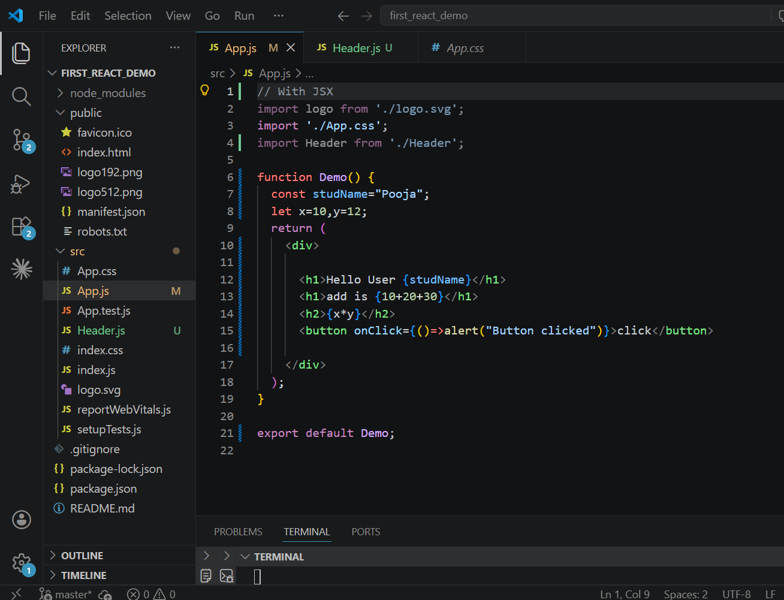

Without JSX
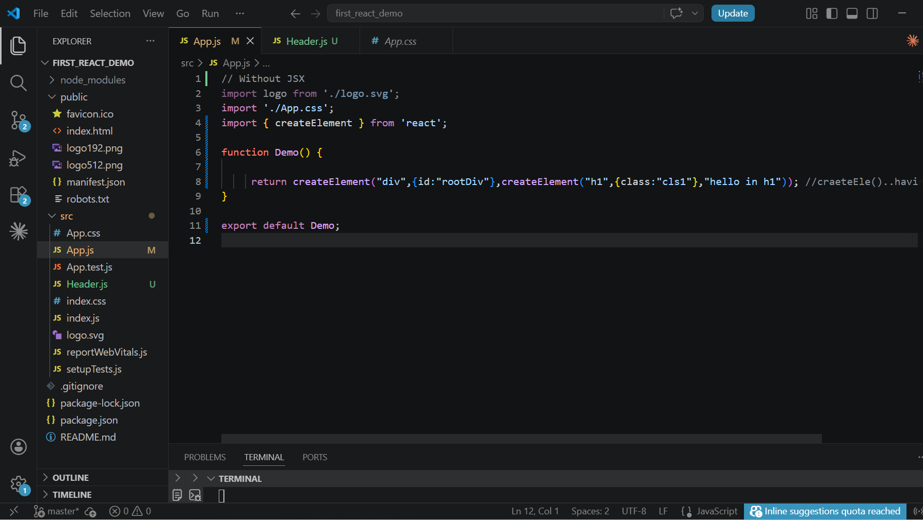
import React from "react";
const element = React.createElement(
"h1",
null,
"Hello React"
);

Rules of JSX
Rule 1: Return Single Parent Element
return (
<div>
<h1>Hello</h1>
<p>Welcome</p>
</div>
);
Or
return (
<>
<h1>Hello</h1>
<p>Welcome</p>
</>
);

Rule 2: Tags Must Be Closed
Html : <input>
JSx: <input />

Rule 3: Attribute Names Use camelCase
HTML: <button onclick="save()">
JSX: <button onClick={save}>
Other examples:
HTML | JSX
class | className
tabindex | tabIndex
onclick | onClick
onchange | onChange

Embedding JavaScript Inside JSX: {}
Expressions in JSX
<h1>{10 + 20}</h1>
<h1>{Math.sqrt(25)}</h1>
----
const user = "Pooja";
<h1>{user.toUpperCase()}</h1>
JSX with Objects
function App() {
const employee = {
id: 101,
name: "Pooja",
salary: 50000
};

return (
<div>
<h2>ID: {employee.id}</h2>
<h2>Name: {employee.name}</h2>
<h2>Salary: {employee.salary}</h2>
</div>
);
}

JSX with Arrays
function App() {
const colors = ["Red", "Blue", "Green"];

return (
<div>
{colors}
</div>
);
}

2.Example – Todo Jsx
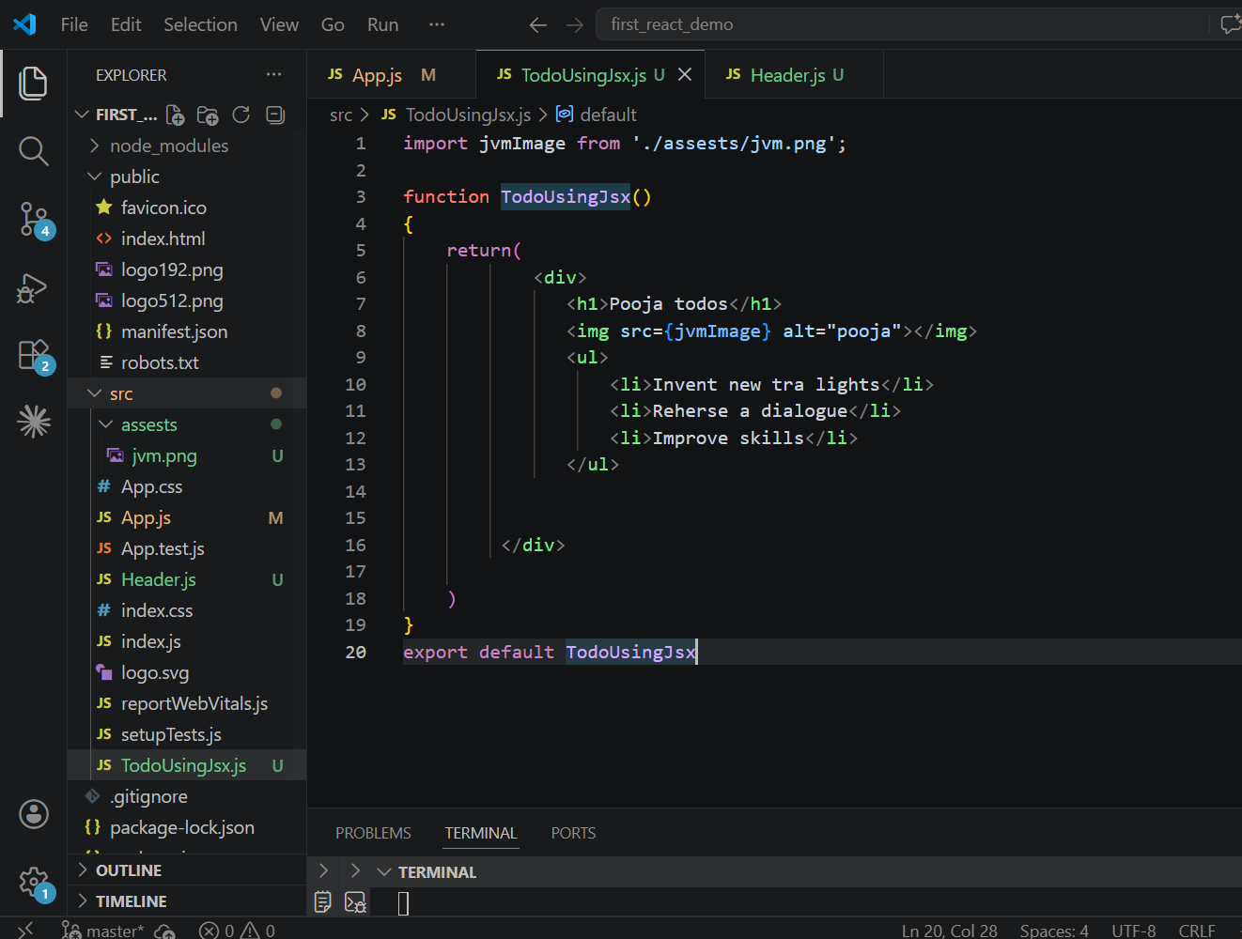

export function Profile()
{
const data="student"
return(
<div>
<h1>{data} Profile{6+7}</h1>
<button onClick={ ()=> alert("welcome") }>Click</button>
</div>

);
}
Without JSX
function App() {
return createElement("div",{id:"rootDiv"},"hello in div");
}
Exercise:

function App() {

return(
<div>
<h1>Pooja todos</h1>
<img src='https://th.bing.com/th/id/OIP.V2MPPXNN2okKuer3WRUTEQHaH_?w=158&h=180&c=7&r=0&o=7&dpr=1.5&pid=1.7&rm=3' alt="oops"></img>
<ul>
<li>Invent new tra lights</li>
<li>Reherse a dialogue</li>
<li>Improve skills</li>
</ul>
<button onClick={callFun}>Click me</button>

</div>

)

function callFun()
{
alert("fun called")
}
JSX with curly braces(for variable,array,objects,conditions, operations,functions ,html tags with property in jsx)

function App() {
const name="raj" //variable

//html tag properties with jsx
let path="https://th.bing.com/th/id/OIP.V2MPPXNN2okKuer3WRUTEQHaH_?w=158&h=180&c=7&r=0&o=7&dpr=1.5&pid=1.7&rm=3"
var userObj={ //object
name:"poojabbh",
email:"pooja@gmail.com"
}

const userArr=['peter','sam','john'] //array

function opeartion(a,b,op) //function
{
if(op=="+")
{
return a+b;
}
else if(op=="-")
{
return a-b;
}
else
{
return a*b;
}
}

return(
<div>
<h1>result is:{opeartion(8,3,"-")}</h1>
<h2>{name? name : "user not found"}</h2>
<h3>{userObj.email}</h3>
<h3>{userArr[1]}</h3>
<input type="text" value={name} /><br></br>
<img src={path} alt="oops"></img>

</div>
)

Click Event and function call
- In react event names must be in camel case format.
e.g onChange, onClick.
2. onClick event accept function definition as value not function calling
e.g <button onClick=”demoFun()”> // wrong
<button onClick={demoFun()}> // wrong
<button onClick={demoFun}>Click Me</button>// right

<button onClick={function demoFun()
{
alert("msg display successfully....")
}}>Click Me</button> >// right
With Arrow function
const task2= ()=>{
alert("in task2")
}
return(
<div>
<button onClick={task2}>Click Me 2nd</button>
</div>
)
Function with Parameters
const task3= (a,b)=>{
alert("add= "+(a+b))
}
return(
<div>
<button onClick={ () => task3(4,5)}>Add1</button>
<button onClick={ () => task3(8,2)}>Add2</button>
</div>
If same function is present inside and outside of app component then it calls the one which is inside in app function. If the function is not present inside app component then it will call the function which is present outside app component.

To install the latest version of React and React DOM:
npm install --save-exact react@^19.0.0 react-dom@^19.0.0
State in React JS
In react, state is like a variable in which we can store dynamic data. But the difference between both is that components re-render automatically(so that data can be visible on UI) when the data in state gets changed but that is not happen in case of variable.States are mutable and dynamic.
We need to import state:
import { useState } from 'react';
import logo from './logo.svg';
import './App.css';
//import {User} from './User'
import React, { createElement } from 'react';
import Login, { UserKey } from './UserComp'; //default import
import {Profile,Setting} from './UserComp';//multiple import
import { useState } from 'react';
import Counter from './counter';

function App()
{
const [frnd, setFrnd] = useState("rajesh"); //here, frnd is a state and setFrnd is function which can change the value of state.. this function name can be anything

const changeFrnd = ()=>{

if (frnd === "rajesh") {
setFrnd("priya");
} else if (frnd === "priya") {
setFrnd("riya");
}

}

return( <div>
<h1>States in React</h1>
<h2>{frnd}</h2>
<button onClick={changeFrnd}>Click to change</button>
<Counter></Counter>
</div>)
}
export default App;
Creating state in other component
import { useState } from "react"

const Counter= ()=>{
let [count,setCount]=useState(0)
let [revCount,setRevCount]= useState(0)

const increaseValue=() =>{
//count++
setCount(count+1)
}

const decreaseValue=() =>{
//count++
setRevCount(revCount-1)
}

return(
<div>
<button onClick={increaseValue}>Increase</button>
<h1>Counter : {count}</h1>
<button onClick={decreaseValue}>Decrease</button>
<h1>Rev Counter : {revCount}</h1>
</div>
)
}

export default Counter

Toggling in react
import logo from './logo.svg';
import './App.css';
//import {User} from './User'
import React, { createElement } from 'react';
import Login, { UserKey } from './UserComp'; //default import
import {Profile,Setting} from './UserComp';//multiple import
import { useState } from 'react';
import Counter from './counter';

//toggling in react
function App()
{
const [display,setDisplay] = useState(true)
const [display1,setDisplay1] = useState(true)

return(
<div>
<button onClick={()=>setDisplay(!display)}>Toggle</button>
{
display? <h1>Pooja B</h1> : null
}

{/* Component Toggling */}
<button onClick={()=>setDisplay1(!display1)}>Componnet Toggle</button>
{
display1? <Counter></Counter> : null
}
</div>
)

}

export default App
Multiple Conditions in React
import logo from './logo.svg';
import './App.css';
//import {User} from './User'
import React, { createElement } from 'react';
import Login, { UserKey } from './UserComp'; //default import
import {Profile,Setting} from './UserComp';//multiple import
import { useState } from 'react';
import Counter from './counter';

//Multiple Conditions in React
function App()
{
const [count,setCount] = useState(0)

return(
<div>
<h1>{count}</h1>
<button onClick={()=>setCount(count+1)}>Counter</button>
{
count ==0 ? <h1>Condition 0</h1>
: count==1 ? <h1>Condition 1</h1>
: count==2 ? <h1>Condition 2</h1>
: count==3 ? <h1>Condition 3</h1>
: count==4 ? <h1>Condition 4</h1>
: <h1>Other Condition</h1>
}

</div>
)
}

export default App

Props in React
Props -> used to transfer data from one component to another in react
App.jsx
//Multiple Conditions in React
function App()
{

return(
<div>
/* here name is props that we are passing to Home component */
<Home name="pooja b"></Home>
</div>
)
}

export default App
Home.jsx
function Home(props)
{
console.log(props.name)
return(
<div>
<h1>in home- props</h1>
<h2 style={{color:'red'}}>{props.name}</h2>
</div>
)
}
export default Home;

------------------------------------------------------------------------------------
Default Props
App.js
//Pass JSX with props
function App()
{
return(
<div>
<h1>Props in React</h1>

<Pass1 name="raj jjj"></Pass1>
<Pass1 name="uday jjj"></Pass1>
<Pass1></Pass1>
<Pass1></Pass1>
<Pass1></Pass1>
</div>
)
}
PassProps.js
function Pass1({name="JAYA"}) //setting default value for props if not passed by parent componet
{
return(
<div>

<h2>Hi, {name}</h2>
</div>
)
}
export default Pass1
------------------------------------------------------------------------------------
Pass JSX(means html code) with props - using "{children}" props
App.js
//Pass JSX(means html code) with props - using "{children}" props
function App()
{
return(
<div>
<Wrapper color="pink">
<h2>Wrapper Compo..</h2>
</Wrapper>

<Wrapper>
<h2>Hi everyone..</h2>
</Wrapper>

<Wrapper color="purple">
<h2>bye everyone..</h2>
<h3 style={{color:"red"}}>Thank u</h3>
</Wrapper>
</div>
)
}
Wrapper.js
function Wrapper({children,color}) //setting default value for props if not passed by parent componet
//function Wrapper({children,color="yellow"}) //default color
{
return(
<div style={{color: color, border: "5px solid green", width:"300px",margin:"5px"}}>

{children}
</div>
)
}
export default Wrapper;
Get Input Field Value
App.jsx
//Get Input Field Value
function App()
{
const [val,setVal]= useState("")
return(
<div>
<h1> Get Input Field Value</h1>
<input type='text'value={val} onChange={(event) => setVal(event.target.value)} placeholder='Enter Username : '></input>
<h1>{val}</h1>

<button onClick={()=>setVal("")}>Clealr Value</button>
</div>
)
}
--------------------------------------------------------------------------------------------------
Controlled Components
A controlled component is a form whose input field value is controlled by React’s state.
App.jsx
//Controlled Compo
function App()
{

const [name,setName]= useState("");
const [password,setPassword]= useState("");
const [email,setEmail]= useState("");

return(
<div>
<h1> Get Input Field Value</h1>
<form action="" method='get'>
<input type='text' value={name} onChange={(event)=> setName(event.target.value)} placeholder='Enter Username : '></input>
<br/><br/>

<input type='password' value={password} onChange={(event)=> setPassword(event.target.value)} placeholder='Enter Password : '></input>
<br/><br/>

<input type='text' value={email} onChange={(event)=> setEmail(event.target.value)} placeholder='Enter Email : '></input>
<br/><br/>
<button>Submit</button>
<button onClick={()=>
{setEmail(''); setName(''); setPassword('')}}>Clear</button>

<h2>{name}</h2>
<h2>{password}</h2>
<h2>{email}</h2>
</form>

</div>
)
}

Handle Checkbox
App.jsx
//Handle Checkbox
function App()
{
return(

<div>
<h1>In App JSx</h1>
<CheckBoxes></CheckBoxes>
</div>
)
}
CheckBoxes.jsx
//Handle Checkbox
import { useState } from "react";
function CheckBoxes()
{
const [skills,setSkills]= useState([]);

const handleSkills= (event) =>{
console.log(event.target.value, event.target.checked);
if(event.target.checked)
{
setSkills([...skills, event.target.value])
}
else{
setSkills([...skills.filter((item)=>item != event.target.value)])

}
}
return(
<div>
<h1> Select Your Skills in Checkbox</h1>
<input onChange={handleSkills} type="checkbox" id="php" value="php" />
<label htmlFor="php">PHP</label>
<br></br>

<input onChange={handleSkills} type="checkbox" id="js" value="js" />
<label htmlFor="js">JS</label>
<br></br>

<input onChange={handleSkills} type="checkbox" id="node" value="node" />
<label htmlFor="node">Node</label>
<br></br>

<input onChange={handleSkills} type="checkbox" id="java" value="java" />
<label htmlFor="java">JAVA</label>
<br></br>

<h1>{skills.toString()}</h1>
</div>
)
}export default CheckBoxes;

//Loop in JSX with Map function
function App()
{
const userData=[
{
id:1,
userName:"raj",
email:"raj@gmail.com",
age:19
},
{
id:2,
userName:"ajay",
email:"ajay@gmail.com",
age:23
},
{
id:3,
userName:"priya",
email:"priya@gmail.com",
age:20
}
]
return(

<div>
<h1>Loop in JSX with Map function</h1>
<table border="1">
<thead>
<tr>
<td>ID</td>
<td>NAME</td>
<td>EMAIL</td>
<td>AGE</td>
</tr>
</thead>
<tbody>
{
userData.map((us)=>(
<tr key={us.id}> //loop
<td>{us.id}</td>
<td>{us.userName}</td>
<td>{us.email}</td>
<td>{us.age}</td>
</tr>
))
}
</tbody>

</table>

</div>
)
}

key={us.id} is to uniquely identify row in a loop

//Reuse component in loop
App.jsx
function App()
{
const userData=[
{
id:1,
userName:"raj",
email:"raj@gmail.com",
age:19
},
{
id:2,
userName:"ajay",
email:"ajay@gmail.com",
age:23
},
{
id:3,
userName:"priya",
email:"priya@gmail.com",
age:20
}
]
return(

<div>
<h1>Reuse component in loop</h1>
{
userData.map((user)=>(

<div key={user.id}>

<UserDetails us1={user}></UserDetails>
</div>
))
}

</div>
)
}
UserDetails.jsx
const UserDetails=({us1}) =>{
return(
<div style={{
border: "1px solid red",
padding: "10px",
margin: "10px",
width: "400px",
borderRadius: "10px"
}}>
<h3>Name : <span style={{color:"green"}}>{us1.userName}</span> </h3>
<h3>Age : <span style={{color:"green"}}>{us1.age}</span> </h3>
<h3>Email : <span style={{color:"green"}}>{us1.email}</span> </h3>
</div>
)
}

export default UserDetails

