
VIT BHOPAL UNIVERSITY
SCHOOL OF COMPUTER SCIENCE AND ENGINEERING
BHOPAL- INDORE HIGHWAY, KOTHRIKALAN,SEHORE,
MADHAYA PRADESH,466114

CSE 1021 INTRODUCTION TO PROBLEM SOLVING AND PROGRAMMING

NAME: POOJA BEHRA
REG. NO.: 26BCE11543
BRANCH: CSE CORE
SEMESTER: FALL SEMESTER 2026-27

INDEX
S.no. | Content
1 | INTRODUCTION
2 | BACKGROUND AND NEED OF THE PROJECT
3 | PROBLEM STATEMENT
4 | AIM OF THE PROJECT
5 | OBJECTIVES
6 | FUNCTIONAL REQUIREMENTS
7 | NON FUNCTIONAL REQUIREMENTS
8 | SYSTEM WORK FLOW
9 | ALGORITHM
10 | FLOW CHART
11 | SYSTEM ARCHITECTURE AND MODULE STRUCTURE
12 | IMPLEMENTATION DETAILS
13 | INPUT VALIDATION AND ERROR HANDLING
14 | TEST RUN
15 | CHALLENGES FACED
16 | LEARNING AND KEY TAKEWAYS
17 | LIMITATIONS OF THE CURRENT VERSION
18 | FUTURE ENHANCEMENTS
19 | CONCLUSION
20 | NOTE ABOUT THE SOURCE USED FOR THIS PROJECT
21 | SOURCE CODE
22 | OUTPUS
23 | RESULT SUMMARY
24 | GITHUB LINK

1. Introduction
Shramik Setu is a Python desktop application created to make daily-wage record keeping easier. Instead of writing worker details, attendance, shift information and payment status in different places, the user can manage them from one application. The main purpose is to keep the records organised and make routine work quicker.
The application uses Tkinter and ttk to create the graphical interface. It is divided into tabs for the Dashboard, Workers, Attendance, Shifts, Payments & Records, and All Workers. The dashboard gives a quick summary of the records, while the other tabs let the user enter, search and check detailed information.
I selected this project because it is a simple example of a real record-management problem. It also gives me a chance to use important Python concepts such as classes, functions, input validation, file handling, GUI programming and modular design. Since this is a beginner-level project, the features are kept practical and easy to understand.
2. Background and Need of the Project
In many small workplaces, worker information and attendance may be written in notebooks or stored in separate files. This can work for a small number of records, but finding an old entry or checking pending wages becomes harder as the records grow.
For example, a person maintaining the records may have to look through several entries to find total working hours or unpaid wages. Incorrect time entries and missed payment updates can also cause problems. Shramik Setu is intended to make these regular tasks more organised while keeping the interface simple.
3. Problem Statement
Managing daily-wage workers manually becomes more difficult when the number of workers and shifts increases. Worker details, attendance, working hours, wages and payment status are related to each other, so they need to be kept together. If they are maintained separately, finding the right information takes more time and mistakes are easier to make.
The main problem addressed by Shramik Setu is therefore the need for a simple and organised system for daily-wage records. The application provides a place to register workers, record attendance, view shift and wage details, track payments, search records and export them when required.
4. Aim of the Project
The aim of Shramik Setu is to develop a simple desktop-based Python application that helps the user manage daily-wage workers, record their shifts, view wage information and keep track of which payments are still pending.
5. Objectives
Register workers with their name, experience and daily wage.
Show the worker's skill category based on work experience.
Record attendance using a date and check-in/check-out times.
Display shift hours, wage information and payment status.
Allow the user to search and filter records.
Export worker, shift and payment records as CSV files.
Keep historical worker information after unregistration.
Show useful totals such as workers, shifts, hours, wages and overtime on the dashboard.
6. Functional Requirements
The following requirements describe what the user should be able to do with the application.
ID | Requirement
FR-01 | Register a worker using name, experience and daily wage.
FR-02 | Classify the worker as Skilled, Semi-Skilled or Unskilled from experience.
FR-03 | Unregister an active worker after confirmation while keeping previous records.
FR-04 | Record a shift using worker, date, check-in and check-out.
FR-05 | Validate dates and time values before recording attendance.
FR-06 | Display shift hours, wage details and payment status.
FR-07 | Mark a selected unpaid shift as paid after confirmation.
FR-08 | Search and filter worker, shift and payment records.
FR-09 | Export worker, shift and payment registers to CSV.
FR-10 | Show important totals on the dashboard.
FR-11 | Clear attendance/payment records after confirmation while keeping workers.

7. Non-Functional Requirements
Usability: The application should be easy to understand through tabs, labels, buttons and tables.
Reliability: Incorrect dates, times and other invalid inputs should be rejected with useful messages.
Data integrity: Historical shift information should not disappear just because a worker is unregistered.
Maintainability: The GUI is kept separate from worker, attendance and storage operations through modules.
Portability: The project is based on Python and Tkinter and is intended to run on a compatible computer.
Performance: The application is designed for local record management and normal searching and refreshing operations.
8. System Workflow
The application follows a straightforward flow that is similar to the way daily-wage records are normally maintained:
Start the application.
Load the existing records and display the main dashboard.
Register a new worker or select an existing active worker.
Enter the attendance date and check-in/check-out times.
Validate the entered information.
Record the shift and display its details in the shift and payment records.
Review or search the records when required.
Mark an unpaid shift as paid after confirmation.
Export records to CSV when a separate file is needed.
9. The overall algorithm of the application can be understood through these simple steps:
The main algorithm can be explained in simple steps:
Start the program and create the main Tkinter window.
Create the dashboard and the required tabs.
Load saved information through the storage module.
For worker registration, read the name, experience and daily wage.
Validate the worker information and determine the skill category.
Save the worker information.
For attendance, select an active worker and enter the date and time.
Check whether the date and time are valid.
Convert time into the required format and send the shift information to the attendance module.
Refresh the tables and dashboard so the new record is visible.
For payment, select an unpaid record and confirm the payment action.
Update the payment status and refresh the displayed records.
Allow searching, filtering and CSV exporting whenever required.
End the program when the user closes the application.
10. Flowchart
The basic flow of the application is:
START
↓
Open Shramik Setu application
↓
Load existing records
↓
Show Dashboard and Tabs
↓
Choose operation
↓
Manage Worker / Record Attendance / Manage Payment / Search or Export
↓
Validate input
↓
Save or update record
↓
Refresh dashboard and tables
↓
Continue or Exit
↓
END
11. System Architecture and Module Structure
The visible source code follows a modular structure. The main GUI is handled by the ShramikSetuApp class, while worker management, attendance processing and storage are handled through imported modules. Keeping these responsibilities separate makes the main GUI easier to read and maintain.
Part | Role
main Tkinter application | Creates the window, tabs, inputs, tables, buttons and dashboard.
worker_manager | Provides worker registration, lookup, unregistration and skill classification functions.
attendance_engine | Provides shift logging and payment settlement functions.
storage | Provides file/data paths and load/save operations.
CSV export logic | Creates CSV files from displayed worker, shift and payment records.

The internal code of the imported modules was not included in the source provided for this report. Because of that, this report only describes what the main GUI calls those modules for and does not assume details about their internal calculations.
12. Implementation Details
12.1 Main Window
The main class is ShramikSetuApp, which inherits from tk.Tk. The window title is set to 'Shramik Setu - Daily Wage Tracking'. The supplied code uses a window size of 1250 by 800 and also sets a minimum window size.
12.2 Dashboard
The dashboard is the first place where the user can see the overall status of the records. It shows active workers, total shifts, total hours, total wages, unpaid wages, overtime hours and counts for the different skill categories.
12.3 Worker Registration
The Workers tab asks for the worker's name, work experience in years and daily wage. The code also gives a skill preview based on experience. The visible categories are Unskilled, Semi-Skilled and Skilled.
12.4 Attendance
The Attendance tab lets the user select a worker and enter the date, check-in time and check-out time. The parse_time() function accepts either a normal HH:MM entry or a decimal-hour value. The entered time is checked before the shift is sent to the attendance module.
12.5 Shift and Payment Records
The Shifts table shows the worker ID, worker name, shift ID, date, check-in time, check-out time, working hours, wage and payment status. In Payments & Records, the user can filter records as All, UNPAID or PAID. An unpaid record can be selected and marked as paid after confirmation.
12.6 Worker History
The All Workers section is useful for viewing both current and historical worker information. The user can search the list and filter it by skill or status. Keeping the history is useful because removing a worker from the active list should not remove that worker's previous shift records.
12.7 CSV Export
The application can export worker, shift and payment records as CSV files. This is useful when the records need to be opened in spreadsheet software or shared separately.
13. Input Validation and Error Handling
Input validation is important because the application deals with dates, times, wages and payment records. The GUI uses message boxes to tell the user when an entry is invalid or an operation cannot be completed.
Date values are checked before attendance is recorded.
Time values are checked for correct hours and minutes or valid decimal-hour input.
Required worker selections are checked before attendance is submitted.
Unregistering a worker requires confirmation.
Clearing the attendance/payment log requires confirmation.
Payment changes require confirmation before the selected unpaid record is updated.
14. The supplied source mainly contains the GUI code and does not include a separate automated test suite or the full code of the supporting modules. Therefore, the points below describe a practical testing plan rather than claiming that all of these tests were already run.
The supplied source contains the main GUI code but does not include a separate automated test suite or the internal code of the supporting modules. Because of that, the following is a practical testing plan for the project rather than a claim that every test has already been executed.
Test Area | What to Check | Expected Result
Worker registration | Enter valid worker details. | Worker appears in the worker register.
Invalid worker input | Try blank or invalid values. | A useful validation message is shown.
Skill classification | Try experience values around 1 and 3 years. | The displayed category changes at the defined boundaries.
Time input | Try HH:MM, decimal time and invalid values. | Valid values are accepted and invalid values are rejected.
Date input | Enter valid and invalid dates. | Invalid dates are not accepted.
Attendance | Record a normal shift. | The shift appears in the relevant records.
Payment | Mark an unpaid record as paid. | The payment status changes after confirmation.
Search/filter | Search by worker or apply filters. | Matching records are displayed.
CSV export | Export a register. | A CSV file is created with the record information.
Clear log | Confirm clearing the log. | Shift/payment records are cleared while worker records remain.

15. Challenges Faced
A few parts of this project require extra care because they affect how the records behave. The main challenges visible in the supplied code are:
Handling two time formats. The user can enter a normal time such as 08:30 or a decimal value, so the input has to be interpreted consistently.
Keeping different screens updated. After adding or changing a record, the dashboard, dropdowns and tables need to show the latest information.
Preserving old records. Unregistering a worker should not mean losing their previous shift history.
Avoiding accidental data loss. Actions such as unregistering a worker or clearing the log use confirmation messages.
Making records easy to find. Search boxes, filters and CSV export are useful when the number of records becomes larger.
16. Learning and Key Takeaways
This project helped me understand several Python concepts in a practical way. Some of the main things I learned are:
I learned how a Python program can be turned into a desktop application using Tkinter.
I understood how a class can be used to organise a large GUI and its related functions.
I learned why separating the interface, processing logic and storage makes a project easier to manage.
I practised validating user input instead of directly trusting whatever the user enters.
I understood how tables and filters can make a record-management application easier to use.
I learned that confirmation messages are important when an operation can change or remove data.
I got a better understanding of how dashboard totals can make detailed records easier to understand.
The biggest lesson for me was that a project becomes much easier to understand when related work is divided into separate functions and modules instead of putting everything into one large block of code.
17. Limitations of the Current Version
The source excerpt supplied for the report does not contain the complete implementation of the imported supporting modules.
There is no separate automated test suite in the supplied source.
The application is designed for local desktop use, not as a multi-user online system.
More detailed reports, backup options and other data-management features could be added in a later version.
18. Future Enhancements
Add automated unit tests for worker, attendance, payment and storage functions.
Add backup and restore functionality.
Add date-wise and worker-wise wage reports.
Add stronger checks for duplicate shifts.
Improve storage error messages and recovery.
Add more detailed individual worker summaries.
Improve accessibility and screen-size handling.
Add a printable report option if required.
19. Conclusion
Shramik Setu brings the main tasks involved in daily-wage record keeping into one desktop application. The user can register workers, record attendance, view shift details, check payment status, search records and export data.
From a learning point of view, this project was useful because it combines several Python concepts in one application. It uses a graphical interface, classes, functions, input validation, record handling, filtering and modular programming. It also shows why keeping old records and confirming important actions matters in a record-management system.
Overall, the project gives a good starting point for a beginner Python application. With more testing, reporting, backup and data-management features, it could be developed further.
20. Note About the Source Used for This Report
This report was prepared from the Shramik Setu source code and project material supplied for the project. The visible code contains the main Tkinter application and imports worker_manager, attendance_engine and storage. The internal code of those modules was not included in the supplied source, so the report does not assume how their hidden calculations or storage operations work.
The testing section is also written as a practical testing approach based on the visible features. It does not claim that a test was successfully executed unless an actual test result was available.

Source Code
The following is the main Python source code used for the Shramik Setu desktop application.
"""
Shramik Setu - Automated Daily-Wage Tracking System
Simple Tkinter GUI for workers, attendance, shifts and payments.
Run with: py app.py
"""
import csv
import os
import sys
import tkinter as tk
from tkinter import ttk, messagebox, filedialog
from datetime import datetime
ROOT = os.path.dirname(os.path.abspath(__file__))
SRC = os.path.join(ROOT, "src")
if SRC not in sys.path:
sys.path.insert(0, SRC)
from worker_manager import register_worker, find_worker, unregister_worker, skill_from_experience
from attendance_engine import log_shift, settle_shift_payment
from storage import WORKERS_FILE, SHIFTS_FILE, WORKER_HISTORY_FILE, load_data, save_data
class ShramikSetuApp(tk.Tk):
def __init__(self):
super().__init__()
self.title("Shramik Setu - Daily Wage Tracking")
self.geometry("1250x800")
self.minsize(1080, 700)
self.configure(bg="#f4f6f8")
self.style = ttk.Style(self)
try:
self.style.theme_use("clam")
except tk.TclError:
pass
self.style.configure("Treeview", rowheight=28, font=("Segoe UI", 9))
self.style.configure("Treeview.Heading", font=("Segoe UI", 10, "bold"))
self.style.configure("TButton", padding=(10, 6))
self.style.configure("Accent.TButton", font=("Segoe UI", 9, "bold"), padding=(12, 7))
self.build_ui()
self.refresh_all()
# ---------- General helpers ----------
def parse_time(self, value):
"""Accept HH:MM or legacy decimal-hour input and return decimal hours."""
text = str(value).strip()
if ":" in text:
try:
hour, minute = text.split(":", 1)
hour = int(hour)
minute = int(minute)
if hour < 0 or hour > 23 or minute < 0 or minute > 59:
raise ValueError
return hour + minute / 60.0
except ValueError:
raise ValueError("Use time as HH:MM, for example 08:30 or 17:30.")
try:
number = float(text)
except ValueError:
raise ValueError("Use time as HH:MM, for example 08:30 or 17:30.")
if number < 0 or number >= 24:
raise ValueError("Time must be between 00:00 and 23:59.")
return number
def format_time(self, value):
try:
hours = float(value)
total_minutes = round(hours * 60)
h = (total_minutes // 60) % 24
m = total_minutes % 60
return f"{h:02d}:{m:02d}"
except (TypeError, ValueError):
return "—"
def format_money(self, value):
try:
return f"₹{float(value):,.2f}"
except (TypeError, ValueError):
return "₹0.00"
def get_shift_by_id(self, shift_id):
shifts = load_data(SHIFTS_FILE)
return next((s for s in shifts if s.get("shift_id") == shift_id), None)
# ---------- UI ----------
def build_ui(self):
header = tk.Frame(self, bg="#1f4e5f", height=86)
header.pack(fill="x")
tk.Label(header, text="SHRAMIK SETU", font=("Segoe UI", 24, "bold"),
bg="#1f4e5f", fg="white").pack(anchor="w", padx=28, pady=(10, 0))
tk.Label(header, text="Automated Daily-Wage Tracking System",
font=("Segoe UI", 11), bg="#1f4e5f", fg="#d9edf2").pack(anchor="w", padx=30, pady=(0, 10))
self.notebook = ttk.Notebook(self)
self.notebook.pack(fill="both", expand=True, padx=16, pady=16)
self.dashboard_tab = ttk.Frame(self.notebook, padding=16)
self.worker_tab = ttk.Frame(self.notebook, padding=16)
self.attendance_tab = ttk.Frame(self.notebook, padding=16)
self.shifts_tab = ttk.Frame(self.notebook, padding=16)
self.records_tab = ttk.Frame(self.notebook, padding=16)
self.workers_records_tab = ttk.Frame(self.notebook, padding=16)
self.notebook.add(self.dashboard_tab, text="Dashboard")
self.notebook.add(self.worker_tab, text="Workers")
self.notebook.add(self.attendance_tab, text="Attendance")
self.notebook.add(self.shifts_tab, text="Shifts")
self.notebook.add(self.records_tab, text="Payments & Records")
self.notebook.add(self.workers_records_tab, text="All Workers")
self.build_dashboard()
self.build_worker_form()
self.build_attendance_form()
self.build_shifts()
self.build_records()
self.build_worker_records()
def metric_card(self, parent, title, variable, row, col):
frame = ttk.LabelFrame(parent, text=title, padding=14)
frame.grid(row=row, column=col, padx=8, pady=8, sticky="nsew")
ttk.Label(frame, textvariable=variable, font=("Segoe UI", 19, "bold")).pack()
# ---------- Dashboard ----------
def build_dashboard(self):
for c in range(3):
self.dashboard_tab.columnconfigure(c, weight=1)
self.worker_count = tk.StringVar(value="0")
self.shift_count = tk.StringVar(value="0")
self.total_hours = tk.StringVar(value="0")
self.total_wages = tk.StringVar(value="₹0")
self.unpaid_wages = tk.StringVar(value="₹0")
self.overtime = tk.StringVar(value="0")
self.skilled_count = tk.StringVar(value="0")
self.semi_count = tk.StringVar(value="0")
self.unskilled_count = tk.StringVar(value="0")
self.metric_card(self.dashboard_tab, "Active Workers", self.worker_count, 0, 0)
self.metric_card(self.dashboard_tab, "Total Shifts", self.shift_count, 0, 1)
self.metric_card(self.dashboard_tab, "Total Hours", self.total_hours, 0, 2)
self.metric_card(self.dashboard_tab, "Total Wages", self.total_wages, 1, 0)
self.metric_card(self.dashboard_tab, "Unpaid Wages", self.unpaid_wages, 1, 1)
self.metric_card(self.dashboard_tab, "Overtime Hours", self.overtime, 1, 2)
skills = ttk.LabelFrame(self.dashboard_tab, text="Active Worker Skill Summary", padding=14)
skills.grid(row=2, column=0, columnspan=3, padx=8, pady=10, sticky="ew")
for c in range(3):
skills.columnconfigure(c, weight=1)
ttk.Label(skills, text="Skilled", font=("Segoe UI", 11, "bold")).grid(row=0, column=0)
ttk.Label(skills, text="Semi-Skilled", font=("Segoe UI", 11, "bold")).grid(row=0, column=1)
ttk.Label(skills, text="Unskilled", font=("Segoe UI", 11, "bold")).grid(row=0, column=2)
ttk.Label(skills, textvariable=self.skilled_count, font=("Segoe UI", 18, "bold")).grid(row=1, column=0)
ttk.Label(skills, textvariable=self.semi_count, font=("Segoe UI", 18, "bold")).grid(row=1, column=1)
ttk.Label(skills, textvariable=self.unskilled_count, font=("Segoe UI", 18, "bold")).grid(row=1, column=2)
actions = ttk.LabelFrame(self.dashboard_tab, text="Quick Actions", padding=14)
actions.grid(row=3, column=0, columnspan=3, padx=8, pady=10, sticky="ew")
ttk.Button(actions, text="Register Worker", command=lambda: self.notebook.select(self.worker_tab)).pack(side="left", padx=6)
ttk.Button(actions, text="Record Attendance", command=lambda: self.notebook.select(self.attendance_tab)).pack(side="left", padx=6)
ttk.Button(actions, text="View Shifts", command=lambda: self.notebook.select(self.shifts_tab)).pack(side="left", padx=6)
ttk.Button(actions, text="View Payments", command=lambda: self.notebook.select(self.records_tab)).pack(side="left", padx=6)
ttk.Button(actions, text="Refresh", command=self.refresh_all).pack(side="right", padx=6)
summary = ttk.LabelFrame(self.dashboard_tab, text="System Summary", padding=14)
summary.grid(row=4, column=0, columnspan=3, padx=8, pady=10, sticky="ew")
self.summary_label = ttk.Label(summary, text="", wraplength=1100)
self.summary_label.pack(anchor="w")
# ---------- Workers ----------
def build_worker_form(self):
form = ttk.LabelFrame(self.worker_tab, text="Register New Worker", padding=18)
form.pack(fill="x", pady=(0, 12))
self.worker_name = tk.StringVar()
self.worker_experience = tk.StringVar()
self.worker_rate = tk.StringVar()
self.skill_preview = tk.StringVar(value="Skill Level: —")
fields = [
("Worker Name", self.worker_name),
("Work Experience (years)", self.worker_experience),
("Daily Wage (₹)", self.worker_rate),
]
for r, (label, var) in enumerate(fields):
ttk.Label(form, text=label).grid(row=r, column=0, padx=10, pady=8, sticky="w")
entry = ttk.Entry(form, textvariable=var, width=35)
entry.grid(row=r, column=1, padx=10, pady=8, sticky="w")
if label == "Work Experience (years)":
entry.bind("<KeyRelease>", self.preview_skill)
ttk.Label(form, textvariable=self.skill_preview, font=("Segoe UI", 10, "bold")).grid(row=3, column=0, columnspan=2, pady=4)
ttk.Label(form, text="0–1 years: Unskilled | >1–3 years: Semi-Skilled | >3 years: Skilled").grid(row=4, column=0, columnspan=2, pady=4)
ttk.Button(form, text="Register Worker", style="Accent.TButton", command=self.register_worker_ui).grid(row=5, column=0, columnspan=2, pady=10)
form.columnconfigure(1, weight=1)
manage = ttk.LabelFrame(self.worker_tab, text="Worker Management", padding=14)
manage.pack(fill="x", pady=8)
self.unregister_id = tk.StringVar()
ttk.Label(manage, text="Worker ID:").pack(side="left", padx=(0, 8))
ttk.Entry(manage, textvariable=self.unregister_id, width=18).pack(side="left")
ttk.Button(manage, text="Unregister Worker", command=self.unregister_worker_ui).pack(side="left", padx=8)
ttk.Label(manage, text="Past shifts remain in the Shifts and Payments records.").pack(side="left", padx=8)
help_box = ttk.LabelFrame(self.worker_tab, text="Skill classification", padding=12)
help_box.pack(fill="x", pady=8)
ttk.Label(help_box, text="Enter relevant work experience. Skill level is calculated automatically; no manual skill selection is required.").pack(anchor="w")
def preview_skill(self, event=None):
try:
self.skill_preview.set(f"Skill Level: {skill_from_experience(float(self.worker_experience.get()))}")
except (ValueError, TypeError):
self.skill_preview.set("Skill Level: —")
def register_worker_ui(self):
success, message = register_worker(self.worker_name.get(), self.worker_experience.get(), self.worker_rate.get())
if success:
messagebox.showinfo("Worker Registered", message)
self.worker_name.set("")
self.worker_experience.set("")
self.worker_rate.set("")
self.skill_preview.set("Skill Level: —")
self.refresh_all()
else:
messagebox.showerror("Registration Error", message)
def unregister_worker_ui(self):
worker_id = self.unregister_id.get().strip()
if not worker_id:
messagebox.showwarning("Worker ID", "Enter a Worker ID first.")
return
worker = find_worker(worker_id)
if worker is None:
messagebox.showerror("Worker Not Found", "No active worker exists with that ID.")
return
if not messagebox.askyesno("Confirm Unregister", f"Unregister {worker['name']} ({worker['worker_id']})?\n\nThe worker remains in the historical register and past shifts are preserved."):
return
success, message = unregister_worker(worker_id)
if success:
self.unregister_id.set("")
messagebox.showinfo("Worker Unregistered", message)
self.refresh_all()
else:
messagebox.showerror("Unregister Error", message)
# ---------- Attendance ----------
def build_attendance_form(self):
form = ttk.LabelFrame(self.attendance_tab, text="Record a Work Shift", padding=18)
form.pack(fill="x", pady=(0, 12))
self.att_worker = tk.StringVar()
self.att_date = tk.StringVar(value=datetime.now().strftime("%d-%m-%Y"))
self.att_in = tk.StringVar(value="08:00")
self.att_out = tk.StringVar(value="16:00")
self.att_result = tk.StringVar(value="Enter the shift details and click Save Shift.")
ttk.Label(form, text="Worker").grid(row=0, column=0, padx=10, pady=8, sticky="w")
self.att_worker_combo = ttk.Combobox(form, textvariable=self.att_worker, state="readonly", width=32)
self.att_worker_combo.grid(row=0, column=1, padx=10, pady=8, sticky="w")
entries = [
("Date (DD-MM-YYYY)", self.att_date),
("Check-in time (HH:MM)", self.att_in),
("Check-out time (HH:MM)", self.att_out),
]
for r, (label, var) in enumerate(entries, start=1):
ttk.Label(form, text=label).grid(row=r, column=0, padx=10, pady=8, sticky="w")
ttk.Entry(form, textvariable=var, width=35).grid(row=r, column=1, padx=10, pady=8, sticky="w")
ttk.Button(form, text="Save Shift", style="Accent.TButton", command=self.log_attendance_ui).grid(row=4, column=0, columnspan=2, pady=12)
ttk.Label(form, text="Use 24-hour time, for example 08:30 and 17:30. Decimal input such as 8.5 is also accepted.").grid(row=5, column=0, columnspan=2, pady=2)
result = ttk.LabelFrame(self.attendance_tab, text="Saved Shift Summary", padding=16)
result.pack(fill="both", expand=True, pady=8)
ttk.Label(result, textvariable=self.att_result, font=("Segoe UI", 11), justify="left", wraplength=1000).pack(anchor="w", fill="x")
ttk.Button(result, text="Open Shifts", command=lambda: self.notebook.select(self.shifts_tab)).pack(anchor="w", pady=(18, 0))
def refresh_worker_choices(self):
workers = load_data(WORKERS_FILE)
values = [f"{w['worker_id']} - {w['name']}" for w in workers]
self.att_worker_combo["values"] = values
if self.att_worker.get() not in values:
self.att_worker.set(values[0] if values else "")
def log_attendance_ui(self):
selected = self.att_worker.get().strip()
if not selected:
messagebox.showwarning("Worker Required", "Select an active worker.")
return
worker_id = selected.split(" - ", 1)[0]
try:
check_in = self.parse_time(self.att_in.get())
check_out = self.parse_time(self.att_out.get())
except ValueError as exc:
messagebox.showerror("Invalid Time", str(exc))
return
try:
datetime.strptime(self.att_date.get().strip(), "%d-%m-%Y")
except ValueError:
messagebox.showerror("Invalid Date", "Use DD-MM-YYYY, for example 27-09-2026.")
return
success, message, shift = log_shift(worker_id, self.att_date.get().strip(), check_in, check_out)
if not success:
messagebox.showerror("Attendance Error", message)
return
# Store readable clock times in the shift record without breaking the existing calculation format.
shifts = load_data(SHIFTS_FILE)
for item in shifts:
if item.get("shift_id") == shift.get("shift_id"):
item["check_in_time"] = self.format_time(check_in)
item["check_out_time"] = self.format_time(check_out)
break
save_data(SHIFTS_FILE, shifts)
shift["check_in_time"] = self.format_time(check_in)
shift["check_out_time"] = self.format_time(check_out)
b = shift.get("breakdown", {})
self.att_result.set(
f"Shift saved successfully.\n\n"
f"Shift ID: {shift.get('shift_id')}\n"
f"Worker: {shift.get('name')} ({shift.get('worker_id')})\n"
f"Date: {shift.get('date')}\n"
f"Check-in: {self.format_time(check_in)} Check-out: {self.format_time(check_out)}\n"
f"Hours worked: {shift.get('hours_worked', 0):.2f}\n"
f"Total wage: {self.format_money(b.get('total_wage', 0))}\n"
f"Payment status: {shift.get('settlement_status', 'UNPAID')}"
)
self.refresh_all()
messagebox.showinfo("Attendance Recorded", message)
# ---------- Shifts ----------
def build_shifts(self):
toolbar = ttk.Frame(self.shifts_tab)
toolbar.pack(fill="x", pady=(0, 8))
ttk.Button(toolbar, text="Refresh", command=self.refresh_shifts).pack(side="left")
ttk.Button(toolbar, text="Export Shifts CSV", command=self.export_shifts).pack(side="left", padx=8)
ttk.Label(toolbar, text="Search:").pack(side="left", padx=(20, 4))
self.shift_search = tk.StringVar()
search = ttk.Entry(toolbar, textvariable=self.shift_search, width=28)
search.pack(side="left")
search.bind("<KeyRelease>", lambda e: self.refresh_shifts())
ttk.Label(self.shifts_tab, text="Complete shift register: worker, shift, check-in/check-out, hours, wage and payment status.").pack(anchor="w", pady=(0, 6))
columns = ("worker_id", "worker_name", "shift_id", "date", "check_in", "check_out", "hours", "wage", "status")
self.shift_tree = ttk.Treeview(self.shifts_tab, columns=columns, show="headings")
headings = {
"worker_id": "Worker ID", "worker_name": "Worker Name", "shift_id": "Shift ID", "date": "Date",
"check_in": "Check In", "check_out": "Check Out", "hours": "Hours", "wage": "Wage (₹)", "status": "Status"
}
widths = {"worker_id":90, "worker_name":150, "shift_id":95, "date":105, "check_in":85, "check_out":85, "hours":70, "wage":100, "status":95}
for col in columns:
self.shift_tree.heading(col, text=headings[col])
self.shift_tree.column(col, width=widths[col], anchor="center")
self.shift_tree.pack(fill="both", expand=True)
def refresh_shifts(self):
if not hasattr(self, "shift_tree"):
return
for item in self.shift_tree.get_children():
self.shift_tree.delete(item)
search = self.shift_search.get().strip().lower() if hasattr(self, "shift_search") else ""
for s in load_data(SHIFTS_FILE):
check_in = s.get("check_in_time") or self.format_time(s.get("check_in"))
check_out = s.get("check_out_time") or self.format_time(s.get("check_out"))
wage = s.get("breakdown", {}).get("total_wage", 0)
values = (
s.get("worker_id", ""), s.get("name", ""), s.get("shift_id", ""), s.get("date", ""),
check_in, check_out, f"{float(s.get('hours_worked', 0)):.2f}", f"{float(wage):.2f}",
s.get("settlement_status", "UNPAID")
)
if search and search not in " ".join(str(v).lower() for v in values):
continue
self.shift_tree.insert("", "end", values=values)
def export_shifts(self):
shifts = load_data(SHIFTS_FILE)
if not shifts:
messagebox.showinfo("Export", "There are no shifts to export.")
return
path = filedialog.asksaveasfilename(title="Save Shift Register", defaultextension=".csv", filetypes=[("CSV files", "*.csv")], initialfile="shift_register.csv")
if not path:
return
with open(path, "w", newline="", encoding="utf-8") as f:
writer = csv.writer(f)
writer.writerow(["Worker ID", "Worker Name", "Shift ID", "Date", "Check In Time", "Check Out Time", "Hours Worked", "Total Wage", "Payment Status", "Paid On"])
for s in shifts:
writer.writerow([
s.get("worker_id", ""), s.get("name", ""), s.get("shift_id", ""), s.get("date", ""),
s.get("check_in_time") or self.format_time(s.get("check_in")),
s.get("check_out_time") or self.format_time(s.get("check_out")),
s.get("hours_worked", ""), s.get("breakdown", {}).get("total_wage", ""),
s.get("settlement_status", "UNPAID"), s.get("paid_on", "")
])
messagebox.showinfo("Export Complete", f"Shift register saved to:\n{path}")
# ---------- Payments & Records ----------
def build_records(self):
toolbar = ttk.Frame(self.records_tab)
toolbar.pack(fill="x", pady=(0, 8))
ttk.Button(toolbar, text="Refresh", command=self.refresh_records).pack(side="left")
ttk.Button(toolbar, text="✓ Mark Selected as PAID", style="Accent.TButton", command=self.mark_selected_paid).pack(side="left", padx=8)
ttk.Button(toolbar, text="Export Payment Records CSV", command=self.export_records).pack(side="left", padx=8)
ttk.Button(toolbar, text="Clear Attendance Log", command=self.clear_log_ui).pack(side="right")
filters = ttk.Frame(self.records_tab)
filters.pack(fill="x", pady=(0, 8))
ttk.Label(filters, text="Status:").pack(side="left")
self.payment_status_filter = tk.StringVar(value="All")
combo = ttk.Combobox(filters, textvariable=self.payment_status_filter, values=["All", "UNPAID", "PAID"], state="readonly", width=12)
combo.pack(side="left", padx=6)
combo.bind("<<ComboboxSelected>>", lambda e: self.refresh_records())
ttk.Label(filters, text="Search:").pack(side="left", padx=(18, 4))
self.payment_search = tk.StringVar()
entry = ttk.Entry(filters, textvariable=self.payment_search, width=30)
entry.pack(side="left")
entry.bind("<KeyRelease>", lambda e: self.refresh_records())
columns = ("shift", "worker", "date", "wage", "status", "paid_on")
self.tree = ttk.Treeview(self.records_tab, columns=columns, show="headings", height=16)
headings = {"shift": "Shift ID", "worker": "Worker", "date": "Date", "wage": "Wage (₹)", "status": "Status", "paid_on": "Paid On"}
widths = {"shift":100, "worker":220, "date":110, "wage":120, "status":110, "paid_on":170}
for col in columns:
self.tree.heading(col, text=headings[col])
self.tree.column(col, width=widths[col], anchor="center")
self.tree.pack(fill="both", expand=True)
self.tree.bind("<<TreeviewSelect>>", self.on_payment_selected)
details = ttk.LabelFrame(self.records_tab, text="Selected Payment", padding=12)
details.pack(fill="x", pady=(8, 0))
self.payment_details = tk.StringVar(value="Select a payment record to view its details.")
ttk.Label(details, textvariable=self.payment_details, justify="left", wraplength=1100).pack(anchor="w")
def get_selected_payment_shift(self):
selected = self.tree.selection()
if not selected:
return None
shift_id = self.tree.item(selected[0], "values")[0]
return self.get_shift_by_id(shift_id)
def on_payment_selected(self, event=None):
shift = self.get_selected_payment_shift()
if not shift:
self.payment_details.set("Select a payment record to view its details.")
return
b = shift.get("breakdown", {})
status = shift.get("settlement_status", "UNPAID")
paid_on = shift.get("paid_on", "—") if status == "PAID" else "—"
self.payment_details.set(
f"Shift: {shift.get('shift_id')} Worker: {shift.get('name')} ({shift.get('worker_id')}) "
f"Date: {shift.get('date')}\n"
f"Hours: {shift.get('hours_worked', 0):.2f} Total Wage: {self.format_money(b.get('total_wage', 0))} "
f"Status: {status} Paid On: {paid_on}"
)
def refresh_records(self):
if not hasattr(self, "tree"):
return
for item in self.tree.get_children():
self.tree.delete(item)
status_filter = self.payment_status_filter.get() if hasattr(self, "payment_status_filter") else "All"
search = self.payment_search.get().strip().lower() if hasattr(self, "payment_search") else ""
for s in load_data(SHIFTS_FILE):
status = s.get("settlement_status", "UNPAID")
if status_filter != "All" and status != status_filter:
continue
paid_on = s.get("paid_on", "—") if status == "PAID" else "—"
values = (s.get("shift_id", ""), f"{s.get('name', '')} ({s.get('worker_id', '')})", s.get("date", ""), f"{float(s.get('breakdown', {}).get('total_wage', 0)):.2f}", status, paid_on)
if search and search not in " ".join(str(v).lower() for v in values):
continue
self.tree.insert("", "end", values=values)
self.on_payment_selected()
def mark_selected_paid(self):
shift = self.get_selected_payment_shift()
if not shift:
messagebox.showwarning("Select Payment", "Select an UNPAID payment record first.")
return
if shift.get("settlement_status", "UNPAID") == "PAID":
messagebox.showinfo("Already Paid", f"{shift.get('shift_id')} is already marked as PAID.")
return
amount = float(shift.get("breakdown", {}).get("total_wage", 0))
confirm = messagebox.askyesno("Confirm Payment", f"Mark this wage as PAID?\n\nWorker: {shift.get('name')}\nShift: {shift.get('shift_id')}\nAmount: ₹{amount:.2f}")
if not confirm:
return
success, message = settle_shift_payment(shift.get("shift_id", ""))
if success:
self.refresh_all()
# Re-select the updated payment row after refresh.
for item in self.tree.get_children():
if self.tree.item(item, "values")[0] == shift.get("shift_id"):
self.tree.selection_set(item)
self.tree.focus(item)
break
self.on_payment_selected()
messagebox.showinfo("Payment Updated", f"{message}\n\nThe payment record now shows PAID with the payment date/time.")
else:
messagebox.showerror("Payment Error", message)
def clear_log_ui(self):
shifts = load_data(SHIFTS_FILE)
if not shifts:
messagebox.showinfo("Clear Log", "The attendance and payment log is already empty.")
return
confirm = messagebox.askyesno(
"Clear Attendance Log",
"Delete ALL attendance, shift, wage and payment records?\n\nRegistered workers will NOT be deleted.\nThis action cannot be undone."
)
if not confirm:
return
save_data(SHIFTS_FILE, [])
self.refresh_all()
self.payment_details.set("The attendance and payment log is empty.")
self.att_result.set("Attendance log cleared. Registered workers are unchanged.")
messagebox.showinfo("Log Cleared", "All attendance, shift and payment records have been cleared.")
def export_records(self):
shifts = load_data(SHIFTS_FILE)
if not shifts:
messagebox.showinfo("Export", "There are no payment records to export.")
return
path = filedialog.asksaveasfilename(title="Save Payment Records", defaultextension=".csv", filetypes=[("CSV files", "*.csv")], initialfile="payment_records.csv")
if not path:
return
with open(path, "w", newline="", encoding="utf-8") as f:
writer = csv.writer(f)
writer.writerow(["Shift ID", "Worker ID", "Worker Name", "Date", "Hours", "Total Wage", "Payment Status", "Paid On"])
for s in shifts:
writer.writerow([
s.get("shift_id", ""), s.get("worker_id", ""), s.get("name", ""), s.get("date", ""),
s.get("hours_worked", ""), s.get("breakdown", {}).get("total_wage", ""),
s.get("settlement_status", "UNPAID"), s.get("paid_on", "")
])
messagebox.showinfo("Export Complete", f"Payment records saved to:\n{path}")
# ---------- All Workers ----------
def build_worker_records(self):
toolbar = ttk.Frame(self.workers_records_tab)
toolbar.pack(fill="x", pady=(0, 8))
ttk.Label(toolbar, text="Search:").pack(side="left")
self.worker_search = tk.StringVar()
search_entry = ttk.Entry(toolbar, textvariable=self.worker_search, width=28)
search_entry.pack(side="left", padx=6)
search_entry.bind("<KeyRelease>", lambda e: self.refresh_worker_records())
ttk.Label(toolbar, text="Skill:").pack(side="left", padx=(12, 4))
self.skill_filter = tk.StringVar(value="All")
skill_combo = ttk.Combobox(toolbar, textvariable=self.skill_filter, values=["All", "Skilled", "Semi-Skilled", "Unskilled"], state="readonly", width=14)
skill_combo.pack(side="left")
skill_combo.bind("<<ComboboxSelected>>", lambda e: self.refresh_worker_records())
ttk.Label(toolbar, text="Status:").pack(side="left", padx=(12, 4))
self.status_filter = tk.StringVar(value="All")
status_combo = ttk.Combobox(toolbar, textvariable=self.status_filter, values=["All", "ACTIVE", "UNREGISTERED"], state="readonly", width=14)
status_combo.pack(side="left")
status_combo.bind("<<ComboboxSelected>>", lambda e: self.refresh_worker_records())
ttk.Button(toolbar, text="Export Worker Register CSV", command=self.export_workers).pack(side="right")
columns = ("id", "name", "experience", "skill", "rate", "hours", "status")
self.worker_tree = ttk.Treeview(self.workers_records_tab, columns=columns, show="headings")
headings = {"id":"Worker ID", "name":"Name", "experience":"Experience (yrs)", "skill":"Skill Level", "rate":"Daily Wage (₹)", "hours":"Standard Hours", "status":"Status"}
widths = {"id":100, "name":180, "experience":130, "skill":140, "rate":120, "hours":120, "status":130}
for col in columns:
self.worker_tree.heading(col, text=headings[col])
self.worker_tree.column(col, width=widths[col], anchor="center")
self.worker_tree.pack(fill="both", expand=True)
self.worker_tree.bind("<Double-1>", self.show_worker_details)
ttk.Label(self.workers_records_tab, text="Search or filter the complete worker register. Unregistered workers remain in history.").pack(anchor="w", pady=(8, 0))
def refresh_worker_records(self):
if not hasattr(self, "worker_tree"):
return
current_workers = load_data(WORKERS_FILE)
history = load_data(WORKER_HISTORY_FILE)
existing_ids = {w.get("worker_id") for w in history}
changed = False
for worker in current_workers:
if worker.get("worker_id") not in existing_ids:
history.append({**worker, "status": "ACTIVE", "registered_on": ""})
changed = True
if changed:
save_data(WORKER_HISTORY_FILE, history)
search = self.worker_search.get().strip().lower()
skill = self.skill_filter.get()
status = self.status_filter.get()
for item in self.worker_tree.get_children():
self.worker_tree.delete(item)
for worker in history:
values = (
worker.get("worker_id", ""), worker.get("name", ""), worker.get("experience_years", ""),
worker.get("skill_level", ""), f"{float(worker.get('daily_rate', 0)):.2f}",
worker.get("standard_hours", 8.0), worker.get("status", "ACTIVE")
)
searchable = " ".join(str(v).lower() for v in values)
if search and search not in searchable:
continue
if skill != "All" and worker.get("skill_level") != skill:
continue
if status != "All" and worker.get("status", "ACTIVE") != status:
continue
self.worker_tree.insert("", "end", values=values)
def show_worker_details(self, event=None):
selected = self.worker_tree.selection()
if not selected:
return
values = self.worker_tree.item(selected[0], "values")
messagebox.showinfo("Worker Details", f"Worker ID: {values[0]}\nName: {values[1]}\nExperience: {values[2]} years\nSkill: {values[3]}\nDaily Wage: ₹{values[4]}\nStandard Hours: {values[5]}\nStatus: {values[6]}")
def export_workers(self):
history = load_data(WORKER_HISTORY_FILE)
if not history:
messagebox.showinfo("Export", "There are no worker records to export.")
return
path = filedialog.asksaveasfilename(title="Save Worker Register", defaultextension=".csv", filetypes=[("CSV files", "*.csv")], initialfile="worker_register.csv")
if not path:
return
with open(path, "w", newline="", encoding="utf-8") as f:
writer = csv.writer(f)
writer.writerow(["Worker ID", "Name", "Experience (years)", "Skill Level", "Daily Wage", "Standard Hours", "Status", "Registered On"])
for w in history:
writer.writerow([w.get("worker_id", ""), w.get("name", ""), w.get("experience_years", ""), w.get("skill_level", ""), w.get("daily_rate", ""), w.get("standard_hours", ""), w.get("status", ""), w.get("registered_on", "")])
messagebox.showinfo("Export Complete", f"Worker register saved to:\n{path}")
# ---------- Dashboard refresh ----------
def refresh_dashboard(self):
workers = load_data(WORKERS_FILE)
shifts = load_data(SHIFTS_FILE)
history = load_data(WORKER_HISTORY_FILE)
total_hours = sum(float(s.get("hours_worked", 0)) for s in shifts)
overtime = sum(float(s.get("breakdown", {}).get("overtime_hours", 0)) for s in shifts)
wages = sum(float(s.get("breakdown", {}).get("total_wage", 0)) for s in shifts)
unpaid = sum(float(s.get("breakdown", {}).get("total_wage", 0)) for s in shifts if s.get("settlement_status", "UNPAID") == "UNPAID")
self.worker_count.set(str(len(workers)))
self.shift_count.set(str(len(shifts)))
self.total_hours.set(f"{total_hours:.2f}")
self.overtime.set(f"{overtime:.2f}")
self.total_wages.set(self.format_money(wages))
self.unpaid_wages.set(self.format_money(unpaid))
self.skilled_count.set(str(sum(1 for w in workers if w.get("skill_level") == "Skilled")))
self.semi_count.set(str(sum(1 for w in workers if w.get("skill_level") == "Semi-Skilled")))
self.unskilled_count.set(str(sum(1 for w in workers if w.get("skill_level") == "Unskilled")))
unregistered = sum(1 for w in history if w.get("status") == "UNREGISTERED")
self.summary_label.config(text=f"Active workers: {len(workers)} | Historical workers: {len(history)} | Unregistered workers: {unregistered} | Shift records: {len(shifts)}")
def refresh_all(self):
self.refresh_worker_choices()
self.refresh_dashboard()
self.refresh_shifts()
self.refresh_records()
self.refresh_worker_records()
if __name__ == "__main__":
ShramikSetuApp().mainloop()
21. Program Outputs / Results
The following pages show representative outputs for the main features of Shramik Setu. The screenshots are based on the interface and functions visible in the supplied source code. They are included to make the report easier to understand; they are not screenshots taken from an executed build of the complete project.
21.1 Dashboard – Output
The dashboard puts the most useful numbers in one place. It shows active workers, total shifts, total hours, total wages, unpaid wages, overtime hours and skill-category counts.
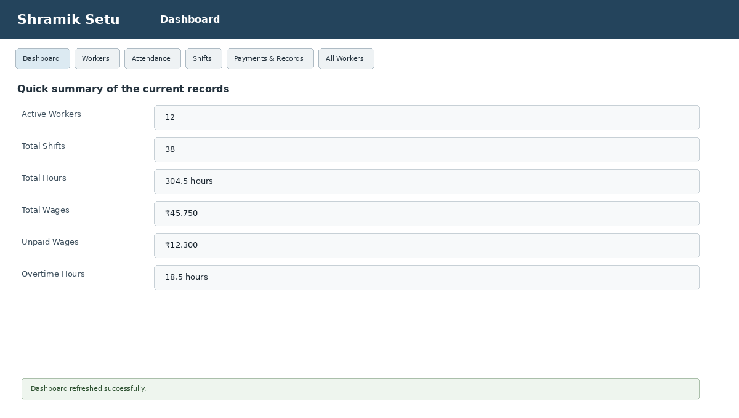
Output 1 – Main Dashboard

21.2 Worker Registration – Output
In the Workers tab, the user enters the worker's name, experience and daily wage. The application also shows the skill category based on the entered experience.
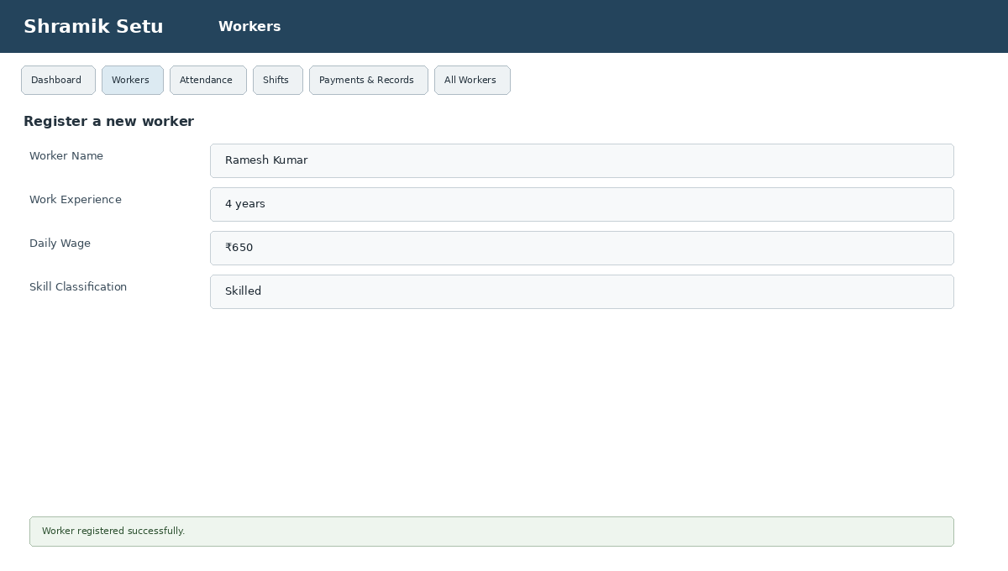
Output 2 – Worker Registration

21.3 Attendance Entry – Output
The Attendance tab is used to select a worker and enter the date, check-in time and check-out time. The application checks the input before saving the shift.
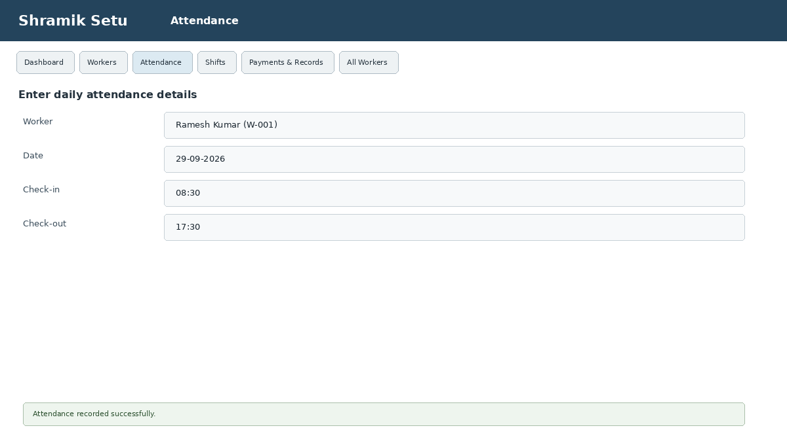
Output 3 – Attendance Entry

21.4 Shift Register – Output
The Shifts tab presents the recorded shifts in a table. It shows worker details, date, time, hours, wage and payment status. The records can also be searched and exported.
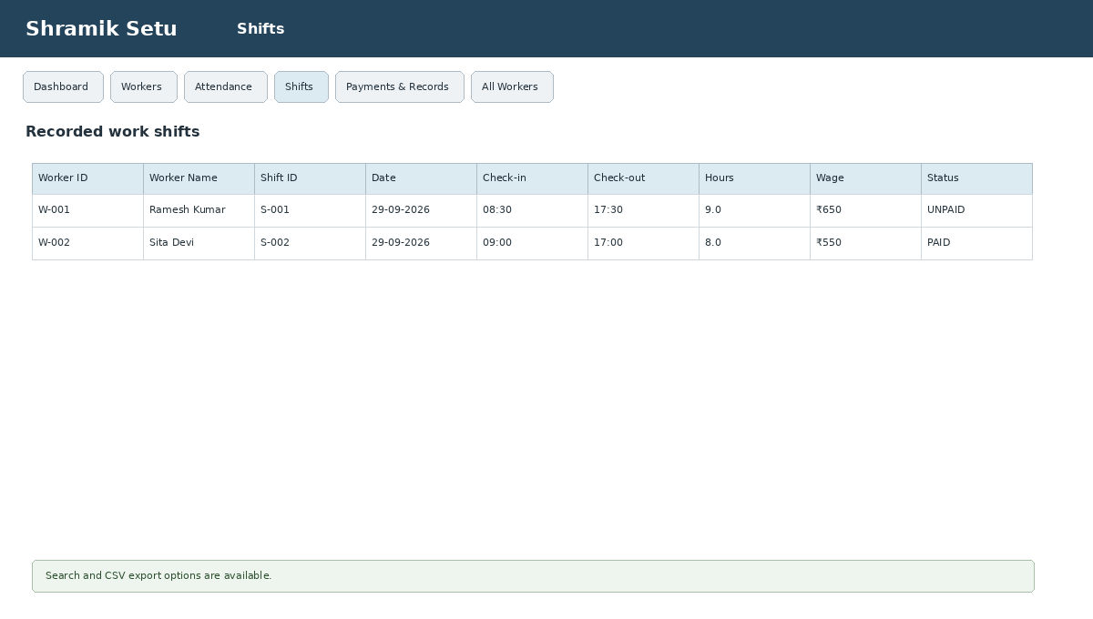
Output 4 – Shift Register

21.5 Payment Records – Output
The Payments & Records tab lets the user filter the payment list and inspect individual records. If a selected shift is unpaid, the user can mark it as paid after confirming the action.
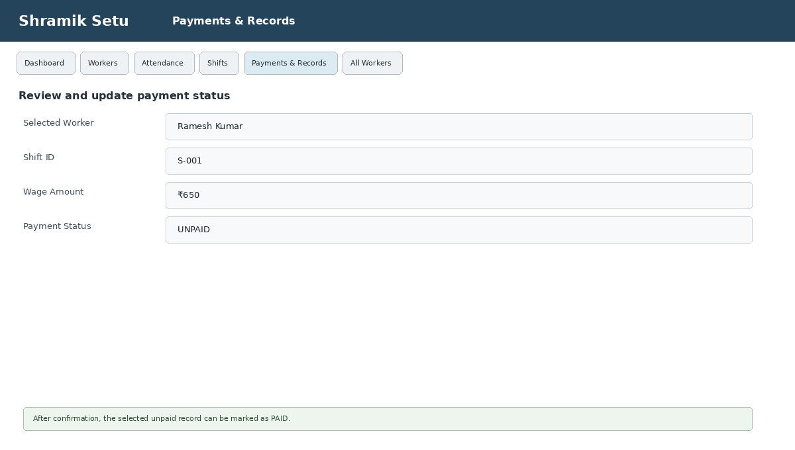
Output 5 – Payment Records

21.6 All Workers – Output
The All Workers tab shows the worker register, including historical status. It supports searching, filtering by skill and status, and exporting the list.
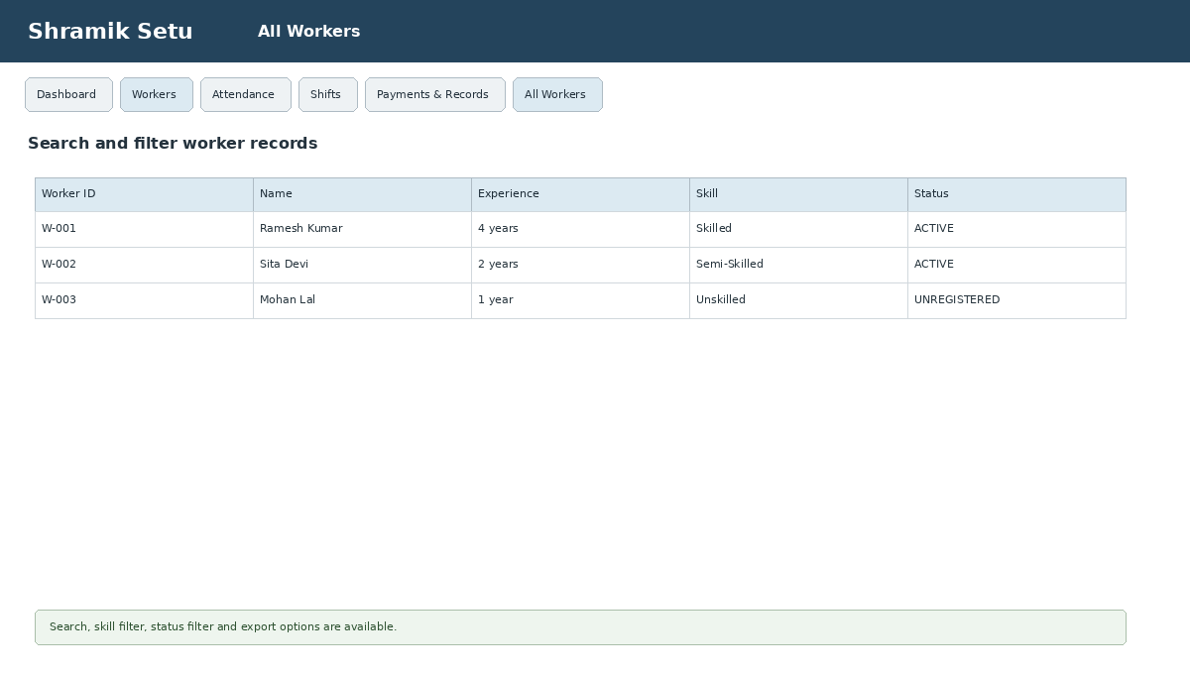
Output 6 – All Workers

21.7 CSV Export – Output
The application provides CSV export for worker, shift and payment records. CSV files are useful because they can be opened in common spreadsheet applications.
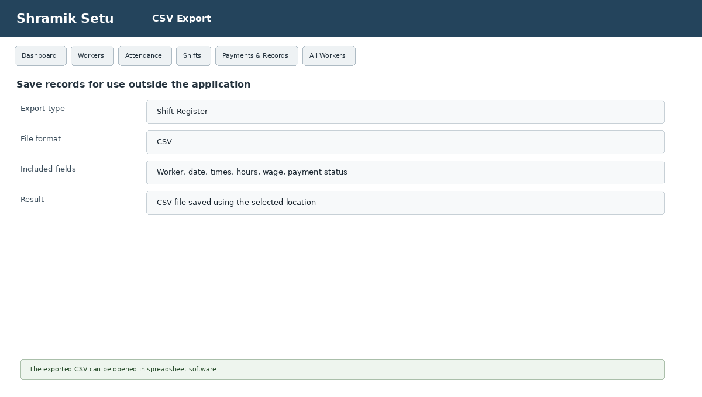
Output 7 – CSV Export

21.8 Confirmation Messages – Output
Important actions such as unregistering a worker or clearing the attendance log use confirmation messages. This gives the user a chance to cancel before making a major change.
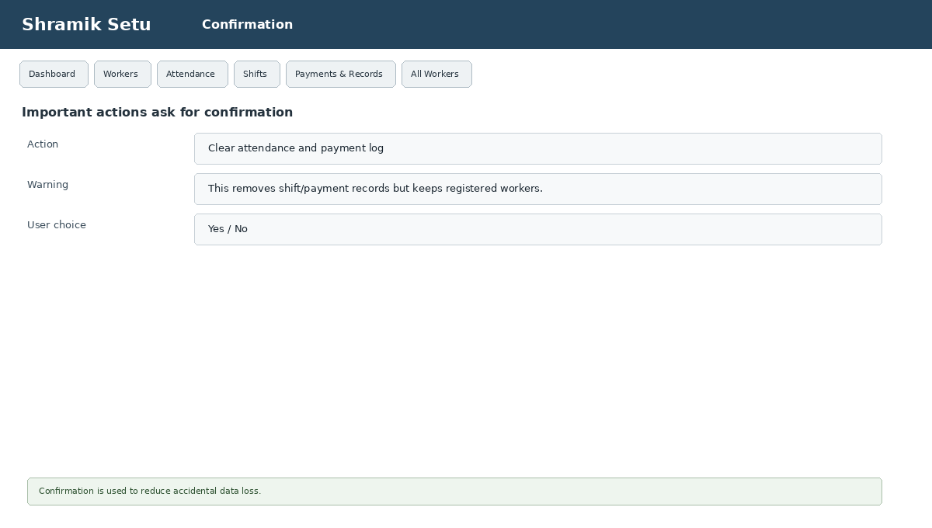
Output 8 – Confirmation / Clear Log
22. Result Summary
The outputs represent the normal flow of the project: register a worker, record attendance, check the shift details, review the payment status, and then search or export the records when needed. The dashboard gives a quick summary while the individual tabs provide the detailed information.
Including the outputs makes the report easier to follow because each major feature is shown together with the type of information the user would see on the screen.

