

**CORPORATE SOCIAL RESPONSIBILTY**

# MSc. in Data and Business Analytics

# Specialization Marketing

**LEGO: Building a more sustainable future—brick by brick**

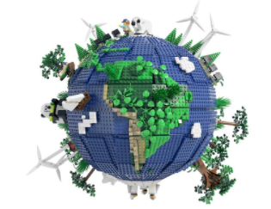

# Student Name -Pooja Bera

# Student Number : ETU20201756

Date of Submission : 15-04-2021

# **Table of Contents**

INTRODUCTION 1

LITERATURE REVIEW 11

RESEARCH OBJECTIVES 13

RESEARCH METHODOLOGY 14

Data source and description 18

Exploratory data analysis 23

Text pre-processing 25

Data Analysis 26

Sentiment Analysis 34

Natural Language Processing 38

Model building and explanation 42

RESULT AND ANALYSIS IMPLEMENTATIONS 48

CONCLUSION AND RECOMMENDATIONS 49

LIMITATIONS 50

REFERENCES 51

**INTRODUCTION**

The Danish brand "**LEGO**" has a steady and strong presence, as it weaves a consistent narrative around its ideals of **sustainability, education, and social contrib**utions. They recently replaced their plastic products with **sugarcane-based plant-based plastics**, which is yet another way the company has pushed its CSR principles.

Furthermore, there is tremendous work on the company's Sustainable Materials Program, which employs over 150 experts to develop sustainable goods and packaging, will continue. The Group had set a goal in 2015 to use sustainable materials in all its goods by 2030. It plans to increase the **use of bio-bricks**, such as those made from sugar cane, which currently make up nearly 2% of its element portfolio.

The LEGO Group was the first toy corporation to join the United Nations Global Compact in 2003, and they continue to adhere to its ten principles today. They joined the Ellen MacArthur Foundation in 2020 to exchange ideas and accelerate the global transition to a circular economy, and they signed on to the UN Women's Empowerment Principles in favor of gender equality and workplace empowerment.

They are also into renewable energy, phasing out single use of plastics, Carbon neutral, reducing CO2 impact, and achieving zero waste. The details of each plan will be discussed below.

**BACKGROUND**

The LEGO Group plans to spend up to **$400 million** in **sustainability and social responsibility** projects over the next three years, covering both long-term commitments and continuing expenses, including its goal of making all its packaging sustainable by the end of 2025.

### **The UN Sustainable Development Goals (SDGs)**

## They are committed to making a positive impact on youth, and SDG 4, ‘Quality Education,'

## and SDG 12, ‘Responsible Consumption and Production,’, motivate them. This is where

## they believe their contribution would have the greatest effect on children's lives and the environment.

## **Quality Education**

They advocate for the transformative power of play to be adopted in education and early childhood development around the world.

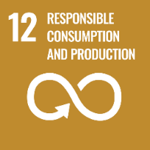

**Responsible consumption and production**

We believe we have a responsibility to minimise the environmental impact of our operations and have set an ambition to make LEGO bricks from sustainable materials by 2030 and our packaging 100% sustainable by 2025.

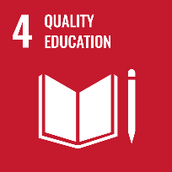

**Phase out single use plastic bags**

As a next move, the LEGO Group will phase out single-use plastic bags used in LEGO boxes to bundle loose bricks. Recyclable paper bags approved by the Forest Stewardship Council will be tested in boxes starting in 2021.Children liked the paper bags being trialed in 2021 as they were environmentally friendly and easy to open.

**Carbon neutral by 2022**

The Group has also underlined that its manufacturing operations will be carbon neutral by 2022. To achieve this, additional solar panels will be installed on all its factories and onsite capacity will be supplemented with the procurement of renewable energy.

**Making a positive impact**- Lego intends to create a more sustainable future and a happier, brighter planet for future generations.



le materials

**Sustainable materials**-By 2030, their most difficult task will be to make all key LEGO items out of recycled materials.

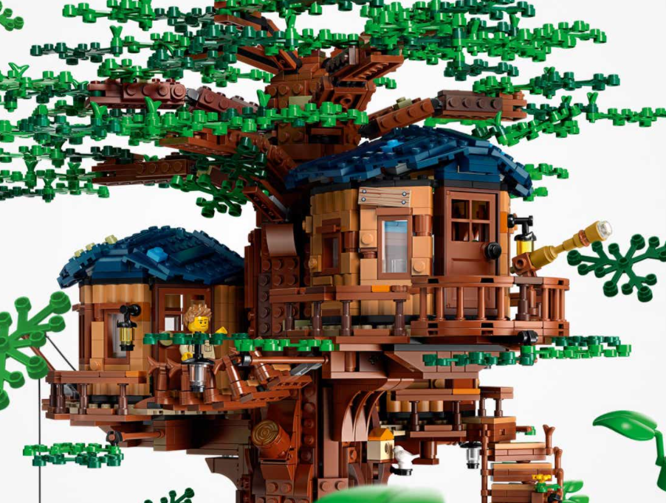

**Sustainable packaging**- By 2025, they want all LEGO packaging to be made from sustainable or recycled materials, produced as effectively as possible, and easy to recycle for customers.



**LEGO Replay**- Is a move toward establishing a circular economy by allowing customers to donate their LEGO bricks to children in need of entertainment.



**Waste to landfill** –

Waste to landfill [tonnes] is calculated as the recorded quantities of waste disposed of by the LEGO Group to landfills. Only data from LEGO Group sites with production are included; these are Billund in Denmark, Nyíregyháza in Hungary, Monterrey in Mexico, Kladno in the Czech Republic and Jiaxing in China. Reported data from sites are based on documentation provided by external contractors. Waste is disposed of through the following methods: Landfill, Recycling, Treatment, Incineration, Incineration with energy recovery. New production facilities will be added to the reporting scope on 1 January, +12 months from the handover of the entire manufacturing facility from project to operational facility department