Software engineering of web-based systems: CS6320 -Project R1

Name: Jaya Pooja Buddharaju

Net id: vr3953

Topic: Simple PhotoSite using Ruby on Rails and SQLite database

**Introduction and Purpose:**

Name of the application: PhotoSite3

YouTube URL: <https://youtu.be/hF_Vz2K04nY>

This project helps us learn how to develop a web application using ruby on rails and a SQLite database. In this web application we build a basic website where we can view the preloaded data and photos of the given number of users. This is like the beginning of a photo sharing website. For this we have to first create a new rails application wherein we create three models user, photo and comment. After doing the specified things for the respective models we have to add a new migration file called load_data which is used to bring in the data we require on the screen when we open the web application. When we complete this we can import everything into the database with the database tool on the right side of rubymine. Now after the import we can see the database tables and the information in it. Now we have to create the controllers photo and comment and add the required code to it. Now we have to routes.rb file such that our web application is set up in the specified URLs. We also have to add all the html and css code required for the web application.

**Demonstration Screenshots:**

1. <http://localhost:3000/users/index>

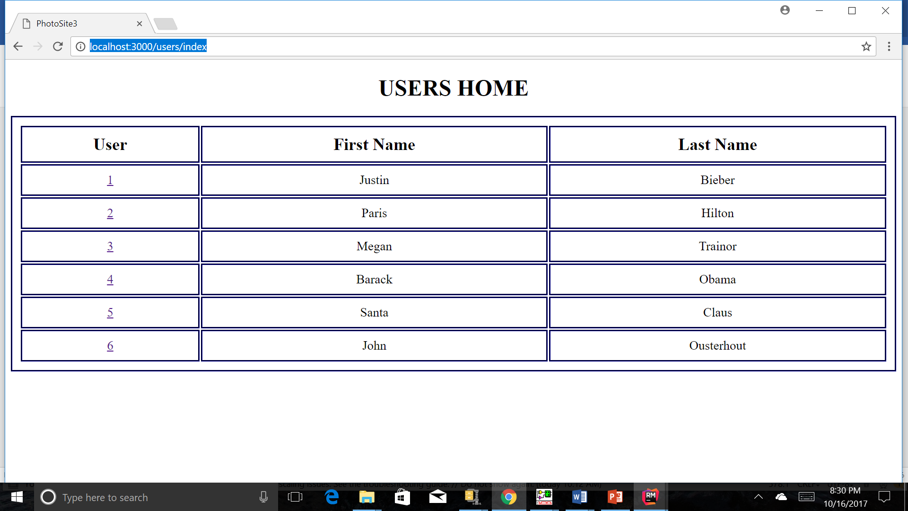

1. <http://localhost:3000/photos/index/1>

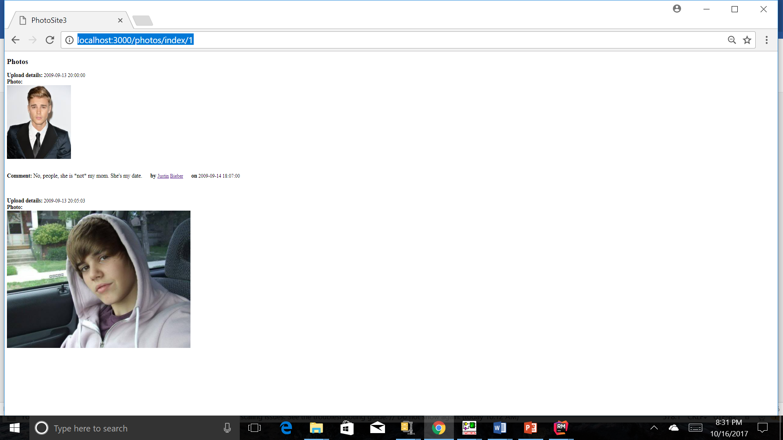

1. <http://localhost:3000/photos/index/2>

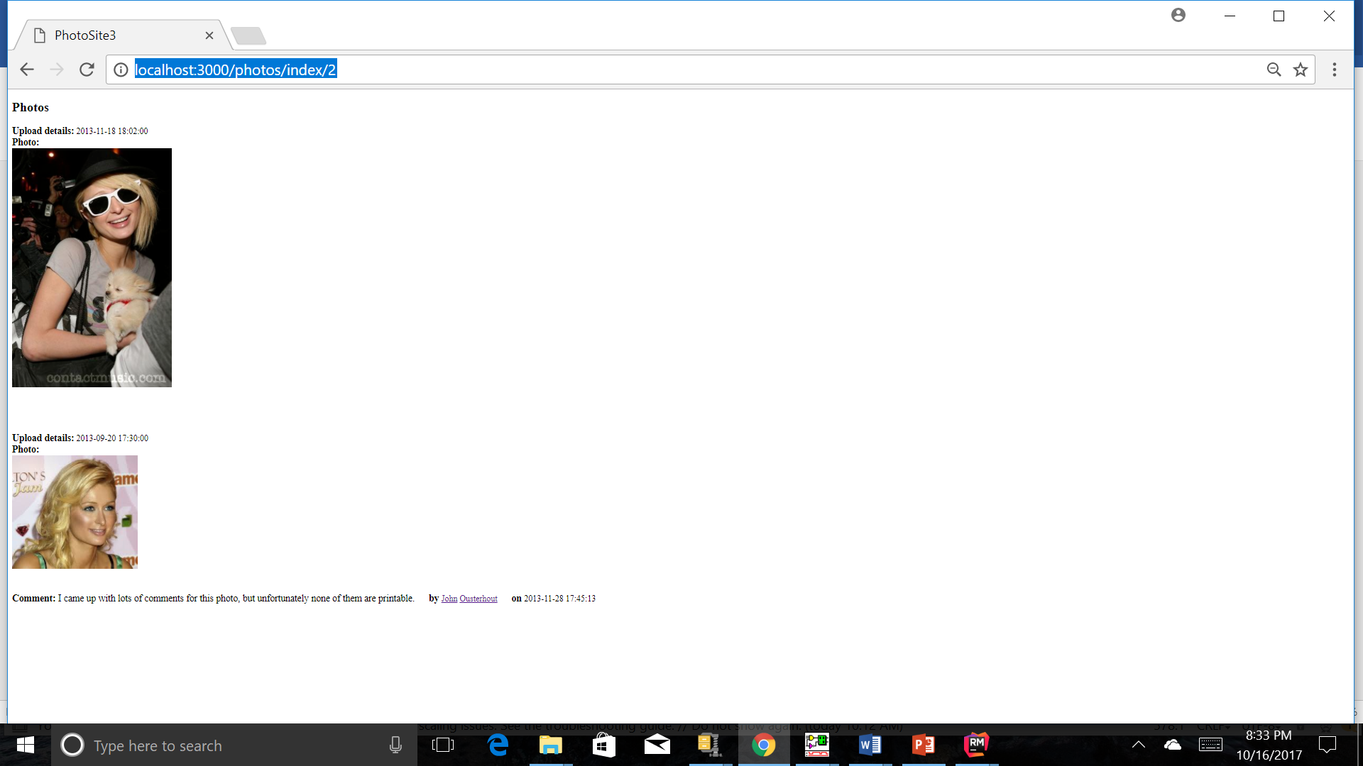

1. <http://localhost:3000/photos/index/3>

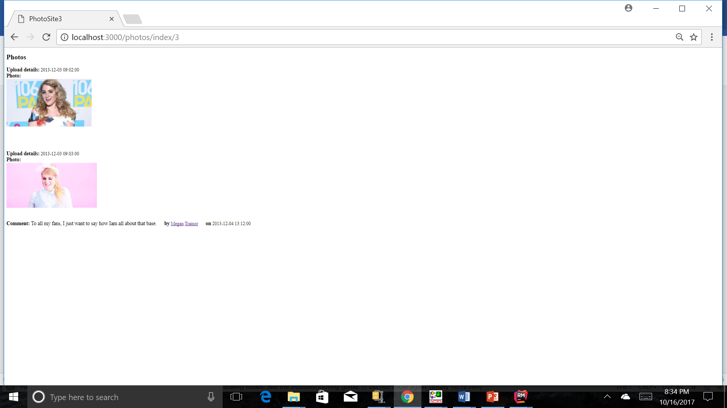

1. <http://localhost:3000/photos/index/4>

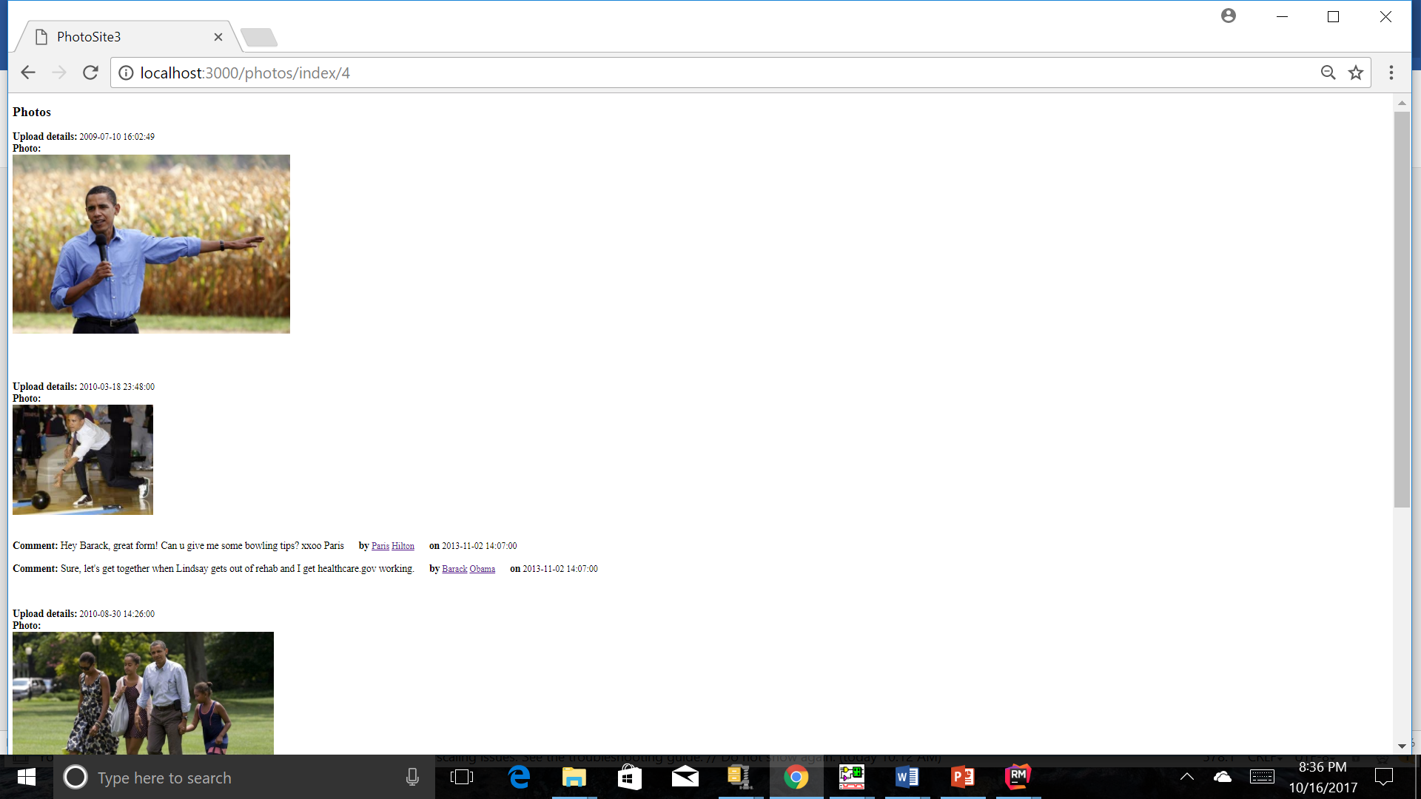

1. <http://localhost:3000/photos/index/5>

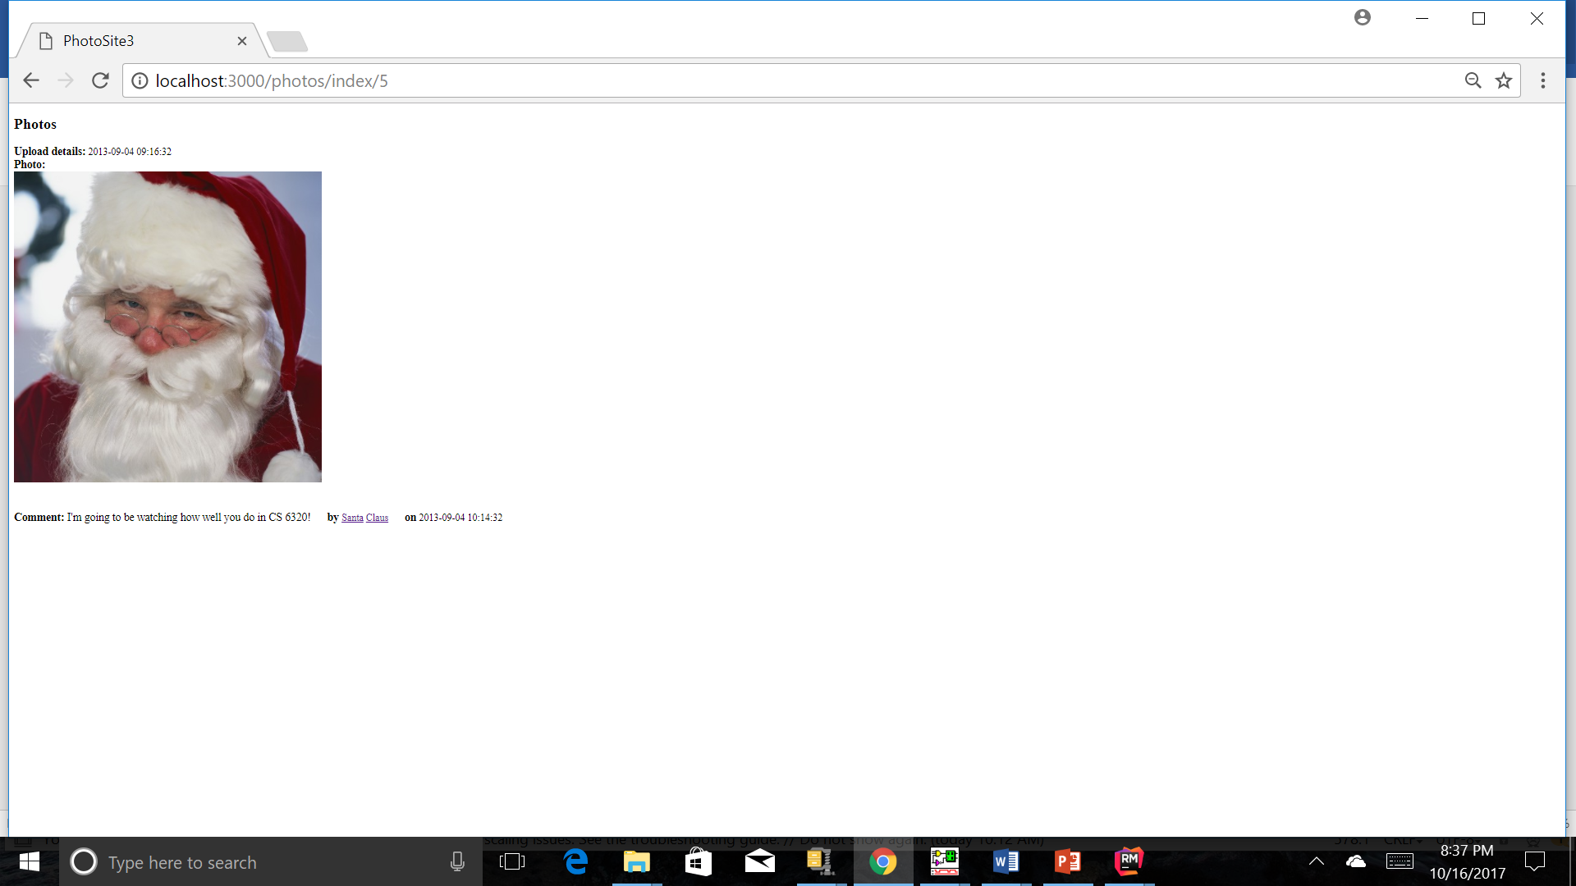

7)<http://localhost:3000/photos/index/6>

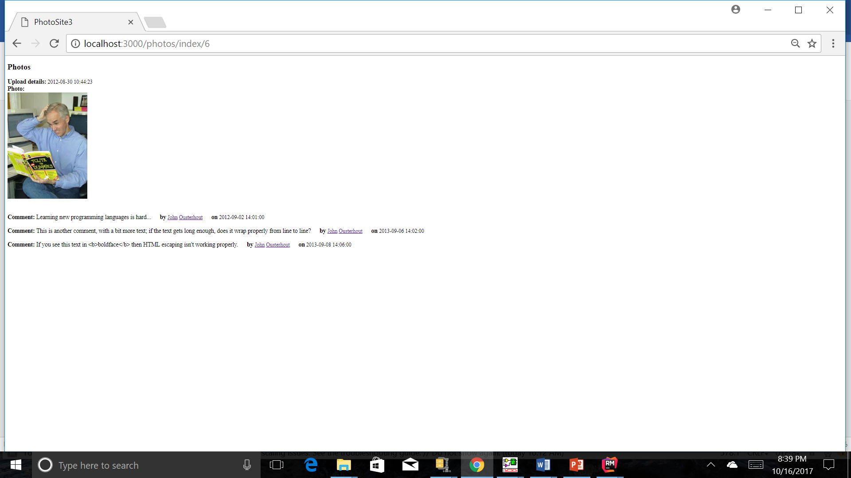

**Discussion of anything NOT working**

The project is working well with all the requirements being satisfied.