1.Overall attrition happened in the company



2. Presence of overtime and correlation in attrition

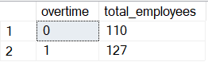

3. Gender distribution in the company

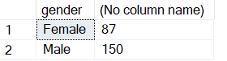

4.corelation amongst performance rating & attrition

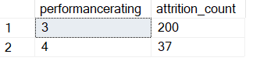

5. Attrition count based on the job roles

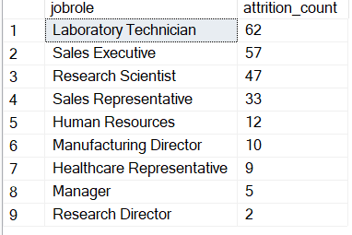

6. Attrition count based on distance from home variable

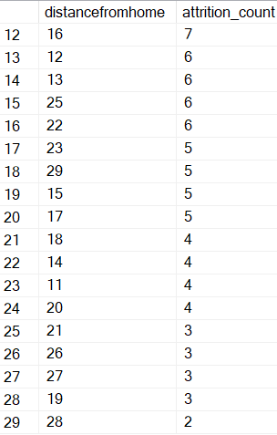

7. Relation between salary and attrition

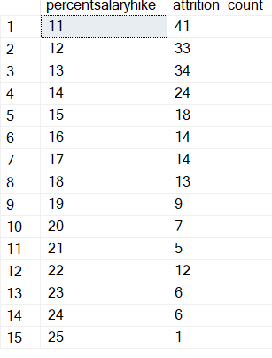

8. Education field is related to attrition count or not

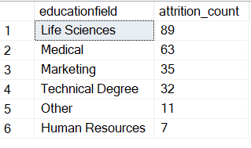

9. Relation between years in current role and attrition count

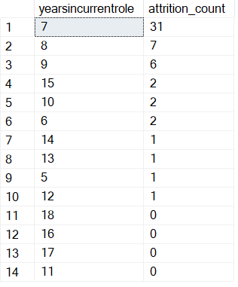

10. Job satisfaction and monthly income

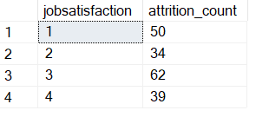

11. Employee attrition based on the age range

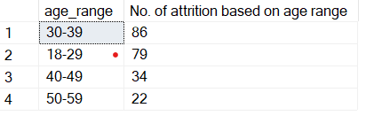

12. Environment satisfaction & Relationship satisfaction based on the age range

