Tables
Q.1 Create a file named assignment_table.html which displays the following
table.
<html>
<head>
<title>assigmentTable</title>
</head>
<body>
<table border="10" height="59%"width="50%"bgcolor="lightpink"cellspacing="2"cellpading="10" bgcolor="lightpink">
<tr>
<td rowspan="4"align="justify"background="pic.jpg"><b>Day</b></td>
<td colspan="3"><b>Seminar</b></td>
</tr>
<tr>
<td colspan="2"><b>Schedule</b></td>
<td rowspan="3"><b>Topic</b></td>
</tr>
<tr>
</tr>
<tr>

<td bgcolor="green">Start</td>
<td bgcolor="red">End</td>
</tr>
<tr>
<td>Monday</td>
<td>9:00am</td>
<td>1:00pm</td>
<td>Internet&www</td>
</tr>
<tr>
<td>Tuesday</td>
<td>9:00am</td>
<td>1:00pm</td>
<td color="blue"><u>Web site</u></td>
</tr>
<tr>
<td rowspan="2">Wednesday</td>
<td>9:00am</td>
<td>11:00am</td>
<td>Web hosting</td>
</tr>
<td>11:00am</td>
<td>1:00pm</td>
<td>Web Development</td>
</tr>
</table>
</body>
</html>
Output:
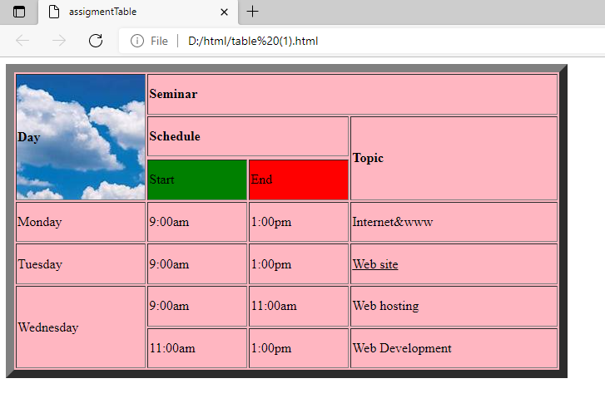
Q.2 Create similar table structure in HTML as shown below:
Code:
<html>
<head>
<title>tables</title>
</head>
<body>
<table border="5"bgcolor="lightgray"height="20%"width="50%"cellspacing="5"cellpadding="5">

<tr>
<td table border="5"align="centre"bgcolor="lightgray">This is a table inside a cell</td>
<td colspan="2">This is another cell of main table</td>
</tr>

<tr>
<td>
<table border="5"Align="centre"bgcolor="skyblue">
<tr>
<td>Plan</td>
<td>Price</td>
</tr>

<tr>
<td>One year plan</td>
<td>60USD</td>
</tr>

<tr>
<td>Two year plan</td>
<td>50USD</td>
</tr></table>

<tr>
<td table border="5"bgcolor="lightgray">Main table cell</td>
<td>Main Table cell</td>
</tr>

</table>
</body>
</html>
Output:
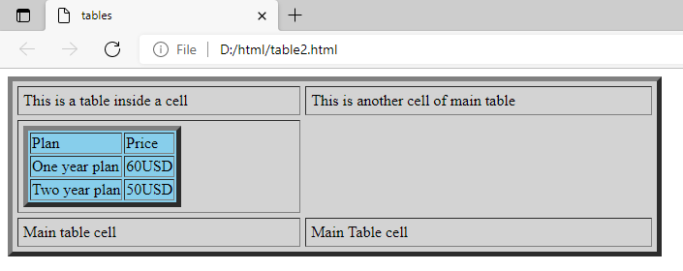
Q.3 Make time table of your class in HTML.
<html>
<head>
<title>Time table</title>
</head>
<body>
<table border="7"align="centre"hight="50%"width="40%"bgcolor="lightpink"cellspacing="10"cellpadding="10">
<caption><b>PGDCA TIME TABLE</caption>
<tr>
<th>Day</th>
<th>8:45-9:30</th>
<th>8:45-9:30</th>
<th >10:15-11:00</th>
<th>11:00-11:45</th>
<th>11:45-12:30</th>
<th>12:30-1:15</th>
<th>1:15-2:00</th>
<th>2:00-2:45</th>
</tr>
<tr>
<td><b>Mon</b></td>
<td>PGD-2101th lab5 Manmeet</td>
<td>PGD-2105pr lab5 Manmeet</td>
<td>CBA-2104th lab5</td>
<td colspan="2">PGD-2106pr lab5 VS</td>
<td>PGD-2106pr lab5 Manmeet</td>
<td>PGD-2102th lab5 sonali</td>
<td>PGD-2103th lab5 sonali</td>
</tr>
<tr>
<td><b>Tue</b></td>
<td>PGD-2101th lab5 Manmeet</td>
<td>PGD-2105pr lab5 Manmeet</td>
<td>CBA-2104th lab5</td>
<td><br>PGD-2106pr lab5 VS</br></td>
<td>PGD 2105pr lab5IA
<td>PGD-2106pr lab5 Manmeet</td>
<td>PGD-2102th lab5 sonali</td>
<td>PGD-2103th lab5 sonali</td>
</tr>
<tr>
<td><b>wed</b></td>
<td>PGD-2101th lab5 Manmeet</td>
<td>PGD-2105pr lab5 Manmeet</td>
<td>CBA-2104th lab5</td>
<td colspan="2">PGD-2106pr lab5 VS</td>
<td>PGD-2106pr lab5 Manmeet</td>
<td>PGD-2102th lab5 sonali</td>
<td>PGD-2103th lab5 sonali</td>
</tr>
<tr>
<td><b>thur</b></td>
<td>PGD-2101th lab5 Manmeet</td>
<td>PGD-2105pr lab5 Manmeet</td>
<td>CBA-2104th lab5</td>
<td colspan="2">PGD-2106pr lab5 VS</td>
<td>PGD-2106pr lab5 Manmeet</td>
<td>PGD-2102th lab5 sonali</td>
<td>PGD-2103th lab5 sonali</td>
</tr>
<tr>
<td><b>fri</b></td>
<td>PGD-2101th lab5 Manmeet</td>
<td>PGD-2105pr lab5 Manmeet</td>
<td>CBA-2104th lab5</td>
<td colspan="2">PGD-2106pr lab5 VS</td>
<td>PGD-2106pr lab5 Manmeet</td>
<td>PGD-2102th lab5 sonali</td>
<td>PGD-2103th lab5 sonali</td>
</tr>
<tr>
<td><b>sat</b></td>
<td>PGD-2101th lab5 Manmeet</td>
<td>PGD-2105pr lab5 Manmeet</td>
<td>CBA-2104th lab5</td>
<td colspan="2">PGD-2106pr lab5 VS</td>
<td>PGD-2106pr lab5 Manmeet</td>
<td>PGD-2102th lab5 sonali</td>
<td>PGD-2103th lab5 sonali</td>
</tr>
</table>
</body>
</html>
Output:
