Email-to-Case Test Report
Case Number: 07930582 | Date: 26-Feb-2026

Step 1: Login to Gmail
Successfully logged into Gmail as postest96@gmail.com. Inbox is visible with existing emails.
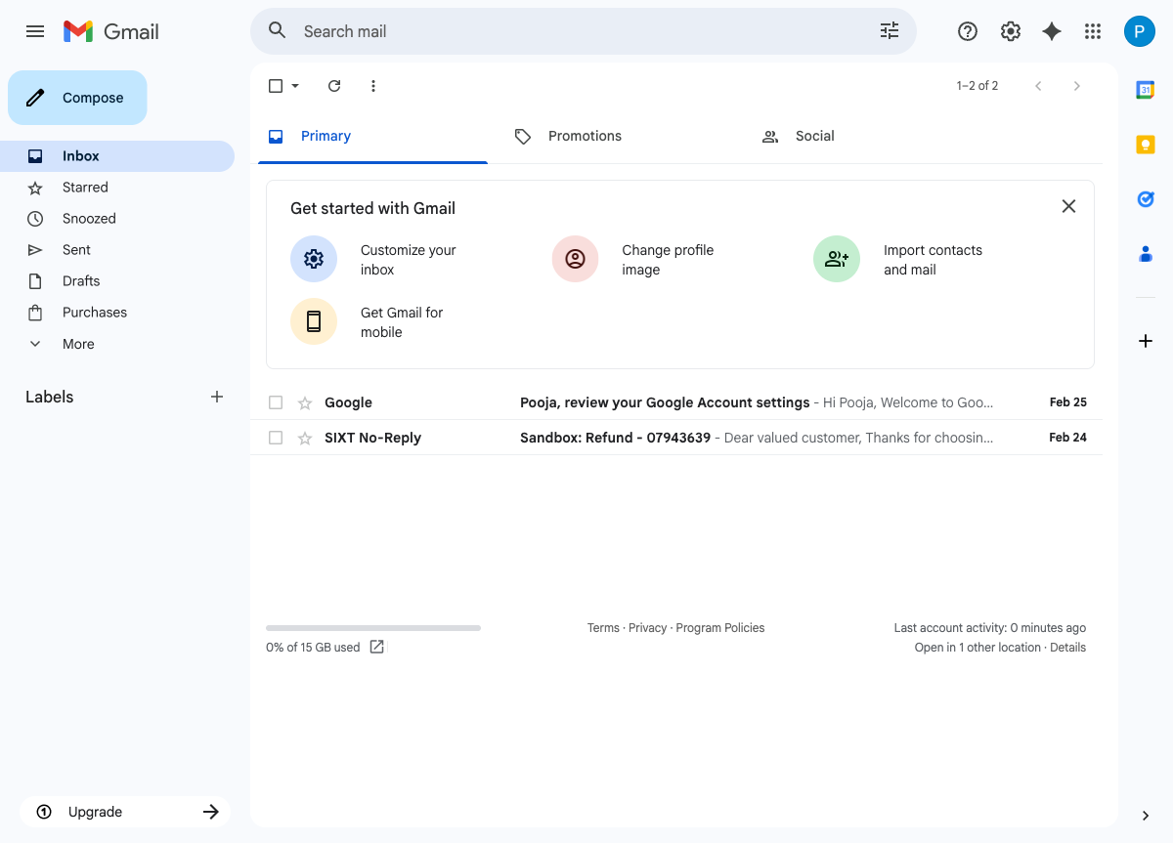

Step 2: Compose Email
Composed new email with:
- To: service.cstdev@sixt.nl
- Subject: Login not working
- Body: Hi, I am unable to login to my account. I have tried resetting my password but the issue persists. Please help. Thank you.
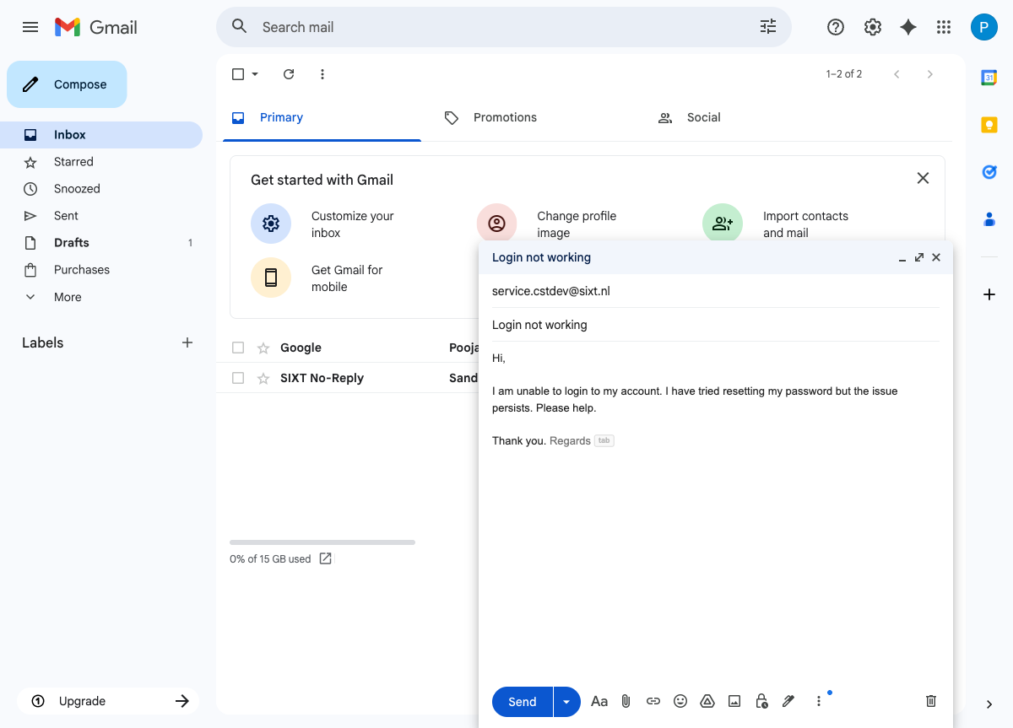

Step 3: Send Email
"Message sent" confirmation displayed at the bottom of the screen.
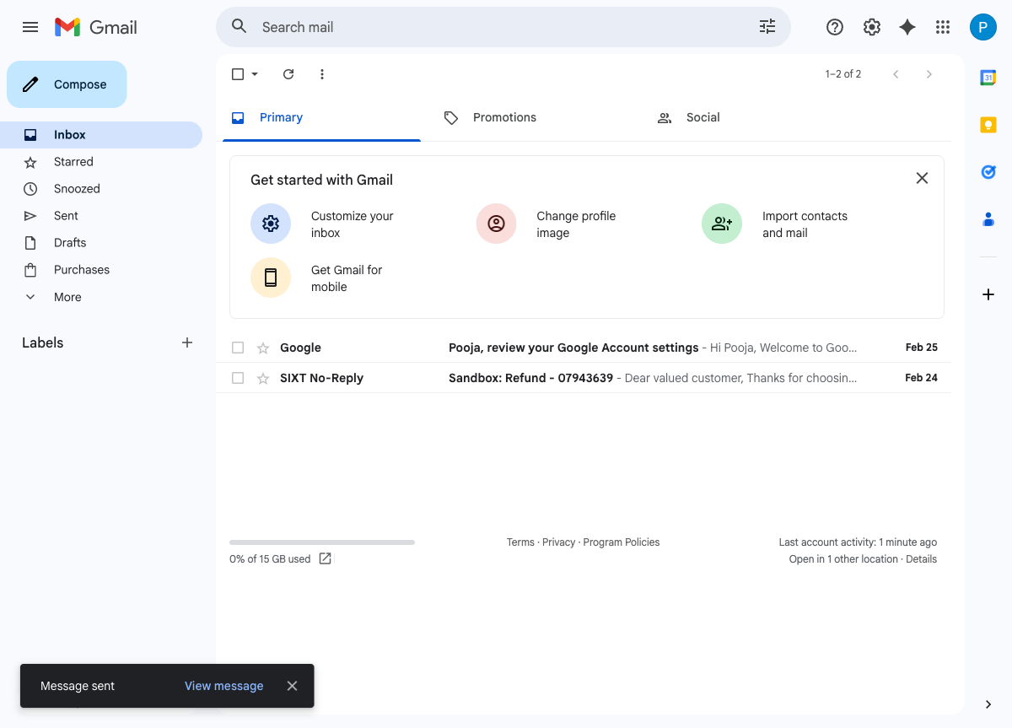

Step 4: Login to Salesforce
Logged into Salesforce sandbox (SprintDev1). Cases list view shows newly created Case 07930582 at the top.
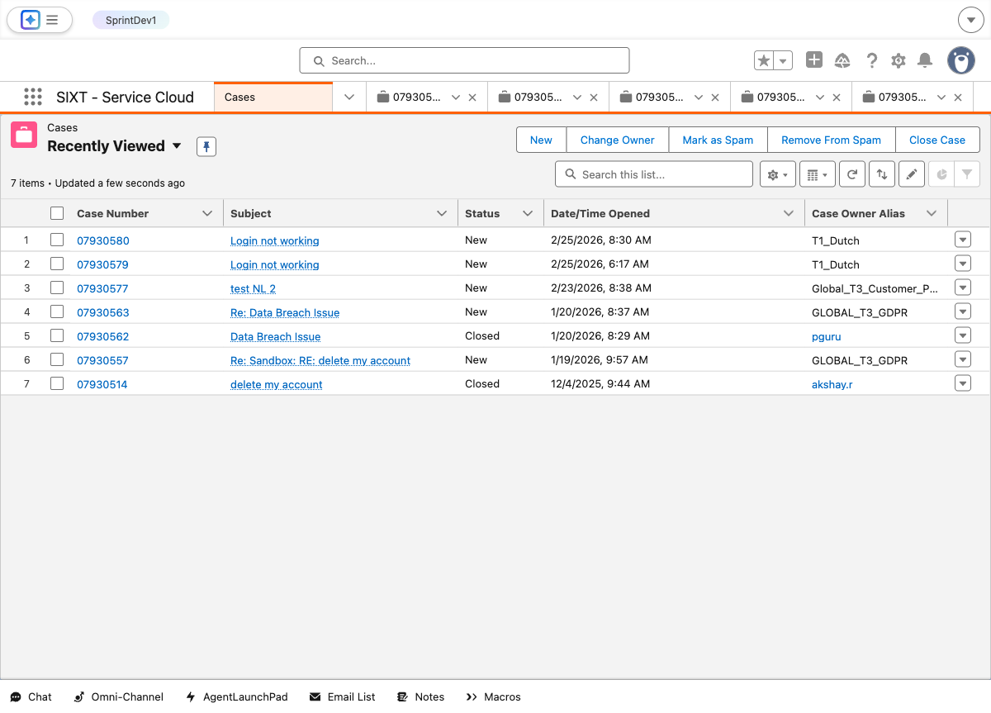

Step 5: Navigate to Case Record Detail Page
Navigated to Case 07930582. Details tab is active showing Case Information fields including Owner (T1_Dutch), Origin (Email), Status (New), Priority (High), Point of Sale (Netherlands).
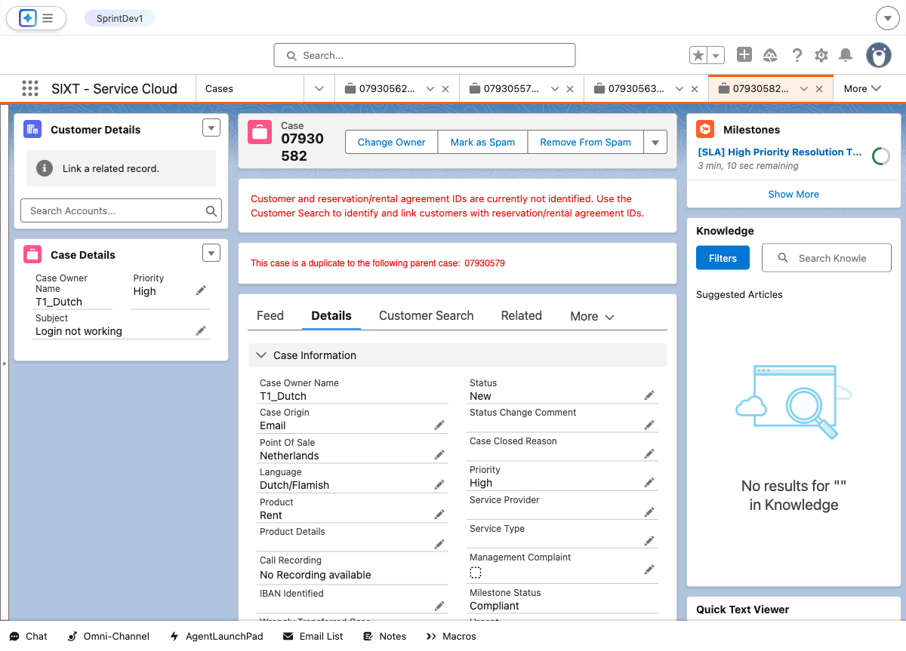

Step 6a: Page Refresh #1
First page refresh completed. All field values remain intact.
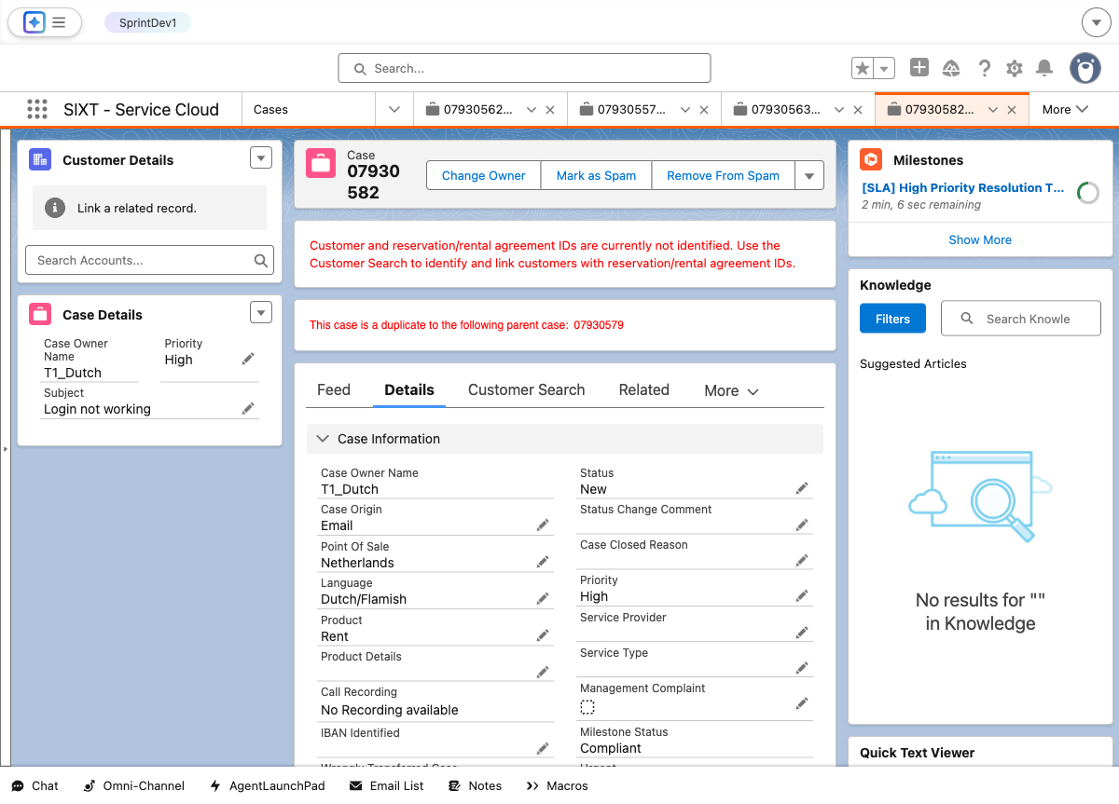

Step 6b: Page Refresh #2
Second page refresh completed. All field values remain intact.
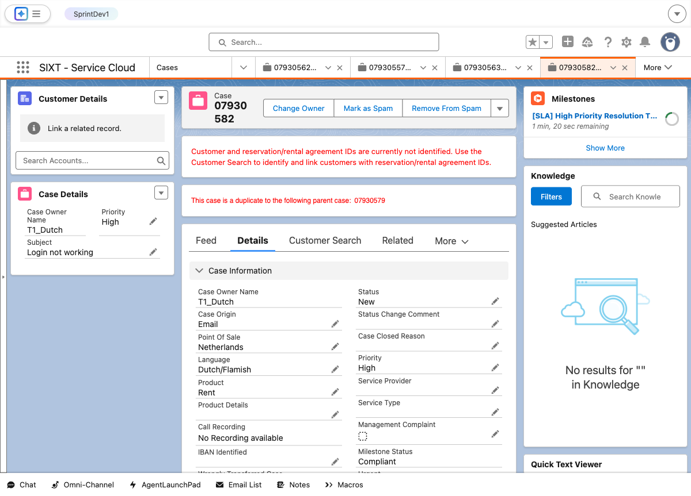

Step 7: Verify All Field Values
Scrolled to view additional sections: Case Classification, Description Information (Subject: "Login not working", Description: email body text), and Country Specifications.
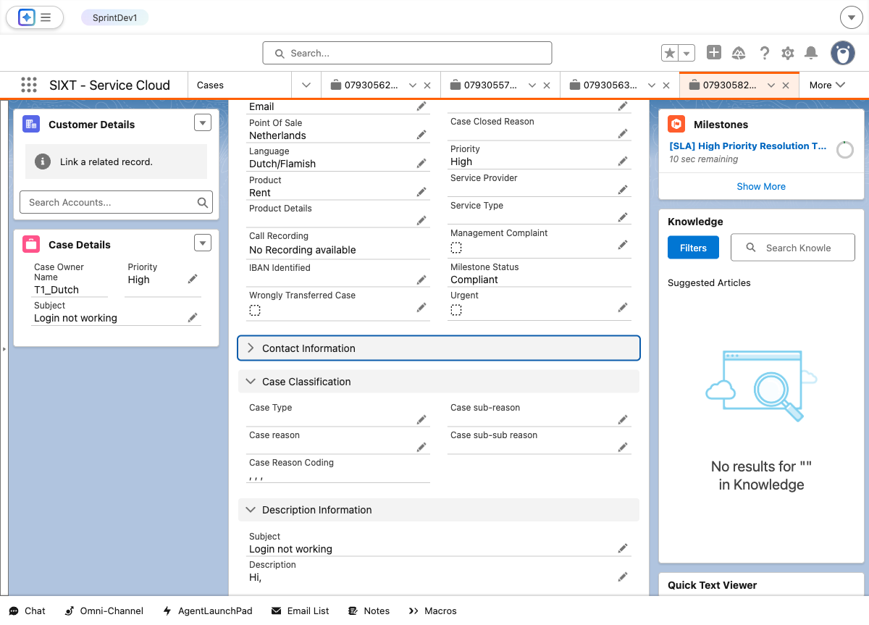

Field Validation Summary
Field | Value | Status
Case Number | 07930582 | PASS
Subject | Login not working | PASS
Status | New | PASS
Case Origin | Email | PASS
Priority | High | PASS
Case Owner Name | T1_Dutch (Queue) | PASS
Record Type | Rent | PASS
Point Of Sale | Netherlands | PASS
Language | Dutch/Flamish | PASS
Product | Rent | PASS
Web Email (SuppliedEmail) | postest96@gmail.com | PASS
Supplied Name | Pooja G | PASS
Description | Hi, I am unable to login to my account... | PASS
Call Recording | No Recording available | PASS
Wrongly Transferred Case | False | PASS
Management Complaint | False | PASS
Urgent | False | PASS
Milestone Status | Compliant | PASS
IsClosed | False | PASS
Duplicate Detected | Parent Case: 07930579 | INFO

Test Summary
Test Result: PASSED
The Email-to-Case functionality is working as expected. An email sent from Gmail (postest96@gmail.com) to service.cstdev@sixt.nl with Subject "Login not working" was successfully routed by Salesforce Email-to-Case and a new Case (07930582) was automatically created with the correct field values. The case was assigned to the T1_Dutch queue with Point of Sale set to Netherlands, Language as Dutch/Flamish, Product as Rent, and Priority as High. All field values were verified and match the expected configuration.

