RSA Queue Routing - Email-to-Case Test Report
QA Sandbox | Test Execution Date: March 2, 2026

Field | Expected | Actual
To Address | service.prestage@sixt.de | service.prestage@sixt.de
Subject | Breakdown | Breakdown
Email Body | Hi, Breakdown.Pls do the needfull. Thank you. | Hi, Breakdown.Pls do the needfull. Thank you.
Case Number | Auto-generated | 07930640
Case Origin | Email | Email
Point Of Sale | - | Germany
Case Owner Name | DACH_RSA_After_Claims | DACH_RSA_During_Support

Note: The Case Owner Name is "DACH_RSA_During_Support" instead of the expected "DACH_RSA_After_Claims". The case was auto-classified as "4 During Rental > 4.5 Roadside > 4.5.3 Mechanical Breakdown" which routes to the DACH_RSA_During_Support queue. The routing to DACH_RSA_After_Claims may require a different case classification or Point of Sale configuration.

Step 1: Login to Gmail
Gmail inbox logged in as postest96@gmail.com.
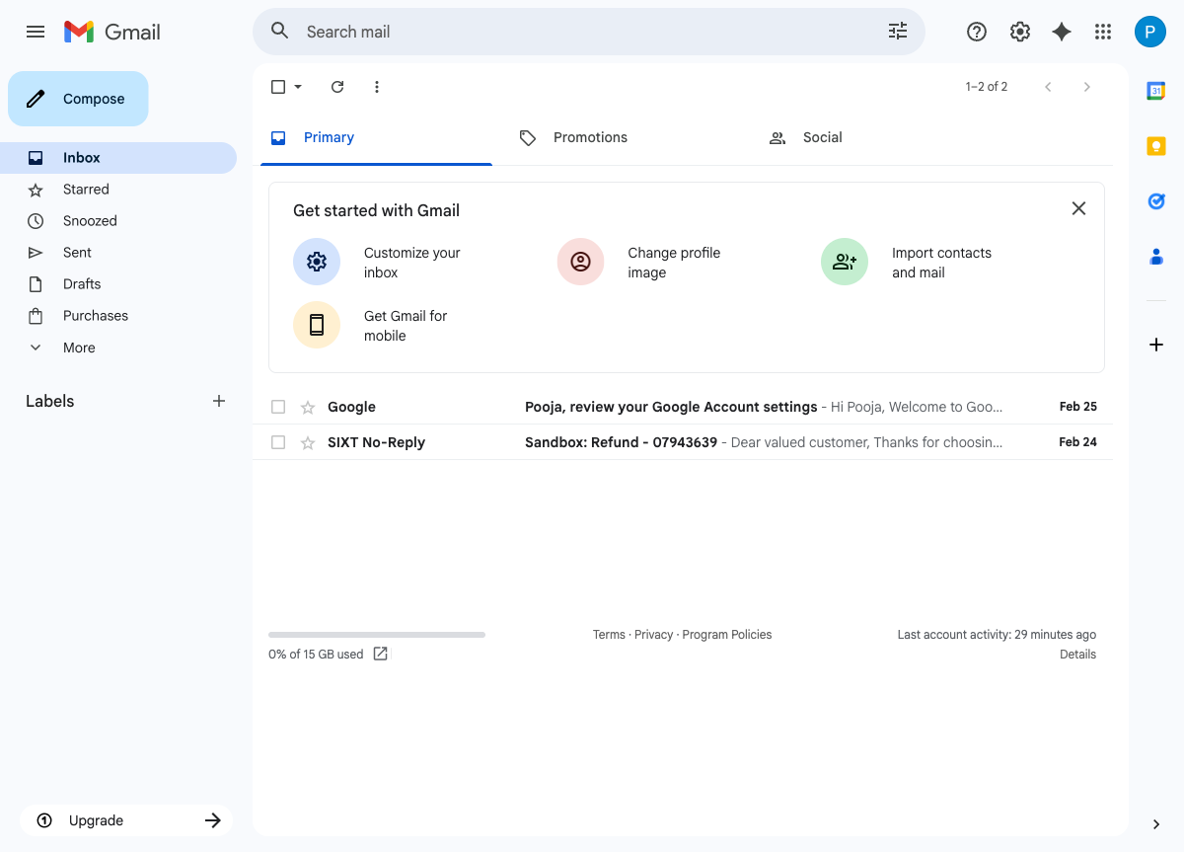

Step 2: Compose Email
Email composed with To: service.prestage@sixt.de, Subject: Breakdown, and email body.
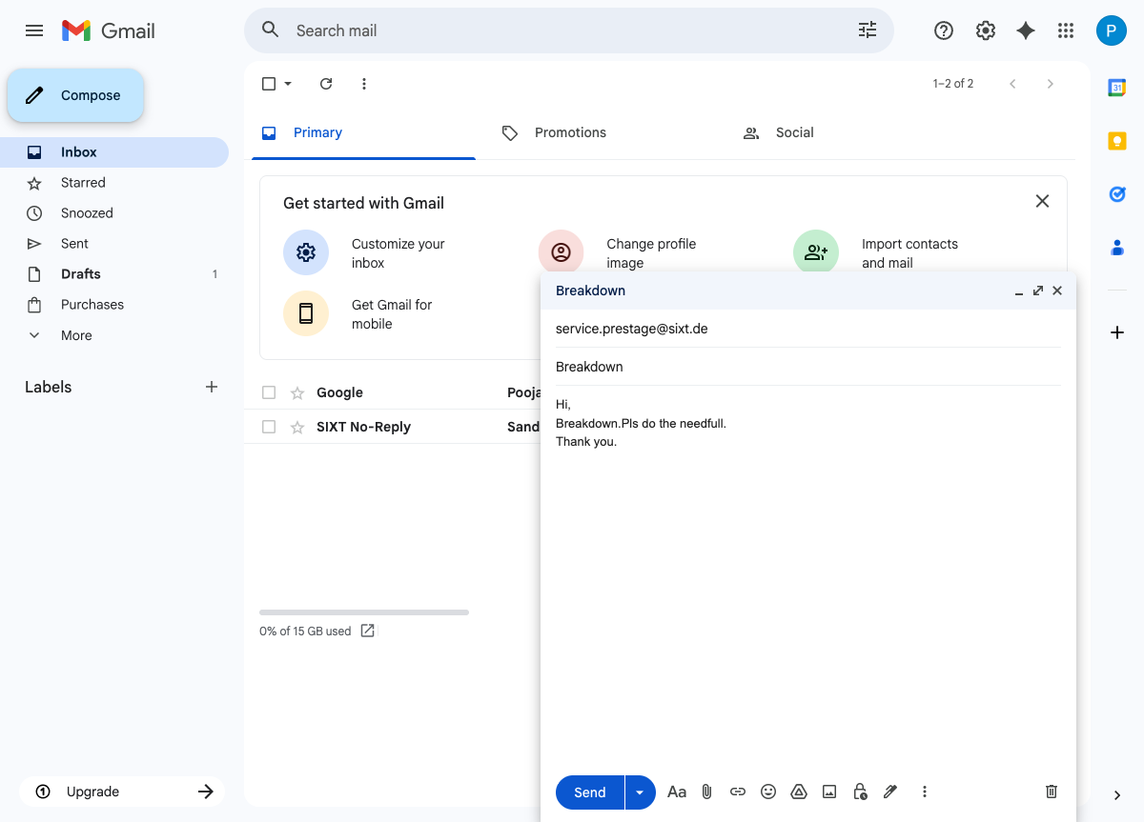

Step 3: Send Email
"Message sent" confirmation displayed in Gmail.
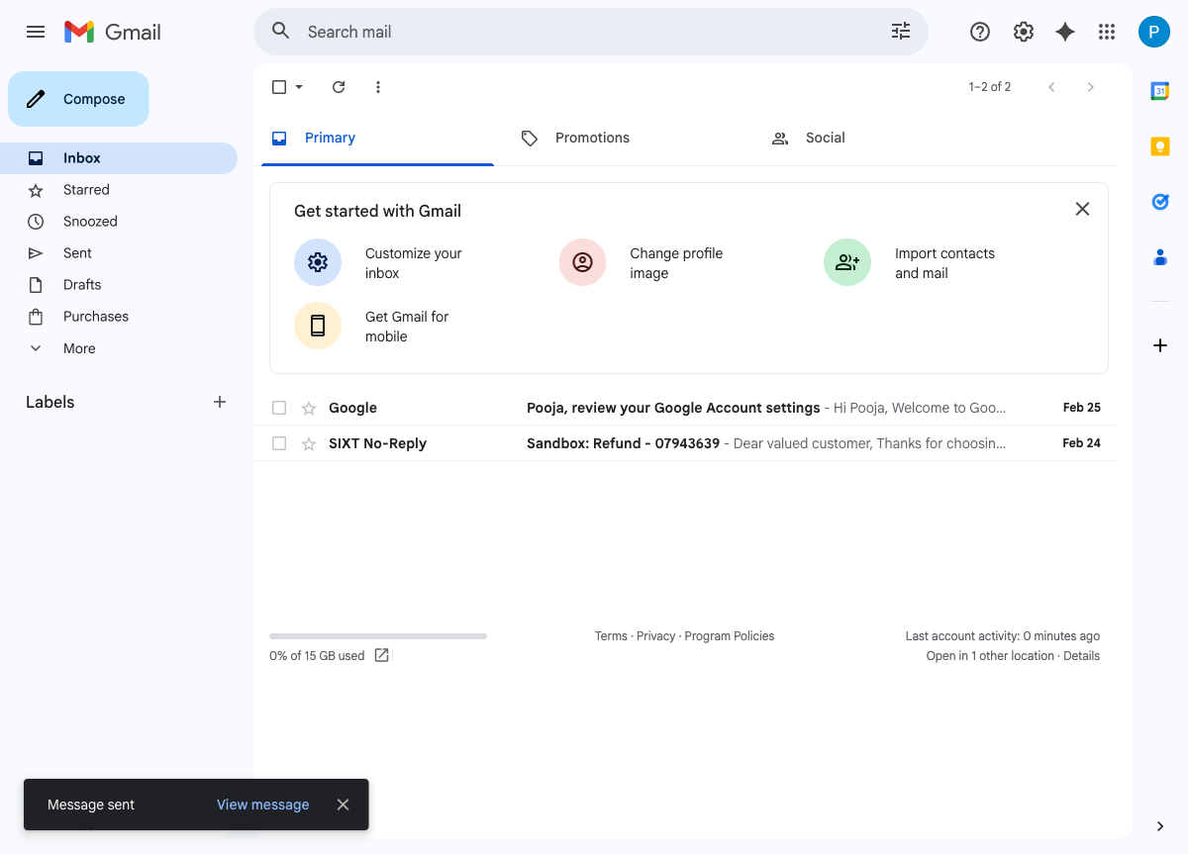

Step 4: Login to Salesforce QA Sandbox
Salesforce QA sandbox logged in showing the SIXT - Service Cloud app.
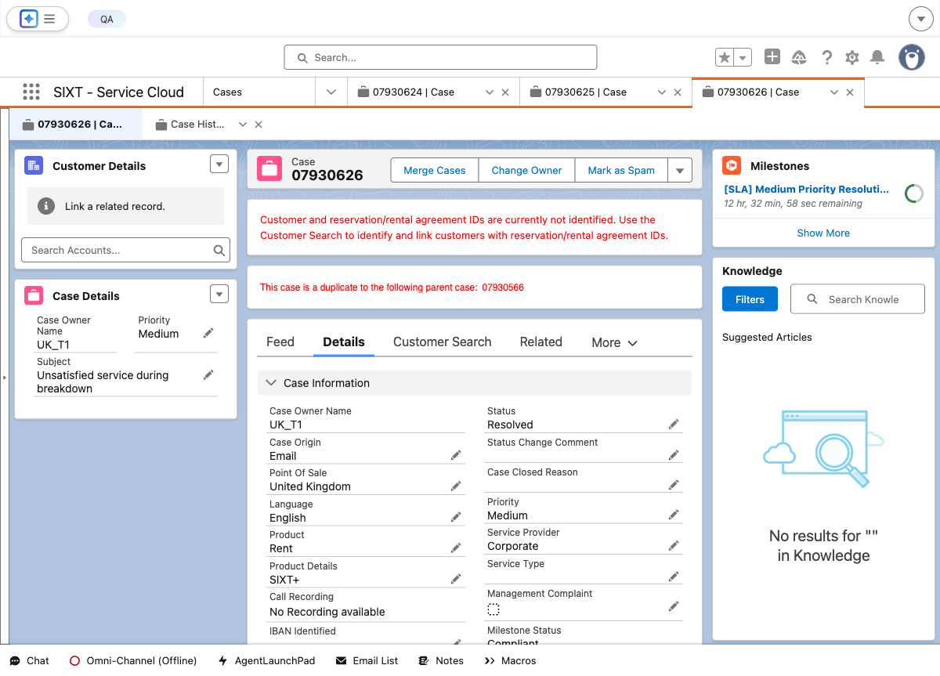

Step 5: Navigate to Case Record
Case 07930640 detail page showing all field values including Case Owner Name: DACH_RSA_During_Support.
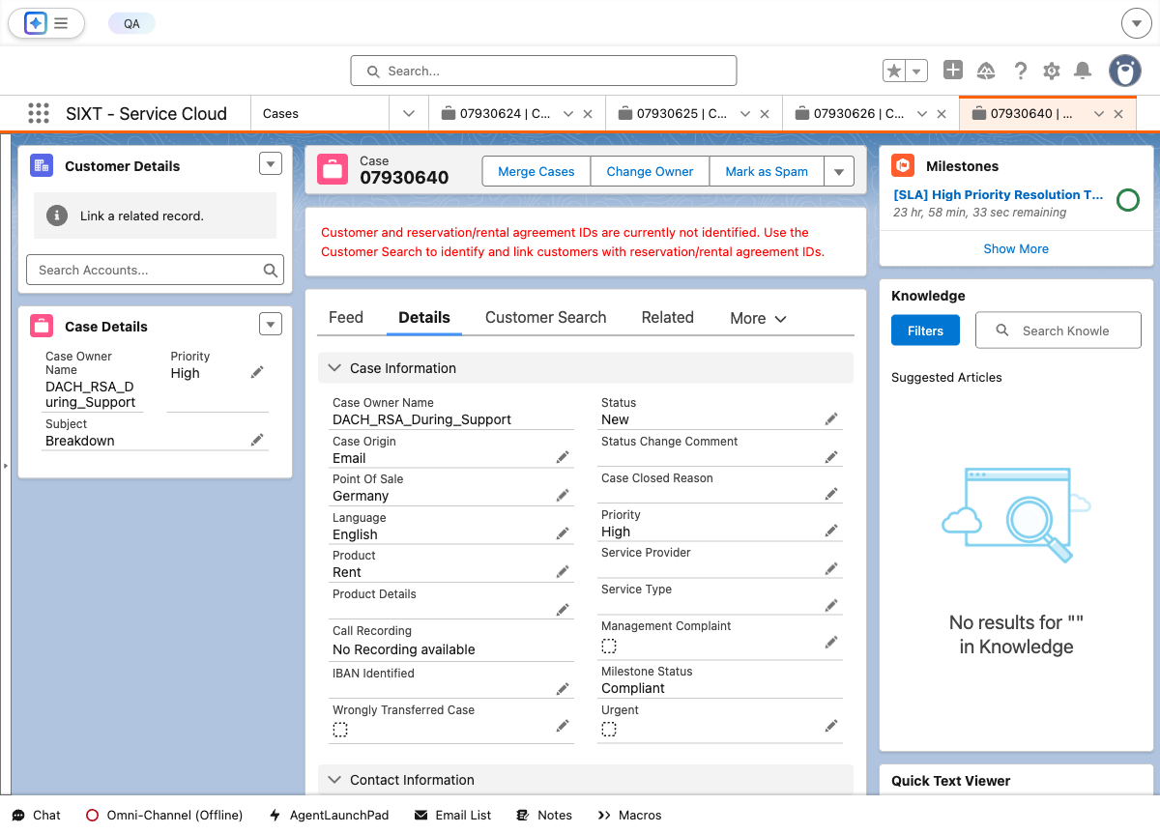

Step 6: Refresh Page 2 Times
Case detail page after 2 refreshes showing Contact Information, Case Classification, and Description.
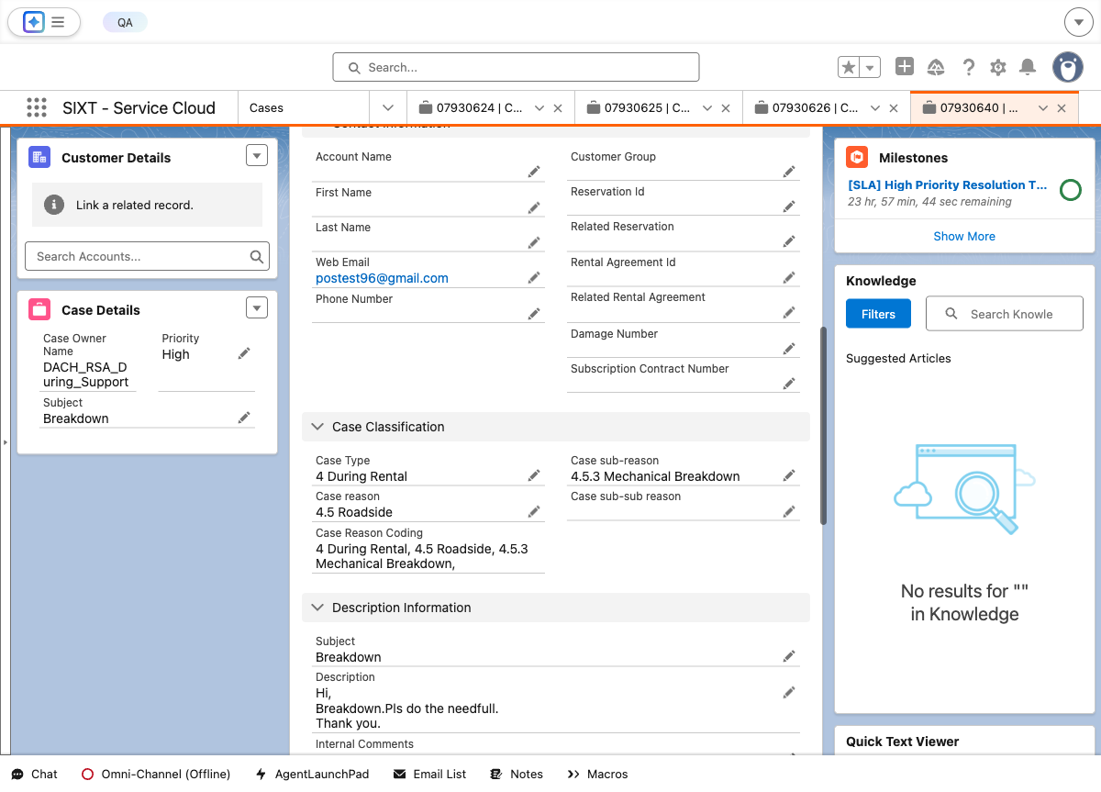

Step 7: Verify Case Owner Name
Case Owner Name field verification - Current value: DACH_RSA_During_Support.
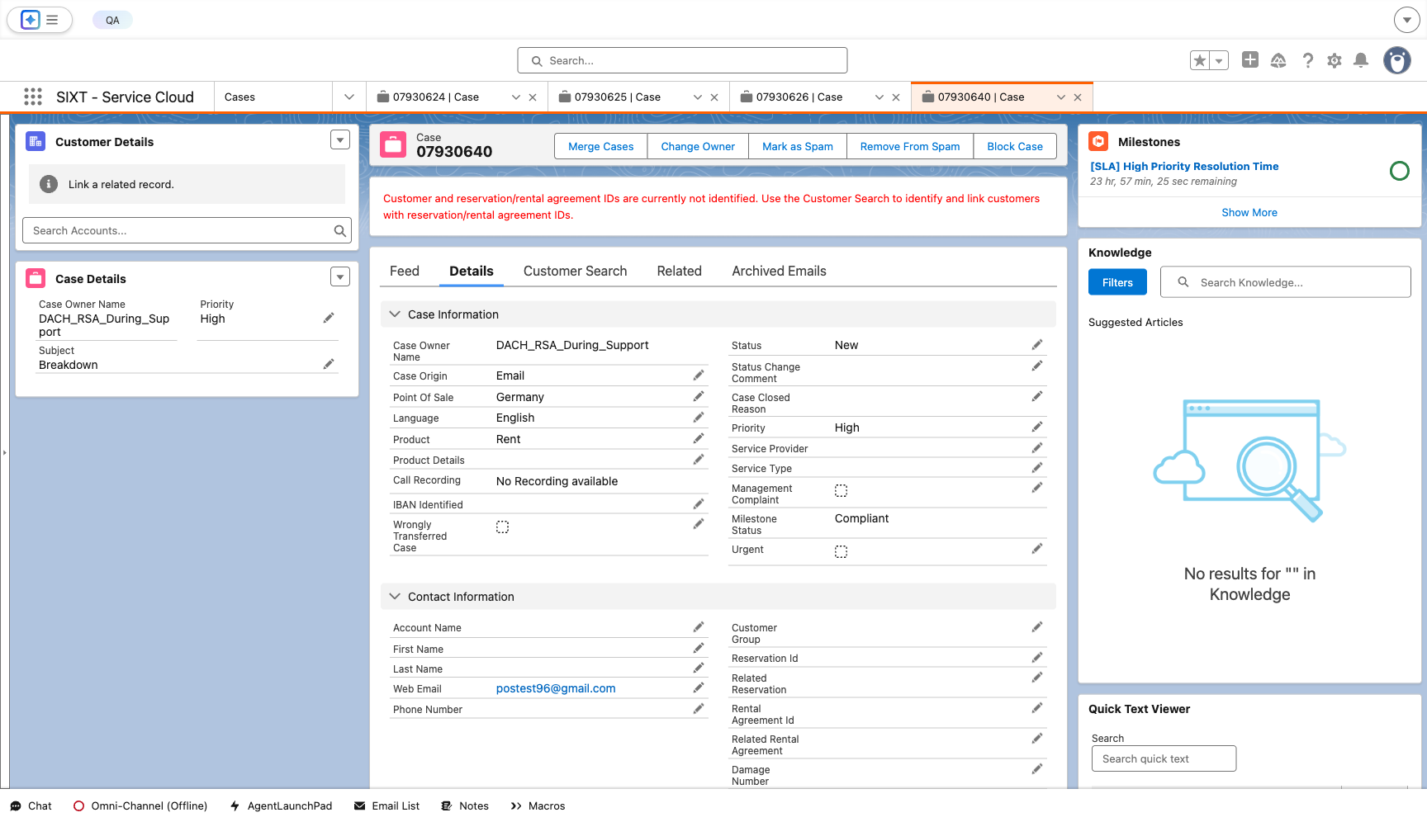

Test Execution Summary
Step | Description | Status
1 | Login to Gmail | PASS
2 | Compose email to service.prestage@sixt.de | PASS
3 | Send the email | PASS
4 | Login to Salesforce QA Sandbox | PASS
5 | Navigate to Case Record detail page | PASS
6 | Refresh the page 2 times | PASS
7 | Verify Case Owner = DACH_RSA_After_Claims | OBSERVATION
8 | Screenshots in Word document | PASS

