Unsatisfied Service During Breakdown - Email-to-Case Test Report
QA Sandbox | Test Execution Date: March 2, 2026

Field | Expected | Actual
To Address | service.prestage@sixt.de | service.prestage@sixt.de
Subject | Unsatisfied service during breakdown | Unsatisfied service during breakdown
Email Body | Hi, Unsatisfied service during breakdown. Thank you. | Hi, Unsatisfied service during breakdown. Thank you.
Case Number | Auto-generated | 07930641
Case Origin | Email | Email
Point Of Sale | - | Germany
Case Owner Name | DACH_RSA_After_Claims | DACH_RSA_After_Claims

Result: The Case Owner Name is "DACH_RSA_After_Claims" which matches the expected value. The email with subject "Unsatisfied service during breakdown" was correctly routed to the DACH_RSA_After_Claims queue via Email-to-Case in the QA Sandbox.

Step 1: Login to Gmail
Gmail inbox logged in as postest96@gmail.com.
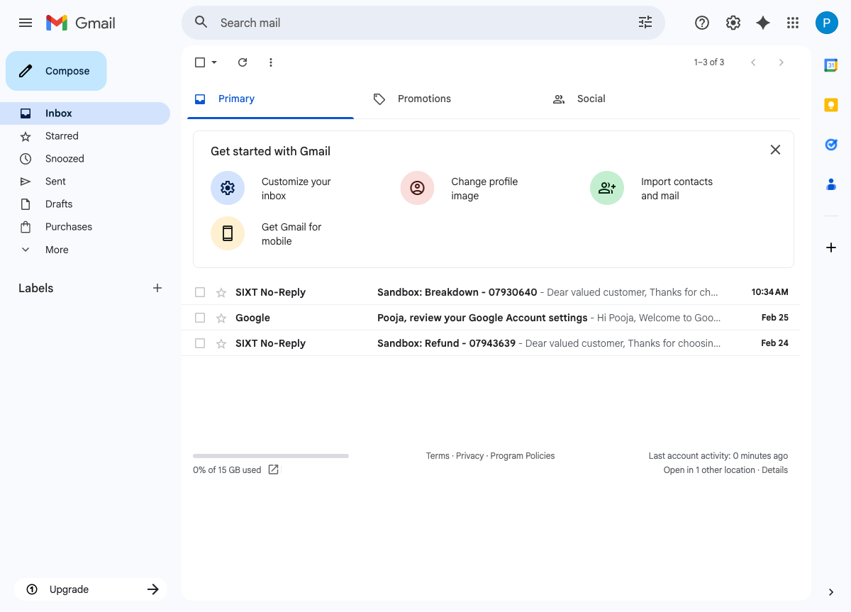

Step 2: Compose Email
Email composed with To: service.prestage@sixt.de, Subject: Unsatisfied service during breakdown, and email body.
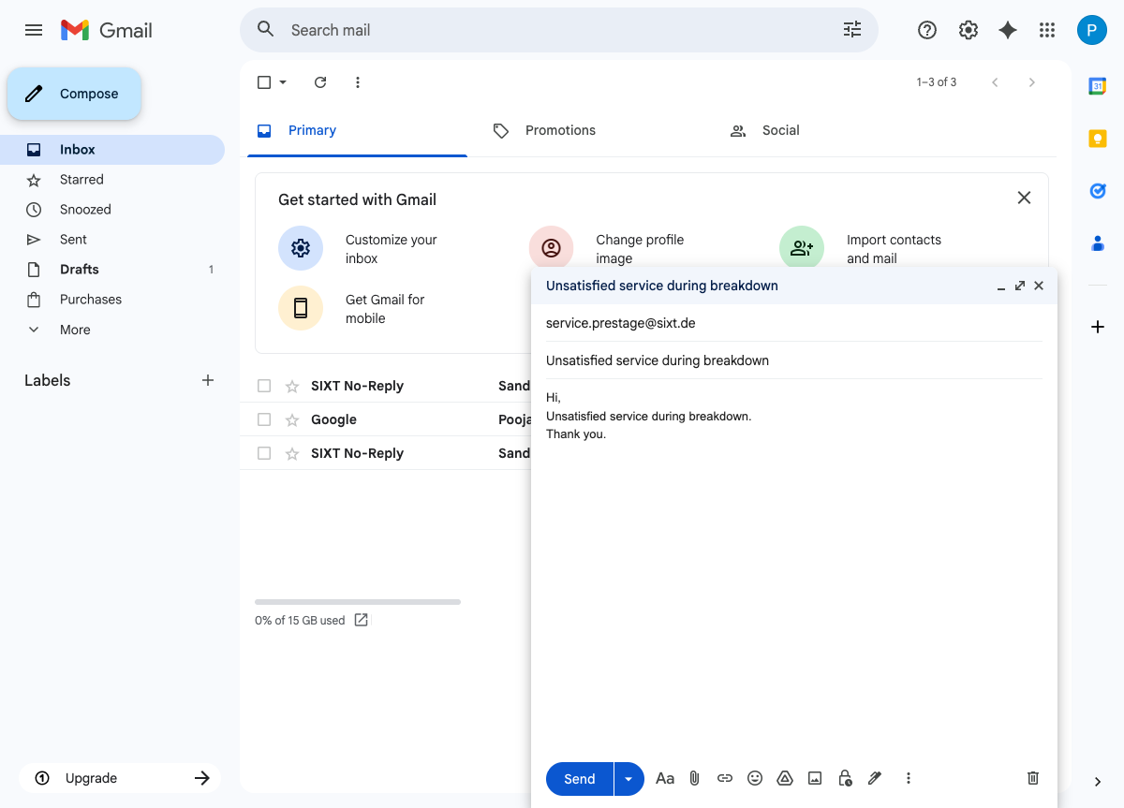

Step 3: Send Email
"Message sent" confirmation displayed in Gmail.
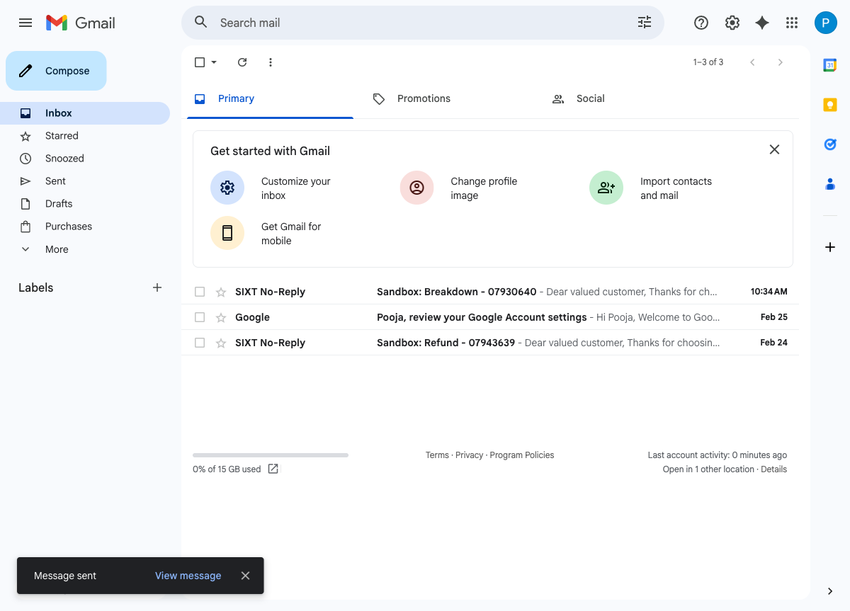

Step 4: Login to Salesforce QA Sandbox
Salesforce QA sandbox logged in showing the SIXT - Service Cloud app.
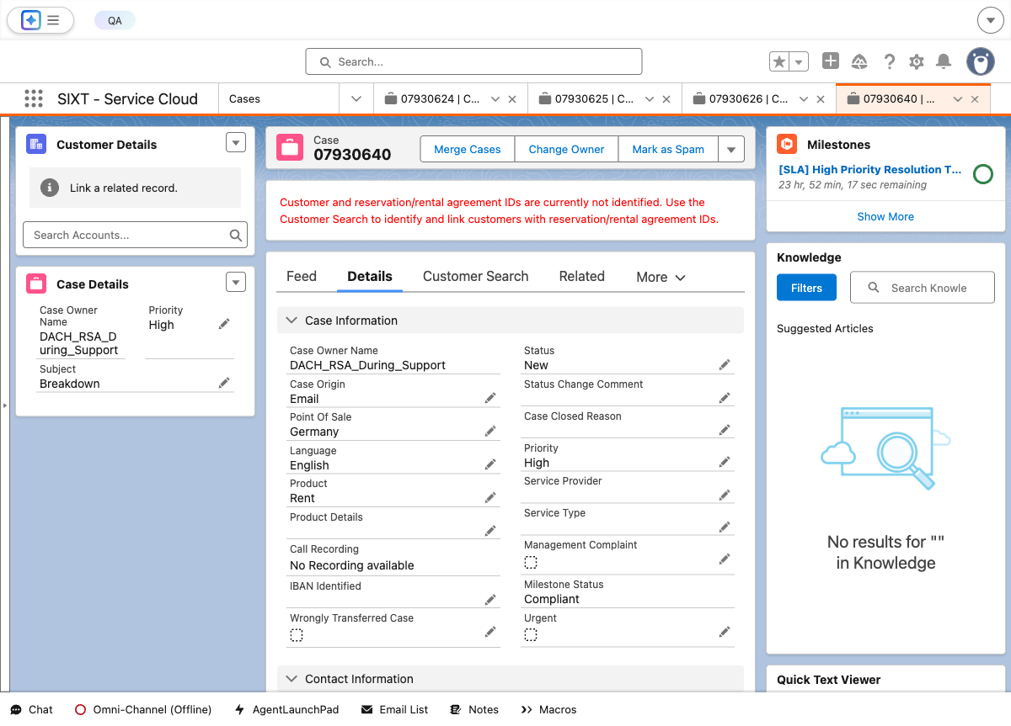

Step 5: Navigate to Case Record
Case 07930641 detail page showing Case Owner Name: DACH_RSA_After_Claims.
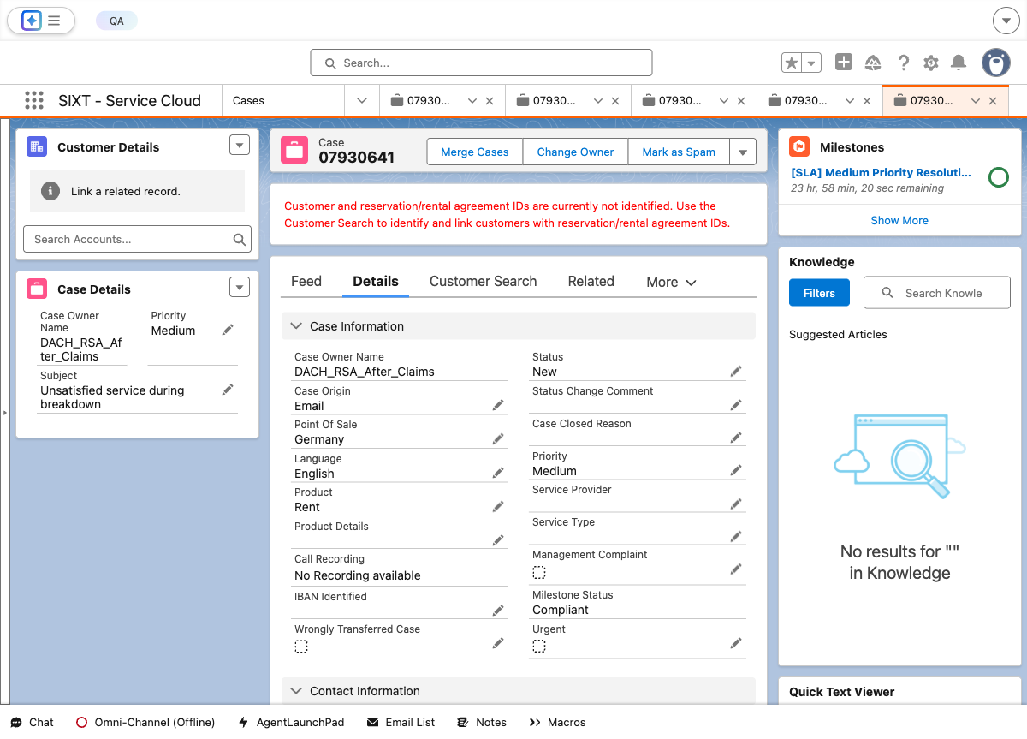

Step 6: Refresh Page 2 Times
Case detail page after 2 refreshes confirming Case Owner Name: DACH_RSA_After_Claims.
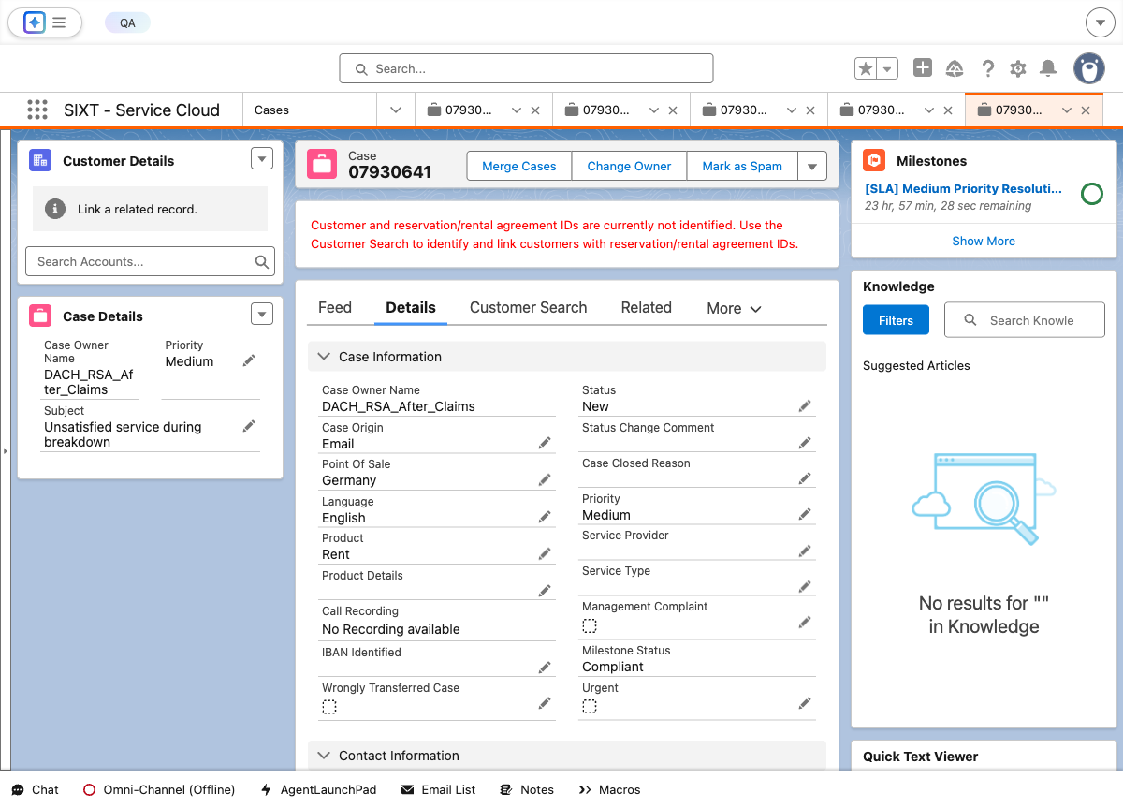

Step 7: Verify Case Owner Name
Case Owner Name field verified as DACH_RSA_After_Claims - PASS.
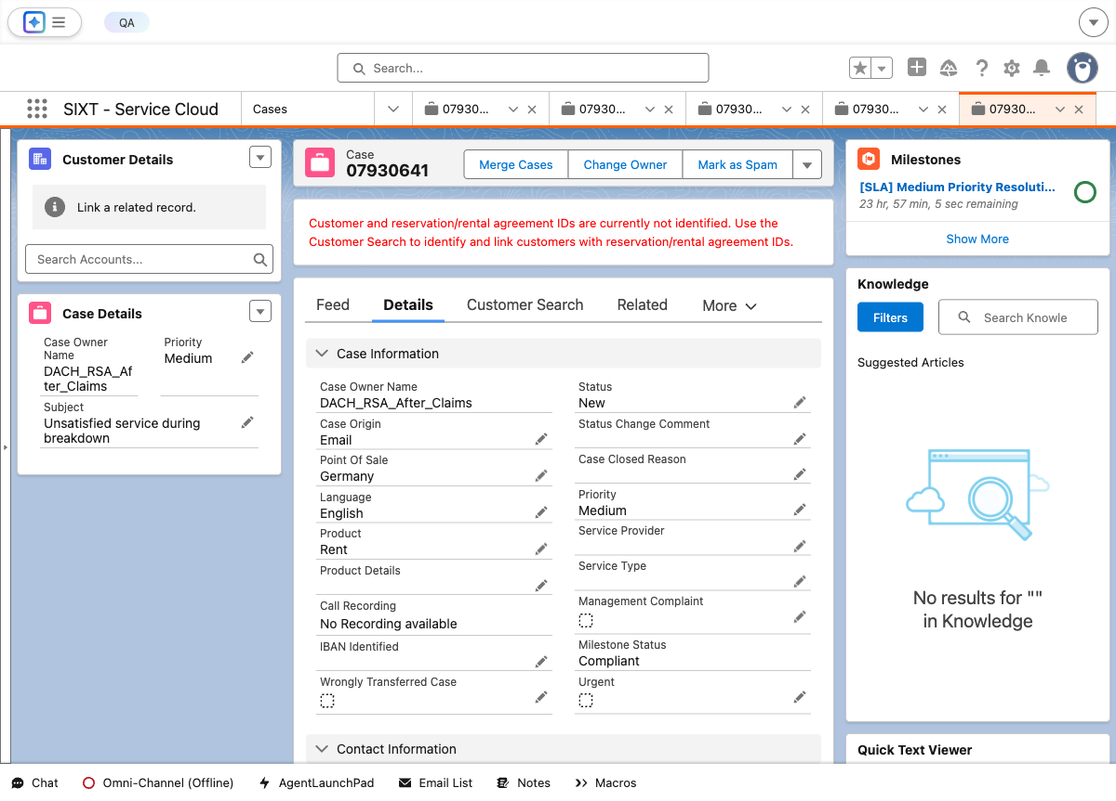

Test Execution Summary
Step | Description | Status
1 | Login to Gmail | PASS
2 | Compose email to service.prestage@sixt.de | PASS
3 | Send the email | PASS
4 | Login to Salesforce QA Sandbox | PASS
5 | Navigate to Case Record detail page | PASS
6 | Refresh the page 2 times | PASS
7 | Verify Case Owner = DACH_RSA_After_Claims | PASS
8 | Screenshots in Word document | PASS

