SCI-3857 (Scenario 5) Test Execution Report

BNL_RSA_During_Support - Email-to-Case Routing & Priority Verification

Case Number | 15557612
Subject | Met with an accident
Email To | service.qafull@sixt.nl
Expected Owner | BNL_RSA_During_Support
Actual Owner | BNL_RSA_During_Support
Point of Sale | Netherlands
Omni-Channel | Yes (Skills-Based)
Execution Date | April 10, 2026

Email Composed
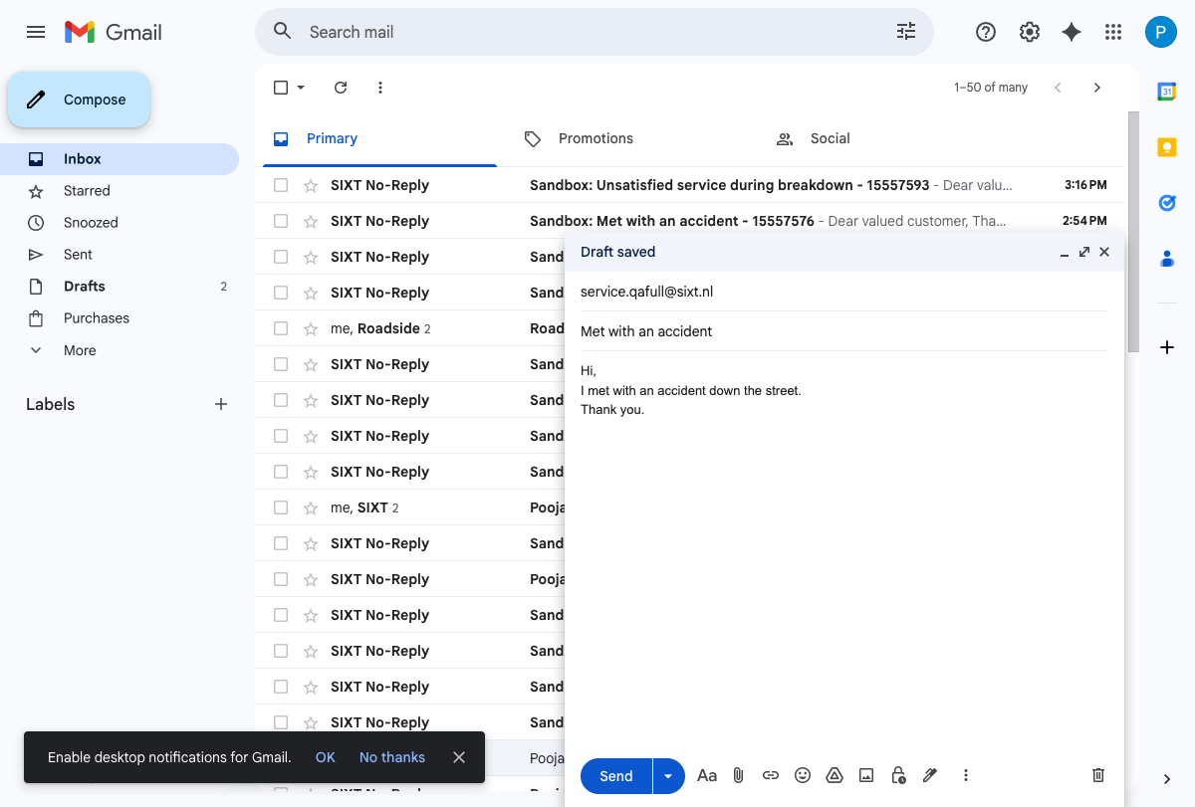

Email Sent
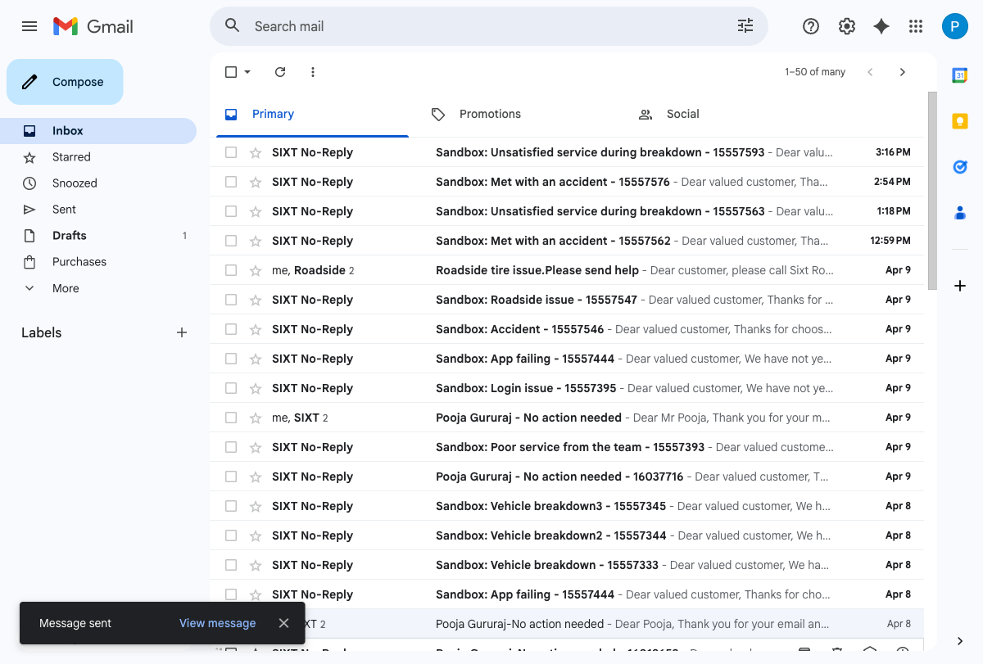

Case Record - Owner Verification
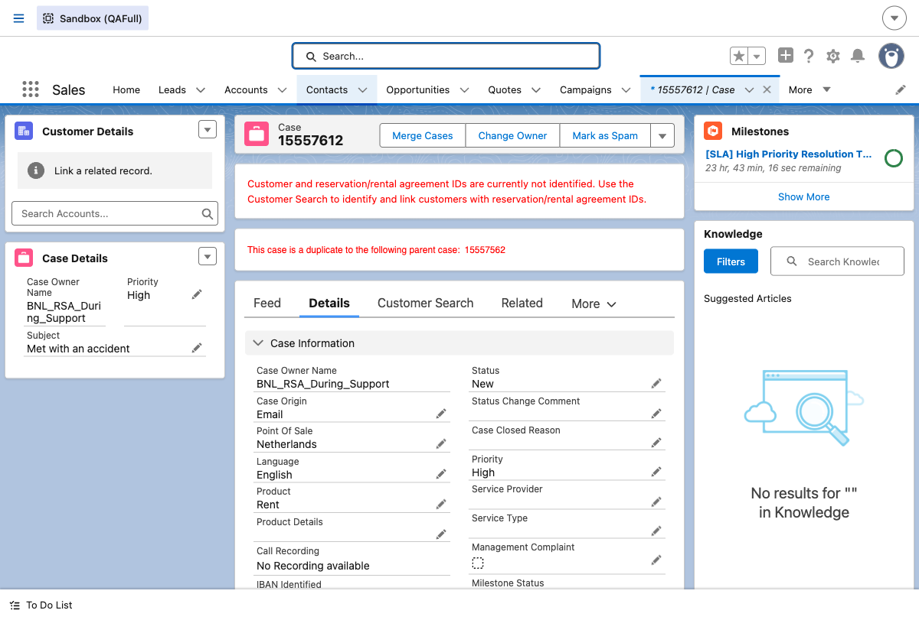

Priority Verification Results
Case Priority | Expected PSR Priority | Actual PSR Priority
High | 71 | 71
Medium | 75 | 75
Low | 77 | 77

Summary - Pass/Fail Table
Test Step | Expected Result | Status
Email-to-Case Creation | Case created for service.qafull@sixt.nl | PASS
Owner = BNL_RSA_During_Support | Case routed to BNL_RSA_During_Support | PASS
PSR Priority (High=71) | Routing priority = 71 for High | PASS
PSR Priority (Medium=75) | Routing priority = 75 for Medium | PASS
PSR Priority (Low=77) | Routing priority = 77 for Low | PASS
Priority Update (Medium) | Case priority set to Medium | PASS
Priority Update (Low) | Case priority set to Low | PASS
Priority Update (High) | Case priority set to High | PASS

