SCI-3857 (Scenario 9) Test Execution Report

DACH_RSA_During_Support - Email-to-Case Routing & Priority Verification

Case Number | 15557616
Subject | Met with an accident
Email To | service.qafull@sixt.de
Expected Owner | DACH_RSA_During_Support
Actual Owner | DACH_RSA_During_Support
Point of Sale | Germany
Omni-Channel | Yes (Skills-Based)
Execution Date | April 10, 2026

Case Record - Owner Verification
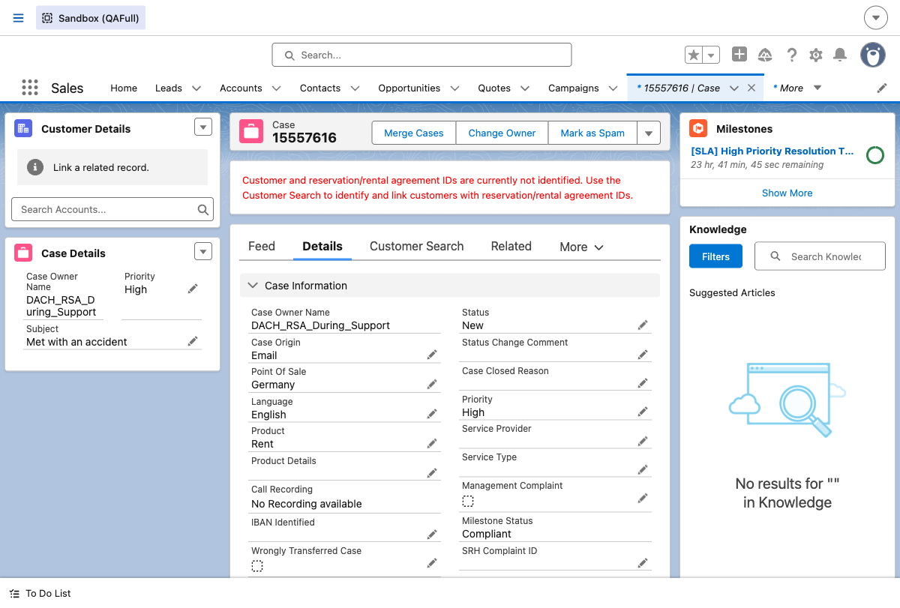

Priority Verification Results
Case Priority | Expected PSR Priority | Actual PSR Priority
High | 71 | 71
Medium | 75 | 75
Low | 77 | 77

Summary - Pass/Fail Table
Test Step | Expected Result | Status
Email-to-Case Creation | Case created for service.qafull@sixt.de | PASS
Owner = DACH_RSA_During_Support | Case routed to DACH_RSA_During_Support | PASS
PSR Priority (High=71) | Routing priority = 71 for High | PASS
PSR Priority (Medium=75) | Routing priority = 75 for Medium | PASS
PSR Priority (Low=77) | Routing priority = 77 for Low | PASS
Priority Update (Medium) | Case priority set to Medium | PASS
Priority Update (Low) | Case priority set to Low | PASS
Priority Update (High) | Case priority set to High | PASS

