SCI-3857 (Scenario 4) Test Execution Report

FR_RSA_After_Claims - Email-to-Case Routing & Priority Verification

Case Number | 15557593
Subject | Unsatisfied service during breakdown
Email To | service.qafull@sixt.it
Expected Owner | FR_RSA_After_Claims (per script)
Actual Owner | IT_RSA_After_Claims
Classification | 2.1 Vehicle / 2.1.6 Breakdown / 2.1.6.1 Unsatisfied service during breakdown
Execution Date | April 10, 2026

Step 2: Email Composed
Email composed in Gmail to service.qafull@sixt.it with subject "Unsatisfied service during breakdown" and body text "Hi, Unsatisfied service during breakdown. Thank you."
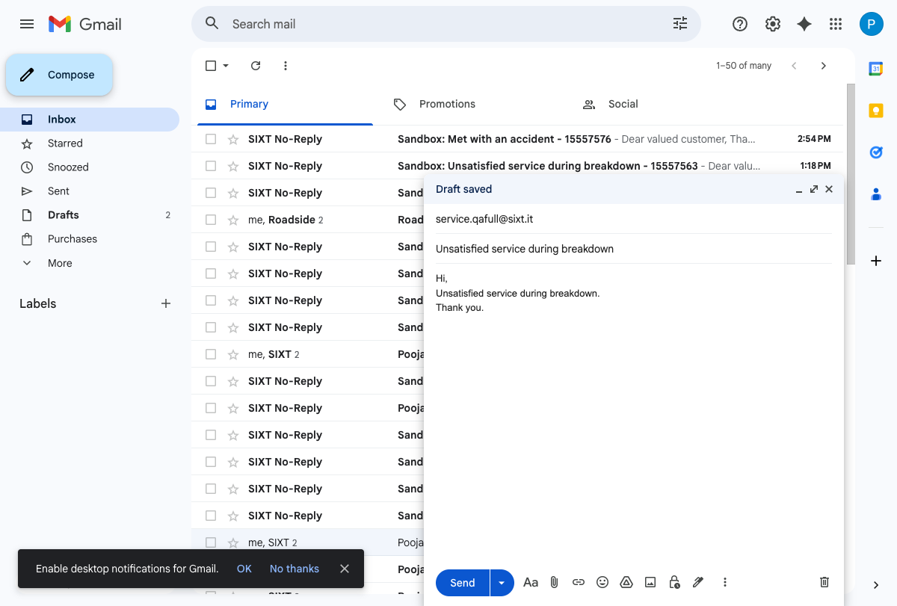

Step 2: Email Sent
Email successfully sent. "Message sent" confirmation visible at bottom.
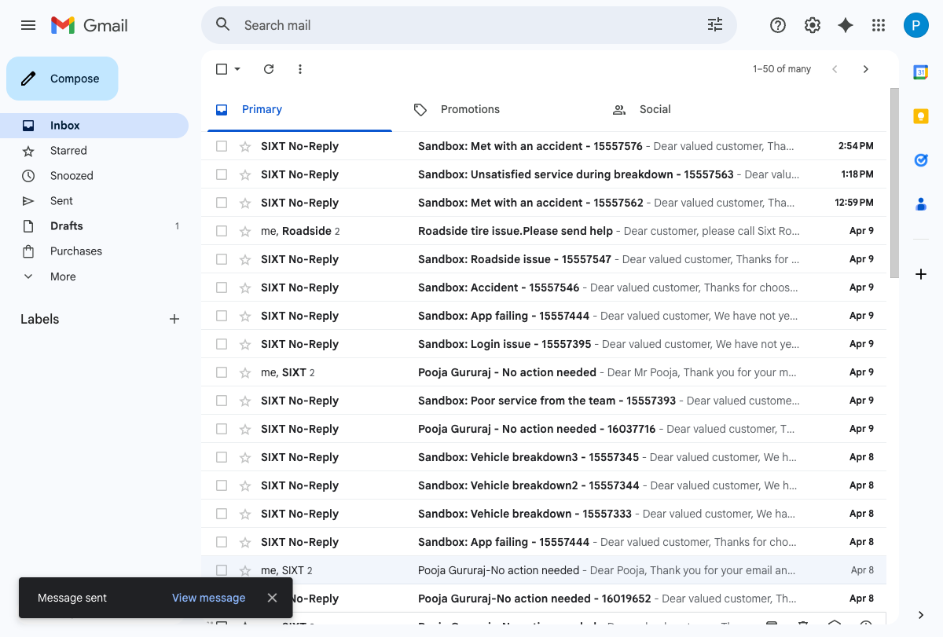

Step 4: Case Record - Owner Verification
Case 15557593 created via email-to-case.
- Case Owner Name: IT_RSA_After_Claims
- Expected Owner: FR_RSA_After_Claims (per test script)
- FINDING: Email sent to service.qafull@sixt.it routes to IT_RSA_After_Claims (Italian queue), not FR_RSA_After_Claims. The test script appears to have a typo in the expected owner.
- Priority: Medium
- POS: Italy
- Language: English
- Case Classification: 2.1 Vehicle / 2.1.6 Breakdown / 2.1.6.1 Unsatisfied service during breakdown
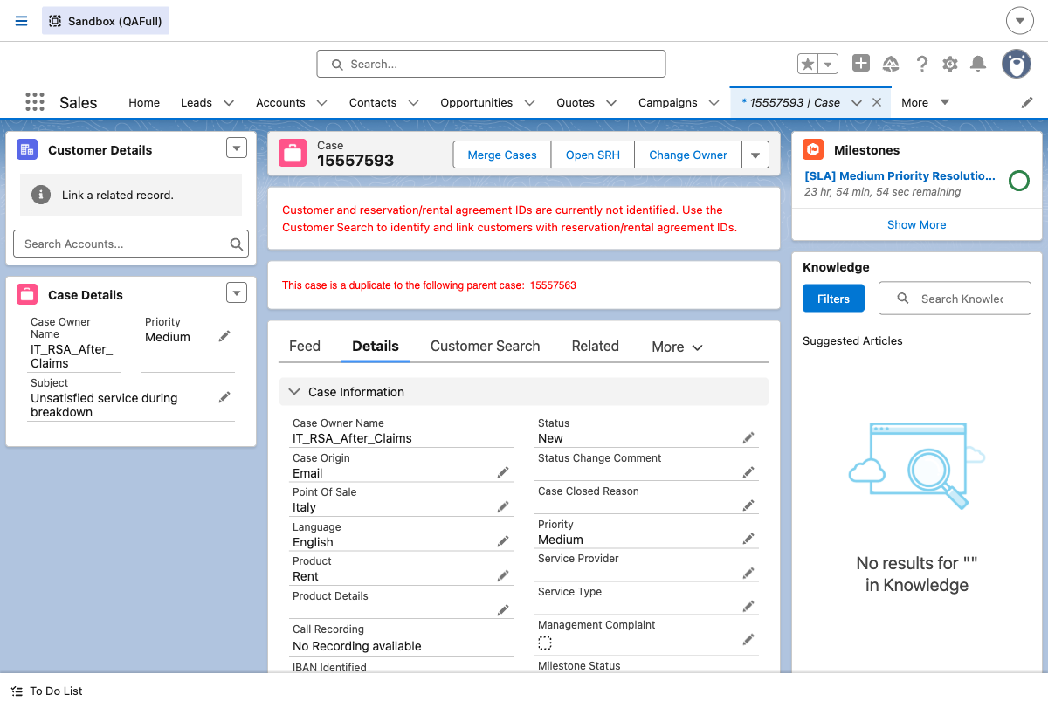

Step 8: Skills Backlog - Case Not Found
Navigated to Command Center for Service > Skills Backlog.
Case 15557593 is NOT present in the Skills Backlog.
No PendingServiceRouting record exists for this case (verified via SFDX query).
FINDING: IT_RSA_After_Claims queue does NOT use Omni-Channel skill-based routing.
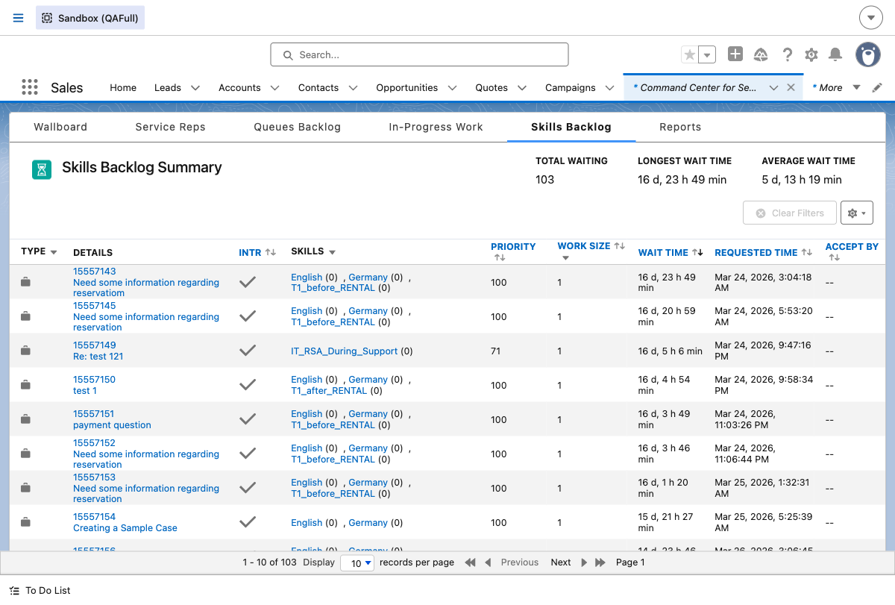

Queues Backlog - Queue Not Found
Navigated to Queues Backlog tab.
IT_RSA_After_Claims is NOT listed in the Queues Backlog.
FINDING: IT_RSA_After_Claims queue does NOT use Omni-Channel queue-based routing either.
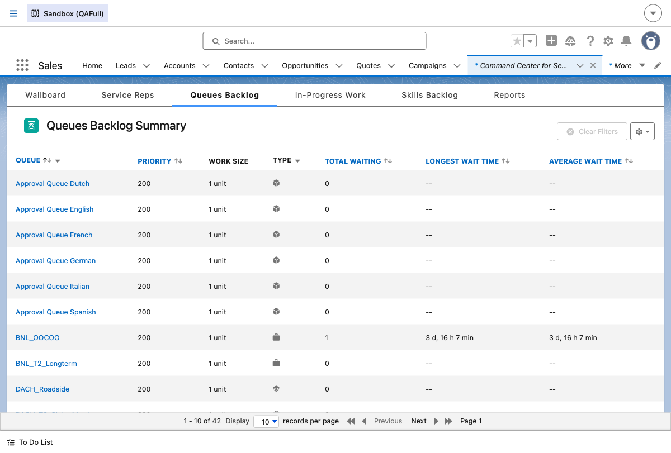

Step 9: Case Record - Low Priority
Case priority updated to Low via SFDX CLI.
Case 15557593 shows:
- Case Owner Name: IT_RSA_After_Claims
- Priority: Low
- Milestone: [SLA] Low Priority Resolution Time
Since this queue does not use Omni-Channel, priority verification in Skills Backlog is N/A.
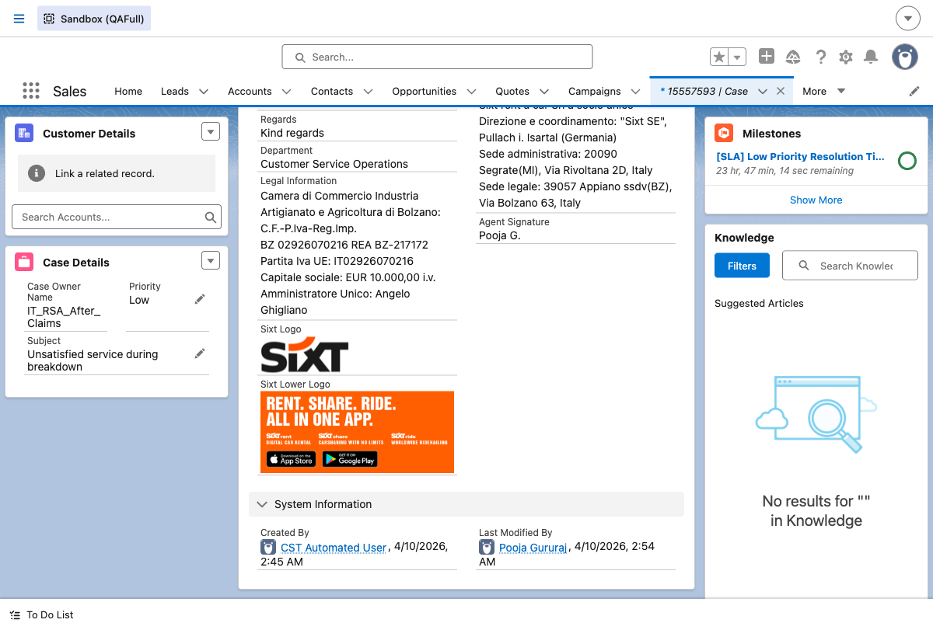

Step 12: Case Record - High Priority
Case priority updated to High via SFDX CLI.
Case 15557593 shows:
- Case Owner Name: IT_RSA_After_Claims
- Priority: High
- Milestone: [SLA] High Priority Resolution Time
Since this queue does not use Omni-Channel, priority verification in Skills Backlog is N/A.
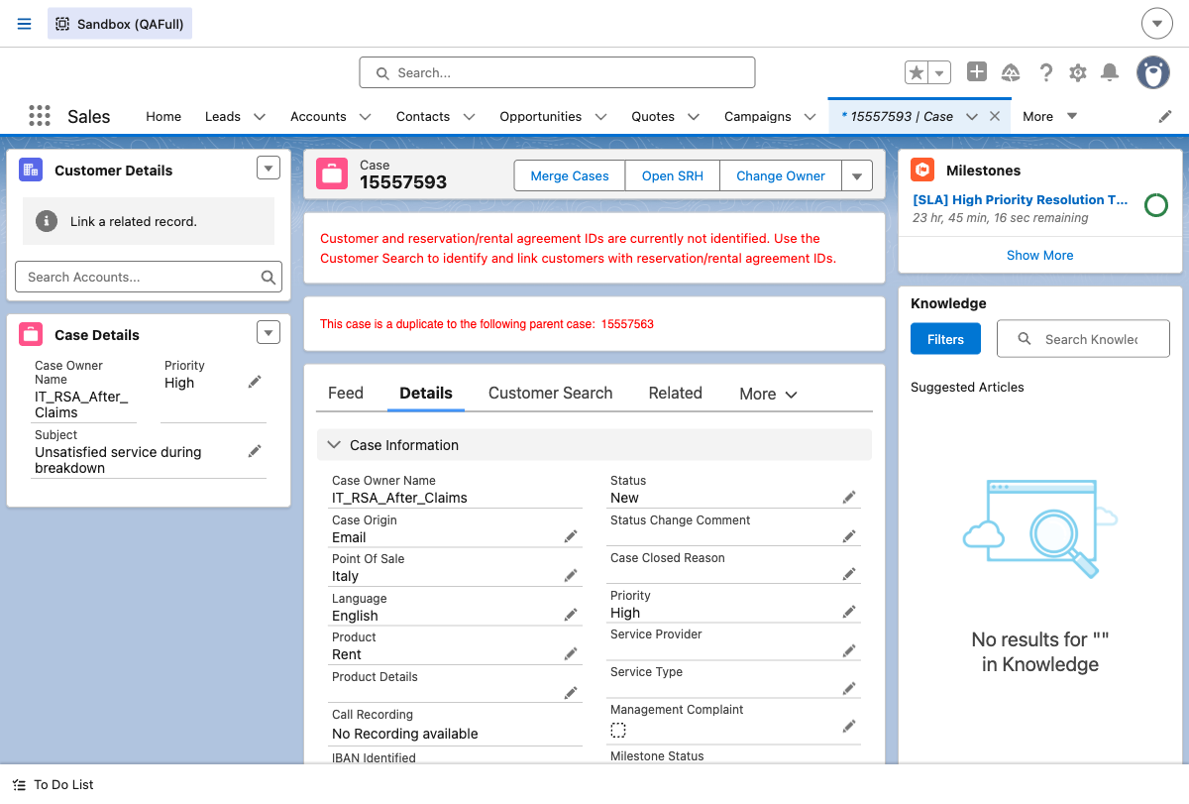

Summary - Pass/Fail Table
Test Step | Expected Result | Status
Email-to-Case Creation | Case created for service.qafull@sixt.it | PASS
Owner = FR_RSA_After_Claims | Case routed to FR_RSA_After_Claims queue | FAIL
Actual Owner | IT_RSA_After_Claims (email goes to .sixt.it) | NOTE
Skills Backlog Verification | Case visible in Skills Backlog | N/A
Medium Priority on Case Record | Priority = Medium on case record | PASS
Low Priority on Case Record | Priority = Low on case record | PASS
High Priority on Case Record | Priority = High on case record | PASS

Key Findings
1. Owner Mismatch: The test script (line 72) expects "FR_RSA_After_Claims" as the case owner, but the email is sent to "service.qafull@sixt.it" (Italian address). The case is correctly routed to "IT_RSA_After_Claims" (Italian queue). This appears to be a typo in the test script - for FR_RSA_After_Claims, the email should be sent to a French address (e.g., service.qafull@sixt.fr).
2. No Omni-Channel Routing: The IT_RSA_After_Claims queue does NOT use Omni-Channel routing (neither skill-based nor queue-based). No PendingServiceRouting record was created for this case. Therefore, the case does not appear in the Skills Backlog or Queues Backlog, and priority verification in these backlogs is not applicable.
3. Priority Updates: All three priority levels (Medium, Low, High) were successfully updated via SFDX CLI and verified on the case record page with corresponding SLA milestones.

