SCI-3857 (Scenario 3) Test Execution Report

FR_RSA_During_Support - Email-to-Case Routing & Priority Verification

Case Number | 15557576
Subject | Met with an accident
Email Address | service.qafull@sixt.fr
Queue Owner | FR_RSA_During_Support
Case Classification | 4 During Rental / 4.5 Roadside / 4.5.1 Accident
Execution Date | April 10, 2026

Step 2: Email Composed
Email composed in Gmail to service.qafull@sixt.fr with subject "Met with an accident" and body text "Hi, I met with an accident down the street. Thank you."
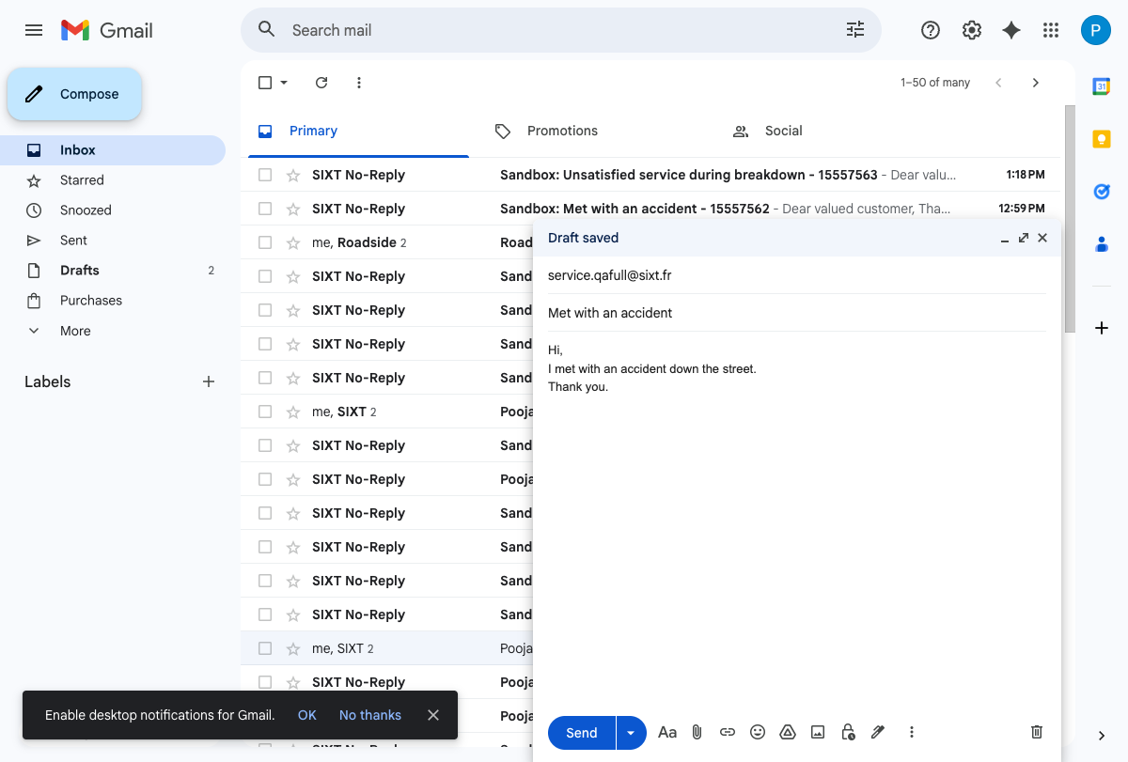

Step 2: Email Sent
Email successfully sent. "Message sent" confirmation visible at bottom.
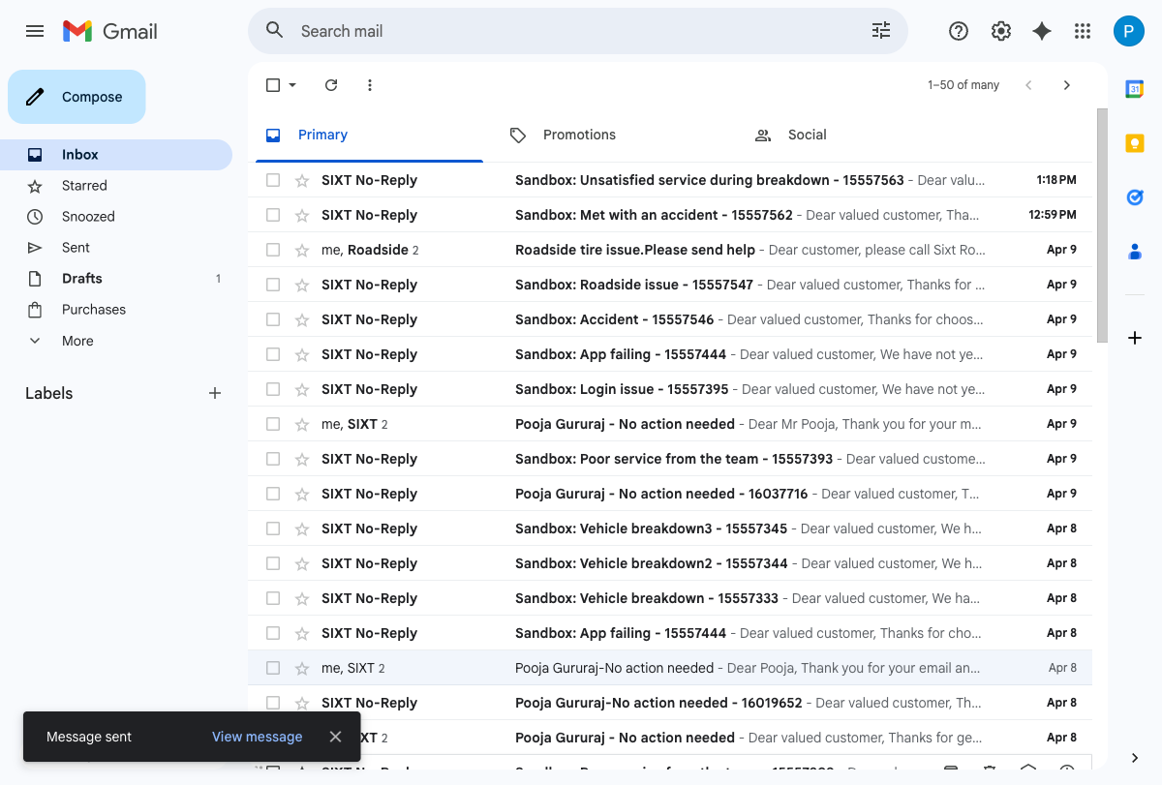

Step 4: Case Record - Owner Verification
Case 15557576 created via email-to-case.
- Case Owner Name: FR_RSA_During_Support (PASS)
- Priority: High
- POS: France
- Language: English
- Case Classification: 4 During Rental / 4.5 Roadside / 4.5.1 Accident
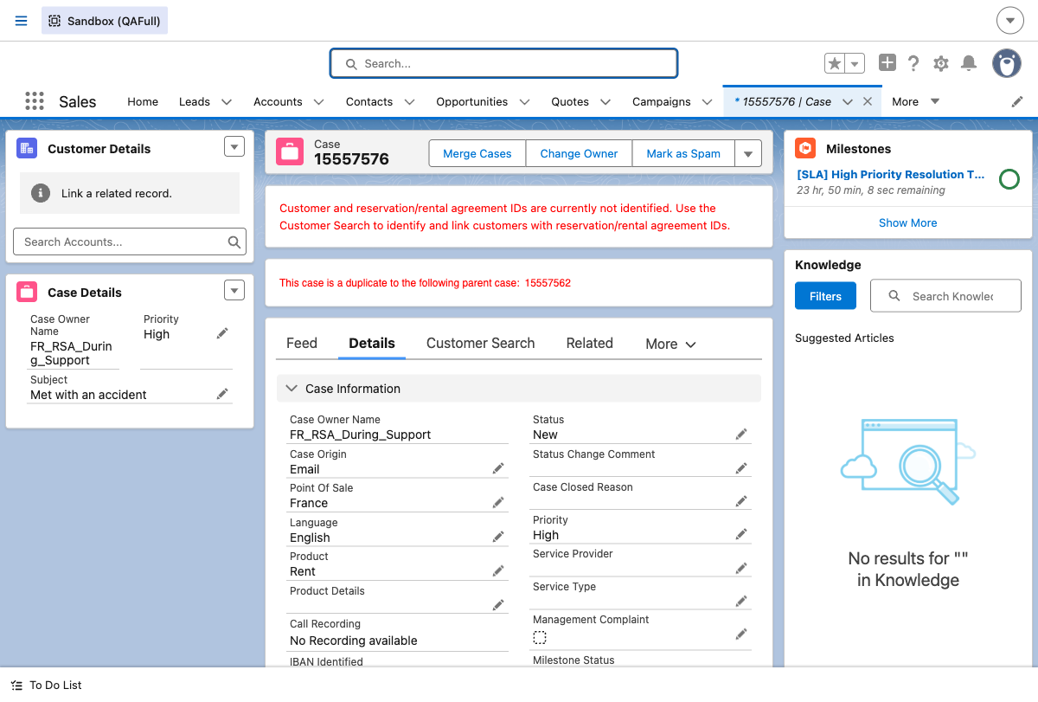

Step 8: Skills Backlog - Medium Priority (75)
Case priority updated to Medium via SFDX CLI.
Case 15557576 appears in Skills Backlog with:
- Skills: FR_RSA_During_Support (0)
- Priority: 75 (Medium = 75) (PASS)
- Routing Type: SkillsBased
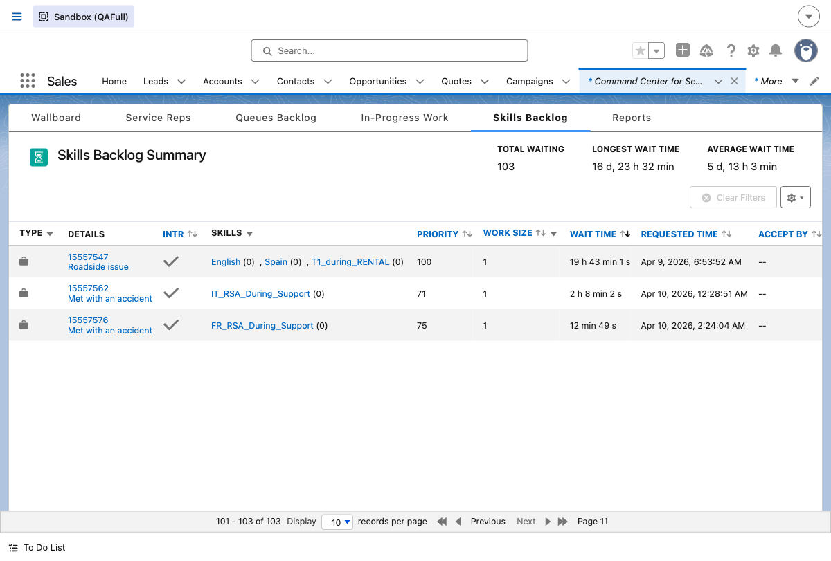

Step 11: Skills Backlog - Low Priority (77)
Case priority updated to Low via SFDX CLI.
Case 15557576 appears in Skills Backlog with:
- Skills: FR_RSA_During_Support (0)
- Priority: 77 (Low = 77) (PASS)
- Routing Type: SkillsBased
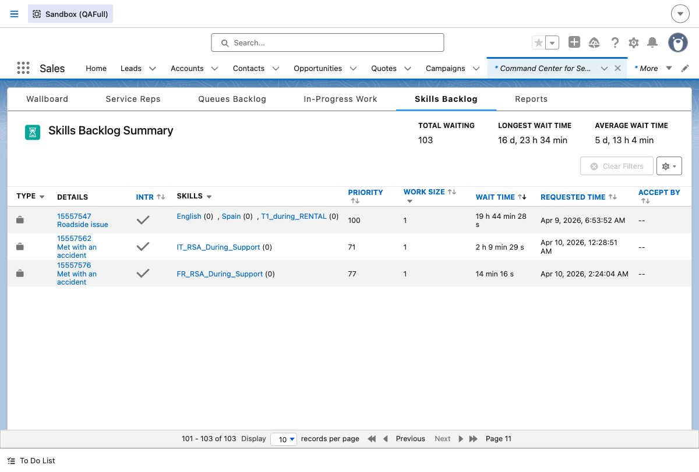

Step 14: Skills Backlog - High Priority (71)
Case priority updated to High via SFDX CLI.
Case 15557576 appears in Skills Backlog with:
- Skills: FR_RSA_During_Support (0)
- Priority: 71 (High = 71) (PASS)
- Routing Type: SkillsBased
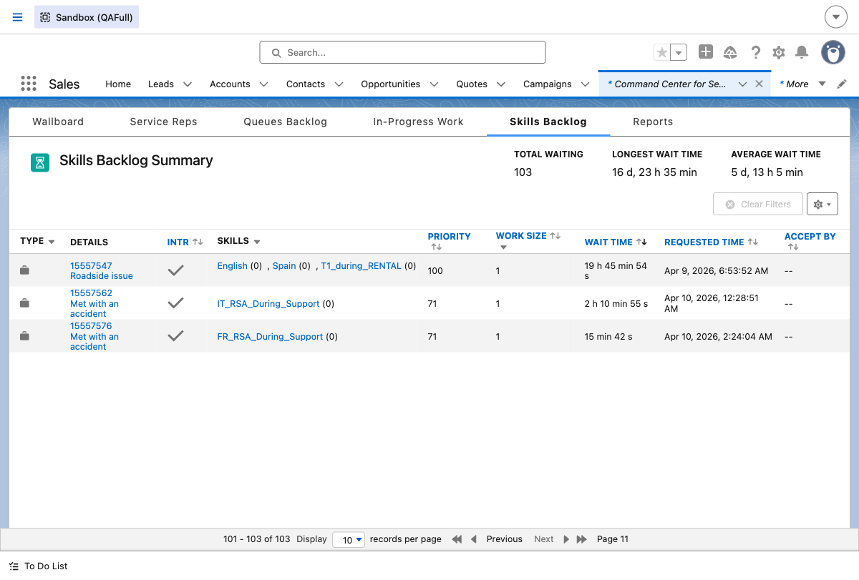

Summary - Pass/Fail Table
Test Step | Expected Result | Status
Email-to-Case Creation | Case created for service.qafull@sixt.fr | PASS
Owner = FR_RSA_During_Support | Case routed to FR_RSA_During_Support queue | PASS
Case Classification | 4 During Rental / 4.5 Roadside / 4.5.1 Accident | PASS
Medium Priority -> Skill Backlog = 75 | Priority number 75 in Skill Backlog for Medium | PASS
Low Priority -> Skill Backlog = 77 | Priority number 77 in Skill Backlog for Low | PASS
High Priority -> Skill Backlog = 71 | Priority number 71 in Skill Backlog for High | PASS

Key Findings
The FR_RSA_During_Support queue uses Omni-Channel skill-based routing. Case 15557576 appeared correctly in the Skills Backlog with the FR_RSA_During_Support skill. All three priority mappings were verified successfully:
- High = 71
- Medium = 75
- Low = 77
All test steps PASSED.

