SCI-3857 (Scenario 2) Test Execution Report

IT_RSA_After_Claims - Email-to-Case Routing & Priority Verification

Case Number | 15557563
Subject | Unsatisfied service during breakdown
Email Address | service.qafull@sixt.it
Queue Owner | IT_RSA_After_Claims
Case Classification | 2.1 Vehicle / 2.1.6 Breakdown / 2.1.6.1 Unsatisfied service during breakdown
Execution Date | April 10, 2026

Step 2: Email Composed
Email composed in Gmail to service.qafull@sixt.it with subject "Unsatisfied service during breakdown" and body text.
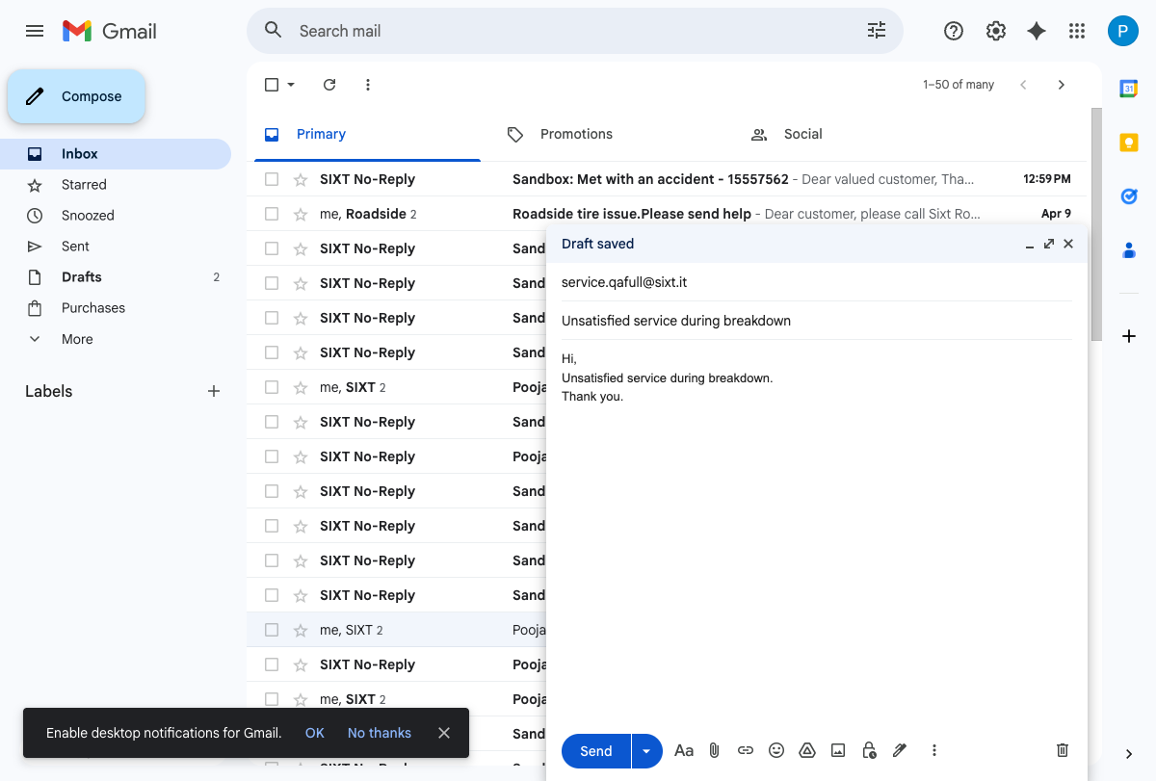

Step 2: Email Sent
Email successfully sent. "Message sent" confirmation visible at bottom.
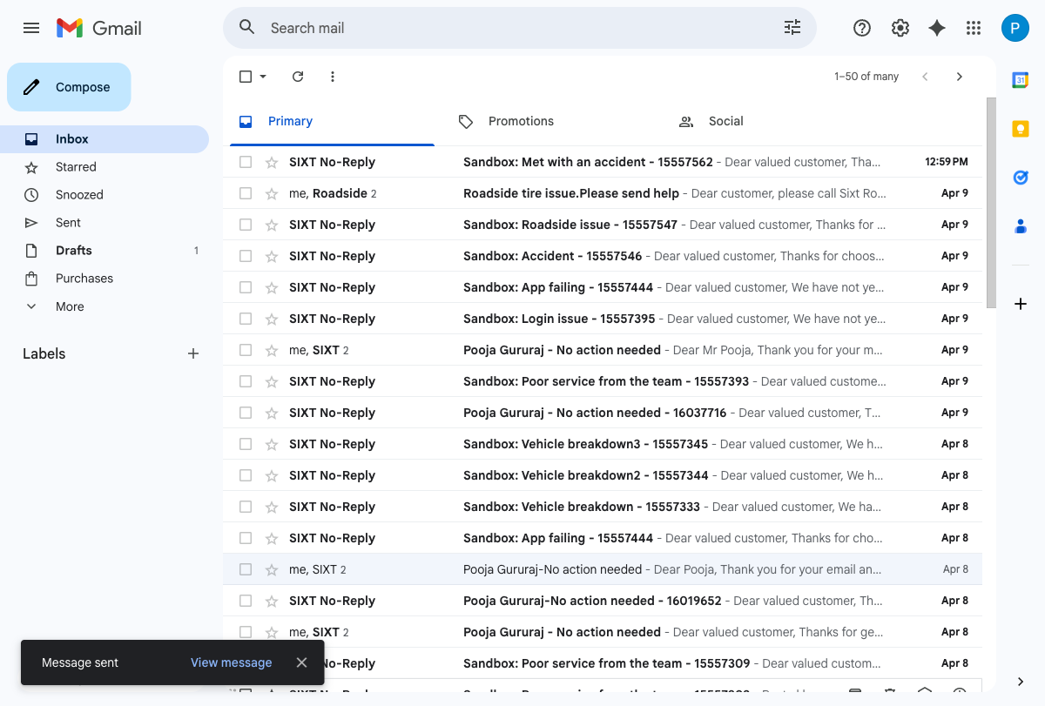

Step 4: Case Record - Owner Verification
Case 15557563 created via email-to-case.
- Case Owner Name: IT_RSA_After_Claims (PASS)
- Priority: Medium
- POS: Italy
- Case Classification: 2.1 Vehicle / 2.1.6 Breakdown / 2.1.6.1 Unsatisfied service during breakdown
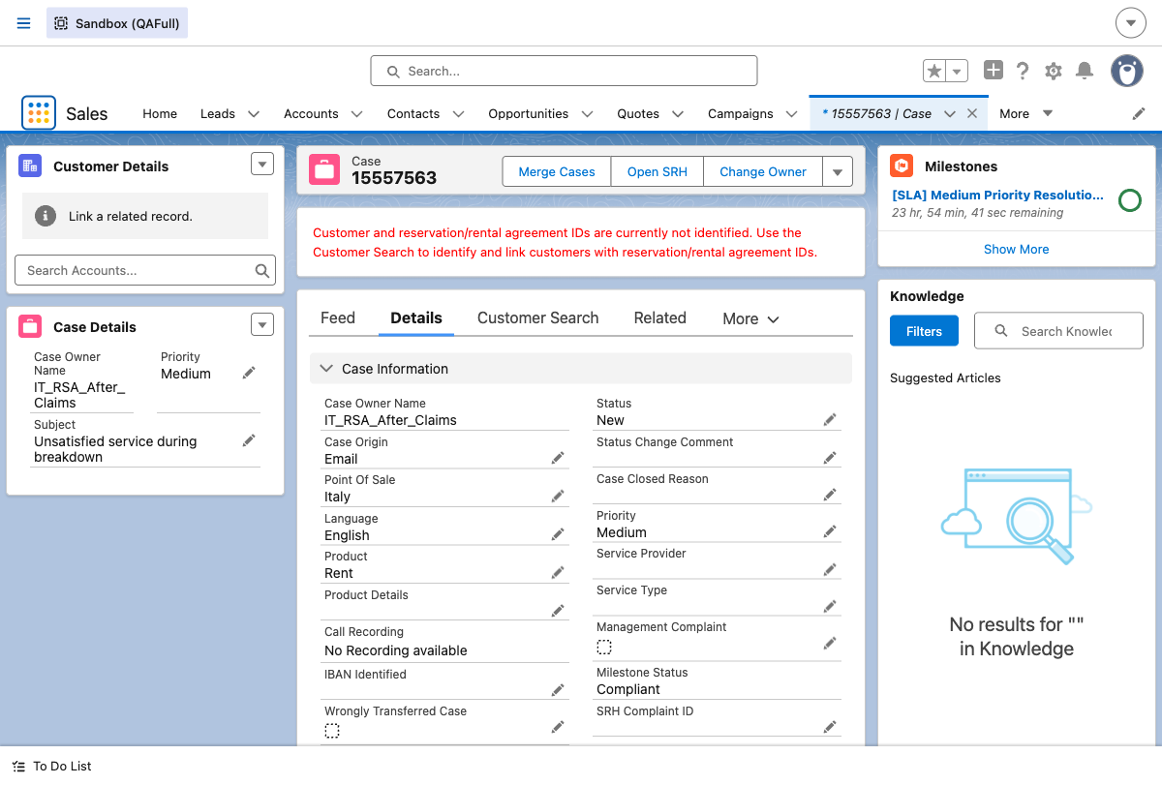

Steps 5-8: Skills Backlog - Case Not Found
FINDING: Case 15557563 does NOT appear in the Skills Backlog.
IT_RSA_After_Claims queue does not use Omni-Channel skill-based routing.
The Skills Backlog shows 101 total items (none for this case).
Only case 15557562 (IT_RSA_During_Support from Scenario 1) appears.
- Priority number verification in Skill Backlog: NOT APPLICABLE
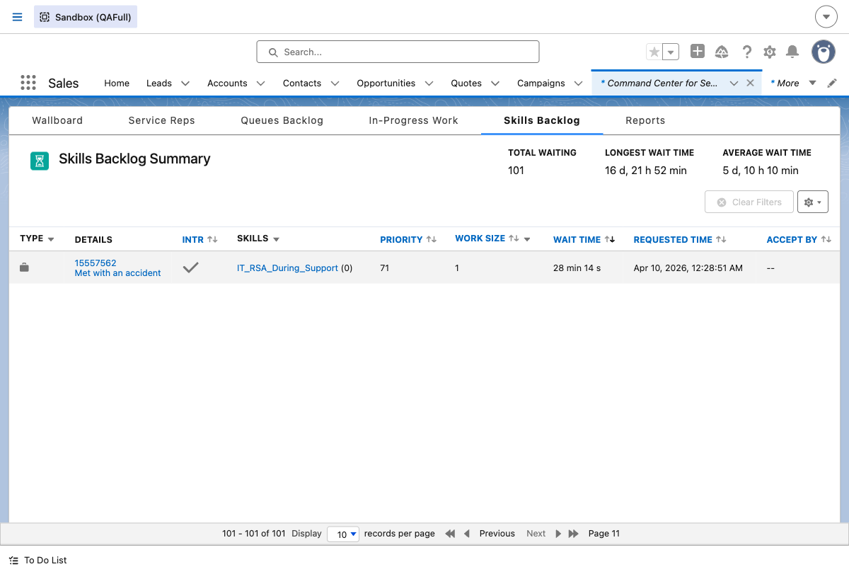

Queues Backlog Verification
FINDING: IT_RSA_After_Claims queue is NOT listed in the Queues Backlog either.
The queue does not use Omni-Channel routing (neither skill-based nor queue-based).
This means priority numbers (71/75/77) cannot be verified in the Skill Backlog for this queue.
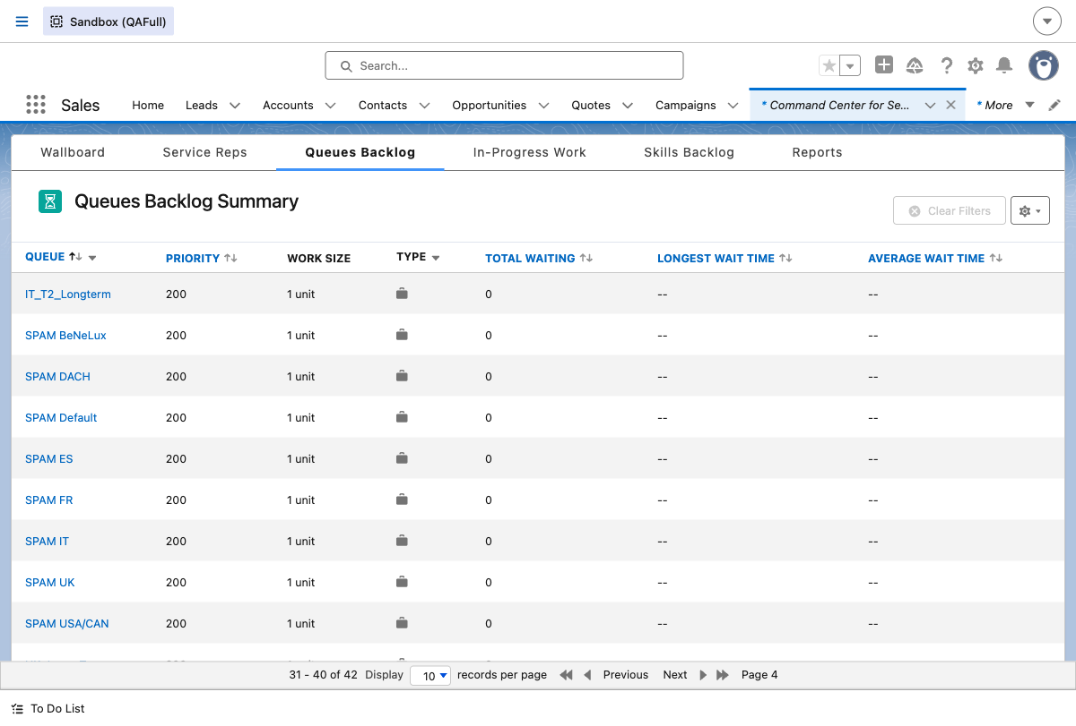

Step 9: Priority Updated to Low
Case priority updated to Low via SFDX CLI.
- Priority: Low (verified on case record page)
- Case Owner: IT_RSA_After_Claims (unchanged)
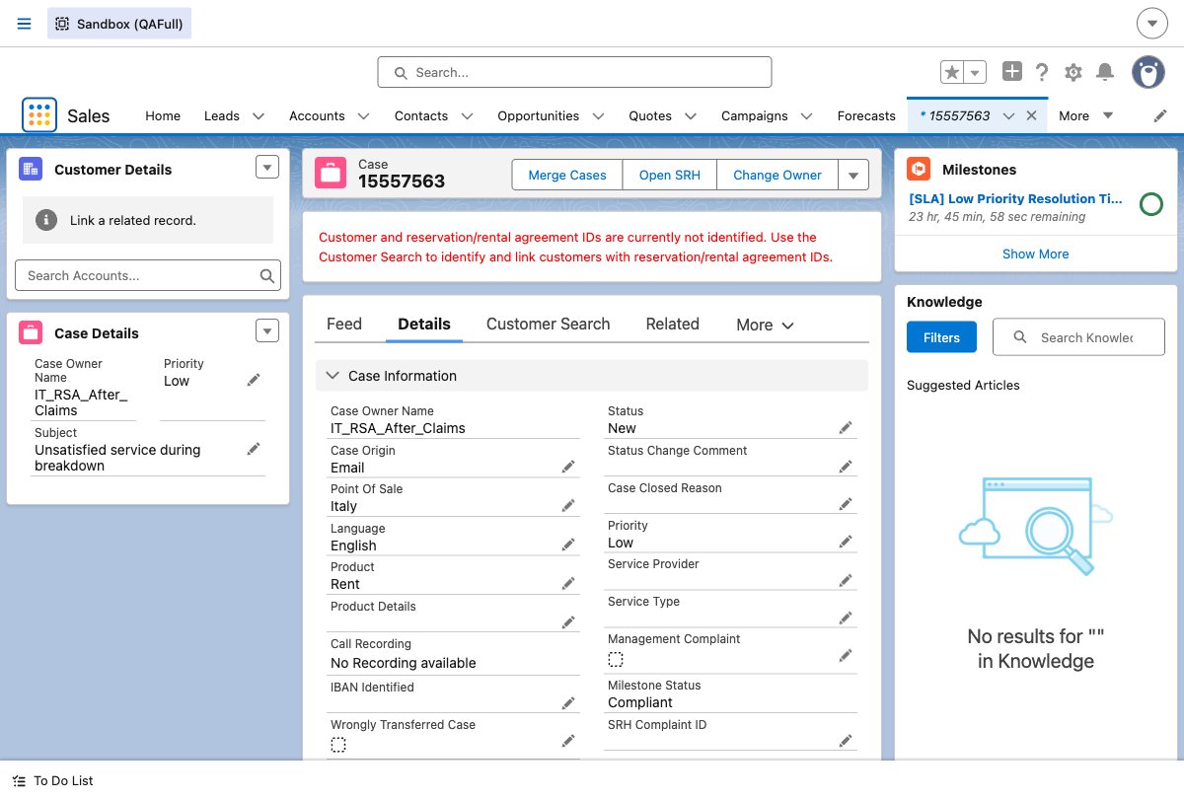

Step 12: Priority Updated to High
Case priority updated to High via SFDX CLI.
- Priority: High (verified on case record page)
- Case Owner: IT_RSA_After_Claims (unchanged)
- SLA Milestone: [SLA] High Priority Resolution Time
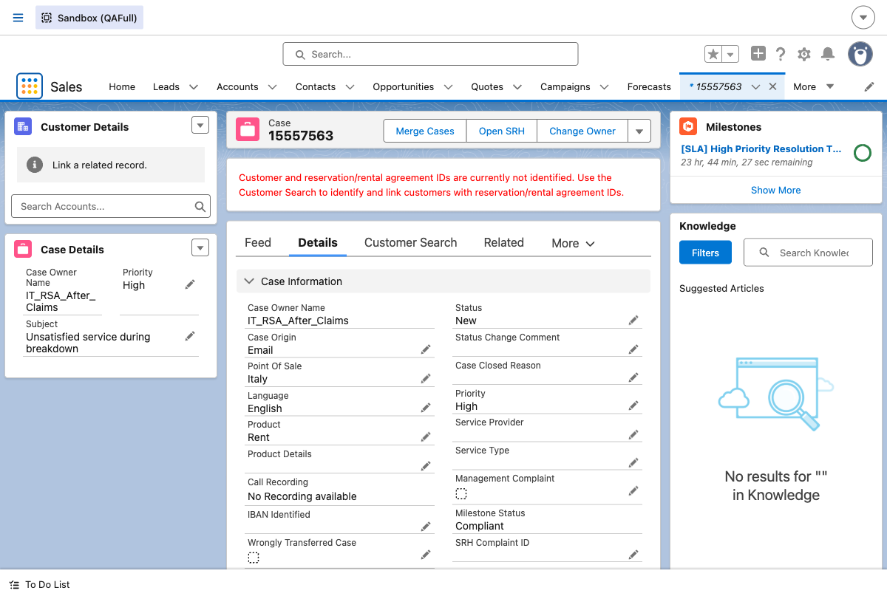

Summary
Test Step | Expected Result | Status
Email-to-Case Creation | Case created for service.qafull@sixt.it | PASS
Owner = IT_RSA_After_Claims | Case routed to IT_RSA_After_Claims queue | PASS
Case Classification | 2.1 Vehicle / 2.1.6 Breakdown / 2.1.6.1 Unsatisfied service during breakdown | PASS
Priority Change - Medium to Low | Priority updated to Low on case record | PASS
Priority Change - Low to High | Priority updated to High on case record | PASS
Skill Backlog Priority Mapping (71/75/77) | Case should appear in Skill Backlog with mapped priority numbers | N/A - Queue not Omni-Channel enabled

Key Finding
The IT_RSA_After_Claims queue does not use Omni-Channel routing (neither skill-based nor queue-based). As a result, Case 15557563 does not appear in either the Skills Backlog or Queues Backlog in the Command Center for Service. The priority mapping verification (High=71, Medium=75, Low=77) cannot be performed for this queue. This is in contrast to IT_RSA_During_Support (Scenario 1) which uses skill-based routing and appears in the Skills Backlog.

