SCI-3862 Test Evidence — IT_VIP
Case: 15856096 | Environment: sixt3--qa | Skills filter: Italy + English + VIP

Step 4 — Change owner to IT_VIP
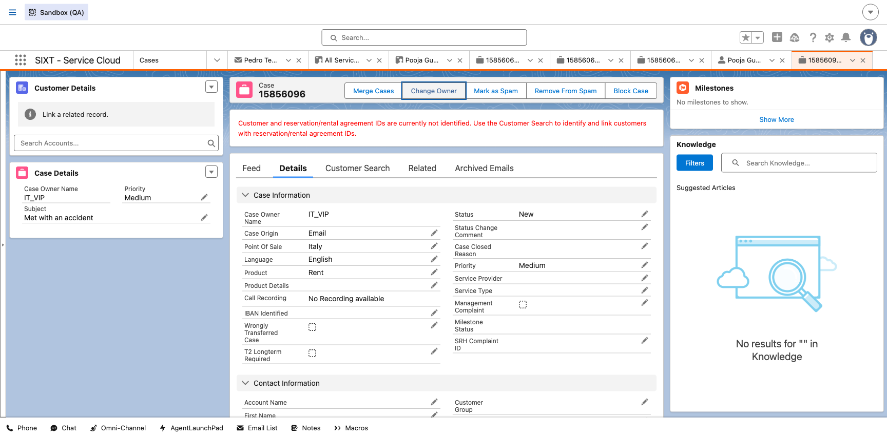

Step 8 — Skills Backlog, Medium priority (expected 55)
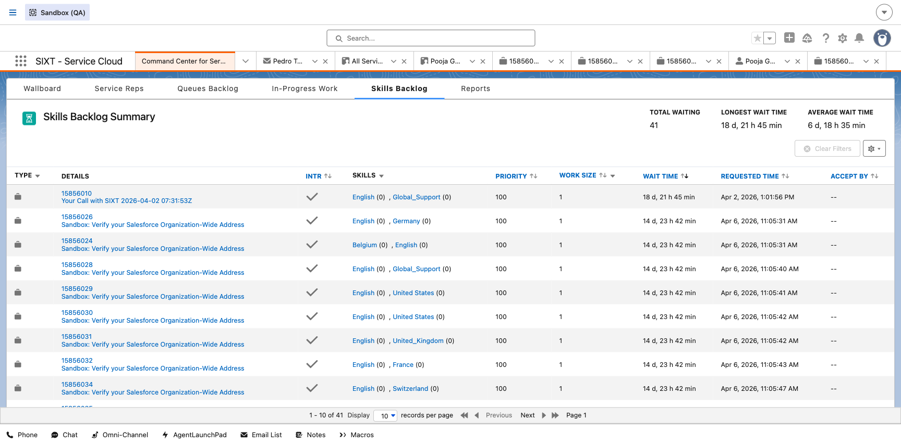

Step 9 — Case priority Low
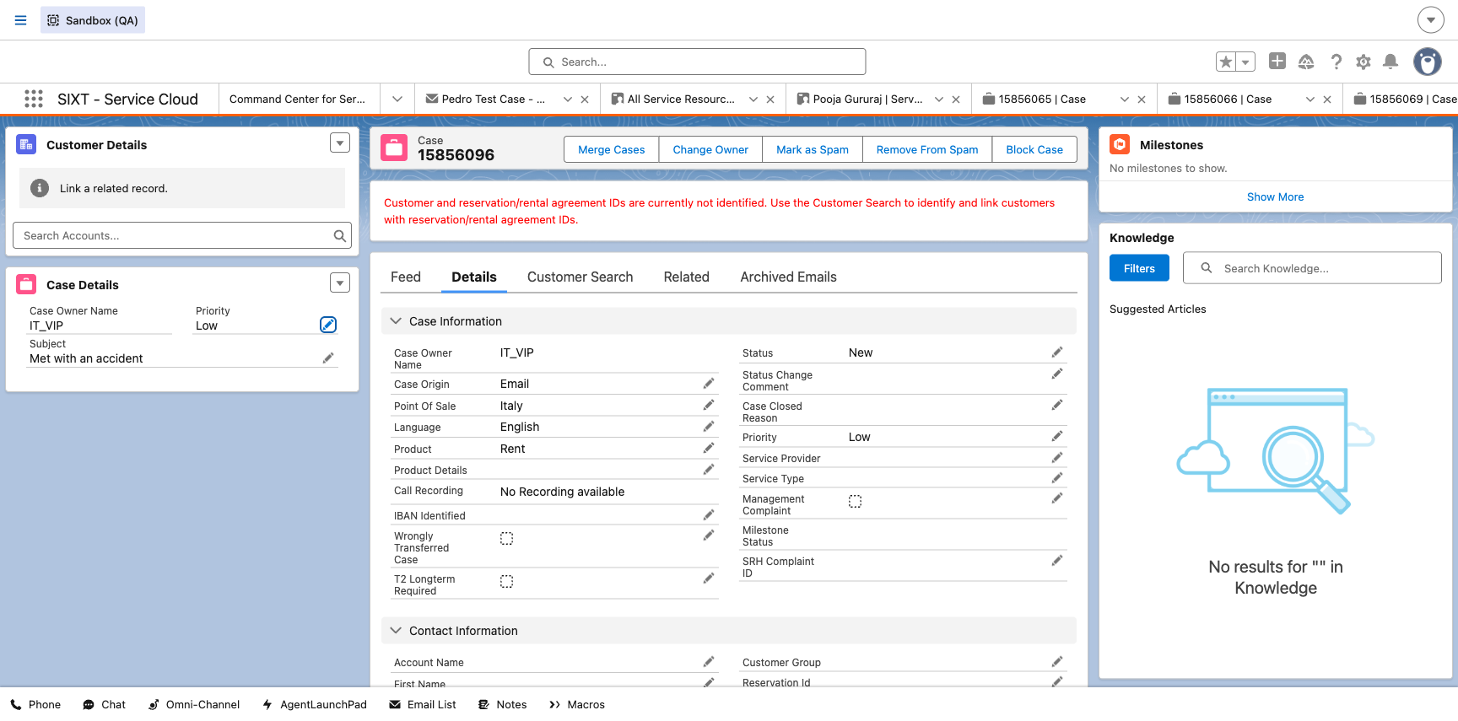

Step 11 — Skills Backlog, Low priority (expected 57)
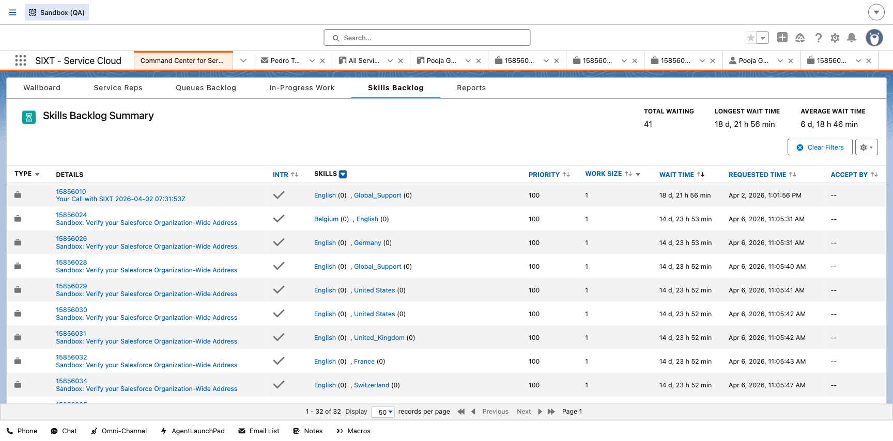

Step 12 — Case priority High
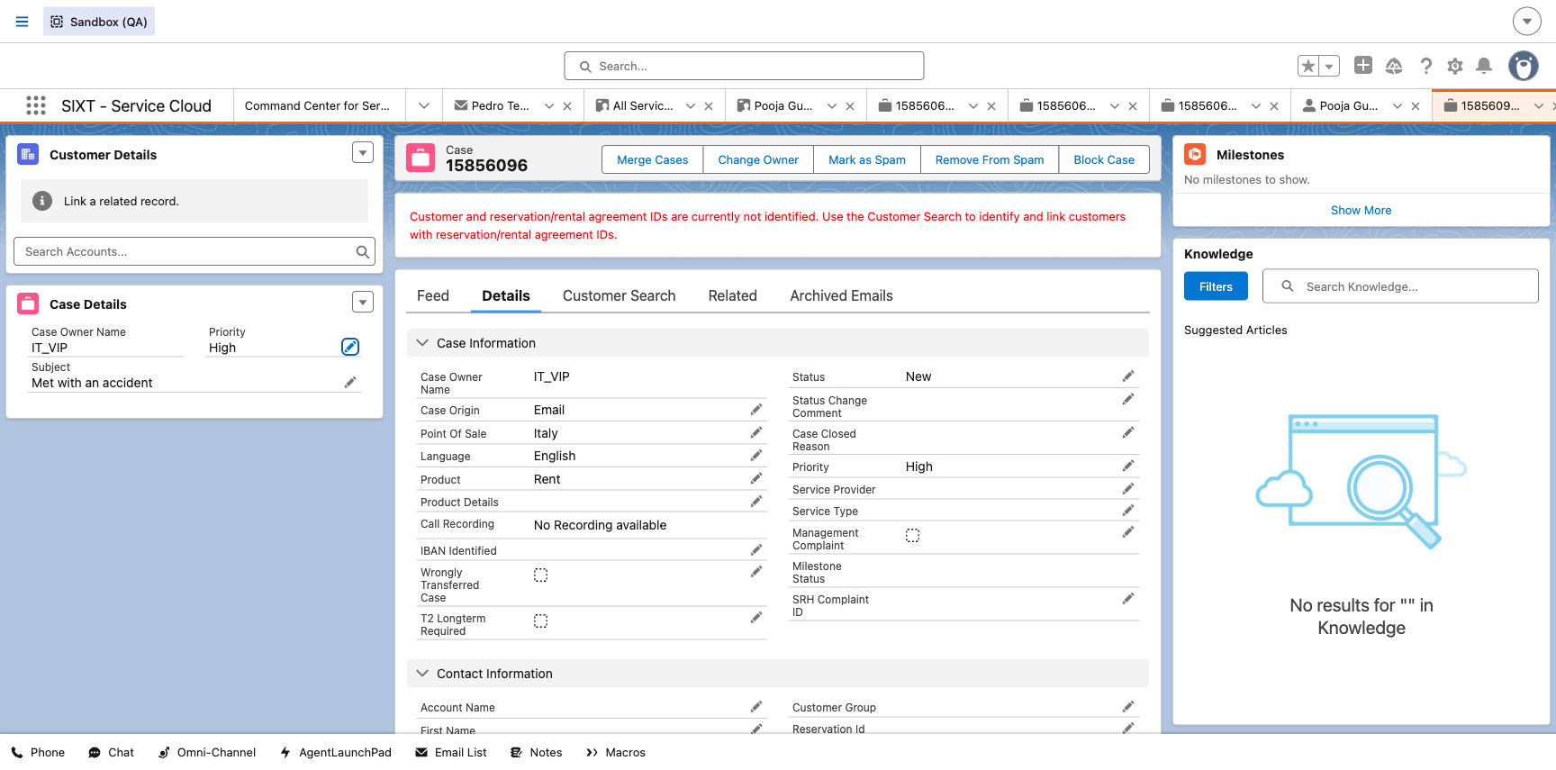

Step 14 — Skills Backlog, High priority (expected 51)
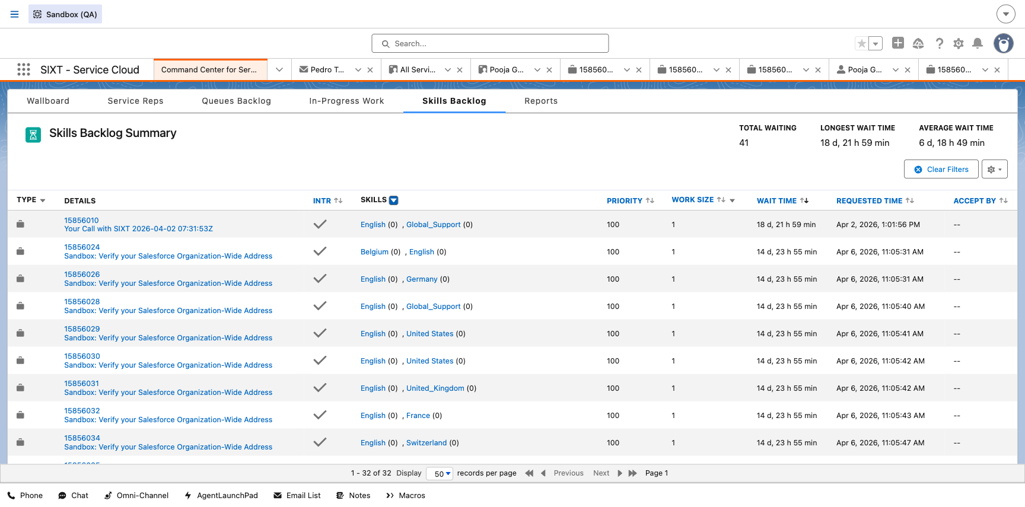

Reference — Skills filter (Italy, English, VIP)
