SCI-3857 (Scenario 8) Test Execution Report

UK_RSA_After_Claims - Email-to-Case Routing & Priority Verification

Case Number | 15557615
Subject | Unsatisfied service during breakdown
Email To | service.qafull@sixt.co.uk
Expected Owner | UK_RSA_After_Claims
Actual Owner | UK_RSA_After_Claims
Point of Sale | United Kingdom
Omni-Channel | No
Execution Date | April 10, 2026

Case Record - Owner Verification
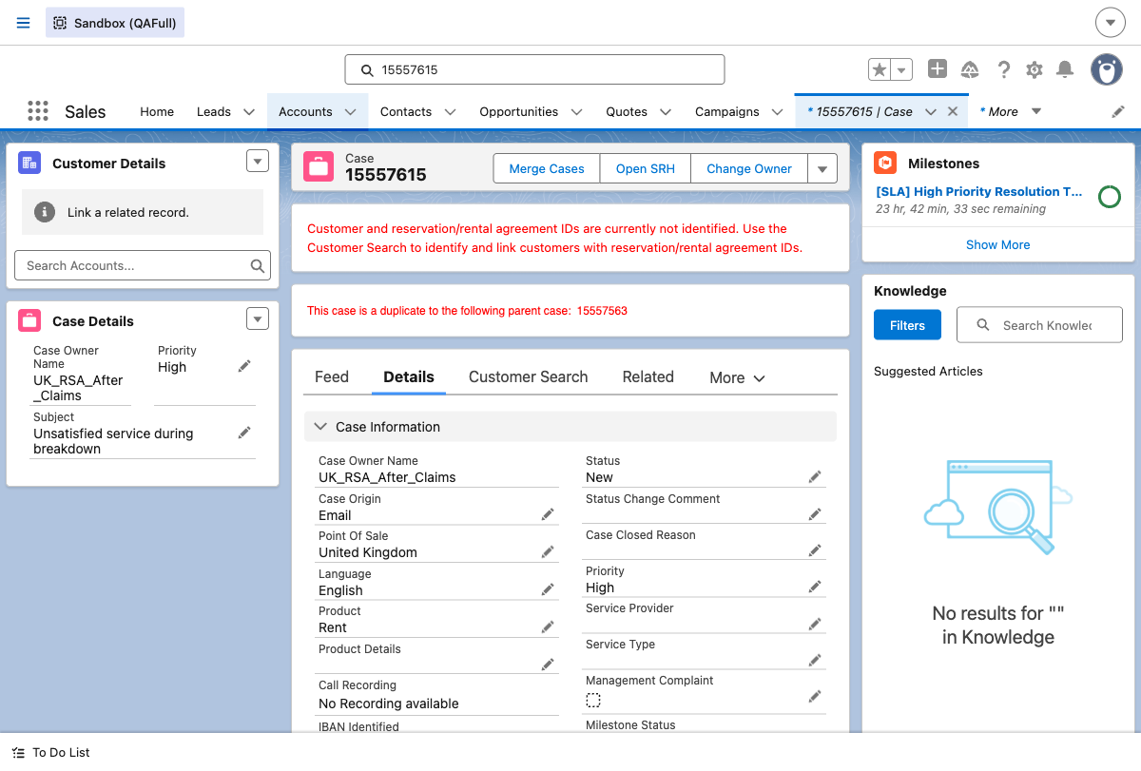

Priority Verification Results
This queue does NOT use Omni-Channel routing. No PendingServiceRouting record exists. Priority changes were verified directly on the case record page.

Summary - Pass/Fail Table
Test Step | Expected Result | Status
Email-to-Case Creation | Case created for service.qafull@sixt.co.uk | PASS
Owner = UK_RSA_After_Claims | Case routed to UK_RSA_After_Claims | PASS
Skills Backlog Verification | No Omni-Channel routing | N/A
Priority Update (Medium) | Case priority set to Medium | PASS
Priority Update (Low) | Case priority set to Low | PASS
Priority Update (High) | Case priority set to High | PASS

Key Findings
UK_RSA_After_Claims does NOT use Omni-Channel routing. No PendingServiceRouting record. Priority changes verified on case record.

