US_RSA_During_Support
SCI-3857 — Email-to-Case & Skills Backlog verification
Environment: Salesforce Sandbox (QAFull) — sixt3--qafull.sandbox.lightning.force.com
Evidence: screenshots captured during test execution.

Case record — Case Owner Name
sci3857_us_during_support_case_owner_qafull.png
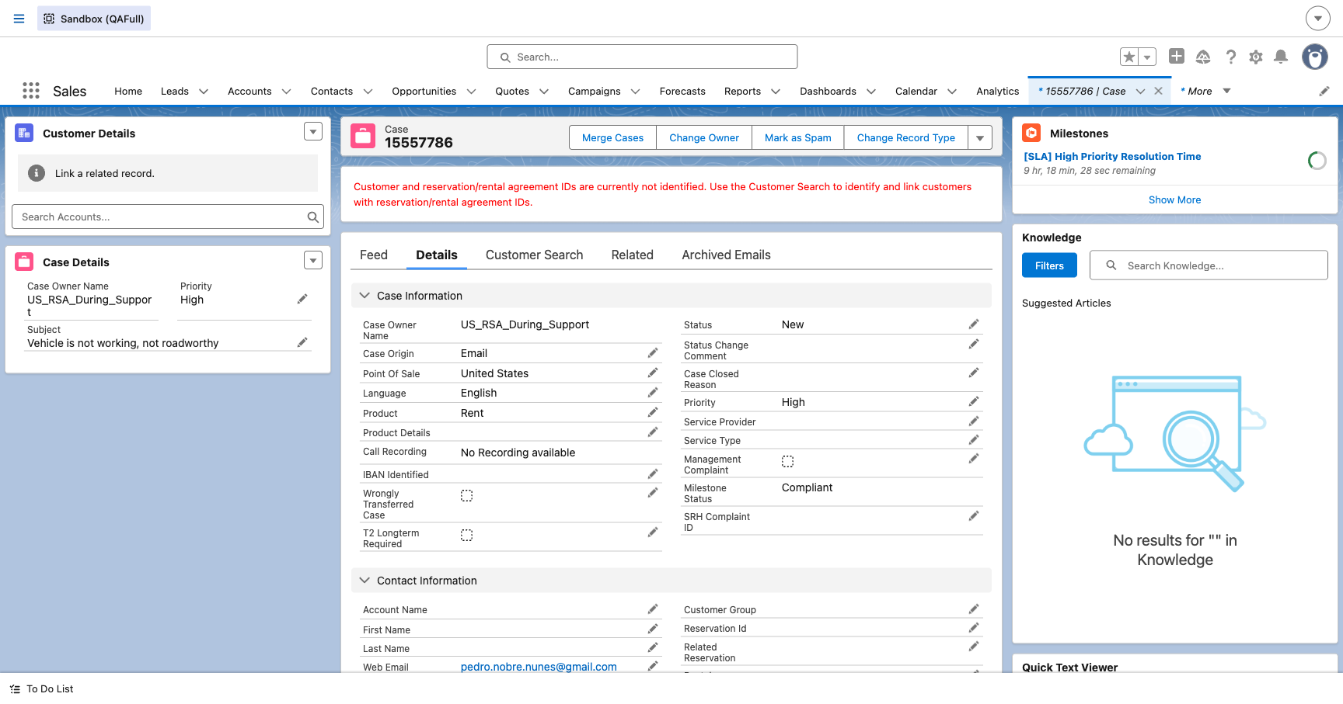

Skills Backlog — filter US_RSA_During_Support
sci3857_us_during_support_skills_backlog_qafull.png
