**MongoDB Lab Assignments -Day 1**

**MongoDB Exercise in mongo shell**

**query the movies collection to**

1. get all documents

1. get all documents with writer set to "Quentin Tarantino"

1. get all documents where actors include "Brad Pitt"

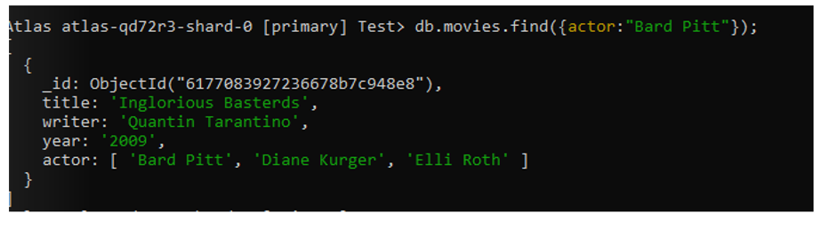

1. get all documents with franchise set to "The Hobbit"

1. get all movies released before the year 2000 or after 2010

**Update Documents**

1. add a synopsis to "The Hobbit: An Unexpected Journey" : "A reluctant hobbit, Bilbo Baggins, sets out to the Lonely Mountain with a spirited group of dwarves to reclaim their mountain home - and the gold within it - from the dragon Smaug."

1. add a synopsis to "The Hobbit: The Desolation of Smaug" : "The dwarves, along with

Bilbo Baggins and Gandalf the Grey, continue their quest to reclaim Erebor, their homeland, from Smaug. Bilbo Baggins is in possession of a mysterious and magical ring."

1. add an actor named "Samuel L. Jackson" to the movie "Pulp Fiction"

