**Academic year 2018-19**

**Department of Computer Science and Engineering**

**KARNATAKA LAW SOCIETY’S**

**GOGTE INSTITUTE OF TECHNOLOGY**

**UDYAMBAG,  BELAGAVI -590008**



**Course Project Synopsis**

**Advanced C and OOPS Lab (16CSL36)**

(Integrated)

**MEDICAL FORM MANAGEMENT SYSTEM**

**SEMESTER** **:- III** SEM

**TEAM MEMBERS :- USN :-**

* Pooja S Harugop 2GI17CS095
* Nidhi B Shah 2GI17CS084
* Pooja J Narasannavar 2GI17CS096

**GUIDE:-** Prof. Manjula. M. Ramannavar

Prof. Umesh. Kulkarni

**ACKNOWLEDGEMENT :-**

It is indeed with a great pleasure and immense sense of gratitude that we acknowledge the help of these individuals. We are highly indebted to our Principal **A S Deshpande**, KLS Gogte Institute of Technology, Belagavi for the facilities provided to accomplish this main project.

We would like to thank our **Prof.Veena Desai**, Head of the Department of Computer Science and Engineering, KLS Gogte Institute of Technology, Belagavi, for this constructive criticism throughout our project.

We feel elated in manifesting our sense of gratitude tour internal project guide **Prof. Manjula M Ramannavar and Prof. Padma S Dandannavar, Associate Professor, Department of Computer Science and Engineering**, KLS Gogte Institute of Technology, Belagavi . They have been a constant source of inspiration for us and we are very deeply thankful to them for their support and valuable advice.

**ABSTRACT :-**

Medical form management system is a process of implementing activity of hospital in a computerized automated way to fasten the performance. Developed to maintain the details of Admission and Discharge of a patient in any Hospital. This system has been prevailed to over write the problems faced in practicing manual system. It maintains the information about Registration of a patient into the hospital and its Dischargeable procedure. This program is considered as a simple data base of a medical organization where the applicant can store patient’s record easily as it is less time consuming.

Here at first the applicant has to choose whether he wants to register or take a discharge between the two functionalities and later has to add the required details of the form. Details such as Name, Age, Blood Group, Phone number, brief condition of the patient etc. After entering the required details the form will be displayed.

**INDEX**

1. INTRODUCTION

2. PROBLEM STATEMENT WITH FUCTIONALITIES

3. OBJETIVES

4. PSEUDO CODE (DESIGN)

5. SAMPLE SCREENSHOTS

6. CONCLUSION

7. REFERENCE

**INTRODUCTION :-**

Hospital are the essential part of our life’s, providing best medical facilities to people suffering from various ailments, which may be due to change in climatic conditions increased work load, emotional trauma, stress etc. It is necessary for the hospitals to keep track of the day-to-day activities and record of its patients.

But keeping the track of all the activities and their records on paper is very cumbersome and error prone. It also is very inefficient and a time consuming process. Observing the continuous increase in population and number of people visiting the hospital. Recording and maintaining all these record is highly unreliable, inefficient and error prone. It is also not economically and technically feasible to maintain these records on paper.

Thus keeping the working of the manual system as the basis of our project, we have developed an automated version of manual system, named as “Medical Form Management System”.

**PROBLEM STATEMENT WITH FUCTIONALITIES :-**

Implement a Medical form application using C making use of structure with following functionalities:

* Add Application Form
* List Application Form
* Add discharge Form
* List Discharge Form

**OBJECTIVES :-**

The project “Medical form management system” is aimed to develop to maintain the day-to-day state of admission or discharge of patients. It is designed to achieve the following objectives:

1. To computerize all details regarding patient.
2. The information of the patients should be kept up to date and their records should be kept in the system for historical purposes.
3. Data can be fetched easily .

**PSEUDO CODE (DESIGN) :-**

1. ADD APPLICATION FORM:-

1. admit()

2. Open file ‘admit.txt’, in append ‘a+’ mode

3. Check if the file is opened or not

4. Read Patient’s information

5. Read Id number, first name, last name, age, sex, city, blood group, marital status, date of birth, date of admission, contact, guardian’s name and contact and all Medical details.

6. Open the file in fwrite

7. Close the file

1. DISPLAY APPLICATION FORM:-
2. admit_disp()
3. Open the File ‘admit.txt’ in read ‘r+’ mode
4. Check if the file is opened or not
5. Read the Id number
6. Print Patient’s information
7. Print first name, last name, age, sex, city, blood group, marital status, date of birth, date of admission, contact, guardian’s name and contact, and all Medical details.
8. Close the file
9. ADD DISCHARGE FORM:-

1. discharge()

2. Open file ‘discharge.txt’, in append ‘a+’ mode

3. Check if the file is opened or not

4. Read Patient’s information

5. Read Id number, first name, last name, age, city, contact number, reason of admit, reason of discharge, date of discharge, contact, Medical fees paid, receipt number

6. Open the file in fwrite

7. Close the file

1. DISPLAY DISCHARGE FORM:-
2. discharge_disp()
3. Open the File ‘discharge.txt’ in read ‘r+’ mode
4. Check if the file is opened or not
5. Read the Id number
6. Print Patient’s information
7. Print first name, last name, age, city, contact number, date of discharge, Medical fees paid, receipt number
8. Close the file

**SAMPLE SCREENSHOTS :-**

1. ADD ADMISSION FORM:-

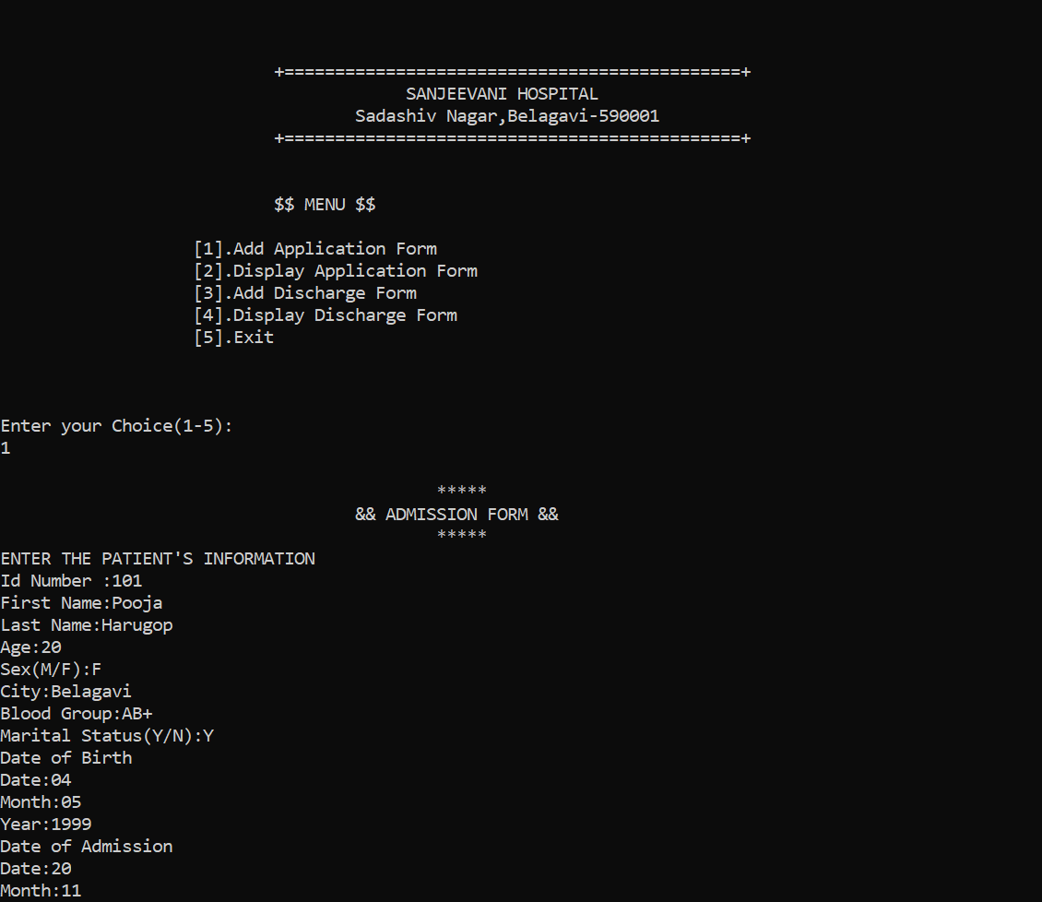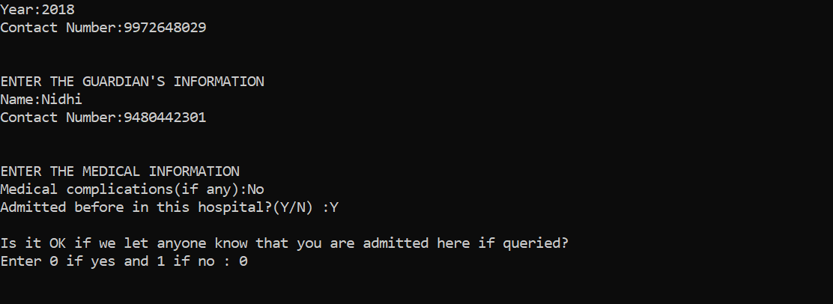

1. DISPLAY ADMISSION FORM:-

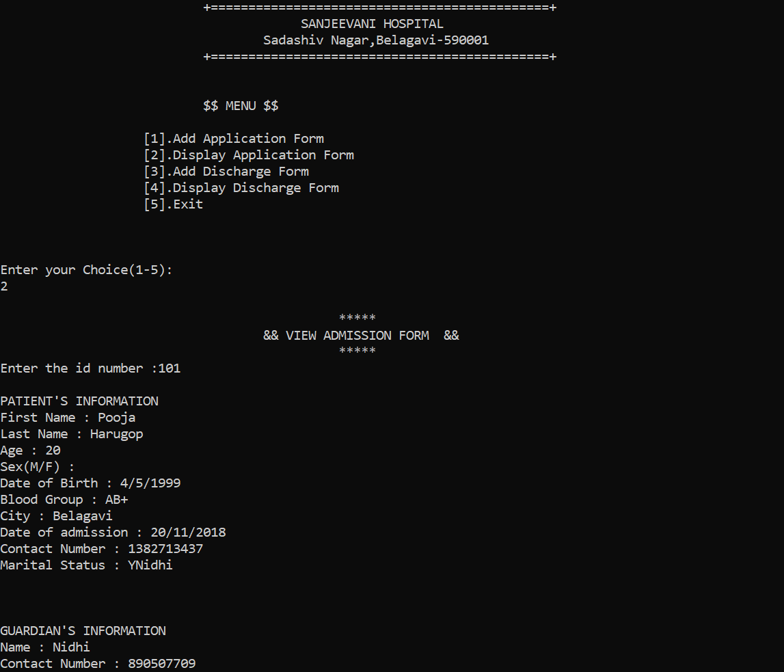

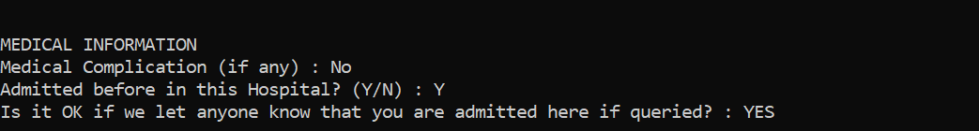

1. ADD DISCHARGE FORM :-

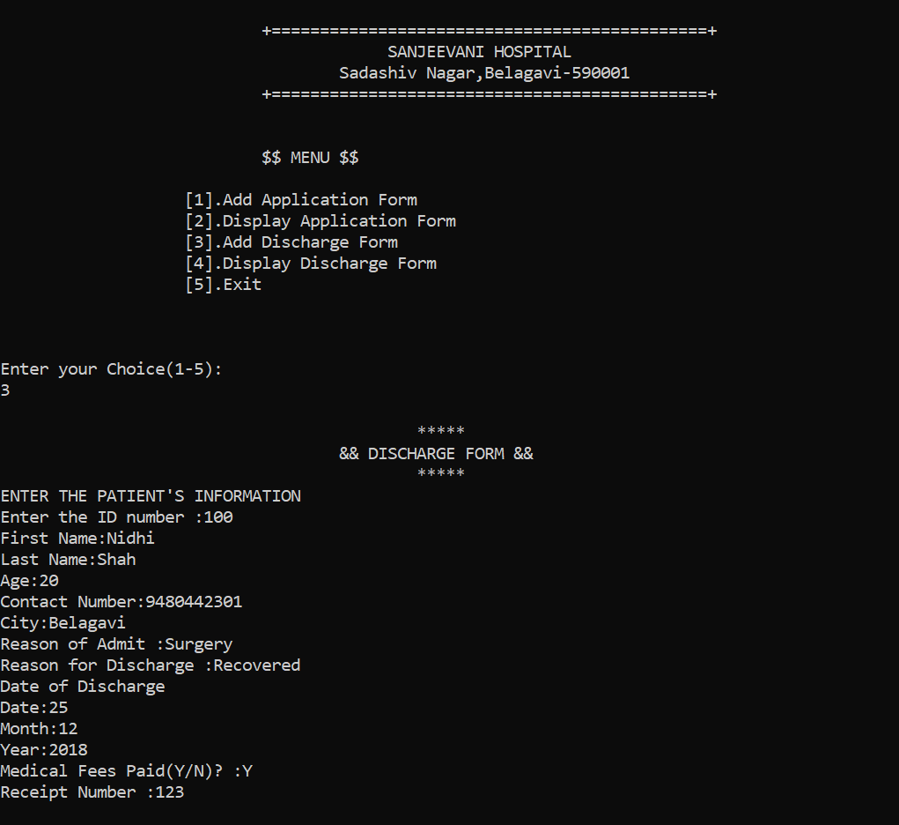

1. DISPLAY DISCHARGE FORM:-

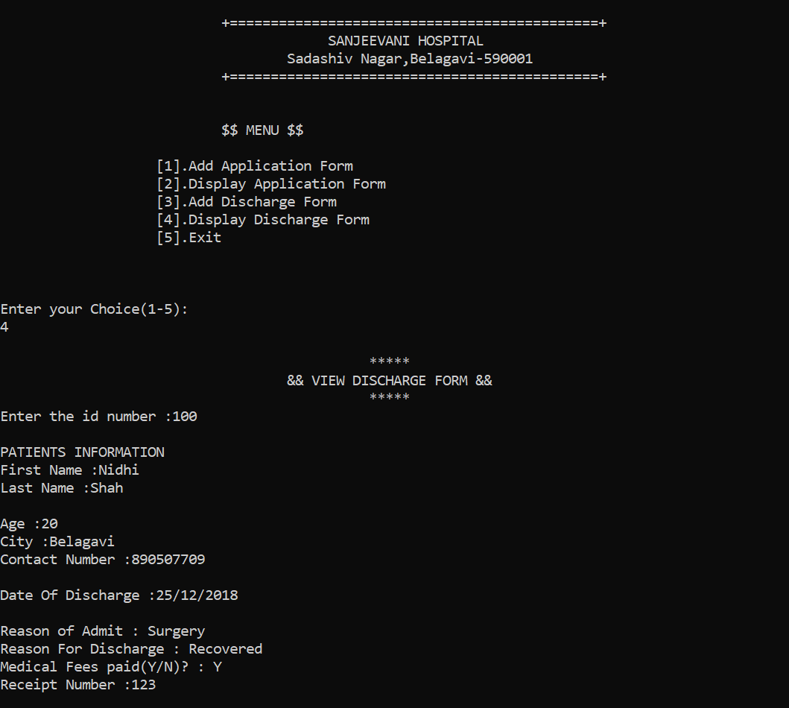

**CONCLUSION :-**

Since we are entering details of the patients electronically in the “Medical Form Management System”, data will be secured in files. Using this application we can retrieve patient’s history with a single click. Thus processing information will be faster. It guarantees accurate maintenance of Patient details. It easily reduces the book keeping task and thus reduces the human effort and increases accuracy speed.

**REFERENCES :-**

1. Fundamentals of Data Structures in C, By Horowitz, Sahani, Anderson Fireed.
2. Object Oriented Programming with C++, By E.Balagurusamy.
3. Software Engineering By Lan Sommerville