**DYNAMIC ALLOCATION OF UE VBS IN 5G NETWORKS**

**A PROJECT REPORT**

***Submitted by***

**KANISHKHA L D (312217106068)**

**POOJAH G (312217106112)**

**SNEHA S (312217106161)**

***in partial fulfillment for the award of the degree***

***of***

**BACHELOR OF ENGINEERING**

**in**

ELECTRONICS AND COMMUNICATION ENGINEERING

**SSN COLLEGE OF ENGINEERING, KALAVAKKAM**

**ANNA UNIVERSITY : CHENNAI 600 025**

**APRIL 2021**

**ANNA UNIVERSITY : CHENNAI 600 025**

**BONAFIDE CERTIFICATE**

Certified that this project report **“DYNAMIC ALLOCATION OF UE VBS IN 5G NETWORKS”** is the bonafide work of “**KANISHKHA LD (312217106068), POOJAH G (312217106112) AND SNEHA S (312217106161)”** who carried out the project work under my supervision.

**SIGNATURE SIGNATURE**

Dr. S. Radha Dr. R. Kishore

**HEAD OF THE DEPARTMENT SUPERVISOR**

**PROFESSOR ASSOCIATE PROFESSOR**

Department of Electronics and Department of Electronics and

Communication Engineering Communication Engineering

SSN College of Engineering SSN College of Engineering

Kalavakkam – 603 110 Kalavakkam – 603 110

**ABSTRACT**

To satisfy the requirements of a person accessing the internet, such as video streaming, gaming, etc., data rate, latency and connectivity have to be improved. In order to facilitate the above-mentioned needs, the existing 4G mobile network has to be upgraded to the next generation i.e., 5G. Since it uses signals with higher frequencies compared to 4G, the 5G signals will face a lot of attenuation which will lead to a short communication range. 5G will require a number of key technological components to meet these ambitious goals, including Heterogeneous Networks and Small Cells. The dense deployment of small cells will play a major role as they can be installed in a more targeted manner to relieve traffic in hot spot areas, increase coverage, and spectral efficiency. However, the current deployment of Base Stations is static, normally deployed on demand around hotspots. In the scenario of unpredictable crowd movement, these static deployments of BS can be inefficient with high Capital Expenditure and Operational Expenditure. In order to reduce these, two things are to be achieved: Dynamic deployment of BS and creating a cost-efficient BS. This can be realized by making a set of UE, such as phones, laptops, etc., emulate the actions of a BS. Hence, the UE can be termed as a VBS. Our project focuses on the scenario where UE-based VBSs can be dynamically selected among the UEs available in the network, on an at-will basis, to deal effectively with the non-stationary, non-uniform distribution of mobile traffic with respect to time and space domain. Thus, D2D communication is enabled. Since one UE cannot provide for a macro cell, the cell has to be split into several small cells with one UE acting as the VBS in each cell. To implement this concept, we propose an efficient clustering technique: Mean shift Clustering to find the number of clusters and K-means Clustering to segregate the UEs into small cells. Communication parameters such as received power, battery discharge rate and SINR are used to select the best set of UE-VBSs to supplement an overlay loaded network. Sum rate, Quality of Service and Power consumption are used to compare the performance of our selection algorithm, against the performance of a random selection algorithm in 5G and 4G networks. Simulations yields results which highlights salient features of the algorithm, as well as its limitations with regard to scalability.

**TABLE OF CONTENTS**

**CHAPTER NO. TITLE PAGE NO.**

**ABSTRACT iii**

**LIST OF TABLES viii**

**LIST OF FIGURES viii**

**LIST OF SYMBOLS x**

**LIST OF ABBREVIATIONS x**

**1. INTRODUCTION 1**

1.1 OVERVIEW 1

1.2 MOTIVATION AND OBJECTIVES 3

1.3 ORGANISATION OF REPORT 4

**2. LITERATURE REVIEW 5**

2.1 INTRODUCTION 5

2.2 LITERATURE SURVEY 5

**3. 5G REQUIREMENTS 8**

3.1 INTRODUCTION 8

3.2 HIGH DATA RATES 9

3.3 LOW LATENCY 10

3.4 LOW ENERGY CONSUMPTION 10

3.5 HIGH SCALABILITY 11

3.6 IMPROVED CONNECTIVITY AND 12

RELIABILITY

3.7 IMPROVED SECURITY 13

3.8 SUMMARY 14

**4. CLUSTERING ALGORITHM 15**

4.1 CLUSTERING 15

4.2 CLUSTERING PARAMETERS AND 16

METRICS

4.3 K-MEANS CLUSTERING 16

4.4 MEAN SHIFT CLUSTERING 18

4.5 SUMMARY 20

**5. METHODOLOGY OF 21**

**IMPLEMENTATION**

5.1 INTRODUCTION 21

5.2 CLUSTERING IN A DYNAMIC 22

ENVIRONMENT

5.3 COMMUNICATION PARAMETERS 22

5.4 BATTERY DISCHARGE RATE 23

CALCULATION

5.5 RECEIVED POWER CALCULATION 24

5.6 SINR CALCULATION 26

5.7 OUTAGE PROBABILITY 28

CALCULATION

5.8 SUMRATE CALCULATION 29

5.8.1 UE level 29

5.8.2 System level 29

5.9 QUALITY OF SERVICE 30

**6. SIMULATION RESULTS AND 32**

**DISCUSSIONS**

6.1 POSITIONING OF UEs FOR 32

CLUSTER SIZE 4

6.2 PERFORMANCE ANALYSIS 35

FOR VARIOUS CLUSTER SIZES

6.3 SYSTEM PERFORMANCE 45

INFERENCE

**7. CONCLUSIONS AND FUTURE SCOPE 48**

7.1 CONCLUSIONS 48

7.2 SCOPE FOR THE FUTURE WORK 48

**REFERENCES 50**

**LIST OF TABLES**

**TABLE NO. TITLE PAGE NO.**

4.1 Comparison between different Clustering 15

Algorithms

4.2 Clustering algorithm parameters and metrics 16

5.1 Variation of PL in different environments 25

**LIST OF FIGURES**

**FIGURE NO. TITLE PAGE NO.**

1.1 Small cell network with UE-VBS 2

4.1 Plot of SSE vs Number of clusters 18

5.1 Flowchart of implementation 21

5.2 Transmission of signal in the presence of 27

interference

6.1 Position of 100 UE’s at time t1, t2 and t3 32

6.2 Selection of UE VBS for 100 UEs, at time t1 33

6.3 Power Consumption at time t1 for 100 UEs 33

6.4 Selection of UE VBS for cluster size 4, at time t3 34

6.5 Selection of UE VBS for cluster size 2 35

6.6 Sum rate of UE VBS for cluster size 2 36

6.7 Selection of UE VBS for cluster size 3 36

6.8 Sum rate of UE VBS for cluster size 3 37

6.9 Selection of UE VBS for cluster size 4 38

6.10 Sum rate of UE VBS for cluster size 4 39

6.11 Selection of UE VBS for cluster size 5 39

6.12 Sum rate of UE VBS for cluster size 5 40

6.13 Selection of UE VBS for cluster size 6 41

6.14 Sum rate of UE VBS for cluster size 6 42

6.15 Selection of UE VBS for cluster size 7 42

6.16 Sum rate of UE VBS for cluster size 7 43

6.17 Selection of UE VBS for cluster size 8 44

6.18 Sum rate of UE VBS for cluster size 8 45

6.19 Average sum rate for varying clusters 46

6.20 Comparison of average sum rate with 46

LTE and NR with no UE VBS

6.21 Quality of Service for each cluster 47

**LIST OF SYMBOLS**

**SYMBOL DEFINITION**

σ2 - Additive white Gaussian noise power

𝜏 - Average SINR

Χ - Gaussian random variable

∫ - Integration

| | - Modulus

- Number density of Base Station

- Number density of UEs

α - Pathloss distance exponent

2√ - Square root

∑ - Summation

- Wavelength

**LIST OF ABBREVIATIONS**

**ABBREVIATION MEANING**

2D - 2-Dimensional

3D - 3-Dimensional

AWGN - Additive White Gaussian Noise

BS - Base Station

CC - Conventional Cellular

D2D - Device to Device

DL - Down Link

5G - Fifth Generation

4G - Fourth Generation

GHz - Giga Hertz

HD - High Definition

ITU - International Telecommunication Union

IoT - Internet of Things

JFI - Jain’s Fairness Index

KDE - Kernel Density Estimation

LTE - Long Time Evolution

LEACH  - Low-energy adaptive clustering hierarchy

MAC - Media Access Control

Mbps - Megabits per second   

ms - Milliseconds

MIMO  - Multiple-In Multiple-Out

NR - New Radio

OSCA - Optimized Stable Clustering Algorithm

QoS - Quality of Service

RAN - Radio Access Network

SINR - Signal to Interference plus Noise Ratio

SBS - Small cell Base Stations

SDN - Software Defined Networks

SSE - Sum of the Squared Error

UL - Up Link

UE - User Equipment

VBS - Virtual Base Station

WSN - Wireless Sensor Networks

**CHAPTER 1**

**INTRODUCTION**

* 1. **OVERVIEW**

5th Generation networks (5G), being the next generation of cellular network, has ambitious set of goals. It aims to achieve low energy consumption, high system spectral efficiency, very high bit rates, lower delays better coverage, and a higher number of connected devices. To meet these key communication features of 5G, the dense deployment of Small cell Base Stations (SBSs) is expected to play a major role [5]. A SBS can serve as a Base Station (BS) to the User Equipment (UEs) in a small neighborhood in its proximity, thereby increasing the range of communication without compromising the data rate and other key parameters mentioned in the report. Small Cells are the primary driver of growth in the overall 5G Radio Access Network (RAN) market [11]. Normally, the deployment of the SBS is static. Small Cells reduce the physical separation between the UEs and the BS, which leads to: i) higher data rates and throughput; ii) increased spectral efficiency and higher capacity; iii) reduced energy; and iv) enable the minimization of power emitted by both the UEs and the BSs [11]. Small Cells are bringing huge amount of capacity and data rates in areas where it is needed the most. However, a major technical concern for 5G networks is its static deployment, making them inflexible to cope with the changing (short term) dynamics of mobile traffic. The mobile traffic is not always uniformly and symmetrically distributed in both spatial and time domains due to the dynamic activity and mobility of the human factor. It shifts with the mobile user population activities that change through time. To cope with the mobile traffic dynamics in Ultra-Dense 5G network, a UE-based virtual BS as a solution is proposed, that provides for a real time and dynamic deployment of virtual BSs in a flexible manner. A group of UEs acts as Virtual Base Stations (VBSs) with BS functionalities to facilitate the networking requirements of other UEs at any time and any location. Hence, this solution removes the restrains of existing Small Cells beyond their static positioning.

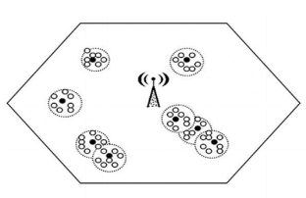

Figure 1.1 Small cell Network with UE VBS-

Network consisting of one BS where active UE-VBSs are the Black Nodes and UEs are the White Nodes. [11]

To illustrate our ideas, a simple scenario of a network consisting of one BS and eight active UE-VBSs is depicted in Figure 1.1. In this scenario, a BS needs to serve a number of UEs. However, the BS does not have the capacity to meet their requirements in terms of number of connections or bandwidth. To minimize the heavy load traffic problem, it is proposed that the BS can select a subset of the UEs served by the BS so as to serve a small neighborhood in their proximity by becoming UE-VBSs. These UE-VBSs are served by the BS and they in turn serve a number of UEs in their proximity. This project primarily focusses on the selection of UE-VBS by first forming clusters using a suitable clustering algorithm and then choosing one UE to act as a VBS for all the nodes in that cluster for a particular time instance t. The allocation of a UE to act as a VBS is dynamic and time-varying as the UEs are all mobile nodes.

**1.2 MOTIVATION AND OBJECTIVES**

Even though 5G has higher data rate, higher capacity, higher QoS among many communication parameters, when compared to 4th Generation networks (4G), the range of communication of 5G is much lesser (uses FR1, i.e., 4.1 Giga Hertz (GHz) to 7.125GHz band of frequencies) [12]. This is a major problem and should be improved for efficient communication. Therefore, a major paradigm shift is to be adopted. Small cells and ultra-dense networks will be deployed to make the network more flexible and to provide more users with network connectivity anywhere and anytime. These deployments are static but the UE nodes are mobile and thus a dynamic allocation is extremely important for the communication system to work with full efficiency.

The objectives of the proposed model are as follows:

* To position the UEs with pseudo random 2-Dimensional (2D) Cartesian coordinate pairs.
* To compute battery discharge rate for each UE in the cell.
* To determine best cluster size for a given small cell with multiple UEs.
* To organize each UE into a cluster by using a suitable clustering algorithm.
* To measure Power received using log-normal path loss.
* To choose eligible UEs from each cluster to act as a VBS based on Power received and battery discharge rate.
* To determine Signal to Interference plus Noise Ratio (SINR) for each eligible UE VBS and select eligible UE with maximum SINR to act as UE VBS.
* To measure sum rate and compare the results with Long Time Evolution (LTE), New Radio (NR) without algorithm and NR with algorithm.
* To measure power consumption and quality of service for evaluation of the performance of each cluster in the algorithm.

**1.3 ORGANISATION OF THE REPORT**

The remainder of the thesis is divided into chapters based on the following:

Chapter 2 deals with literature survey pertaining to the latest trends in VBS selection, Cluster head selection and parameters considered for the same. The pros and cons of the research is discussed.

Chapter 3 explains the current model of 5G, its drawbacks with regards to real-time deployment, and why it is essential to adopt the UE-VBS allocation algorithm for a proper 5G network implementation.

Chapter 4 presents multiple clustering algorithms, such as, Affinity propagation clustering, K-means clustering, Mean shift clustering and K-medoids clustering, the parameters and metrics considered for each and why K-means clustering is considered for clustering purposes and Mean shift clustering to select the number of clusters.

Chapter 5 deals with the different communication parameters like Received power, Battery discharge rate, SINR and Outage Probability which used for the selection of UE VBS and its importance for the same. It also analyses the network performance using Sum rate, Quality of Service (QoS) and Power consumption. It also explains the methodology of simulation and highlights the advantages of the selection algorithm.

Chapter 6 presents the experimental results obtained upon testing the algorithm. The plots obtained from the simulation are used to prove why our proposed selection algorithm performs better than an algorithm that selects UE VBSs in a random manner.

Finally, Chapter 7 summarizes the entire thesis, outlines possible future extensions and addresses the security concerns in the case of a malicious UE VBS.

**CHAPTER 2**

**LITERATURE REVIEW**

**2.1 INTRODUCTION**

Our system aims to produce UE based Virtual Base Station network in a 5G cell. Research is being extensively conducted in this area of 5G. We have listed some of those earlier researches below. While some of them are not directly based on 5G, they do provide an insight into multi hop communication which is slightly analogous to UE VBS communication.

**2.2 LITERATURE SURVEY**

***Selection of UE-Virtual small cell base stations using Affinity Propagation clustering:***Christophoros Christophorou et al (2018) have dealt with the concept of selecting an UE VBS through the prism of received power of an UE from an eligible UE VBS, alone. They have used the affinity propagation clustering to dynamically select UE-VBSs from some eligible UE-VBSs to act like BSs so that they can serve the requirements of UEs in that Small Cell (cluster). Advantage of the proposed method is that instead of the general process of passing messages among all the nodes, the authors have restricted the message passing procedure between the UEs and the eligible UE-VBSs. A major drawback of affinity propagation clustering is that it will not perform well in large-scale data set. Another drawback of this concept is that they have considered the received power of the UE as the only parameter. The authors have taken a message passing approach to selecting the UE VBS whereas, our research uses a path loss model and a probabilistic approach.

***LEACH Based energy efficient routing protocol for wireless sensor networks:***Alka Singh et al (2016) conceptualized a novel clustering protocol, named IEE-LEACH, to reduce energy consumption and improve the lifetime of WSNs. Compared with the existing routing protocols. This mechanism can improve the robustness of the network, extend the network lifetime and can optimize the number of Cluster heads and their distributions, which can effectively reduce the energy consumption. The proposed protocol employs single hop, multi-hop, and hybrid communications instead of a single communication mode in data transmission and thus decreases the overall communication cost and significantly improves the network lifetime. In our research, a similar approach has been taken wherein the communication from the BS to UE VBS to UE is considered a multi hop communication.

***An optimized clustering algorithm for mobile and Ad-Hoc networks:***S.Pathak et al (2017) considered the battery level of the UE to split the UEs into several clusters. This research pursuit analyzes a proposed algorithm named “an Optimized Stable Clustering Algorithm for mobile ad hoc networks (OSCA)” to minimize cluster head change and make cluster more stable and reduces clustering overhead. Through this, it will not only be able to make a network more stable by reducing number of cluster head changes but also reduce the clustering overhead. If a cluster head moves from the cluster, the immediate cluster head election is not required because backup node will act as new cluster head (in absence of cluster head) to make network more stable and later on, a backup node is created by the new cluster head. In this research, the author has implemented the algorithm for Ad Hoc networks, whereas we have used it as one of the parameters in 5G networks for clustering purposes.

***Outage probability for multi-hop D2D communications with shortest path routing:***Siyi Wang et al (2015) provides a tractable theoretical framework for analyzing the performance of Device-to-Device (D2D) communications. The authors have measured the outage probability for both Uplink and Downlink communication and inferred that D2D transmissions can severely degrade Conventional Cellular (CC) communications, but D2D links themselves can be reliable. There is a trade-off between D2D and CC reliability while considering whether to use Up Link (UL) or Down Link (DL) cellular radio resources for D2D communications. They have taken into consideration, both single and multi-hop communications. In our research, we use the SINR and Outage Probability formulae proposed in this literature to be used as one of the parameters in selecting the UE VBS.

**CHAPTER 3**

**5G REQUIREMENTS**

**3.1 INTRODUCTION**

In conventional cellular networks, mobile phones were practically the only type of device expected to be supported. With the proliferation of Internet and its numerous applications, there was the problem of handling several classes of traffic to meet the different Quality of Services (QoS) requirements of diverse applications like video streaming, data, etc. A similar situation is arising now with the need to support several types of devices and applications with drastically varying QoS requirement to provide better experience to the user. Unlike previous generations of cellular networks, 5G cellular network is envisioned to support a multitude of devices and applications like smartwatches, autonomous vehicles, Internet of Things (IoT), and tactile Internet. In particular, according to the International Telecommunication Union (ITU), there are three types of service scenarios to be supported in 5G, which are mobile broadband services, massive machine type communications, and ultra-reliable and low latency communications, respectively. The various types of devices and application scenarios need more sophisticated networks that not only can support high throughput, but also provide low latency in data delivery, efficient energy consumption scheme, high scalability to accommodate a large number of devices, and ubiquitous connectivity for users [17]. These requirements are described and how they can be met by potential solutions are explained below.

**3.2 HIGH DATA RATES**

The metric of data rate has been the most important evaluation factor over generations of wireless communication networks. With the advent of mobile Internet and services such as high-definition (HD) video streaming, pervasive video and video sharing, virtual reality available on mobile phones, as well as the proliferation of tablets and laptops which are accessible to wireless networks, increasing the data rate of cellular network is becoming an inevitable market driving force. Although the current maximum data rates can support HD video streaming which requires 8–15 (Megabits per second) Mbps, there are applications like ultra-HD 4K video streaming, high-definition gaming, and 3 Dimensional (3D) contents, which require even higher data rates at around 25 Mbps to provide a satisfactory experience to users. With these emerging applications demanding higher data rates, 5G networks are expected to have the peak data rate of around 10 Gbps which is a 100-fold improvement over current 4G networks. Besides increasing the maximum data rate, the cell-edge data rate, as the worst-case data rate users experience, should also be improved to 100 Mbps, which is a 100 times improvement over 4G networks at cell edge. The maximum data rate is an optimum estimate that a user can experience [15]. In fact, the effects of intercell interference and transmission loss make the maximum value hardly achievable. Therefore, edge data rate level becomes more important from the perspective of network engineering, as this data rate must support around 95% of users connected to the network. Another metric based on data rate that characterizes the network is the area capacity, which specifies the total data rate the network can serve per unit area. According to its definition, the unit of area capacity is normally bits per second per unit area. This metric is expected to increase 100 times in 5G compared to 4G network. This demand for increase in data rate can be met by techniques such as millimeter wave communications, massive Multiple-In Multiple-Out (MIMO) systems, and wireless software-defined networking (SDN), etc. [9]

**3.3 LOW LATENCY**

The roundtrip latency of data plane in the LTE network is around 15 milliseconds (ms). However, for the recently emerging applications such as tactile Internet, virtual reality, and multiplayer gaming that 5G networks are expected to support, the latency should be upgraded to an order of magnitude faster than current network, at around 1 ms. For instance, tactile Internet is a recently developed application where the wireless network is used for real-time control applications. The latency required for such applications is determined by the typical interaction for steering and control of real and virtual objects without creating cyber sickness. The expected latency that would make these applications feasible is around 1 ms. Although current smartphones have touch screens as the main interface, future devices will integrate various other interfaces like haptic, visual and auditory input and feedback, which will provide a new way of interacting with online environment for applications in virtual reality, healthcare, gaming, and sports, etc. These applications require real-time interactions with the user and any delay in the system will cause degradation to the user experience, thus latency is a crucial factor in 5G [18]. This type of communication requires extremely low latency for applications like vehicle-to-vehicle communication. The requirement of low latency will also improve the user experience for currently existing applications such as multi-user gaming.

**3.4 LOW ENERGY CONSUMPTION**

The 5G networks are expected to support the IoT devices which are basically some sensors that gather information about an environment and transmit it to a central server. These devices are mostly low-power, low-cost devices with lifespans as long as several years. Since these devices are not always connected to the base station and are only switched on occasionally, their battery life cannot afford the process of synchronization with the base station every time, as the synchronization step costs more energy than that of actual data transmission. This specific case in IoT requires that the radio access technique for 5G support loose or no synchronization [7]. Moreover, this type of service also puts constraints on the computational power for decoding, the length of header, and packet forwarding scheme, etc. With the increasing number of connected smart devices, the number of base stations required to support these devices will also escalate. Because of the deployment of small cells, the base station will be densified. This foreseeable trend demands the base stations to be energy efficient since even a small improvement in energy efficiency will translate to huge energy savings in large scale.

**3.5 HIGH SCALABILITY**

To support increasing number of mobile devices that connect to the wireless network and communicate with each other, network scalability becomes an important factor in design of the next generation wireless communications network. The increase in number of devices is further aggravated by the myriad of IoT devices and vehicle-to-vehicle communication technologies that are expected to surge in the 5G cellular network. Consequently, a highly scalable network that can efficiently accommodate this upsurge in number of devices is required [10]. High scalability is also critical to performance of current and emerging applications, such as the IoT services, autonomous vehicles, etc. In the case of autonomous vehicles, prompt communications among them at high traffic densities necessitate the scalability of cellular network. In fact, the scalability of a network requires full-scale upgrade in all network layers. On the physical layer, there should be enough frequency spectrum resources to support high volume of signaling and data transmission. The network infrastructure should also be able to control the transmitted power adaptively for channel estimation and to minimize interference. Scalability also influences the design of efficient media access control (MAC) protocols to accommodate large amounts of connected devices. Scheduling and multicasting protocols based on geographic locations of users can greatly reduce the latency and increase the spectral efficiency. At the network and transport layers, high scalability requires networks to deploy intelligent routing algorithms for huge groups of users to provide fast and reliable connections. For users with high mobility, the vehicular network should also satisfy the scalability by providing efficient and reliable handoffs along the directions of the moving routes, as well as designing dynamic routing algorithms based on the user movement prediction. The scalability in networks will be achieved by changes in all layers from radio access to core networks, using wireless software defined networks and network function virtualization.

**3.6 IMPROVED CONNECTIVITY AND RELIABILITY**

Apart from the aforementioned requirements, coverage and handover efficiency should also be improved for a better user experience, particularly when millimeter wave spectrum is exploited. With the increase in density of the base stations and the number of devices connected, as well as the introduction of femtocells and picocells, the number of handovers that the base station should handle will increase by at least two orders of magnitude. To support this demand, novel handover algorithms and techniques that provide improved coverage in cell edge areas are required. Another related issue is the authentication and privacy concerns related to the handover. The delay to contact the authentication server for each handover will be hundreds of milliseconds which would be intolerable for 5G applications [20]. Also, given the use of higher frequency bands in millimeter wave, the transmission range of signals is greatly reduced. Hence, maintaining connectivity becomes a great challenge for 5G. For mission-critical services, the requirements on high reliability as well as connectivity should always be guaranteed.

**3.7 IMPROVED SECURITY**

The security aspect of wireless network recently attracts high attention, especially after 2015, when the applications of mobile payments and digital wallet became popular. In retrospect of the previous generations of systems, the general purpose of security is to protect basic connectivity and maintain user privacy. However, since the 5G system will ultimately face the dramatically increasing data traffic in the entire network, the requirement of security of 5G should not only be limited to providing trust worthy connectivity to users, but also improving the security on the whole network, addressing concerns on authentication, authorization as well as accounting, developing novel encryption protocols, and safeguarding cloud computing and management activities. As the IoT will come to its prime time in 5G networks, the processes of authentication, authorization, and accounting for interconnected devices should be granted with fine grained protecting mechanisms [20]. Network operators, device manufacturers, as well as standardization bodies should work together on designing services, products, and protocols that can substantially protect the users subscribed to the 5G wireless network. Most importantly, as the Internet has become one of the indispensable infrastructures of the society similar to power grids, there should be enhanced federal regulations on liabilities and obligations on wireless network security. The 10 enabling technologies will collaborate to shape the 5G network architecture. The radio access network architecture will be enhanced with the deployment of wireless software-defined networking, network function virtualization, ultra-densification, device-to-device communications, millimeter wave, massive MIMO, and new radio access techniques, while the core network will evolve with key roles played by wireless software-defined networking, network function virtualization, Internet of Things, green communications, big data and mobile cloud computing.

**3.8 SUMMARY**

One of the key issues with the 5G requirements is that there are many different interested parties involved, each wanting their own needs to be met by the new 5G wireless system. This leads to the fact that not all the requirements form a coherent list. No one technology is going to be able to meet all the needs together.

As a result of these widely varying requirements for 5G, many anticipate that the new wireless system will be an umbrella that enables a number of different RANs to operate together, each meeting a set of needs. As very high data download and ultra-low latency requirements do not easily sit with low data rate and long battery life times, it is likely that different RANs will be needed for each of these requirements.

Accordingly, it is likely that various combinations of a subset of the overall list of requirements will be supported when and where it matters for the 5G wireless system.

**CHAPTER 4**

**CLUSTERING ALGORITHM**

**4.1 CLUSTERING**

Clustering (aka Cluster analysis) is the process of grouping a set of objects in such a way that objects in the same group (called a cluster) have similar features (in some sense) to each other than to those in other groups (clusters). It is important to organize all the UEs into clusters based on one or more attributes of comparison (metric).

Table 4.1. Comparison between different clustering algorithms [4]

|  |  |  |  |  |
| --- | --- | --- | --- | --- |
| **Criteria** | **Affinity Propagation** | **K-mean** | **K-medoid** | **Mean Shift** |
| Initial condition | No | Yes | Yes | Yes |
| Termination condition | Not precise | Precise | Precise | Precise |
| Effect on size of data sets | Not good | Good | Not good | Not good |
| Handling dynamic data | No | Yes | Yes | Yes |
| Implementation | Simple | Simple | Complicated | Complicated |

Table 4.1 shows the comparison between different clustering algorithms and why K-means is more suitable comparatively for the UE VBS selection algorithm. UE VBS selection algorithm handles dynamic data as UEs are mobile nodes and the data sets can be huge as there may be multiple UEs at a given location at an instance.

**4.2 CLUSTERING PARAMETERS AND METRICS**

Each clustering algorithm uses different clustering parameters such as number of clusters, bandwidth, distance threshold, linkage, etc. or a combination of the mentioned.

Table 4.2 Clustering algorithm parameters and metrics

|  |  |  |
| --- | --- | --- |
| **Clustering algorithm** | **Parameters** | **Metric** |
| Affinity propagation | Damping, sample preference | Graph distance |
| K-mean | Number of clusters | Distances between points |
| K-medoid | Number of clusters | Distances between points |
| Mean Shift | Kernel Bandwidth | Surface peak |

Table 4.2 illustrates the parameters considered for different clustering algorithms that is discussed and the evaluation metric with which the accuracy of the algorithm will be tested.

A major drawback of affinity propagation clustering is that it will not perform well in large-scale data sets, that of K-medoid is the complexity of its implementation and that of Mean shift is that even distribution of data points is not observed. [22] K means being one of the oldest algorithms is the most approachable and works well with small-scale and large-scale data sets equally.

**4.3 K-MEANS CLUSTERING ALGORITHM**

The K**-**means clustering algorithm is an unsupervised machine learning technique used to identify clusters of data objects in a dataset. Here, the data objects are UEs and the data set is location information. There are multiple clustering algorithms, but K-means is one of the oldest and most approachable. It is also important to cluster UEs into non-overlapping groups which can be achieved using K-means. K-means clustering algorithm uses distance (Euclidean) as the metric and number of clusters as the parameter. [24]

The steps involved in k-means clustering algorithm is given below-

* Specify number of clusters K.
* Initialize centroids by first shuffling the dataset and then randomly selecting K data points for the centroids without replacement.
* Keep iterating until there is no change to the centroids, i.e., assignment of data points to clusters isn’t changing.
* Compute the sum of the squared distance between data points and all centroids using Euclidean distance formula.

d= (4.1)

Equation 4.1 describes the Euclidean distance formula where d is the Euclidean distance, n is the number of clusters and x1, x2, y1, y2 are UE coordinates.

* Assign each data point to the closest cluster (centroid).
* Compute the centroids for the clusters by taking the average of all data points that belong to each cluster.

The optimum size of number of clusters (K) is extremely essential as it is the only parameter considered for K-means clustering algorithm. This can be determined by using Elbow method. To perform the elbow method, K-means is run several times with k value incremented for each iteration, and the Sum of the Squared Error (SSE) is recorded. The value of SSE takes a dip at a particular cluster size value and this is referred to as elbow. [22]

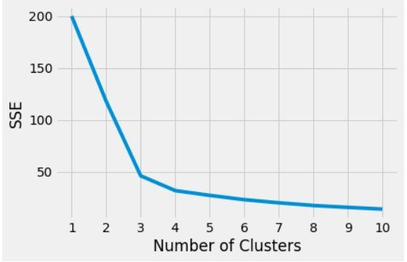

Figure 4.1 Plot of SSE vs Number of clusters

Figure 4.1 is a plot between SSE and number of clusters, from which it can be inferred that SSE continues to decrease as the number of clusters increases (k). The point where SSE takes a bend is the elbow point and at this point, the value of k can be used as the optimum cluster size. There is another clustering method called Mean Shift Clustering.

**4.4 MEAN SHIFT CLUSTERING**

Mean shift is a clustering algorithm in contrast of Unsupervised learning that assigns the data points to the clusters iteratively by shifting points towards the mode (highest density of data points in the region). It is also known as the Mode-seeking algorithm. Unlike the K-Means clustering algorithm, mean-shift does not require specifying the number of clusters in advance. The number of clusters is determined by the algorithm with respect to the data.

Mean-shift builds upon the concept of kernel density estimation (KDE). It is a method to estimate the underlying distribution also called the probability density function for a set of data. It works by placing a kernel on each point in the data set. A kernel is a weighting function generally used in convolution. There are many different types of kernels, but the most popular one is the Gaussian kernel. Adding up all of the individual kernels generates a probability surface example density function. Depending on the kernel bandwidth parameter used, the resultant density function will vary [21].

The steps involved in k-means clustering algorithm is given below-

* Initialize random seed and window W.
* 2. Calculate the center of gravity (mean) of W.
* 3. Shift the search window to the mean.
* 4. Repeat Step 2 until convergence.

Kernel density estimator for the full population’s density function is given by Equation 4.2,

(4.2)

Where, ui is the set of points in d-dimensional space of the given dataset, sampled from some larger population, K is the chosen Kernel function having bandwidth parameter h.

The kernel function, K here is required to satisfy the following two conditions:

1. (4.3)

2. for all values of u (4.4)

Two popular kernel functions that satisfy these conditions are given by-

1. Flat/Uniform K(u) = (4.5)

2. Gaussian = K(u) = (4.6)

**4.5 SUMMARY**

On comparing with different clustering algorithms, Mean Shift Clustering has an advantage over K Means, as the algorithm itself determines the number of clusters. But the downside to Mean Shift clustering is that the data points are not evenly clustered. Thus, K Means Clustering algorithm is found to be most suitable for large and dynamic data sets and the implementation is much easier. The distance between the different UEs is computed using Euclidean distance formula which only requires the two-dimensional coordinates, i.e., the (x, y) coordinates of all the UEs in the data set. The optimal cluster size for a given data set is obtained by either using the elbow method as discussed in the last segment of the sub-chapter 4.3 or, mean Shift Clustering can be used to identify the cluster size alone.

**CHAPTER 5**

**METHODOLOGY OF IMPLEMENTATION**

**5.1 INTRODUCTION**

Having discussed the clustering algorithms and communication parameters prominently used in our UE-VBS selection algorithm, we move on to deal with the methodology of implementation. The flowchart of implementation is shown in Figure 5.1. The location coordinates of UEs are initialized which denote the position of the UEs at a given time ‘t’. These UEs are mobile nodes and hence do not have a static location for a long time, thus the UE VBSs have to be allocated dynamically w.r.t it’s position at different instances.

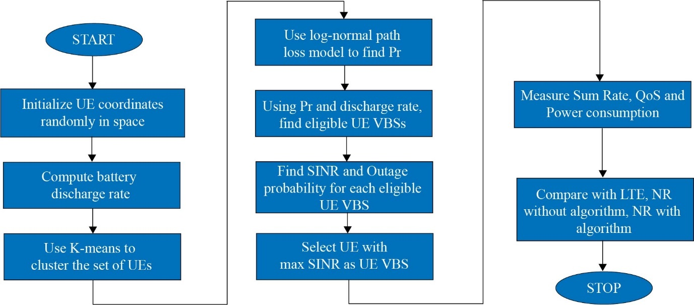

Figure 5.1 Flowchart of implementation

The battery discharge rate is calculated for each UE. Each UE has to be organized into clusters based on their Euclidean distance adopting the K-means clustering algorithm. The cluster size depends on the number of UEs and its positions which again depends on the given data set which is found using Mean shift clustering. The optimal cluster size can be obtained by using Elbow point method as well. Once the UEs are organized into clusters, the received power of each UE from the BS is obtained using the log-normal path loss model.

Based on the battery discharge rate and received power, the eligible UE VBSs in each cluster are marked. The SINR and Outage probability of these eligible UE VBSs in each cluster are calculated and out of the eligible UE VBSs in a particular cluster, the UE with the highest SINR value is selected to act as the UE VBS for that cluster. The sum rate of the allocated UE VBS in each cluster is calculated using Shannon capacity theorem. The QoS is measured using Jain’s Fairness Index. The power consumption is the difference between the transmitted and received powers across the network.

**5.2 CLUSTERING IN A DYNAMIC ENVIRONMENT**

The position of UEs are initialized as Cartesian pairs, i.e., (x, y) coordinates in space. The angle, speed and time intervals are initialized randomly to facilitate movement of UEs to deploy a dynamic selection environment. The UEs are mobile nodes and thus at various intervals, their positions and movements are dynamic. At a time t1, an UE, say UE1, can belong to cluster 1 but at time t2, it can belong to cluster 4. This is because clustering is done using K-means clustering algorithm which uses Euclidean distance to allocate UEs into different clusters.

The speed is randomly varied between 0 m/s to 10 m/s and angle between 10 to 350 degrees and these changes occur at a time interval of 20 s.

**5.3 COMMUNICATION PARAMETERS**

After clustering, the process of cluster head selection has to be carried out, i.e., selection of UE to act as VBS for every cluster. For selection of eligible UEs the communication parameters considered are:

* Battery discharge rate
* Received power
* SINR
* Outage Probability

Using the aforementioned parameters, the cluster head i.e., the UE VBS is selected. The performance of the network is computed with the following Network performance indicators:

* Sum rate
* Quality of Service
* Power consumption

**5.4 BATTERY DISCHARGE RATE CALCULATION**

Battery power is one of the major factors in a wireless Ad hoc network. A node can transmit data to a longer distance only if it has sufficient battery power. Since most UEs are portable devices, they are not often reliable to withstand transmission of 5G signal for a long period of time. When a device’s battery dies, the network functionality gets disrupted. [23], [16] Hence, the battery discharge rate of the eligible UE-VBSs is an important factor in the selection of a suitable VBS.

(5.1)

Equation 5.1 shows that the battery discharge rate is calculated as the ratio of instantaneous battery life, which is a value between 4000 to 7000 (in mAh), to discharge time in hours, which is a value in the range of 1 to 15 hours. These values are assigned and calculated randomly.

In a real-time scenario, these values can be obtained from the battery design information of each node.

**5.5 RECEIVED POWER CALCULATION**

The Power received by each UE in a cluster from the BS is a very important communication parameter, as this decides how much power will be relayed to the other nodes in the cluster once it is assigned as a VBS. When a signal travels over a channel medium, the signal power tends to fade due to power dissipation with distance and effects of the propagation channel. [11]

*[PL(d)]dB= [PL(d0)]dB + 10 n log10 +* *χ* (5.2)

*for df <d0 < d*

Equation 5.2 gives the received power of each UE from a BS is calculated using the log normal path loss model where,

Path loss exponent, n = 4;

χ is a Gaussian random variable;

d is the distance between Tx and Rx.

PL(d0) is reference path loss calculated using Friis free space formula:

PL(d0) = where (5.3)

Equation 5.3 is the Friis free space formula which is used to find the reference path loss, where,

* = Transmit Power
* = Received Power at a distance ‘d’
* = Transmit antenna power gain
* = Received antenna power gain
* = Wavelength
* , System loss factor not related to propagation
* = Separation distance.

The values considered for the received power () calculation are:

Transmit antenna gain = 1; Receiver antenna gain () = 1 (For simplicity)

Transmit Power ()= 43 dBm (Generally in the range of 43-46 dBm)

Path loss exponent (*L*)= 4 (Obstructed in building- includes shadowing)

Frequency (*FR1*) = 5 GHz (5G frequency range; FR2- Transition of signal from indoor to outdoor is very poor)

Wavelength (0.06 m

Path loss gives a measure of signal attenuation. It is usually measured in dB. It is defined as a difference between the transmitted antenna gains. The values of Path Loss for different environments are listed in Table 5.1.

Table No. 5.1 Variation of Path Loss in different environments

|  |  |
| --- | --- |
| **Environment** | **Path Loss Exponent** |
| In building line-of-site | 1.6 to 1.8 |
| Free space | 2 |
| Obstructed in factories | 2 to 3 |
| Urban area cellular radio | 2.7 to 3.5 |
| Shadowed urban cellular radio | 3 to 5 |
| Obstructed in building | 4 to 6 |

The received power predicted by path loss models is influenced by:

* Reflection: Reflection occurs when the propagation waves impinge on objects with dimension larger than λ.
* Diffraction: Diffraction is caused by sharp irregularities in the path of radio waves. It leads to development of secondary wave fronts, bending of waves. It is caused by objects which are in order in λ. It depends on geometry of the objects, amplitude, phase and polarization of incident waves.
* Scattering: Scattering is caused by objects which are smaller than λ.

**5.6 SINR CALCULATION**

Signal to Interference plus Noise Ratio is used to measure channel capacity in wireless communication systems. It is the measure of power of signal of interest divided by the sum of interference power from all interfering signals and power of background noise. If the background noise is zero or negligible, SINR reduces to SIR (Signal to Interference Ratio) and similarly if Interference is zero, SINR reduces to SNR (Signal to Noise Ratio). SINR has multiple important applications which include optimizing transmit power level for a target QOS, assisting with handoff decisions and dynamically adapting the data rate for wireless applications [15].

γn,m (5.4)

Equation 5.4 gives the signal-to-interference-plus-noise ratio (SINR) of a link from UE-n to UE-m, where,

Fading power gain, hn,m and Interference power gain ht.m are Rayleigh random variables (X+jY) where X and Y are Gaussian distributed Random Variables.

rn,m is the distance of the link from UE n to UE m

Pn is the transmit power of UE n (depends on distance of UE, etc.)

Frequency dependent pathloss, λ = 4 (For outdoor communication, path loss is independent of frequency)

Pathloss distance exponent, α = 4

Noise power, = -174 + log10(bandwidth)

m denotes the set of interferers to UE m, and σ2 is the additive white Gaussian noise (AWGN) power. The AWGN power is assumed to be negligible as compared to the interference power and that the traffic follows a full buffer model.

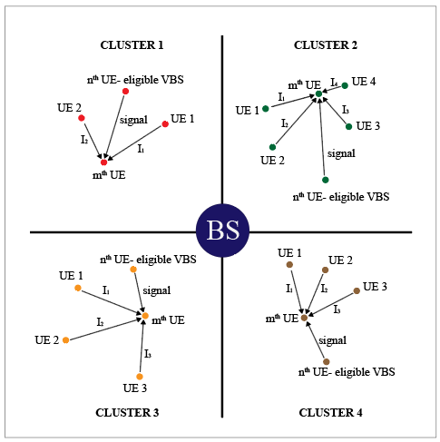

Figure 5.2 Transmission of signal in the presence of interference

Figure 5.2 shows the transmission of downlink signal from the nth UE (Eligible VBS) to mth UE in the presence of interference from UE1, UE2, UE3 and so on, in each cluster.

**5.7 OUTAGE PROBABILITY CALCULATION**

Outage probability is defined as the point at which the received power value falls below the threshold (where the power value relates to the SINR within a cell).

Outage Probability*= P(SINR ⩽ λth )*

The D2D transmission from one UE to another UE using DL radio resources is considered. [16]

*[𝔼](https://en.wiktionary.org/wiki/%F0%9D%94%BC)[R](https://en.wiktionary.org/wiki/%F0%9D%94%BC)[() = 1- ;](https://en.wiktionary.org/wiki/%F0%9D%94%BC)*  [(5.5)](https://en.wiktionary.org/wiki/%F0%9D%94%BC)

where Ω = 1 + and PBS is the power of BS.

Equation 5.5 gives the expected outage probability for a single-hop D2D link using DL resources, where,

is number density of Base Stations = 2/ (Area of the cell)

 is the number density of UEs = (Number of UEs in one cluster-1) / (Area of the cluster)

 𝜏 is the average SINR of the chosen cluster.

**5.8 SUM RATE CALCULATION**

Sum rate is the sum of all rates of communications that is successfully sent/received over the communication link, happening in a network. Sum rate differs from bandwidth due to a range of technical issues, including latency, packet loss, jitter and more. If a signal has more bandwidth, that is, it includes or is compatible with higher frequencies, it can change more rapidly. Thus, more bandwidth corresponds to a higher maximum rate of data transfer. [14]

**5.8.1 UE LEVEL**

R = *Blog10(1 + SINR)* bps (5.6)

Equation 5.6 gives the sum rate/ data rate for individual UEs which is calculated using Shannon Capacity, where,

R is the Data rate,

B is the Channel Bandwidth = 100 MHz for 5G and 20 MHz for LTE,

SINR is the Signal to Interference plus Noise Ratio.

**5.8.2 SYSTEM LEVEL**

(5.7)

The entire system’s sum rate is obtained using Equation 5.7, where,

c-size is the cluster size

SINR i is the SINR of ith cluster

i is the Average SINR of ith cluster

The sum rate obtained from the above formula denotes the NR sum rate using the UE VBS selection algorithm. The sum rate of NR without algorithm and that of LTE is compared with the results obtained using our algorithm and the conclusions are drawn. The UEs are mobile nodes, so when each time a UE moves, it’s Euclidean distance changes and therefore a UE can move in/out of different clusters at different instances, since clustering is done using Euclidean distance as the metric. Therefore, the allocation of UEs into clusters is done dynamically in real-time.

**5.9 QUALITY OF SERVICE**

Quality of Service (QoS) is a set of technologies that work on a network to guarantee its ability to dependably run high-priority applications and traffic under limited network capacity. QoS technologies accomplish this by providing differentiated handling and capacity allocation to specific flows in network traffic. This enables the network administrator to assign the order in which packets are handled, and the amount of bandwidth afforded to that application or traffic flow.

յ(x1,x2, …., xn) = 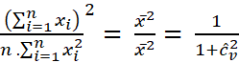 (5.8)

Quality of Service of the network is measured using Equation 5.8 which gives the Jain’s fairness index (JFI), where,

*n* is the number of users in the system at a particular instance of time,

Image is the sample coefficient of variation of spectral efficiency, and

is the spectral efficiency for the *i-*th connection as given in equation 5.9,



(5.9)

Where,

is the spectral efficiency for the link between the ith UE and its corresponding VBS,

N is the number of clusters,

pi is the received power from the BS/VBS,

gi is the Rayleigh channel gain which is a random variable and

Noise power, N0 = -174 + log10(bandwidth)

Absolute fairness (i.e. all users receive the same allocation of the shared medium or metric) is achieved when JFI = 1 and absolute fairness is achieved when JFI = Image. This metric can identify underutilized channels and it is not excessively sensitive to network flow patterns [19].

**5.9 POWER CONSUMPTION**

Power consumption is the difference between the sum of transmitted powers in a cell and the sum of received powers. In this case, the Base station transmits information to all the UEs in the cell to select the UE-VBSs. Following the selection of UE-VBSs, each of them start transmitting information to UEs in their respective cells. Equation 5.10 gives the value of power consumption across the cell.

(5.10)

Where,

N is the total number of UEs in the cell,

is the transmit power of Base station antenna,

is the power received by the ith UE,

M is the total number of clusters,

Ki is the number of UEs in the ith cluster

is the power of the ith VBS and

is the power of the jth UE in the ith cluster.

**CHAPTER 6**

**SIMULATION RESULTS AND DISCUSSIONS**

**6.1 RESULTS OF THE FINAL ALGORITHM**

A hundred UEs are positioned in a pseudo random manner at a time instant t1 as shown in Figure 6.1. From a signaling point of view, the BS requests information from all UEs. Thus, number of UEs, i.e., 100 signals are sent. Then each UE responds back with coordinates, signal quality, etc., which adds another 100 signals. Then the BS responds back to the potential UE-VBS to become UE-VBS. Hence, 3 more signals are added to the overall signaling overhead, making it 203 in total for this scenario. After dt seconds, the positions of the UEs are arbitrarily changed by assigning random velocity to each UE for two other time instances t2 (t1+dt) and t3 (t1+2 x dt).

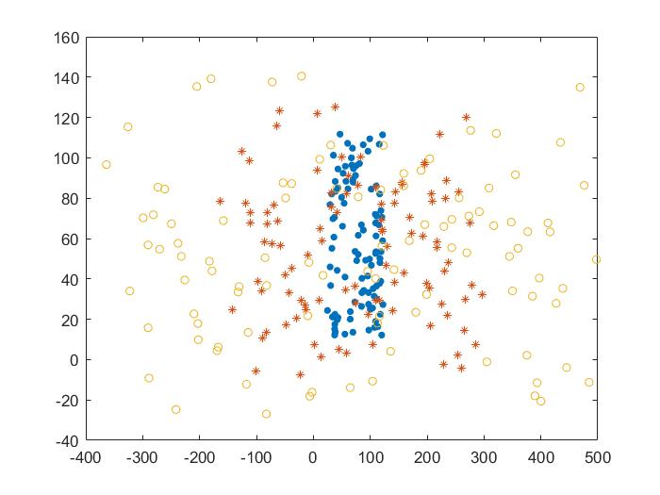

Figure 6.1 Position of 100 UE’s at time t1, t2 and t3

The cluster size is obtained using mean shift clustering and the clustering is done using K-means clustering. From each cluster, the algorithm selects an UE to act as a VBS using power received, battery discharge rate and SINR, at time instance t1 as shown in the Figure 6.2.

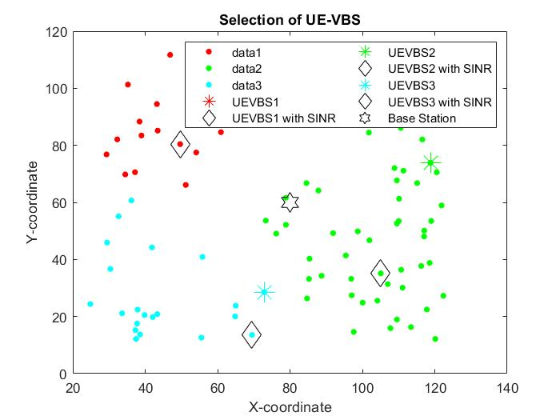

Figure 6.2 Selection of UE VBS for 100 UEs, at time t1

The power consumption in each cluster is computed using the difference between transmitted and received powers between the UEs, Base Station and UE-VBS, selected at using the algorithm, at time instance t1, as shown in the Figure 6.3.

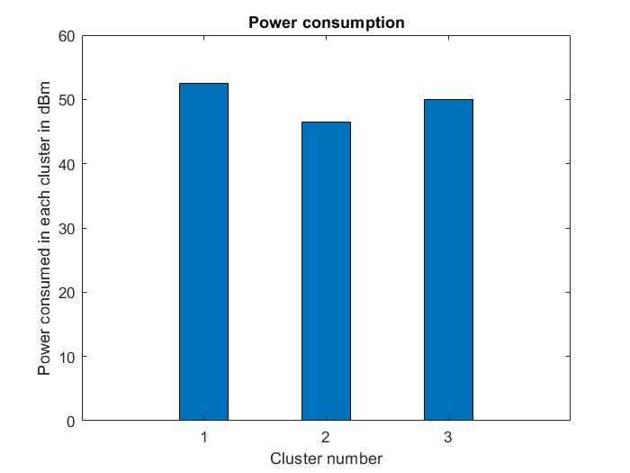

Figure 6.3 Power Consumption at time t1 for 100 UEs

From Figure 6.4, it is observed that QoS values are close to 1 in each cluster at time instance t1. Thus, it can be inferred that all the UEs receive a good quality 5G connection. Hence, applications like streaming, video calls and gaming experiences will match the satisfactory levels.

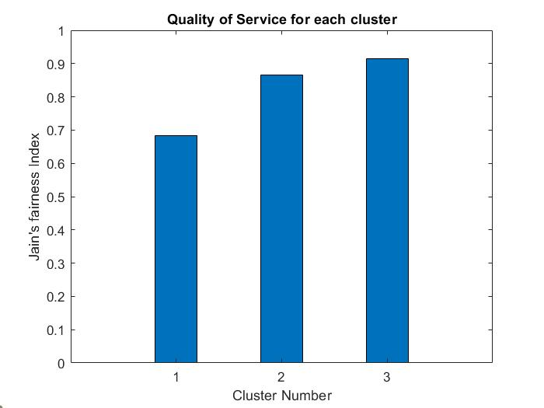

Figure 6.4 Quality of Service at time t1 for 100 UEs

The average sum rate for each cluster is computed using the Shannon-Hartley theorem for an UE VBS selected by the proposed algorithm against an UE VBS selected at random (and for an LTE base station) at time instance t1, as shown in the Figure 6.5.

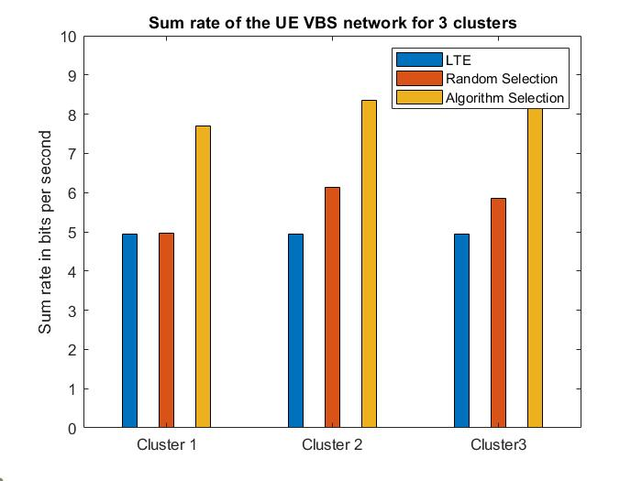

Figure 6.5 Average Sum rate for different clusters at time t1 for 100 UEs

From each cluster, the algorithm selects an UE to act as a VBS using power received, battery discharge rate and SINR, at time instance t2 as shown in the Figure 6.6.

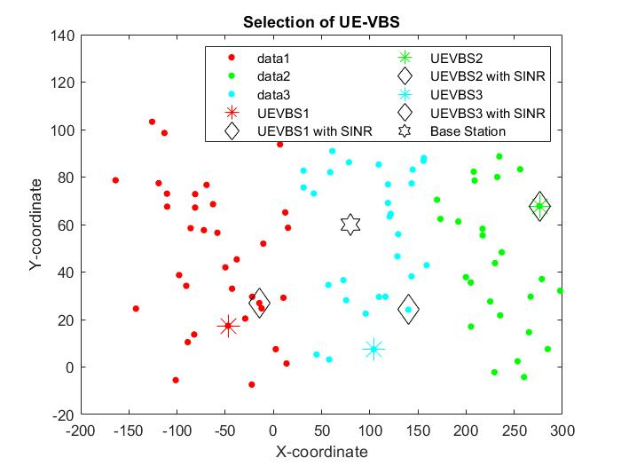

Figure 6.6 Selection of UE VBS for 100 UEs, at time t2

The power consumption in each cluster is computed using the difference between transmitted and received powers between the UEs, Base Station and UE-VBS, selected at using the algorithm, at time instance t2 as shown in the Figure 6.7.

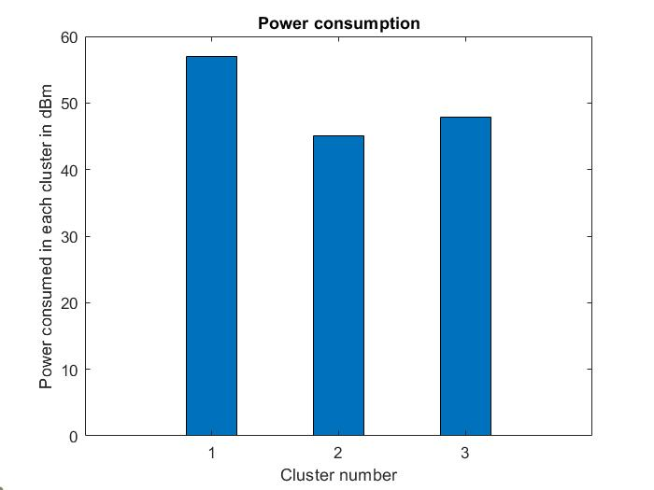

Figure 6.7 Power Consumption at time t2 for 100 UEs

From Figure 6.8, it is observed that QoS values are close to 1 in each cluster, at time instance t2. Thus, it can be inferred that all the UEs receive a good quality 5G connection. Hence, applications like streaming, video calls and gaming experiences will match the satisfactory levels.

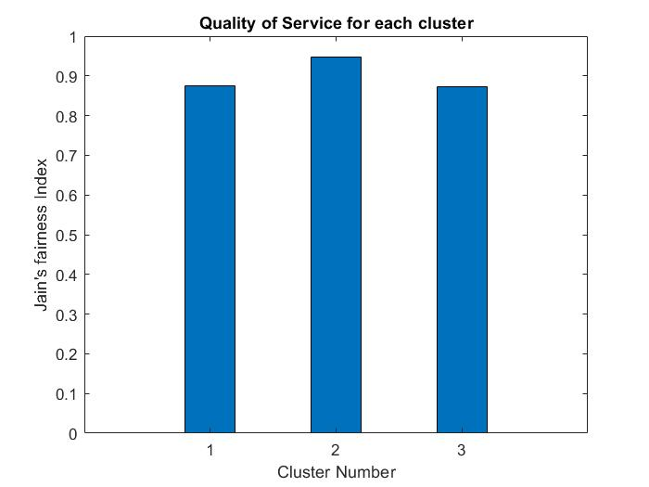

Figure 6.8 Quality of Service at time t2 for 100 UEs

The average sum rate for each cluster is computed using the Shannon-Hartley theorem for an UE VBS selected by the proposed algorithm against an UE VBS selected at random (and for an LTE base station) at time instance t2, as shown in the Figure 6.9.

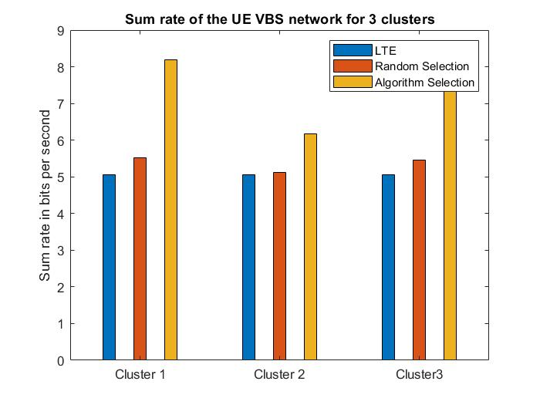

Figure 6.9 Average Sum rate for different clusters at time t2 for 100 UEs

From each cluster, the algorithm selects an UE to act as a VBS using power received, battery discharge rate and SINR, at time instance t3 as shown in the Figure 6.10.

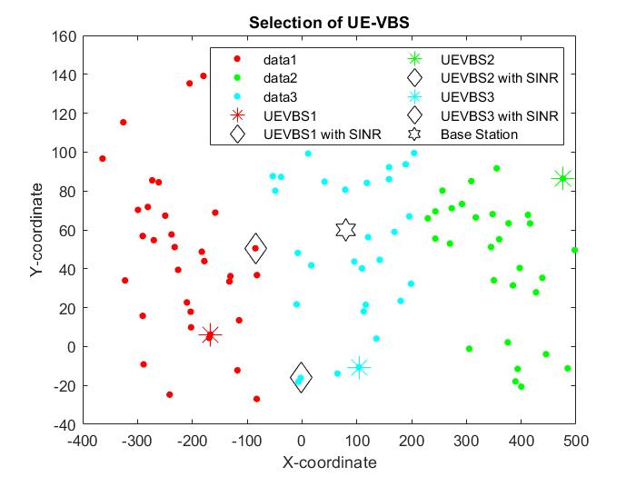

Figure 6.10 Selection of UE VBS for 100 UEs, at time t3

The power consumption in each cluster is computed using the difference between transmitted and received powers between the UEs, Base Station and UE-VBS, selected at using the algorithm, at time instance t3, as shown in the Figure 6.11.

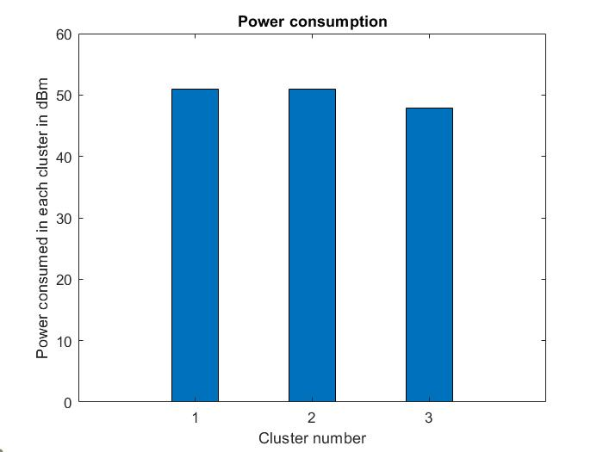

Figure 6.11 Power Consumption at time t3 for 100 UEs

From Figure 6.12, it is observed that QoS values are close to 1 in each cluster, at time instance t3. Thus, it can be inferred that all the UEs receive a good quality 5G connection. Hence, applications like streaming, video calls and gaming experiences will match the satisfactory levels.

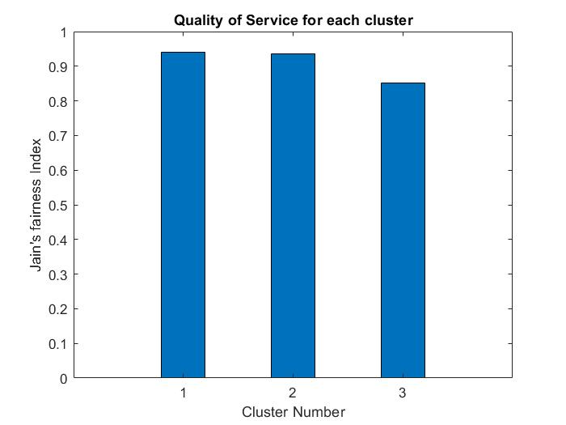

Figure 6.12 Quality of Service at time t3 for 100 UEs

The average sum rate for each cluster is computed using the Shannon-Hartley theorem for an UE VBS selected by the proposed algorithm against an UE VBS selected at random (and for an LTE base station) at time instance t3, as shown in the Figure 6.13.

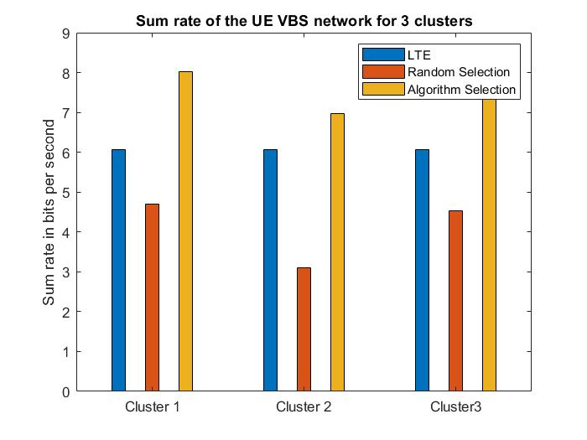

Figure 6.13 Average Sum rate for different clusters at time t3 for 100 UEs

**6.2 PERFORMANCE ANALYSIS FOR VARIOUS CLUSTER SIZES**

From each cluster, the algorithm selects an UE to act as a VBS using power received, battery discharge rate and SINR, for cluster size 2 as shown in the Figure 6.14.

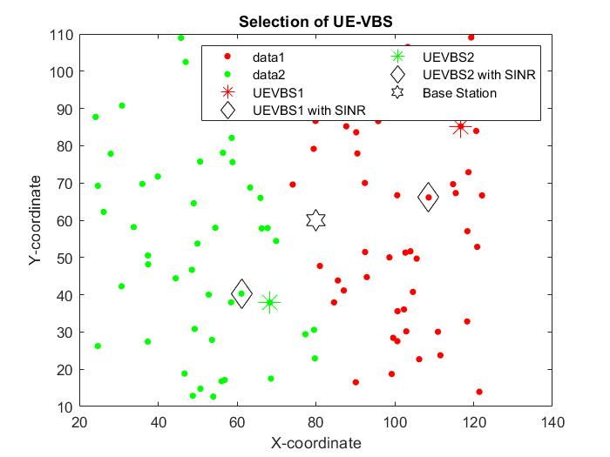

Figure 6.14 Selection of UE VBS for cluster size 2

The power consumption in each cluster is computed using the difference between transmitted and received powers between the UEs, Base Station and UE-VBS, selected at using the algorithm for cluster size 2, as shown in the Figure 6.15.

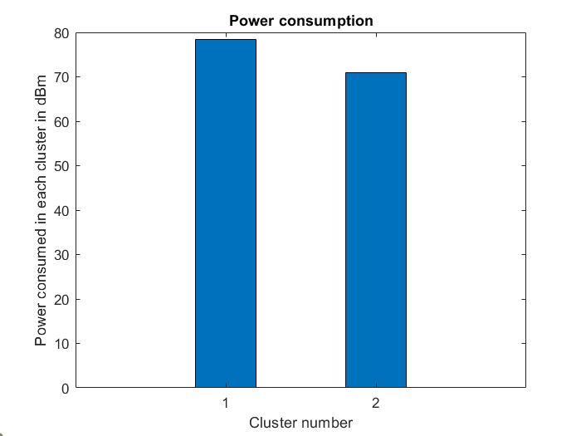

Figure 6.15 Power Consumption of UE VBS for cluster size 2

From Figure 6.16, it is observed that QoS values are close to 1 in each cluster, for cluster size 2. Thus, it can be inferred that all the UEs receive a good quality 5G connection. Hence, applications like streaming, video calls and gaming experiences will match the satisfactory levels.

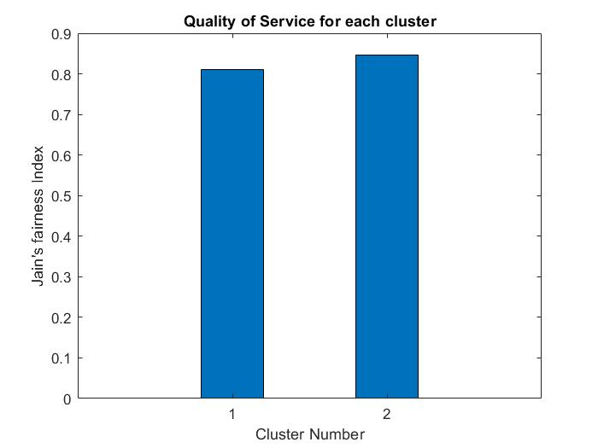

Figure 6.16 Quality of Service for cluster size 2

The average sum rate for each cluster is computed using the Shannon-Hartley theorem for an UE VBS selected by the proposed algorithm against an UE VBS selected at random (and for an LTE base station) for cluster size 2 as shown in the Figure 6.17.

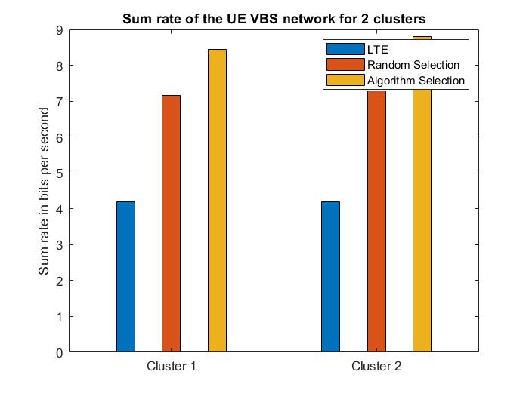

Figure 6.17 Average sum rate of UE VBS for cluster size 2

From each cluster, the algorithm selects an UE to act as a VBS using power received, battery discharge rate and SINR, for cluster size 3 as shown in the Figure 6.18.

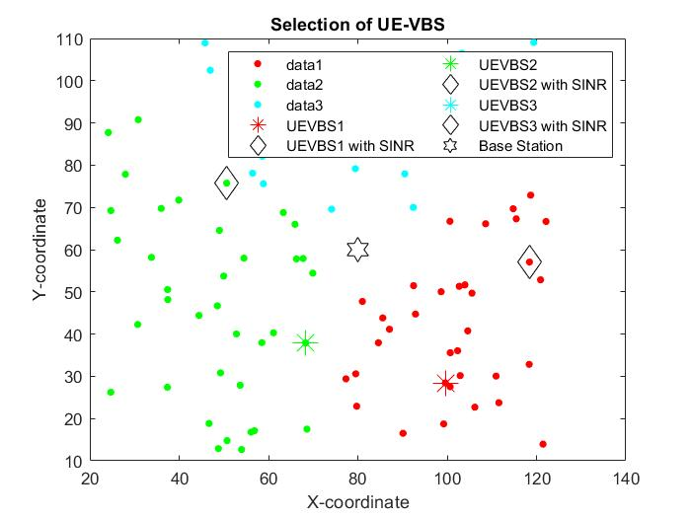

Figure 6.18 Selection of UE VBS for cluster size 3

The power consumption in each cluster is computed using the difference between transmitted and received powers between the UEs, Base Station and UE-VBS, selected at using the algorithm for cluster size 3, as shown in the Figure 6.19.

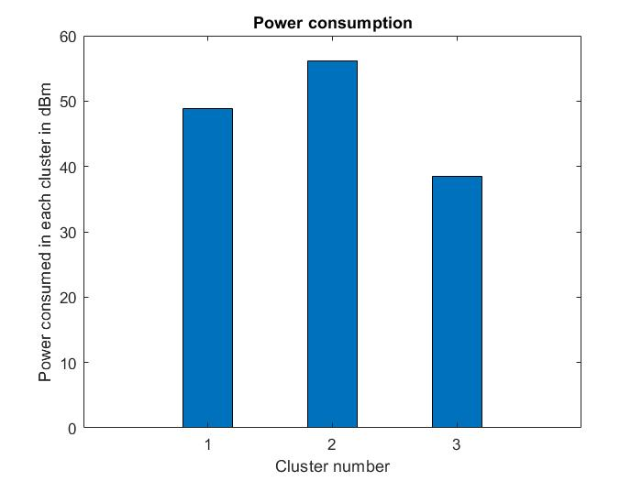

Figure 6.19 Power Consumption of UE VBS for cluster size 3

From Figure 6.20, it is observed that QoS values are close to 1 in each cluster, for cluster size 3. Thus, it can be inferred that all the UEs receive a good quality 5G connection. Hence, applications like streaming, video calls and gaming experiences will match the satisfactory levels.

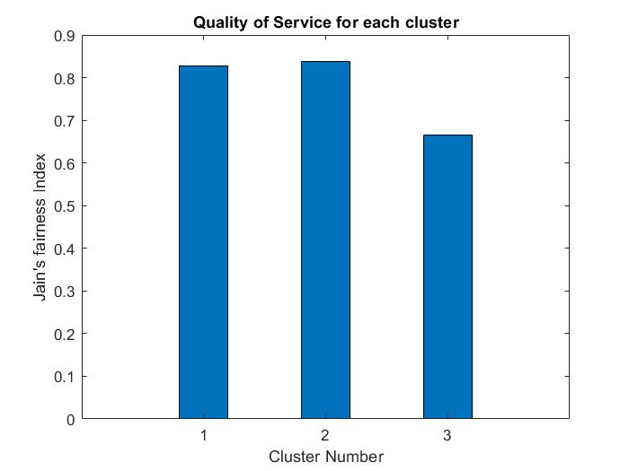

Figure 6.20 Quality of Service for cluster size 3

The average sum rate for each cluster is computed using the Shannon-Hartley theorem for an UE VBS selected by the proposed algorithm against an UE VBS selected at random (and for an LTE base station) for cluster size 3 as shown in the Figure 6.21.

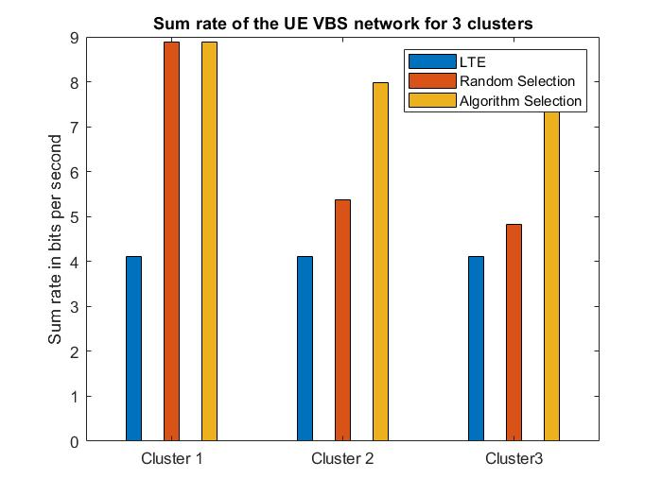

Figure 6.21 Average sum rate of UE VBS for cluster size 3

From each cluster, the algorithm selects an UE to act as a VBS using power received, battery discharge rate and SINR, for cluster size 4 as shown in the Figure 6.22.

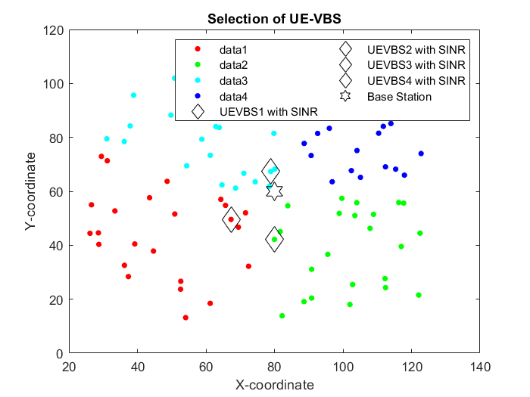

Figure 6.22 Selection of UE VBS for cluster size 4

The power consumption in each cluster is computed using the difference between transmitted and received powers between the UEs, Base Station and UE-VBS, selected at using the algorithm for cluster size 4, as shown in the Figure 6.23.

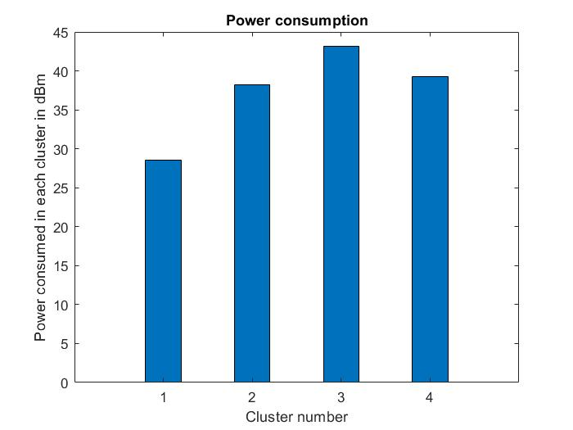

Figure 6.23 Power Consumption of UE VBS for cluster size 4

From Figure 6.24, it is observed that QoS values are close to 1 in each cluster, for cluster size 4. Thus, it can be inferred that all the UEs receive a good quality 5G connection. Hence, applications like streaming, video calls and gaming experiences will match the satisfactory levels.

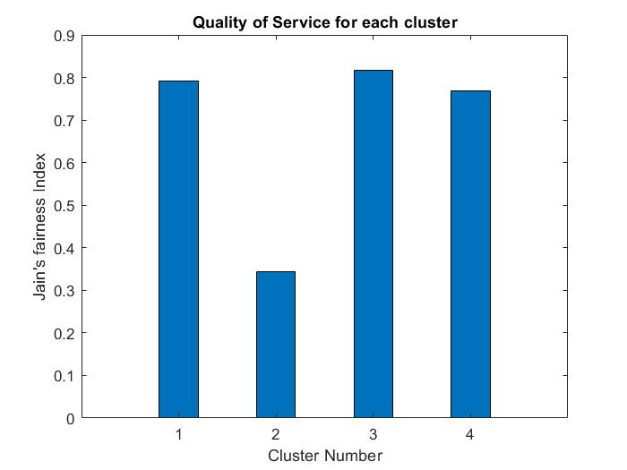

Figure 6.24 Quality of Service for cluster size 4

The average sum rate for each cluster is computed using the Shannon-Hartley theorem for an UE VBS selected by the proposed algorithm against an UE VBS selected at random (and for an LTE base station) for cluster size 4 as shown in the Figure 6.25.

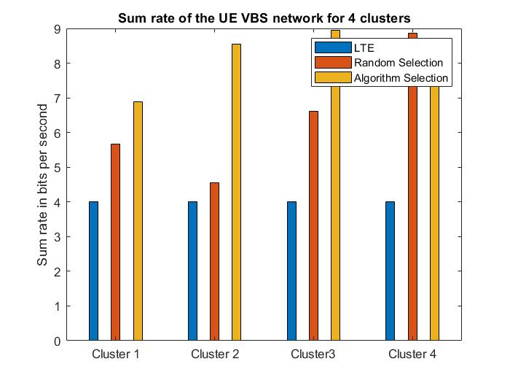

Figure 6.25 Average sum rate of UE VBS for cluster size 4

From each cluster, the algorithm selects an UE to act as a VBS using power received, battery discharge rate and SINR, for cluster size 5 as shown in the Figure 6.26.

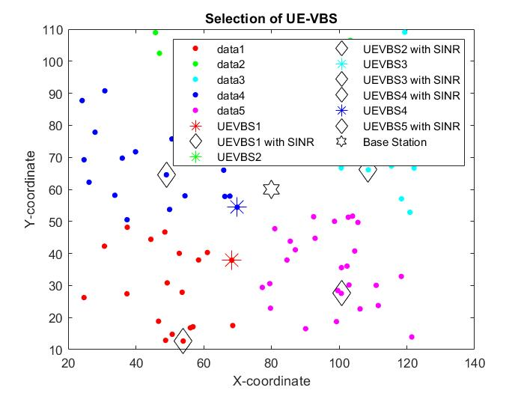

Figure 6.26 Selection of UE VBS for cluster size 5

The power consumption in each cluster is computed using the difference between transmitted and received powers between the UEs, Base Station and UE-VBS, selected at using the algorithm for cluster size 5, as shown in the Figure 6.27.

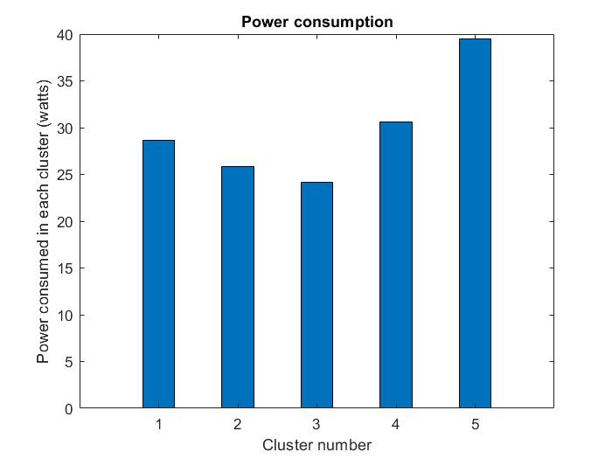

Figure 6.27 Power Consumption of UE VBS for cluster size 5

From Figure 6.28, it is observed that QoS values are close to 1 in each cluster , for cluster size 5. Thus, it can be inferred that all the UEs receive a good quality 5G connection. Hence, applications like streaming, video calls and gaming experiences will match the satisfactory levels.

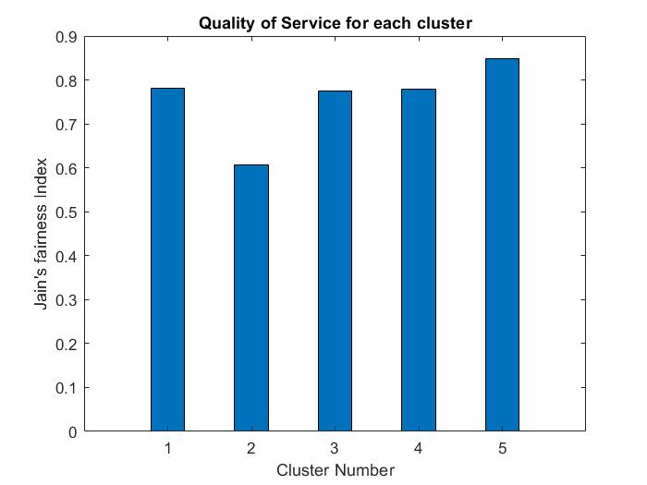

Figure 6.28 Quality of Service for cluster size 5

The average sum rate for each cluster is computed using the Shannon-Hartley theorem for an UE VBS selected by the proposed algorithm against an UE VBS selected at random (and for an LTE base station) for cluster size 5 as shown in the Figure 6.29.

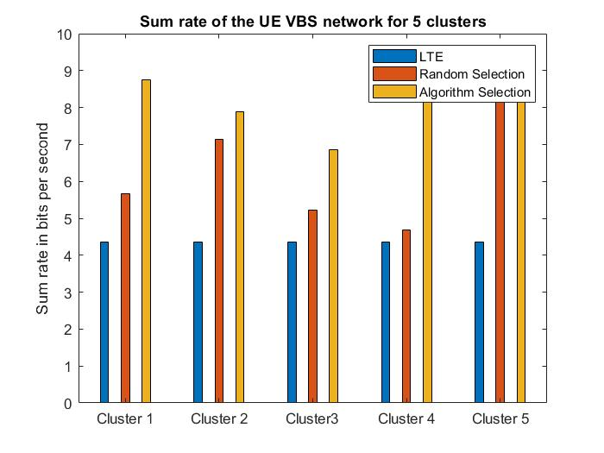

Figure 6.29 Average sum rate of UE VBS for cluster size 5

From each cluster, the algorithm selects an UE to act as a VBS using power received, battery discharge rate and SINR, for cluster size 6 as shown in the Figure 6.30.

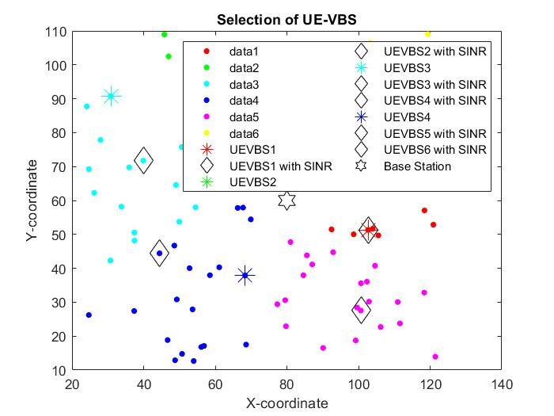

Figure 6.30 Selection of UE VBS for cluster size 6

The power consumption in each cluster is computed using the difference between transmitted and received powers between the UEs, Base Station and UE-VBS, selected at using the algorithm for cluster size 6, as shown in the Figure 6.31.

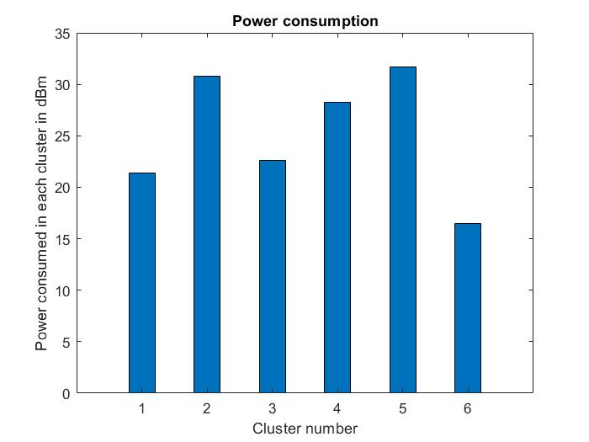

Figure 6.31 Power Consumption of UE VBS for cluster size 6

From Figure 6.32, it is observed that QoS values are close to 1 in each cluster, for cluster size 6. Thus, it can be inferred that all the UEs receive a good quality 5G connection. Hence, applications like streaming, video calls and gaming experiences will match the satisfactory levels.

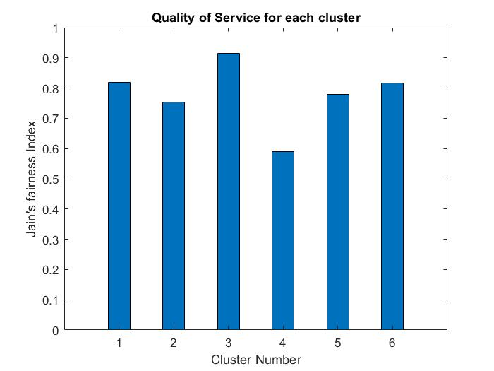

Figure 6.32 Quality of Service for cluster size 6

The average sum rate for each cluster is computed using the Shannon-Hartley theorem for an UE VBS selected by the proposed algorithm against an UE VBS selected at random (and for an LTE base station) for cluster size 6 as shown in the Figure 6.33.

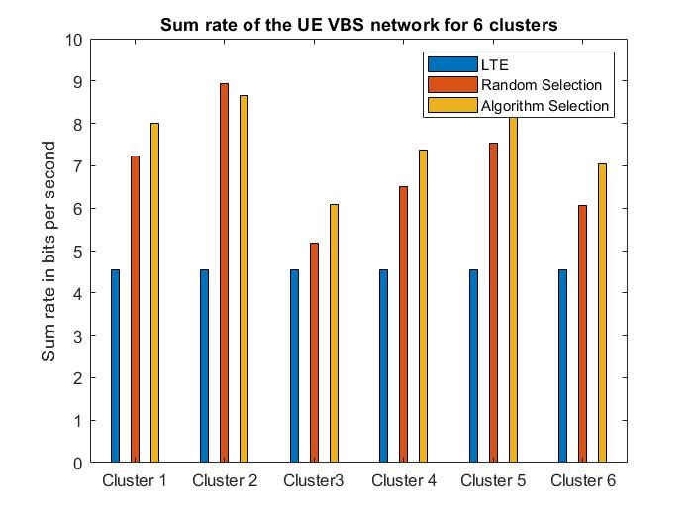

Figure 6.33 Average sum rate of UE VBS for cluster size 6

From each cluster, the algorithm selects an UE to act as a VBS using power received, battery discharge rate and SINR, for cluster size 7 as shown in the Figure 6.34.

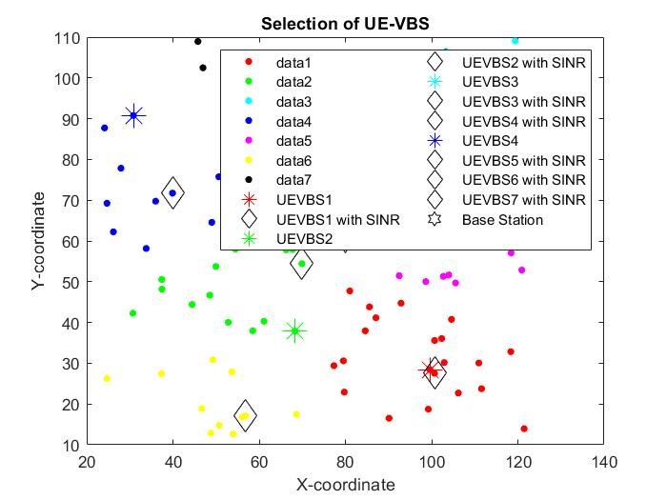

Figure 6.34 Selection of UE VBS for cluster size 7

The power consumption in each cluster is computed using the difference between transmitted and received powers between the UEs, Base Station and UE-VBS, selected at using the algorithm for cluster size 7, as shown in the Figure 6.35.

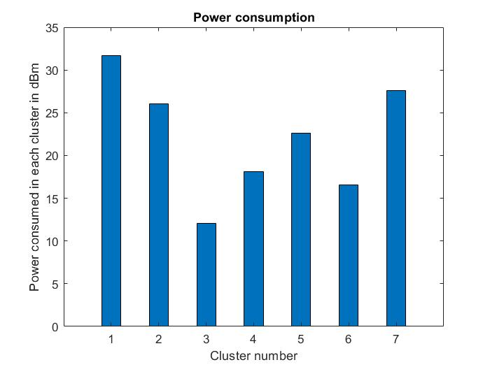

Figure 6.35 Power Consumption of UE VBS for cluster size 7

From Figure 6.36, it is observed that QoS values are close to 1 in each cluster, for cluster size 7. Thus, it can be inferred that all the UEs receive a good quality 5G connection. Hence, applications like streaming, video calls and gaming experiences will match the satisfactory levels.

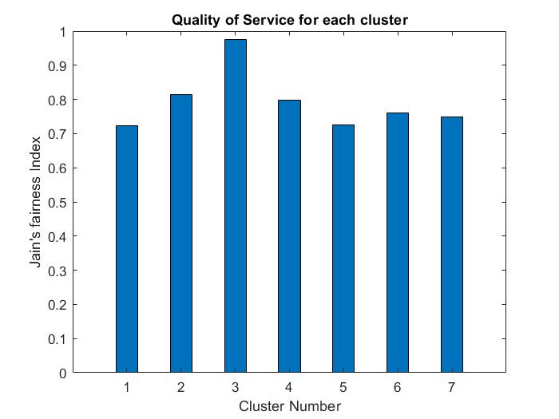

Figure 6.36 Quality of Service for cluster size 7

The average sum rate for each cluster is computed using the Shannon-Hartley theorem for an UE VBS selected by the proposed algorithm against an UE VBS selected at random (and for an LTE base station) for cluster size 7 as shown in the Figure 6.37.

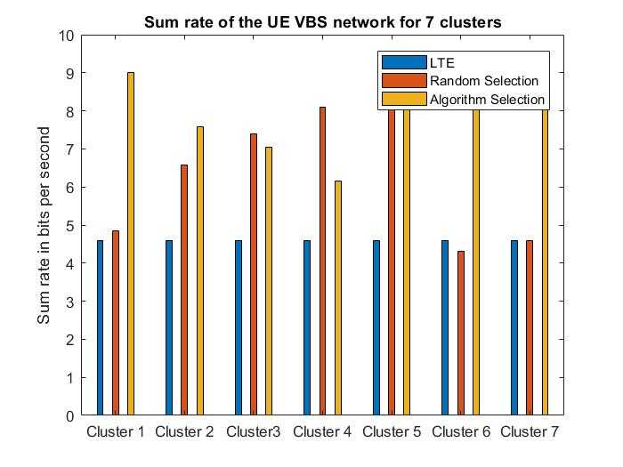

Figure 6.37 Average sum rate of UE VBS for cluster size 7

From each cluster, the algorithm selects an UE to act as a VBS using power received, battery discharge rate and SINR, for cluster size 8 as shown in the Figure 6.38.

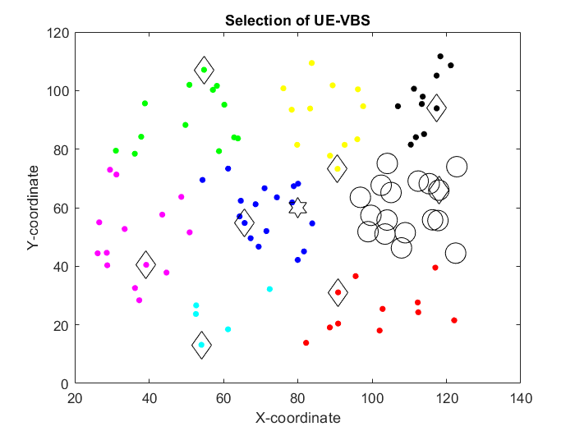

Figure 6.38 Selection of UE VBS for cluster size 8

The power consumption in each cluster is computed using the difference between transmitted and received powers between the UEs, Base Station and UE-VBS, selected at using the algorithm for cluster size 8, as shown in the Figure 6.39.

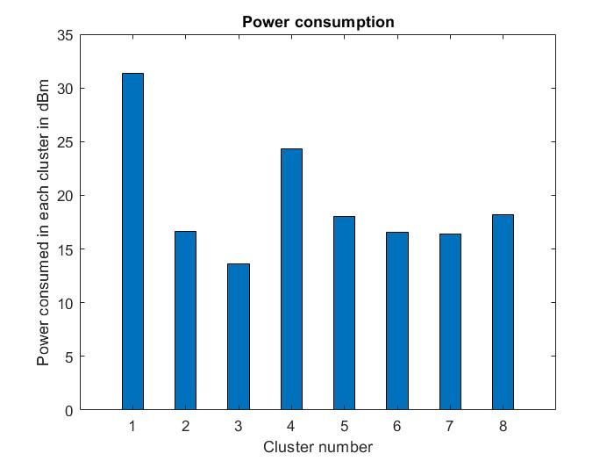

Figure 6.39 Power Consumption of UE VBS for cluster size 8

From Figure 6.40, it is observed that QoS values are close to 1 in each cluster , for cluster size 8. Thus, it can be inferred that all the UEs receive a good quality 5G connection. Hence, applications like streaming, video calls and gaming experiences will match the satisfactory levels.

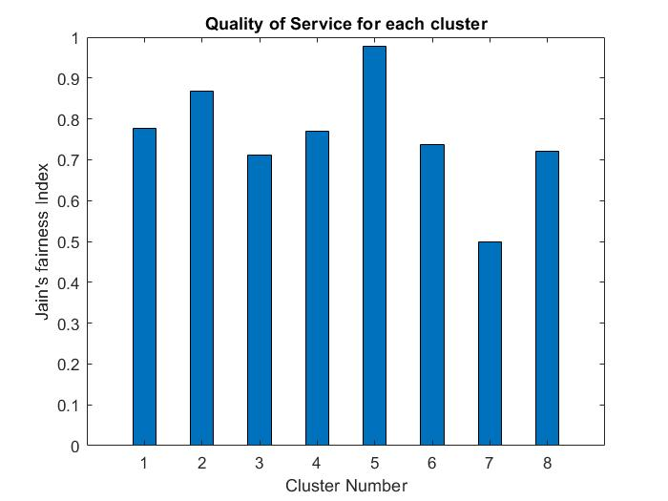

Figure 6.40 Quality of Service for cluster size 8

The average sum rate for each cluster is computed using the Shannon-Hartley theorem for an UE VBS selected by the proposed algorithm against an UE VBS selected at random (and for an LTE base station) for cluster size 8 as shown in the Figure 6.41.

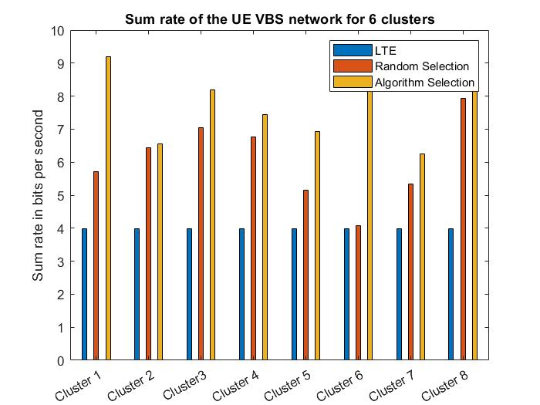

Figure 6.41 Average sum rate of UE VBS for cluster size 8

**6.3 SYSTEM PERFORMANCE INFERENCE**

The average sum rate for the system with different cluster sizes is plotted in the Figure 6.42. Performance of the system with cluster size 2 is neglected since it might lead to underfitting. Since the availability of UE VBS in each cluster is dynamic, the cluster size can be chosen to fit the necessary requirements, ideally 4, 5 or 8 in this case.

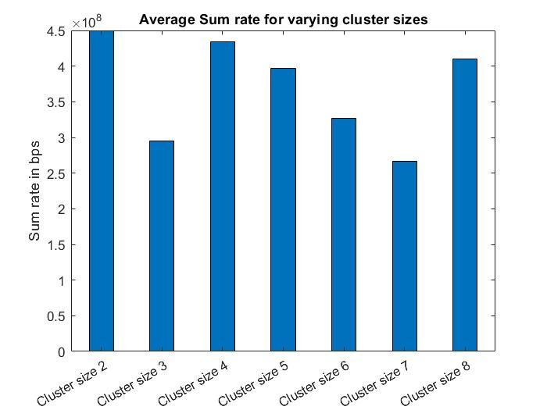

Figure 6.42 Average sum rate for varying clusters

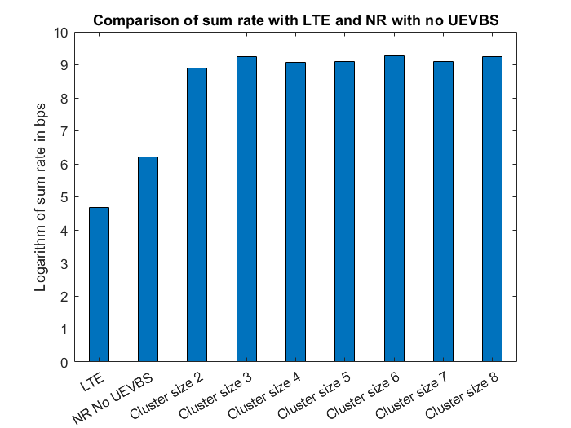

Figure 6.43 Comparison of average sum rate with LTE and NR with no UEVBS

The average sum rate of an LTE system and that of a 5G system with no UE VBS is plotted along with the average sum rate of various 5G UE VBS systems with varying cluster sizes, in the Figure 6.43. It can be inferred that the usage of 5G UE VBSs shows a significantly better system performance than the other mentioned systems.

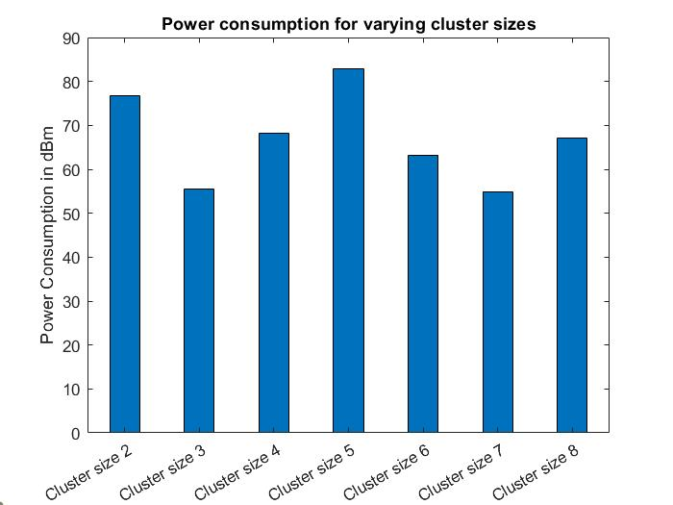

Figure 6.44 Comparison of average power consumption for different cluster sizes

From fig 6.44, it can be inferred that cluster size 5 has the highest cumulative power consumption compared to the other cluster sizes. Hence, it would not be a suitable choice for cluster size. The power consumption across the various sizes varies due to the geographical distribution of the UEs in each cluster. This parameter, along with Quality of Service and Sum Rate, can be effectively used to determine the number of clusters which can operate, at the most ideal behaviour, for a 5G UE-VBS network.

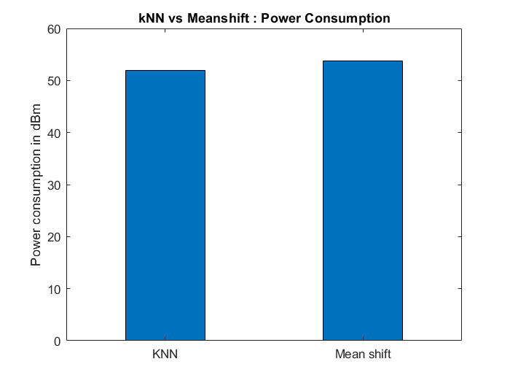

Figure 6.45 Comparison of average power consumption for k-NN and Mean shift clustering methods

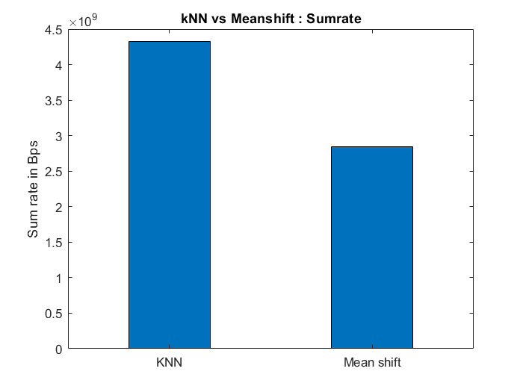

Figure 6.46 Comparison of average sum rate for k-NN and Mean shift clustering methods

From fig 6.45 and 6.46, it can be proved that the performance of k-NN clustering method is superior to Mean shift clustering in terms of average sum rate and power consumption. Hence, k-NN is a more suitable choice for this data.

**CHAPTER 7**

**CONCLUSIONS AND FUTURE SCOPE**

**7.1 CONCLUSIONS**

This report presents the process behind the dynamical selection of UE VBS among UEs to deal effectively with the non-stationary, non-uniform distribution of mobile traffic with respect to time and space domain. This concept is facilitated using K-means Clustering to split one macro cell into small cells. The performance of the algorithm on different cluster sizes are analyzed. Higher accuracy is observed for higher cluster sizes, which might be due to overfitting of the dataset, i.e., the algorithm will perform efficiently for the given data, but fails for new set of data. Thus, the cluster size can be chosen by using the concept of elbow method, which gives a plot between cluster size and sum of squared error. But Mean shift clustering is preferred to finalize the cluster size. Communication parameters such as received power, battery discharge rate and SINR is used to select the best set of UE-VBSs to replace an overlay loaded BS. Average sum rate is used compare the performance of our selection algorithm, against the performance of a random selection algorithm. In some cases, the performance of a 4G network is measured against a 5G network with UE VBS. It is observed from the results that the proposed algorithm outperforms the 4G network and 5G network with random UE VBS selection. QoS and Power consumption are used to validate the usage of the proposed algorithm.

**7.2 SCOPE FOR THE FUTURE WORK**

The project can be extended to include the phenomenon of co-channel interference from other base stations and UEs from other cells. The frequency range of the signals can be changed to the FR2 range of frequencies where concepts like Massive MIMO will play a major role in the selection of UE VBS. The reliability of the UE VBS cannot be predicted with the current selection algorithm as any user might have malicious intent and can cause severe privacy risks for all the other UEs in the small cell. The information loss/theft due to the rogue UE VBS can be a criminal offence of the highest order. To avoid this, the Base Station should select the UE VBS in an intelligent manner with the help Artificial Intelligent tools. The performance of the network using the selection algorithm can also be compared with other algorithms and other networks by measuring the energy efficiency of the networks.

**REFERENCES**

# 1. [Alka Singh](https://ieeexplore.ieee.org/author/37086204045), [Shubhangi Rathkanthiwar](https://ieeexplore.ieee.org/author/37891788500), [Sandeep Kakde](https://ieeexplore.ieee.org/author/37085361391) (2016) ‘LEACH based-energy efficient routing protocol for wireless sensor networks’, [(ICEEOT)](https://ieeexplore.ieee.org/xpl/conhome/7731602/proceeding), pp. 4654-4658.

2. C. Xiong, G. Y. Li, S. Zhang, Y. Chen and S. Xu, (2011) ‘Energy- and Spectral-Efficiency Tradeoff in Downlink OFDMA Networks,’ IEEE International Conference on Communications (ICC), pp. 1-5.

3. Guangyi Liu and Dajie Jiang (2016), ‘5G: Vision and Requirements for Mobile Communication System towards Year 2020’, Chinese Journal of Engineering, Volume 2016, Article ID 5974586, 8 pages.

4. Himanshu Suyal, Amit Panwar, Ajit Singh Negi (2014) ‘Text Clustering Algorithms: A Review’, International Journal of Computer Applications (0975 - 8887) Volume 96- No. 24, pp. 36-39.

5. Ian F. Akyildiz, Shuai Nie, Shih-Chun Lin, Manoj Chandrasekaran (2016) ‘5G Roadmap: 10 Key enabling technologies’, Computer Networks 106 pp. 17-48.

6. Jianhua Zhang, Chih-Lin I, Juho Lee, Jungnickel Volker, Jilei Hou, and Sujit Dey (2016), ‘Enabling Technologies for Fifth-Generation Mobile Communications’, Hindawi Publishing Corporation Chinese Journal of Engineering Volume 2016, Article ID 2847564, 2 pages.

7. M. Azhar, A. Shabbir (2018), '5G Networks: Challenges and Techniques for Energy Efficiency,' Volume: 8, Issue: 2, pp. 2864-2868.

8. Murtaza Ahmed Siddiqi, Heejung Yu, and Jingon Joung (2019) '5G Ultra-Reliable Low-Latency Communication Implementation Challenges and Operational Issues with IoT Devices,' Electronics, ETASR-Volume 8, Issue 9, Article ID 981.

9. P. K. Choudhury, M. Abou El-Nasr (2020), ‘Massive MIMO toward 5G’, Journal of Electromagnetic Waves and Applications Volume 34, Issue 9 pp. 1091-1094.

10. Peter Rost, Christian Mannweiler , Diomidis S. Michalopoulos , Cinzia Sartori (2017) 'Network Slicing to Enable Scalability and Flexibility in 5G Mobile Networks', IEEE Communications Magazine Volume: 55, Issue: 5, pp. 72-79.

11. Pravati Swain, Christophoros Christophorou, Upasana Bhattacharjee, Cristiano M. Silva, Andreas Pitsillides (2018) ‘Selection of UE-based Virtual Small Cell Base Stations using Affinity Propagation Clustering’, IWCMC, pp. 1104-1109.

12. R. Dilli, (2020) ‘Analysis of 5G Wireless Systems in FR1 and FR2 Frequency Bands,’ 2nd International Conference on Innovative Mechanisms for Industry Applications (ICIMIA), 2020, pp. 767-772.

13. Rupendra Nath Mitra, Dharma P.Agrawal (2015) ‘5G mobile technology: A survey’, ICT Express Volume 1, Issue 3, pp. 132-137.

14. S. Shalmashi, E. Björnson, M. Kountouris, K. W. Sung and M. Debbah, (2015) ‘Energy efficiency and sum rate when massive MIMO meets device-to-device communication,’ IEEE International Conference on Communication Workshop (ICCW), 2015, pp. 627-632.

15. Siyi Wang, Weisi Guo, Zhenyu Zhou, Yue Wu, and Xiaoli Chu (2015) ‘Outage Probability for Multi-Hop D2D Communications With Shortest Path Routing’, IEEE Communications Letters, Vol. 19, NO. 11, pp. 1997-2000.

# 16. Sunil Pathak, Sonal Jain (2017) ‘An optimized stable clustering algorithm for mobile ad hoc networks’ EURASIP Journal on Wireless Communications and Networking, Article number: 51.

17. Sven Mattisson (2018), ‘An Overview of 5G Requirements and Future Wireless Networks: Accommodating Scaling Technology,’ IEEE Solid-State Circuits Magazine, Volume: 10, Issue: 3, pp. 54 – 60.

18. Theodore S. Rappaport ‘Wireless Communications: Principles and Practice’ Ch. 4. Mobile Radio Propagation: Small-Scale Fading and Multipath.

19. Z. Zhou, M. Dong, K. Ota, J. Wu and T. Sato, (2014) ‘Energy Efficiency and Spectral Efficiency Tradeoff in Device-to-Device (D2D) Communications,’ IEEE Wireless Communications Letters, vol. 3, no. 5, pp. 485-488.

20. Connected world: An evolution in connectivity beyond the 5G revolution <[https://www.mckinsey.com/industries/technology-media-and-telecommunications/our-insights/connected-world-an-evolution-in-connectivity-beyond-the-5g-revolution#](https://www.mckinsey.com/industries/technology-media-and-telecommunications/our-insights/connected-world-an-evolution-in-connectivity-beyond-the-5g-revolution) > , (accessed 22.03.2021)

21. Geeks for Geeks – ML | Mean Shift Clustering <<https://www.geeksforgeeks.org/ml-mean-shift-clustering>/>, (accessed 15.03.2021).

22. K-Means Clustering in Python - A Practical Guide. <<https://realpython.com/k-means-clustering-python/>> (accessed 15.01.2021).

23. ScienceDirect - Battery life. <<https://www.sciencedirect.com/topics/engineering/battery-life>>, 2003 (accessed 27.02.2021).

24. Scikit-learn 0.24.1 – Clustering <<https://scikit-learn.org/stable/modules/clustering.html#k-means>> (accessed 3.02.2021).