**SSN COLLEGE OF ENGINEERING**

**DEPARTMENT OF ELECTRONICS AND COMMUNICATION**

## **ENGINEERING**

COMPLETION REPORT FOR PROJECT FUNDED LEER INTERNAL

## FUNDING SCHEME

1. Title of the project : Stolen car detection using Image processing and Machine Learning.
2. Faculty Supervisor : Dr. N. Edna Elizabeth
3. Amount sanctioned : Rs. 17,000/-
4. Amount utilized : Rs. 10,625/-
5. Duration : 10 months
6. Details of papers published directly from the project : Nil
7. Details of papers published with related research : Nil
8. Details of papers presented in conferences/seminars/workshops : Nil
9. Best paper/Special awards received : Nil
10. Students involved

|  |  |  |  |  |
| --- | --- | --- | --- | --- |
| S.No | Register No. | Name of the Students | UG/PG | Year |
| 1 | Kanishkha LD | 312217106068 | B. E ECE | 4 |
| 2 | Poojah G | 312217106112 | B. E ECE | 4 |
| 3 | Raj Vignesh K | 312217106126 | B. E ECE | 4 |

## Patent details NA

1. List of equipment / items purchased under the project:

|  |  |  |  |
| --- | --- | --- | --- |
| **S.No** | **COMPONENTS** | **QUANTITY** | **PRICE (in Rs)** |
| 1. | Raspberry Pi 4.0 processor | 1 | 5,675 |
| 2. | Camera module for Raspberry Pi 4 720p | 2 | 3,960 |
| 3. | Power Supply for Raspberry Pi, 4000mAh | 1 | 300 |
| 4. | HDMI to Micro HDMI Cable | 1 | 250 |
| 5. | 32 GB Micro SD Memory Card | 1 | 440 |
| **TOTAL AMOUNT (IN RUPEES)** | | | 10,625 |

1. List of Items used other than the purchased items: Nil
2. Achievements of the project:

The project is an implementation of a real-time license plate detection system which can be extremely useful for stolen car detection. Without using expensive high-speed processors to process all the information and detect license plates, efficient algorithms have been used to produce the output. The execution of this task shows that new and creative ways of thinking about a problem statement can drastically reduce the expenses it might incur if we do it in a tried and tested manner.

1. Deviation If any.

Nil

## Signature of the Students Involved:

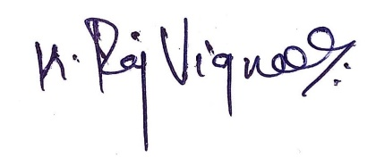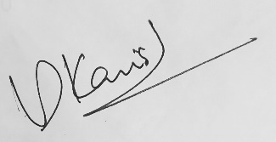

[ Raj Vignesh K ] [ Kanishkha LD ] [ Poojah G ]

Signature of the Faculty Supervisor:

[Dr.N. Edna Elizabeth,

Associate Professor,

Department of ECE,

SSN College of Engineering]

Signature of the H.O.D.

## [Dr.S.Radha

## Professor and Head,

## Department of ECE,

SSN College of Engineering]

Signature of the Dean (Research):

[SSN College of Engineering]