Bank Customer Churn Analysis
1. Project Overview
This project analyzes customer churn patterns based on 10,000 customers’ demographic, credit etc. It consists of data regarding customer demographics like geography, age, gender, along with data like how many years the customer has been with the bank, whether they are an active member, if they have a credit card etc.
2. Dataset Summary
i) Rows: 10000
ii) Columns: 18
iii) Missing Values: There are no missing values within the dataset.
iv) Key Features: This dataset contains information regarding the following :-
a) Customer Demographics – Age, Gender, Geography
b) Banking Related – Has Cr Card, Is Active Member, Card Type, Tenure, Balance, Num of Products
c) Financial Profile – Credit Score, Estimated Salary, Balance
d) Service and Loyalty – Complain, Satisfaction Score, Point Earned
e) Target Variable – Exited
3. Exploratory Data Analysis using Python
We start with some data cleaning and transformation using Python :-
i) Data Loading: Imported the data into Python using pandas.
ii) Initial Exploration: Used .info() and .describe() to get information about the structure and the statistics of the data.
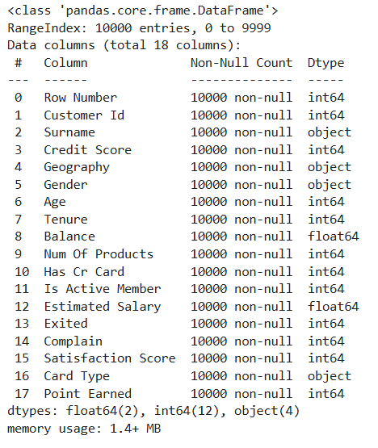
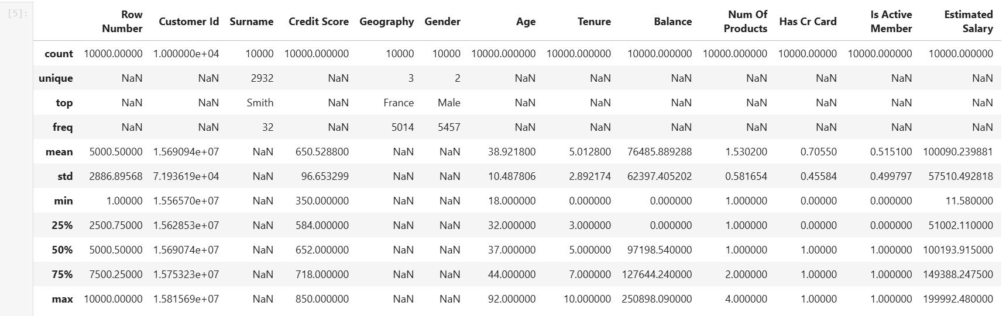
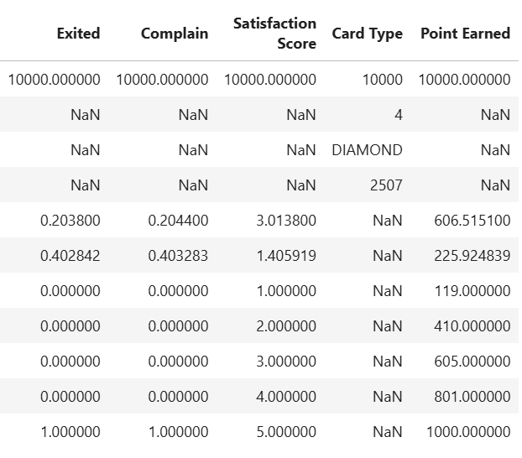
iii) Checked for Null Values: Checked if there were any null values, there weren’t any, so no imputation needed.
iv) Standardized Column Names: Standardized the names of the columns to snake case, for better documentation and readability.
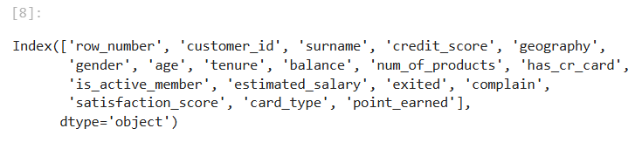
v) Data Quality Check: Dropped unnecessary columns like Row Number and Surname.
vi) Feature Engineering: Created 2 new columns :-
a) credit_score_range – Created from the credit_score column.
b) age_group – Grouped together customers based on their ages.
vii) Checked for Duplicate values – There weren’t any duplicates within the data.
viii) Database Connection – Loaded the transformed data intoPostgreSQL using psycopg2 and sqlalchemy, for further analysis.
4. Data Analysis using SQL
Performed some analysis using PostgreSQL to answer some business questions :-
i) No of Active Customers who Churn
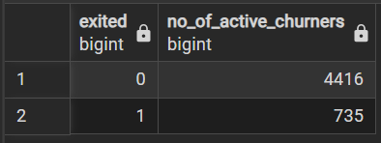
ii) No of Churners and Non-Churners by Gender
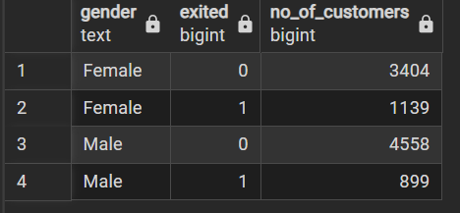
iii) No of Churners and Non-Churners by Geography
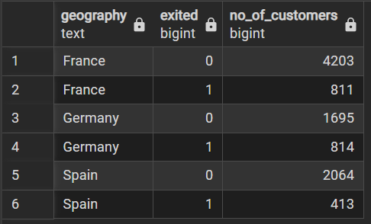
iv) Customer Churn by Age Group
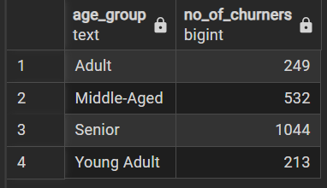
v) No of Churners and Non-Churners by Tenure
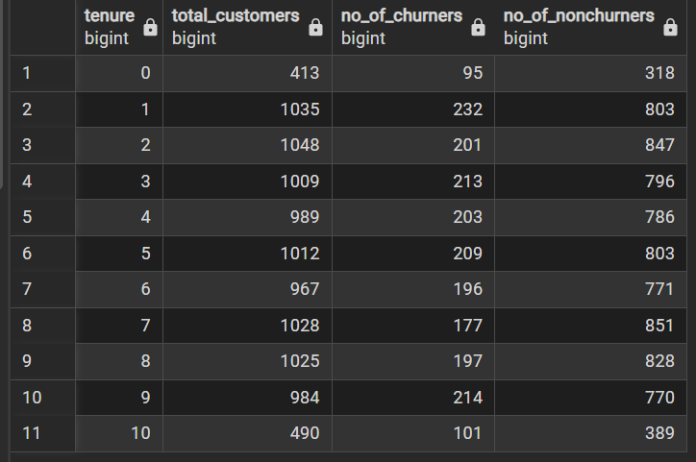
vi) Customer Churn based on the number of products they use from the Bank
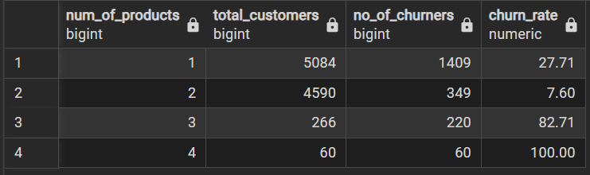
vii) No of Customers and Churners by Complaint Status
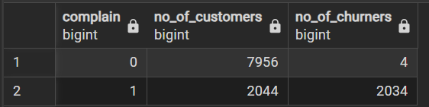
viii) Customer Churn based on whether or not they own a Credit Card
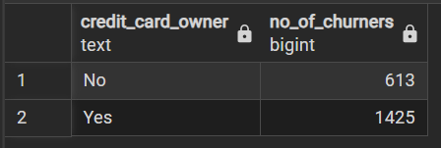
ix) Customer Churn based on Balance (highest, lowest and average balance)
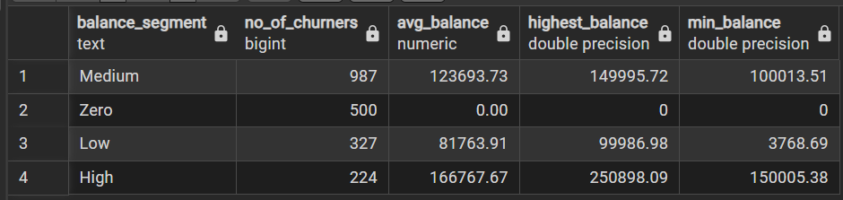
x) Top 3 Age Groups by Churn Rate in each Country
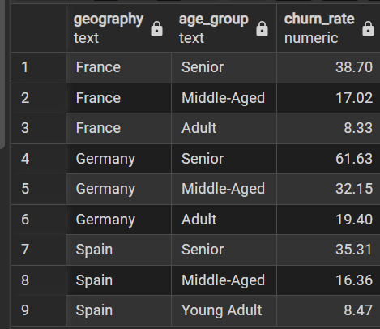
xi) Churn Rate by Balance Quartile within Each Country
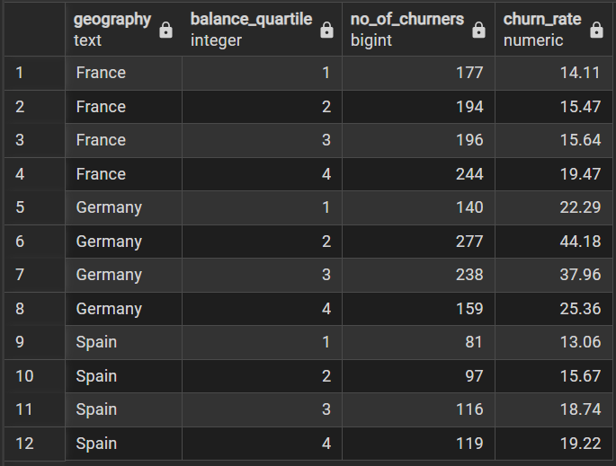
5. Dashboard in Power BI
Finally, we built an interactive dashboard to visualize our data, to get better insights.
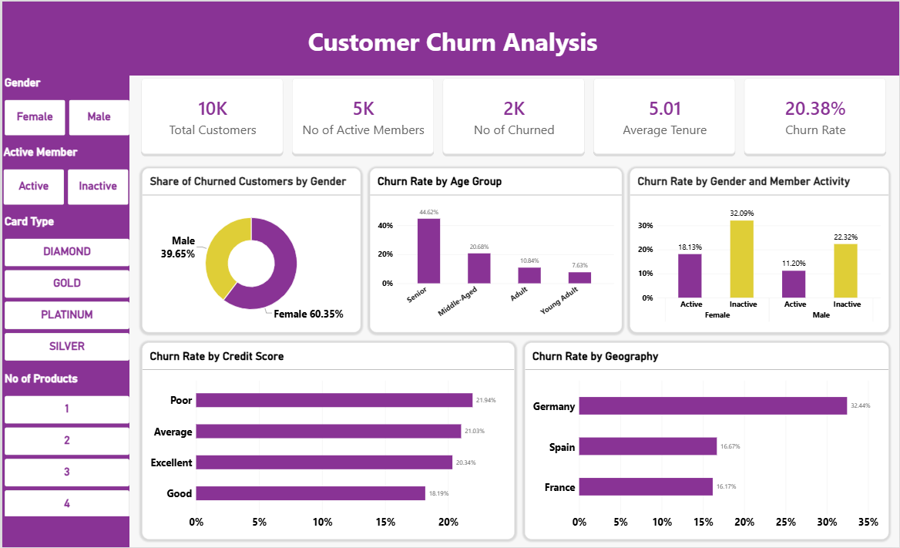
6. Business Recommendations
i) Gender Targeted Efforts – Female customers make up 60.35% of all churners vs 39.65% for male customers, investigate the reason for it and apply some targeted retention schemes based on customer behavior and needs.
ii) Product Depth Strategy – Customers with 2 products tend to have the lowest churn rate, 7.6%, while those who purchase 3 or 4 products have the highest churn rate, 82.71% and 100%. Though the last 2 categories have lesser amount of customers, it is still worth investigating the cause behind this (for example – price, fees, product fit etc.), before promoting any selling further than 2 products.
iii) Region Based Efforts – Germany’s churn rate is 32.44% as compared to Spain and France’s 16.67% and 16.17%, look into the reasons for it and rectify it using some targeted retention strategies, and track the churn rate quarterly.

