Customer Shopping Behavior Analysis
1. Project Overview
This project analyzes customer purchase behavior based on transactional data of 3,900 customers. It consists of data regarding various product categories, the items purchased, spending habits of the customers, whether the customer has a subscription or not etc., all of these together can help us in making strategic business decisions.
2. Dataset Summary
i) Rows: 3900
ii) Columns: 18
iii) Missing Data: There are 37 missing values in the Review Rating column.
iv) Key Features: This dataset consists of information regarding the following :-
a) Customer Demographics – Age, Gender, Location, Subscription Status
b) Purchase Details – Item Purchased, Purchase Amount (USD), Season, Size, Color, Category
c) Shopping Behavior – Discount Applied, Promo Code Used, Previous Purchases, Frequency of Purchases, Review Rating, Shipping Type
3. Exploratory Data Analysis using Python
We start with some data cleaning and transformation in Python :-
i) Data Loading: Imported the dataset into Python.
ii) Initial Exploration: Used .info() and .describe() to check the structure and get summary statistics, respectively.
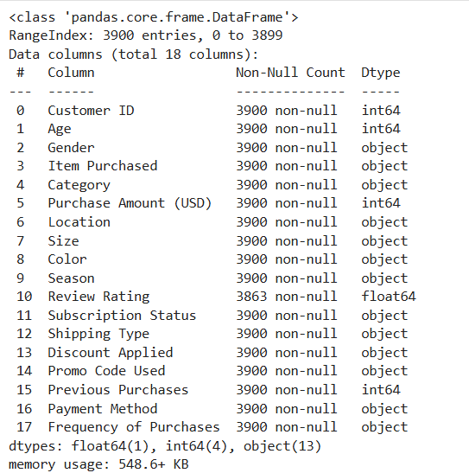
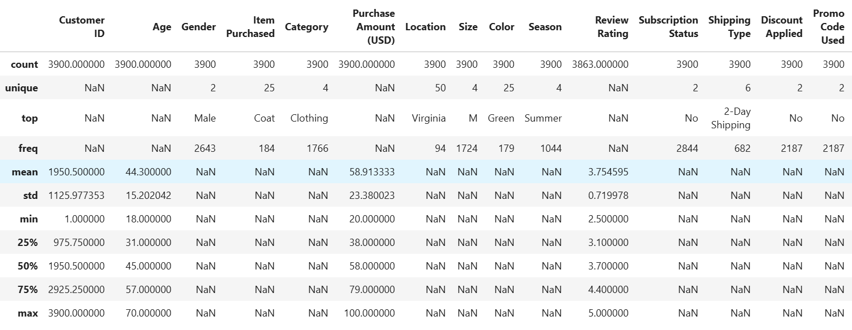
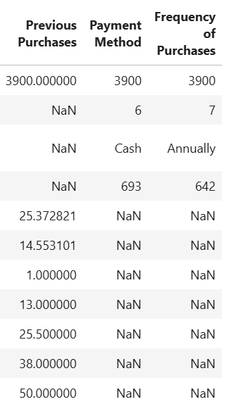
iii) Dealt with Missing Values: Checked for null values and imputed the missing values in the Review Rating using the median rating of each product category.
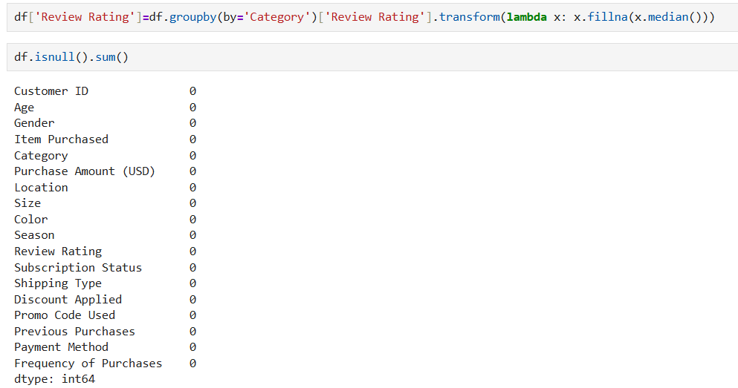
iv) Standardizing Columns: Renamed the columns to snake case for better readability and documentation.
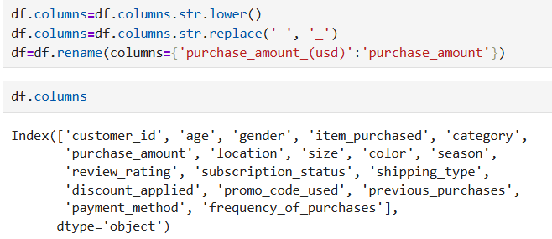
v) Feature Engineering: Created 2 new columns :-
a) age_group – Grouped together customers based on their ages.
b) purchase_freq_days – Created from the frequency_of_purchases column.
vi) Redundancy Check: Checked if the discount_applied and the promo_code_used columns are the same, and dropped the promo_code_used column.
vii) Database Connection: Connected Python script to PostgreSQL and loaded the cleaned dataframe into PostgreSQL for analysis.
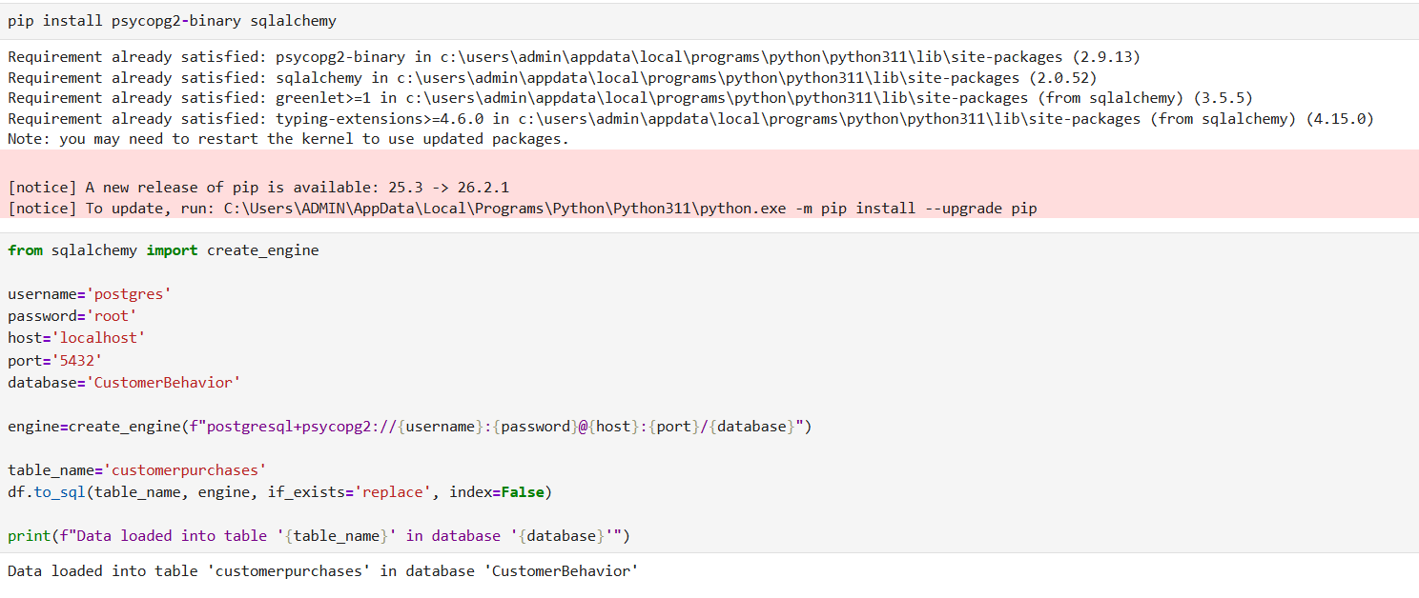
4. Data Analysis using SQL
Performed some analysis using PostgreSQL to answer key business questions :-
i) Total Revenue by Gender
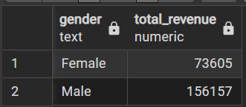
ii) Customers who used discounts but still spent higher than the average purchase amount
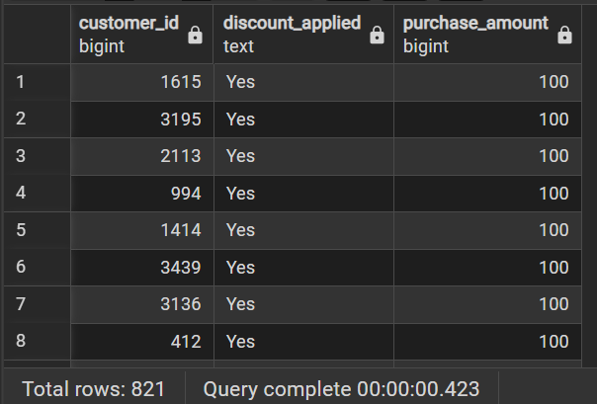
iii) Found the top 5 products based on the highest average review ratings.
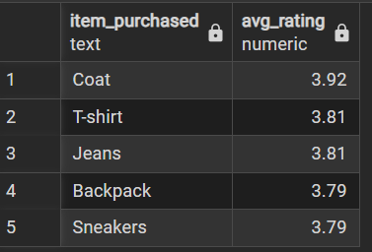
iv) Compared the average purchase amounts for express shipping and standard shipping.
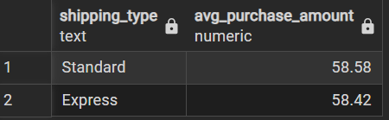
v) Compared the average spend and total revenue between customers who have subscribed vs those who haven’t subscribed.
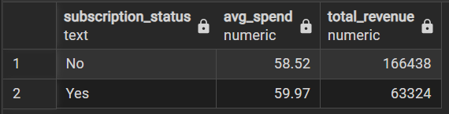
vi) Found the top 5 products that have the highest percentage of purchases even with discounts applied.
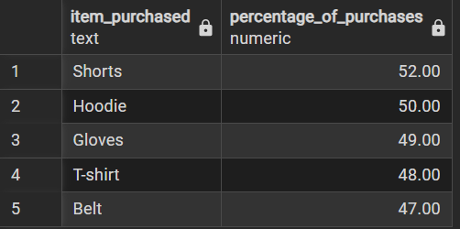
vii) Segmented the customer into New, Returning and Loyal Categories based on the total no. of their previous purchases.
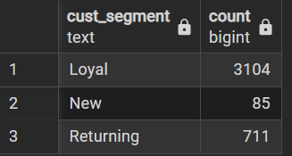
viii) Top 3 most purchased products per category.
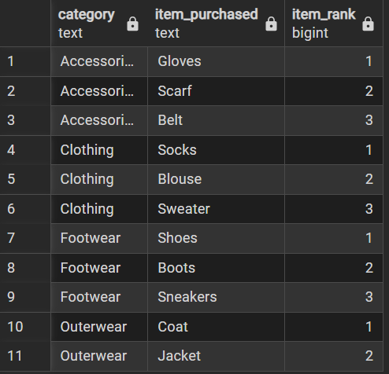
ix) Checking whether customers who have more than 5 purchases are likely to subscribe or not.
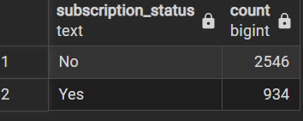
x) Revenue Contribution divided by age group.
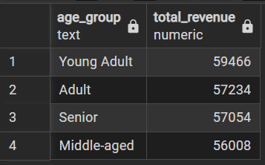
5. Dashboard in Power BI
Finally, we built an interactive dashboard to visualize the data, with slicers to filter based on specific things, like gender, subscription status, category and shipping type.
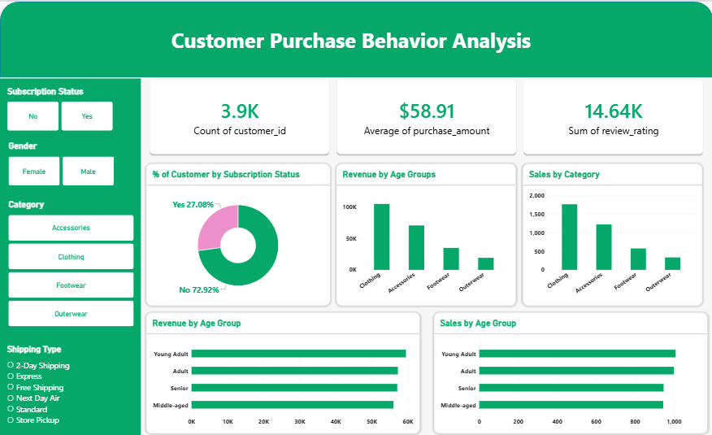
6. Business Recommendations
i) Better Subscription Plans – Improve the subscription plan, give better benefits to encourage more people to get subscriptions.
ii) Incentives for Loyal Customers – Introduce some kind of incentives for returning customers to move them into the “Loyal” category.
iii) Best Seller Products – Promote the best-selling/ highest rated products in marketing campaigns.
iv) Targeted Marketing – Focus on the highest revenue age groups and express-shipping users.

