Exercise
- Git Setup https://confluence.atlassian.
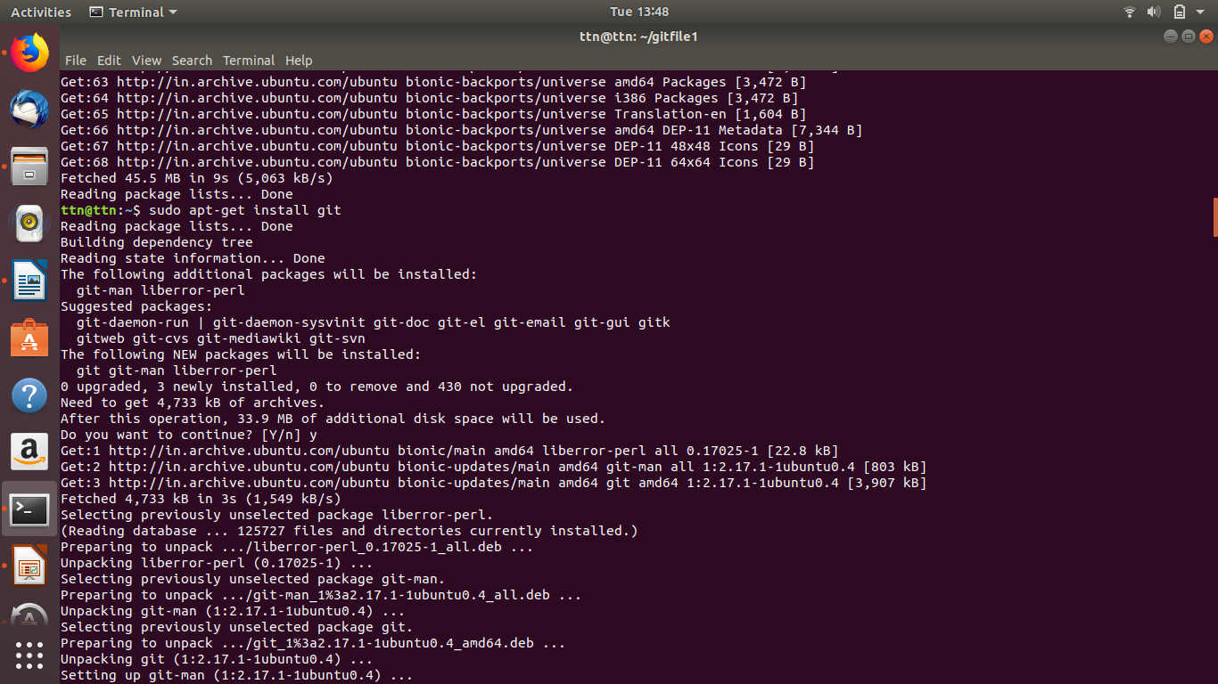

- Initialize a Git Repository and
- add file to the repository
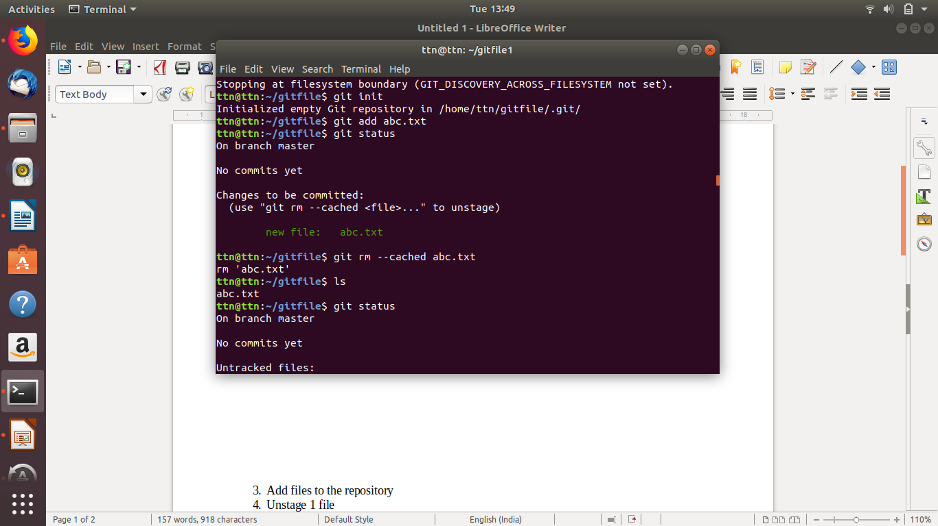

- Unstage 1 file
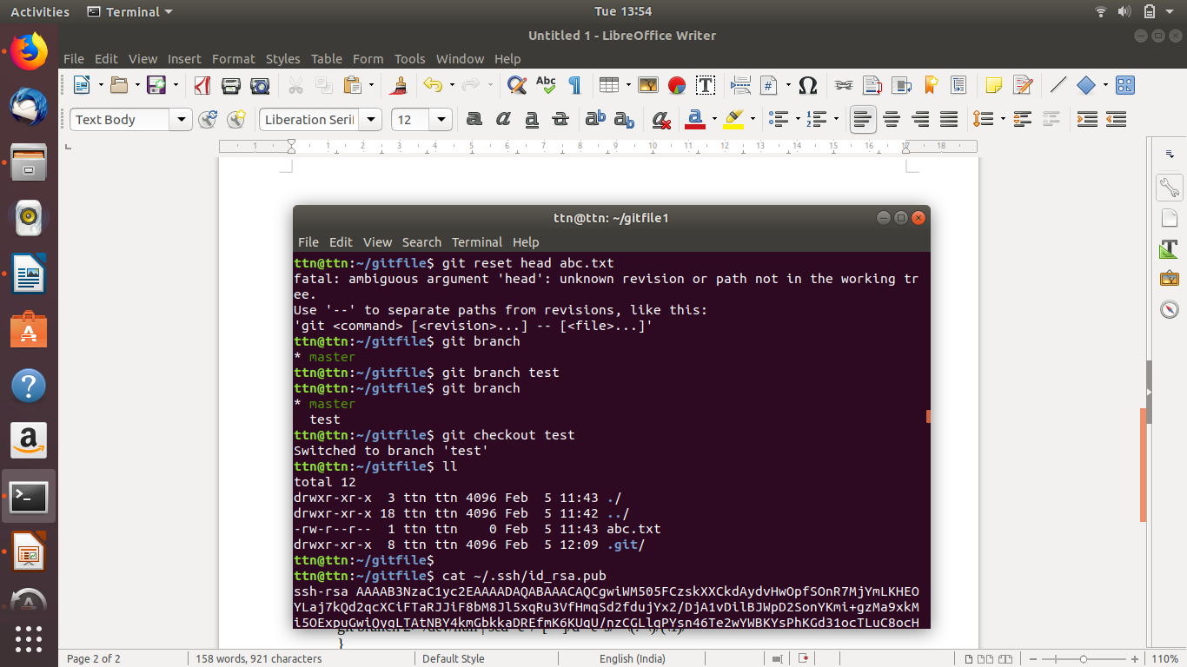

- Commit the file
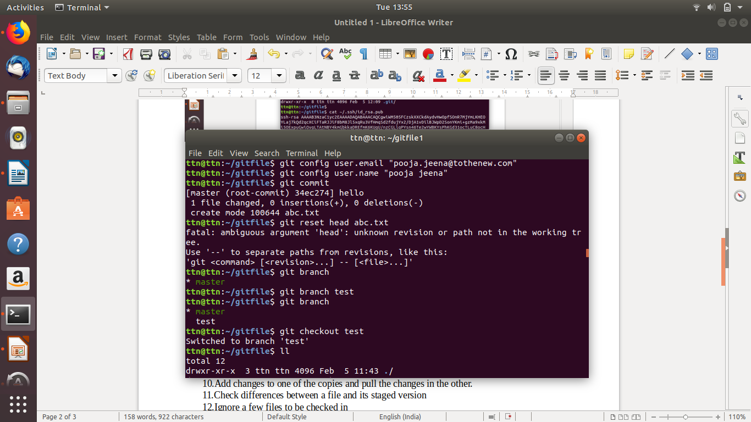

- Add a remote
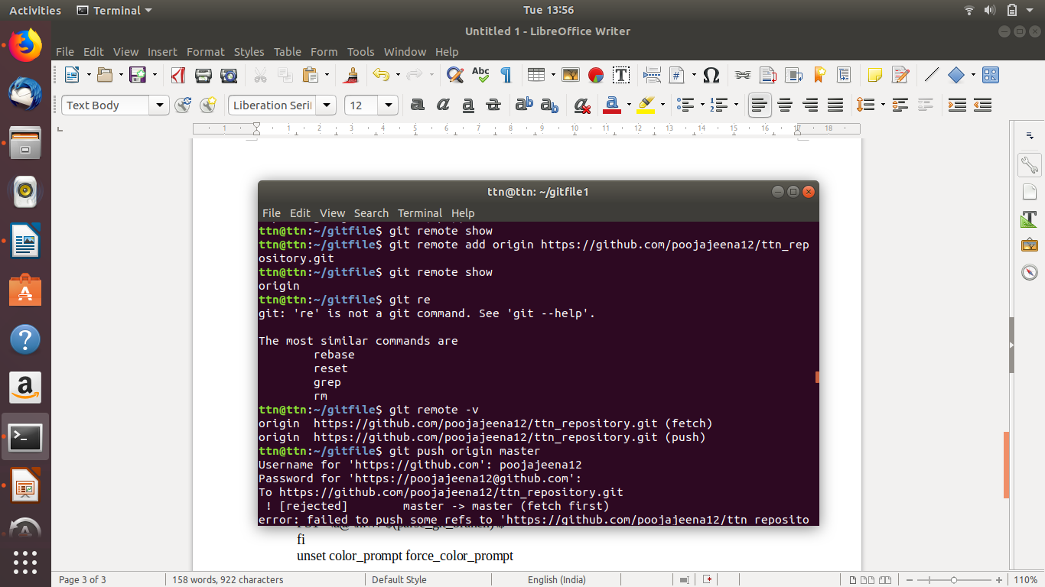

- Undo changes to a particular file
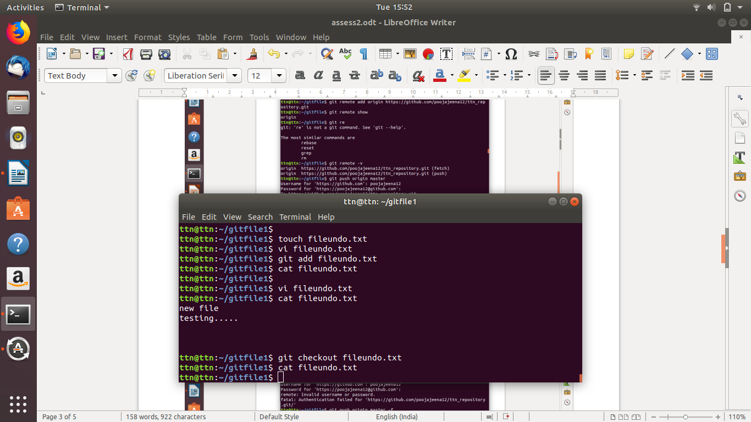

- Push changes to Github
- Clone the repository
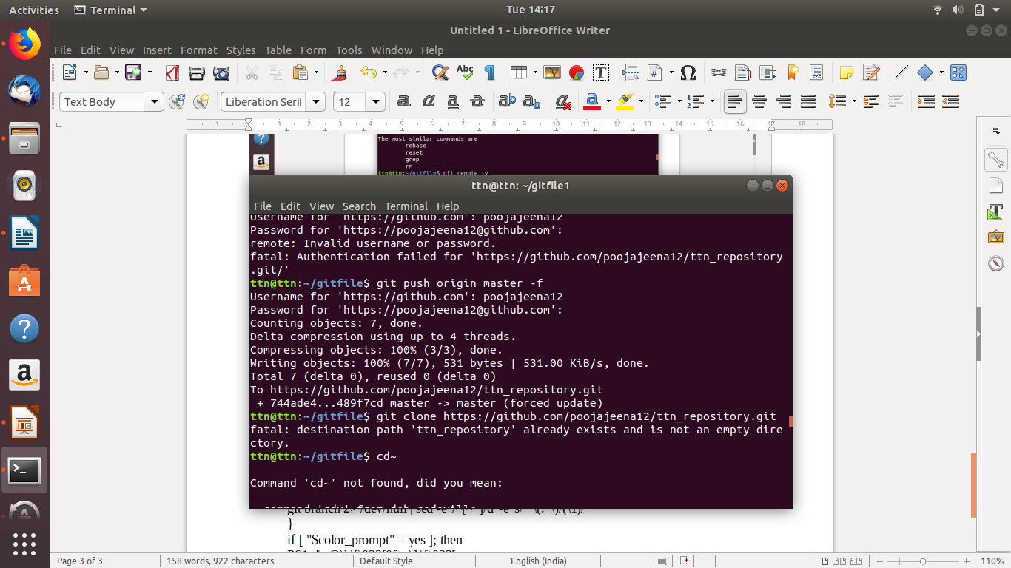

- Add changes to one of the copies and pull the changes in the other.
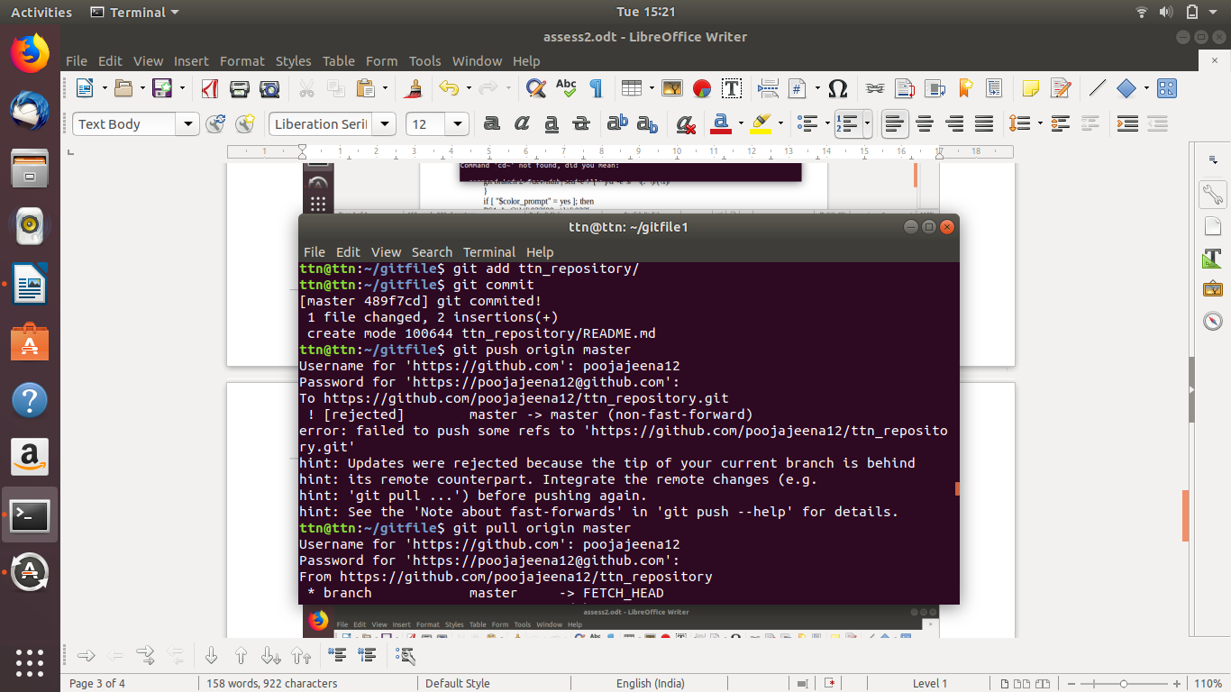

- Check differences between a file and its staged version
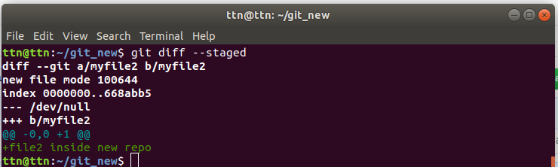

- Ignore a few files to be checked in
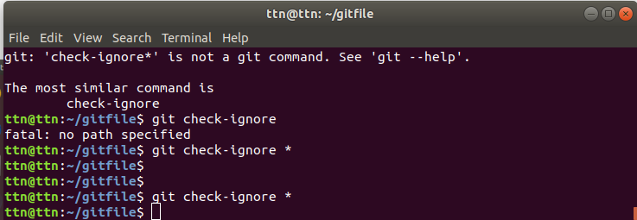

- Create a new branch.

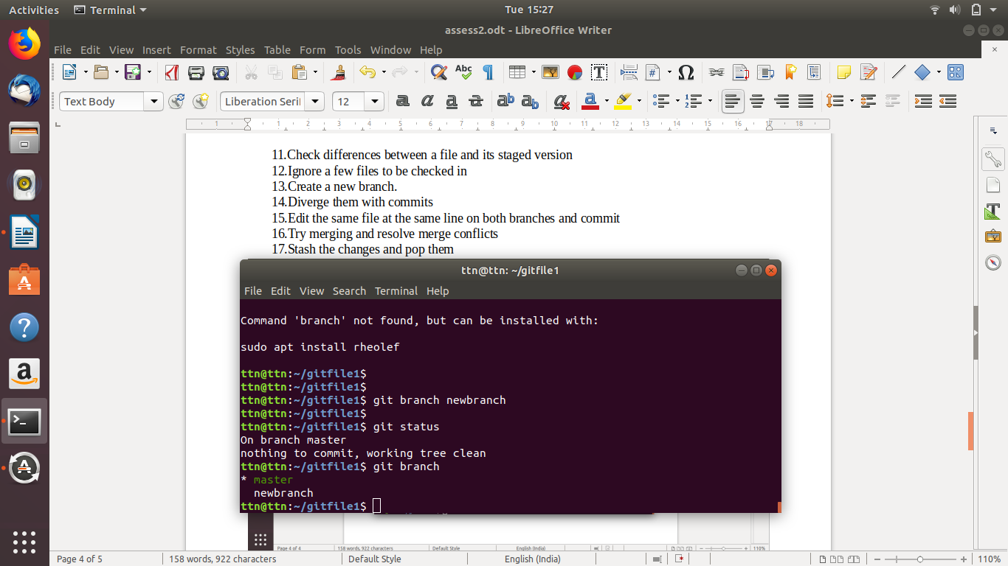

- Diverge them with commits
Ans. Diverge with commit is a situation in which let’s assume there is a remote server and two directories dir1 and dir2.
All the three will have same commit status in initial stage but later on dir1 and dir2 will send their commit c2 and c3 respectively to remote server. Now on receiving c2 and c3, remote server will diverge the commit c2 and c3 under c1.

- Edit the same file at the same line on both branches and commit

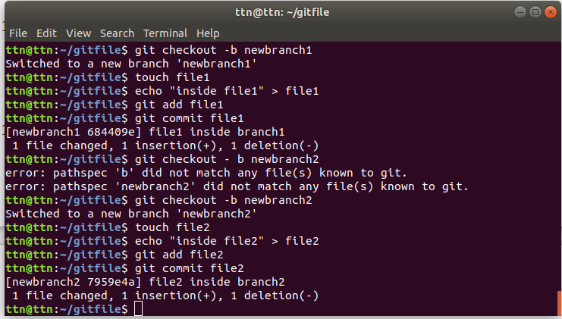

- Try merging and resolve merge conflicts

- Stash the changes and pop them

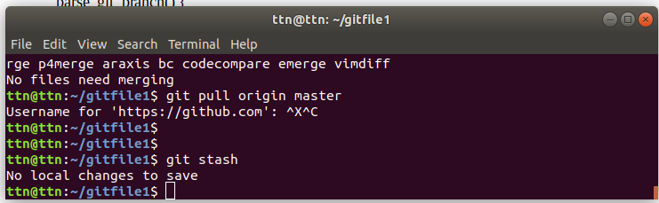

- Add the following code to your .bashrc file : color_prompt="yes"
parse_git_branch() {
git branch 2> /dev/null | sed -e '/^[^*]/d' -e 's/* \(.*\)/(\1)/'
}
if [ "$color_prompt" = yes ]; then
PS1='\u@\h\[\033[00m\]:\[\033[
else
PS1='\u@\h:\W $(parse_git_branch)\$ '
fi
unset color_prompt force_color_prompt

