Exercise

- Create and Run a Thread using Runnable Interface and Thread class.

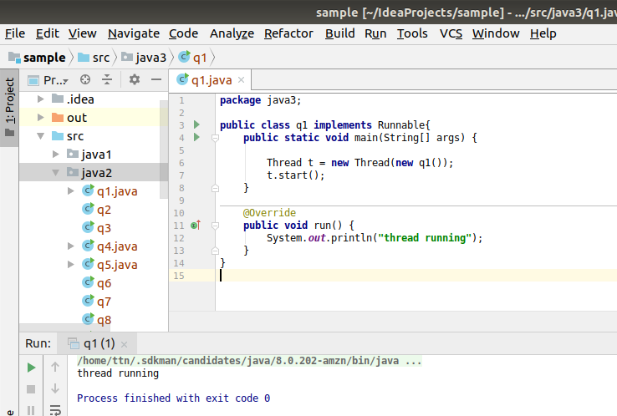

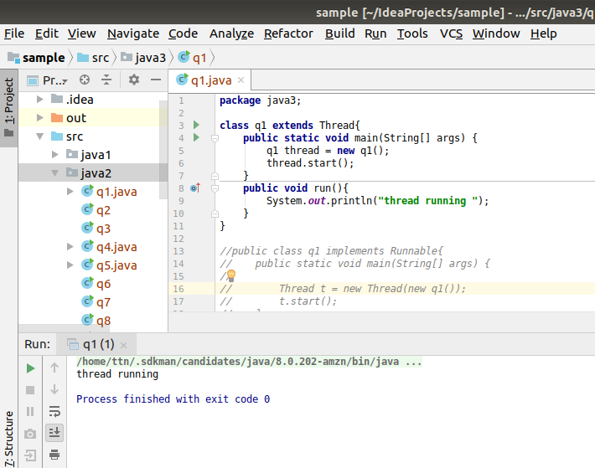

- Use sleep and join methods with thread.

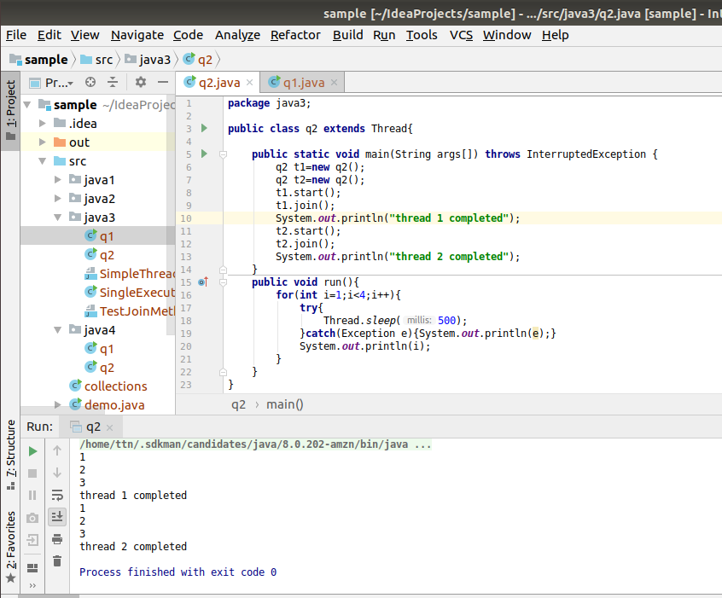

- Use a singleThreadExecutor to submit multiple threads.

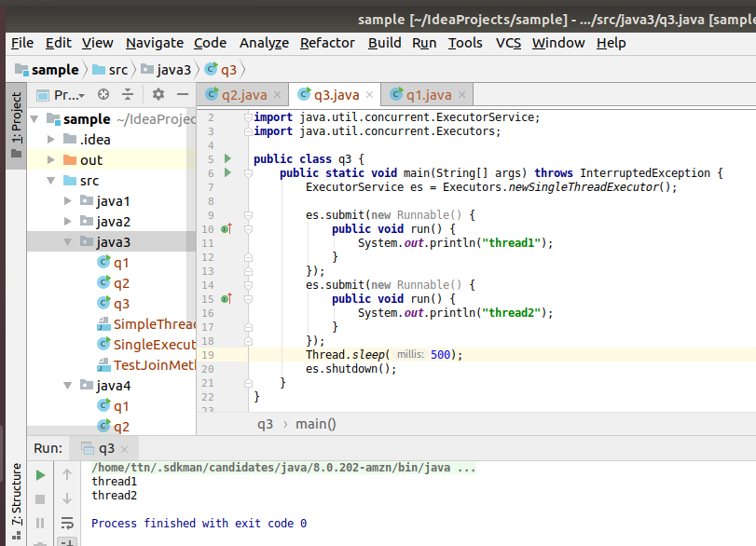

- Try shutdown() and shutdownNow() and observe the difference.

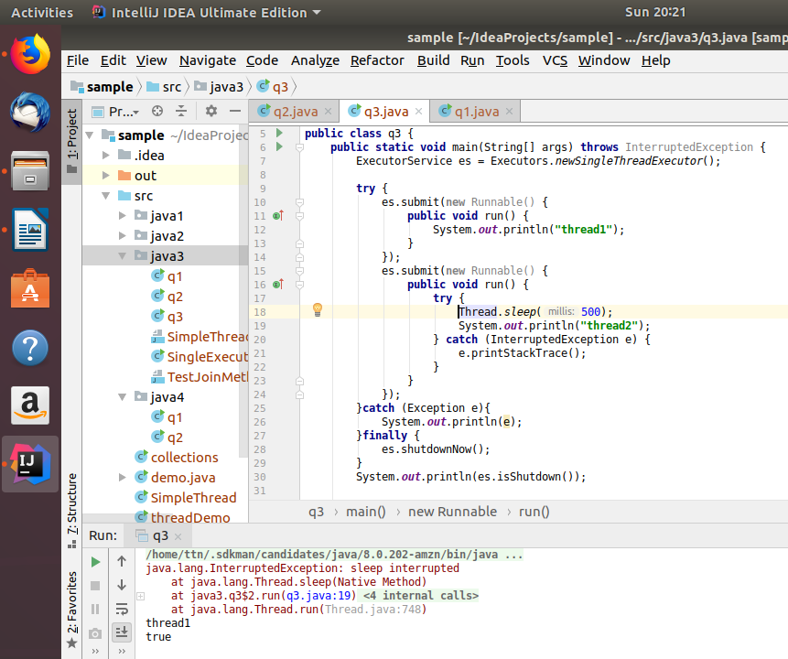

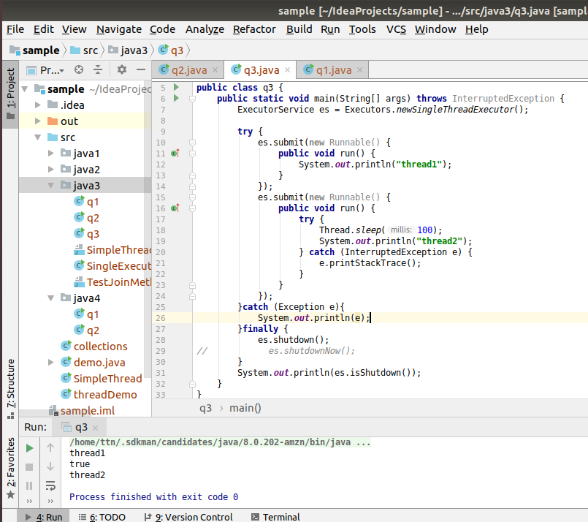

- Use isShutDown() and isTerminate() with ExecutorService.

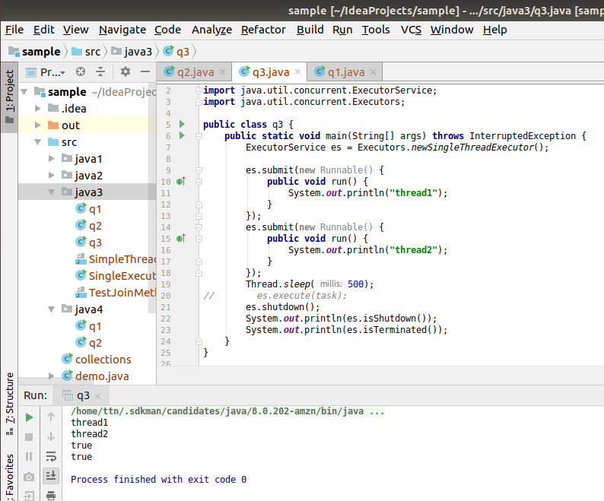

- Return a Future from ExecutorService by using callable and use get(), isDone(), isCancelled() with the Future object to know the status of task submitted.
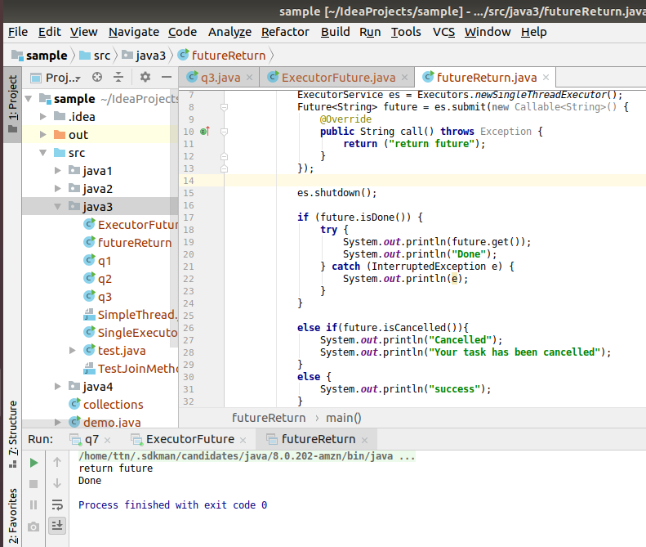

- Submit List of tasks to ExecutorService and wait for the completion of all the tasks.

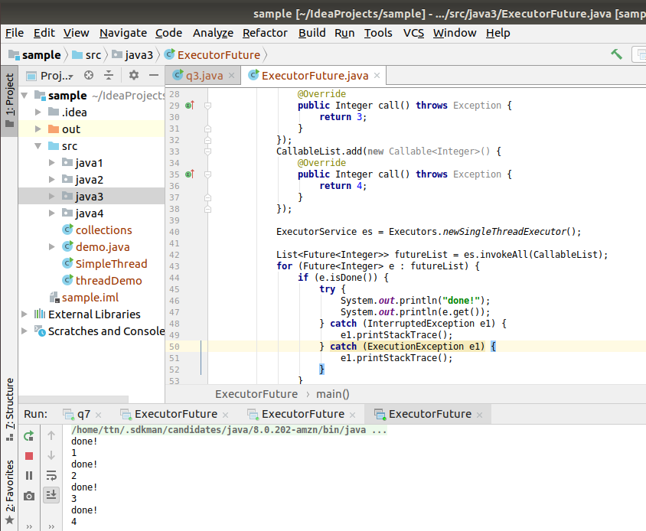

- Schedule task using schedule(), scheduleAtFixedRate() and scheduleAtFixedDelay()

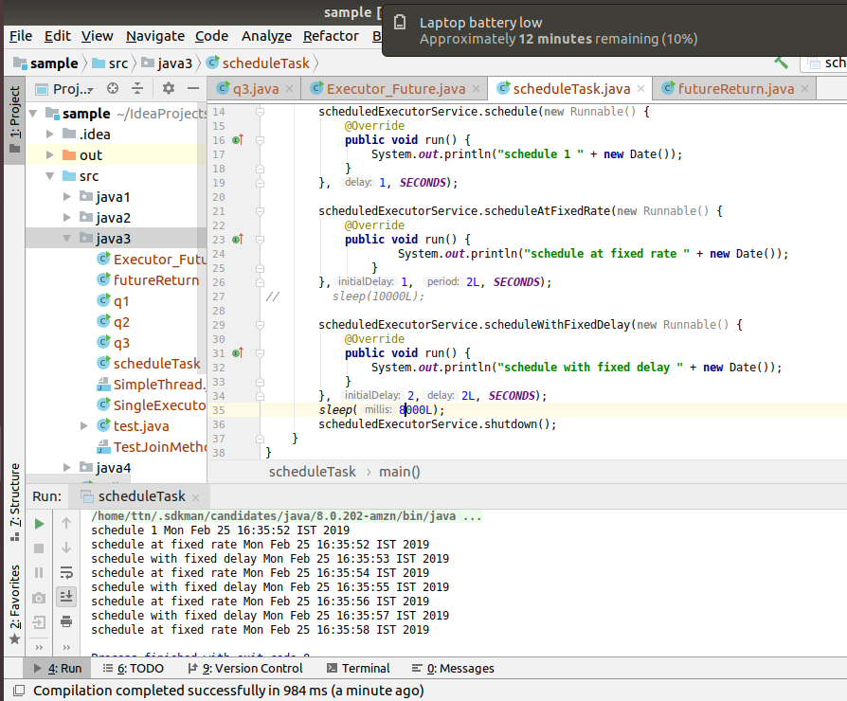

- Increase concurrency with Thread pools using newCachedThreadPool() and newFixedThreadPool().

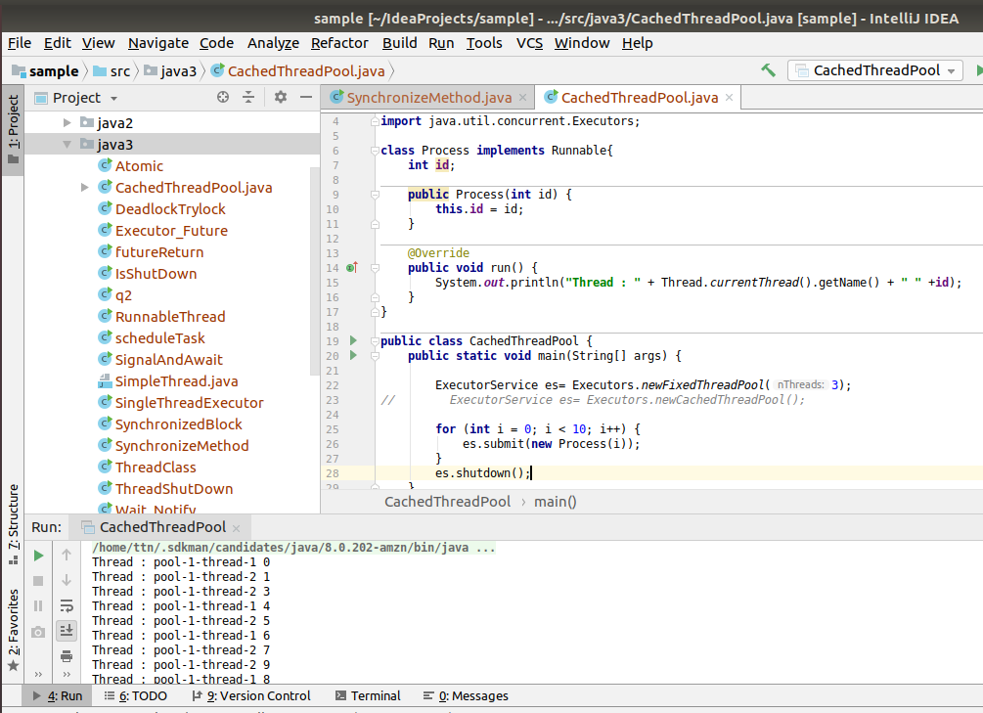

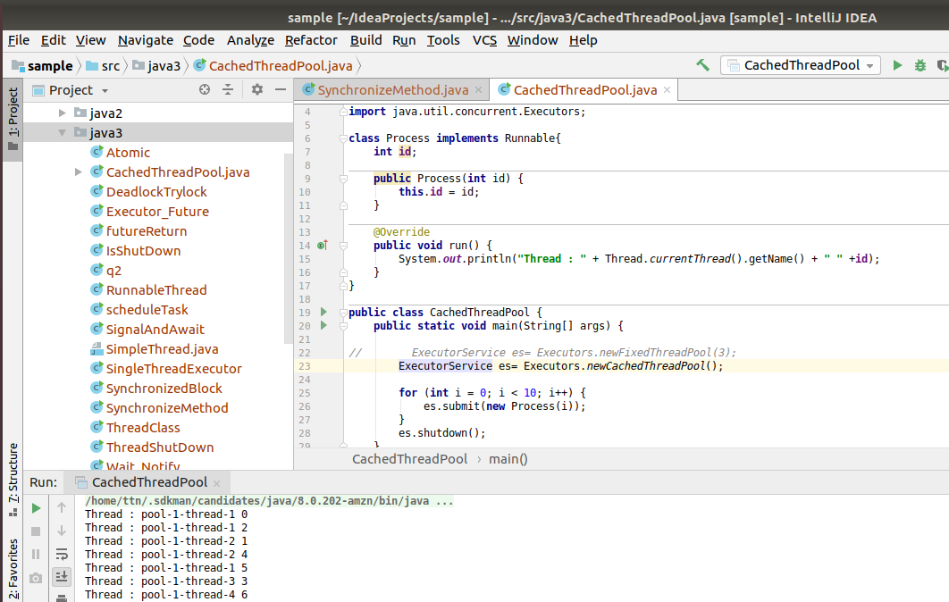

- Use Synchronize method to enable synchronization between multiple threads trying to access method at same time.

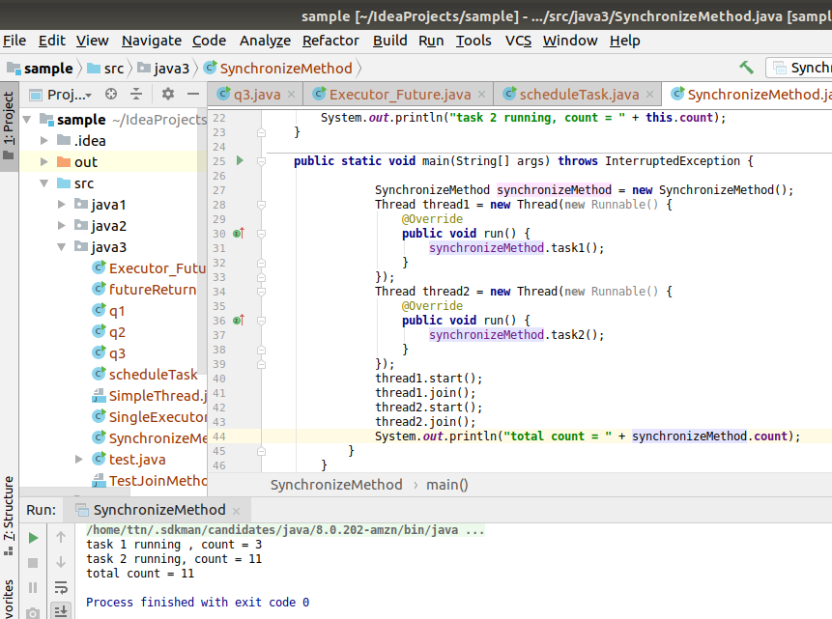

- Use Synchronize block to enable synchronization between multiple threads trying to access method at same time.

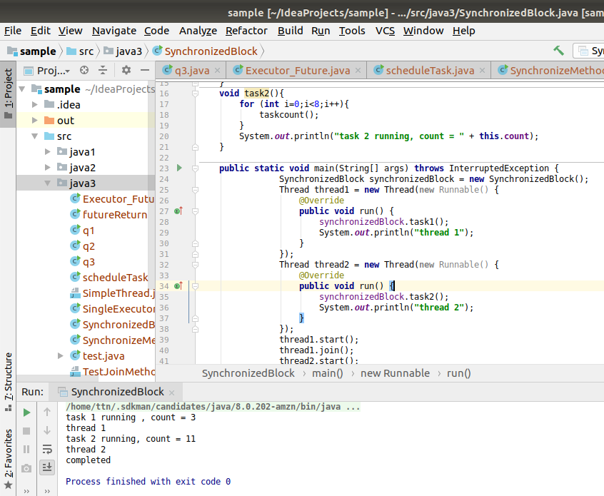

- Use Atomic Classes instead of Synchronize method and blocks.

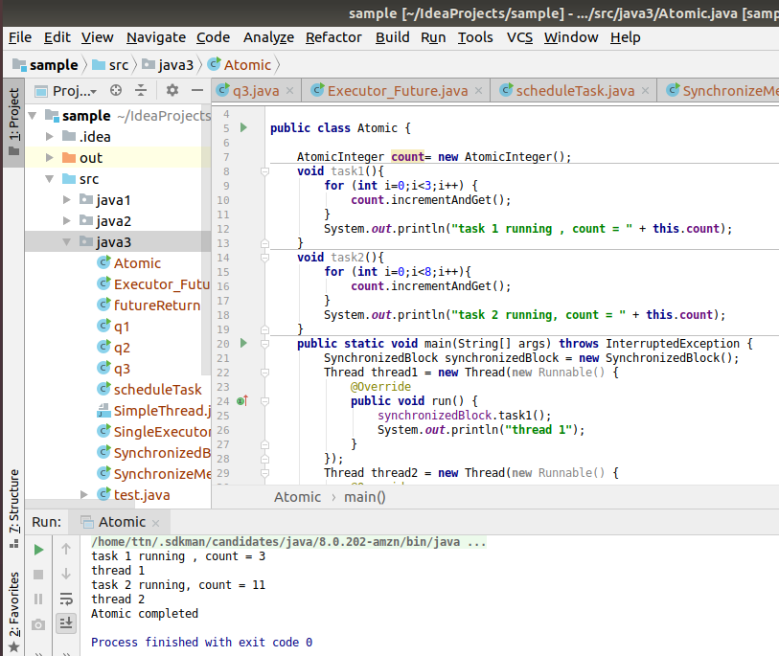

- Coordinate 2 threads using wait() and notify().

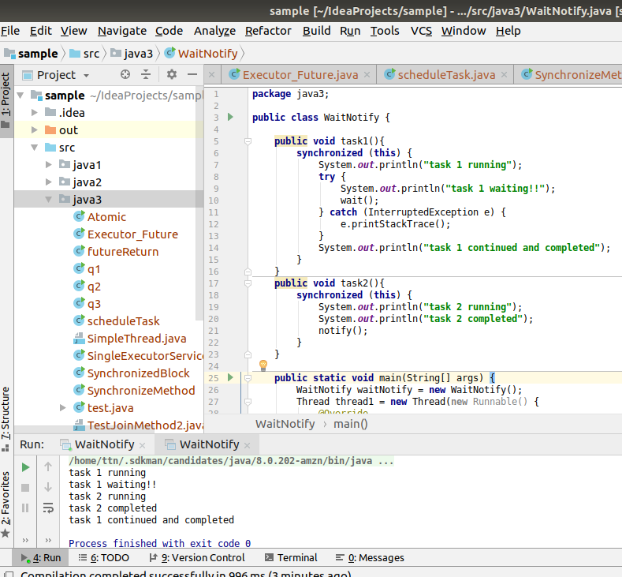

- Coordinate mulitple threads using wait() and notifyAll()

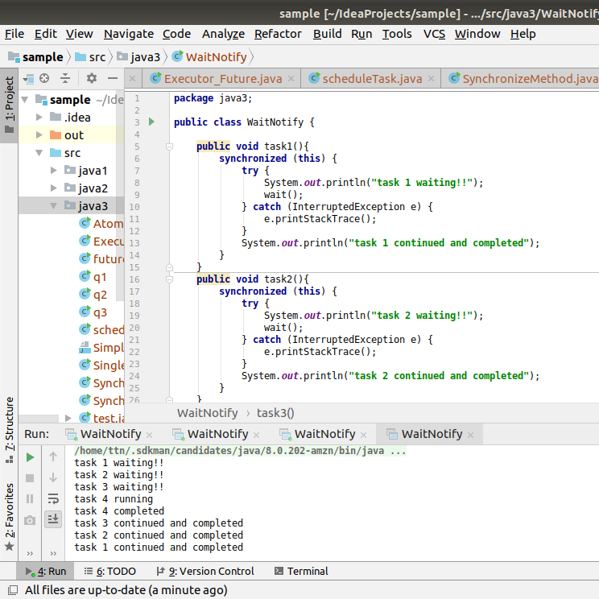

- Use Reentract lock for coordinating 2 threads with signal(), signalAll() and wait().

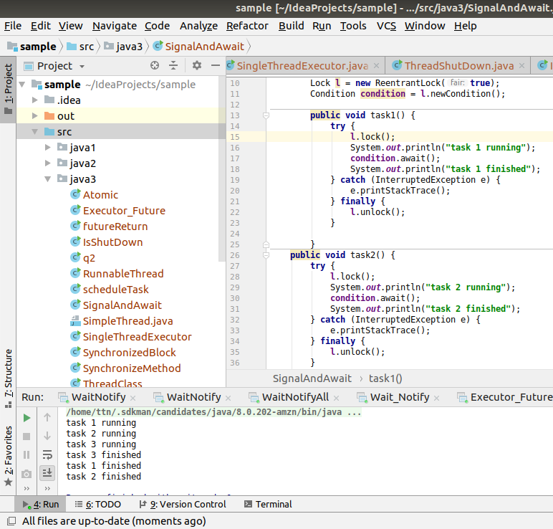

- Create a deadlock and Resolve it using tryLock().
