Exercise
1.How are inline and block elements different from each other?
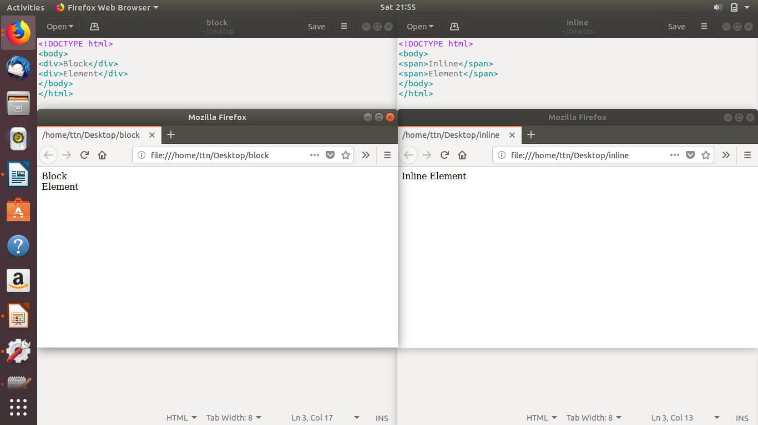

2.Explain the difference between visibility:hidden and display:none
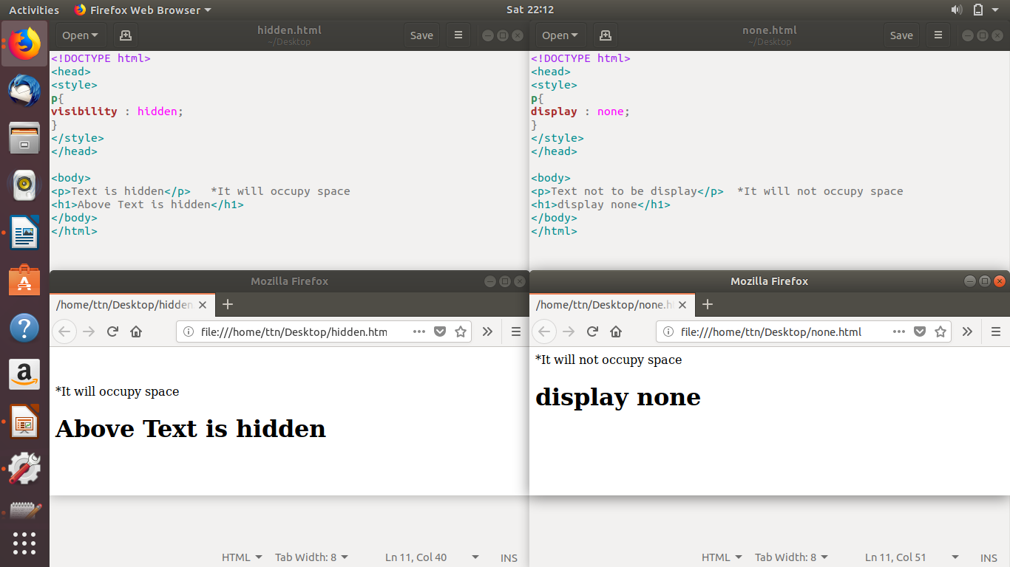

3. Explain the clear and float properties.

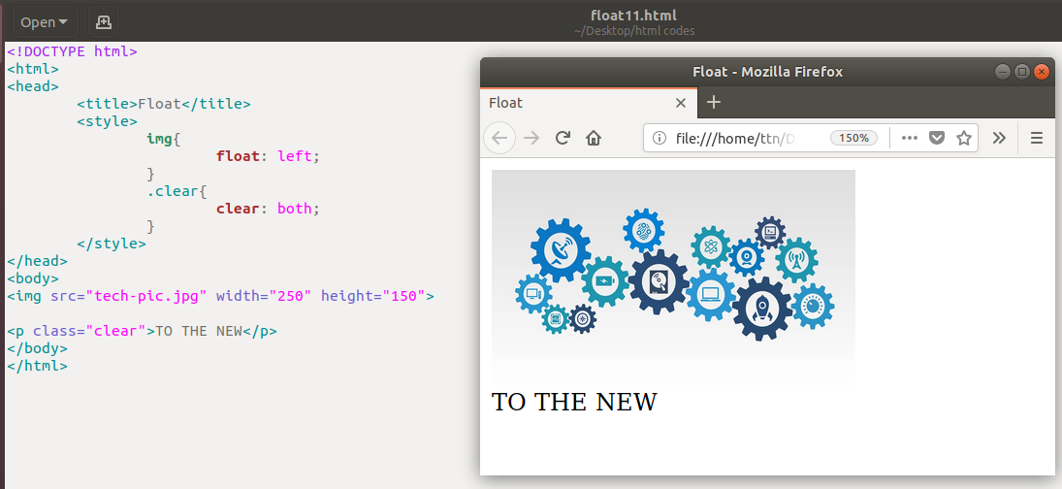

4. explain difference between absolute, relative,fixed and static.
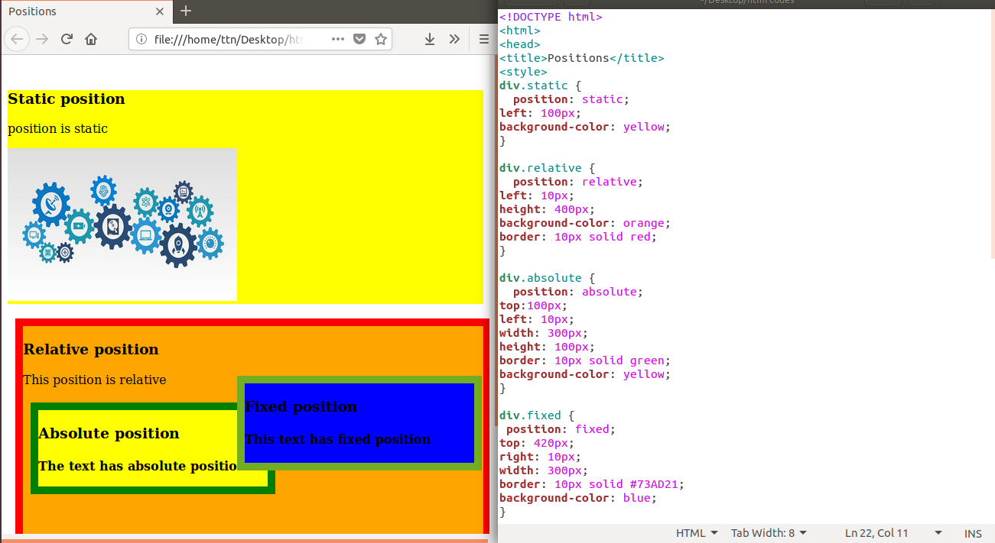

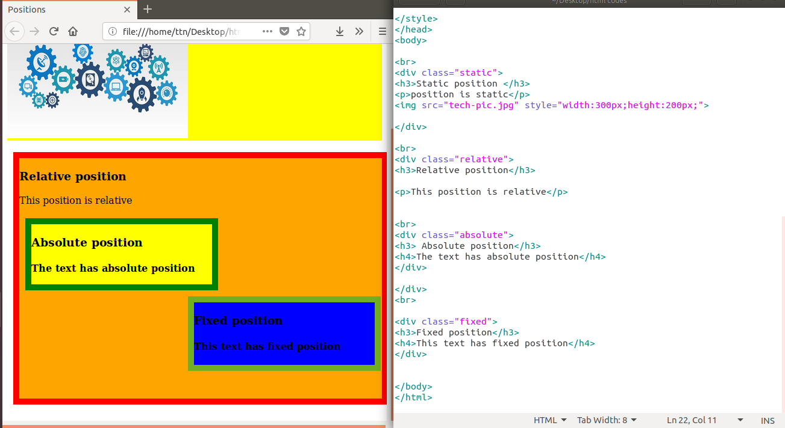
Here the fixed position text is not changing its position even while scrolling.

5. Write the HTML code to create a table in which there are 4 columns( ID , Employee Name, Designation, Department) and at least 6 rows. Also do some styling to it.
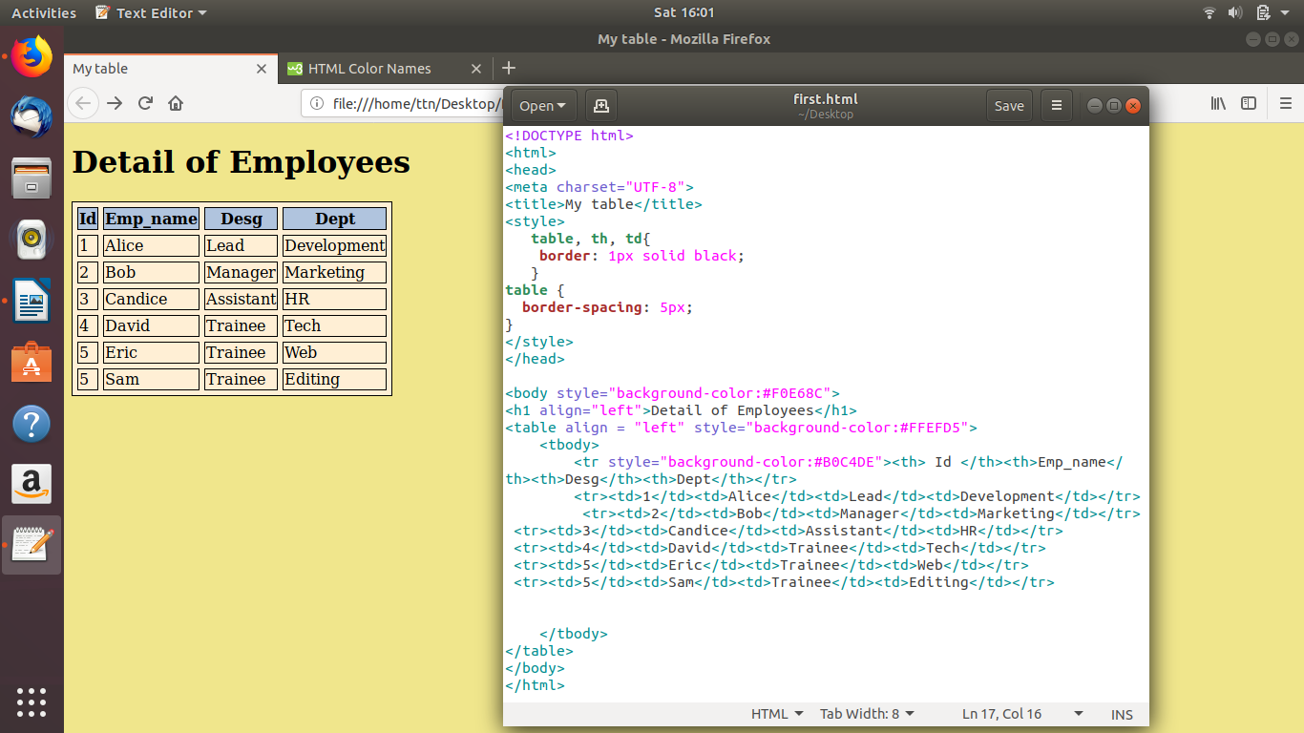

6. Why do we use meta tags?
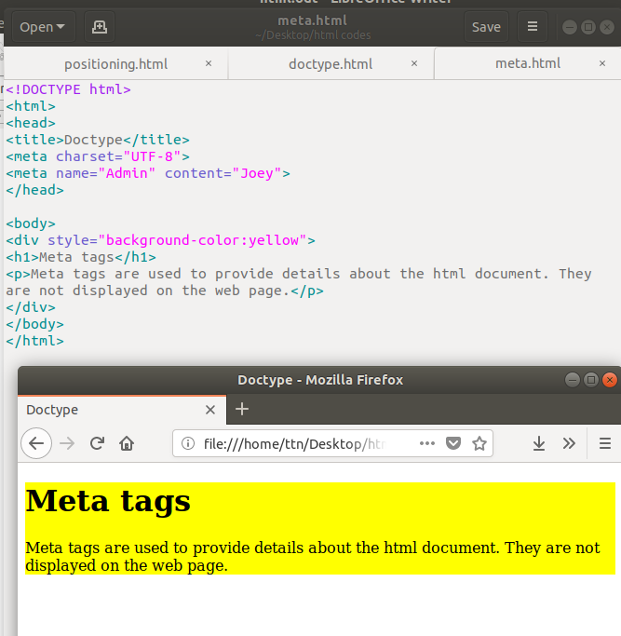

7. Explain box model.
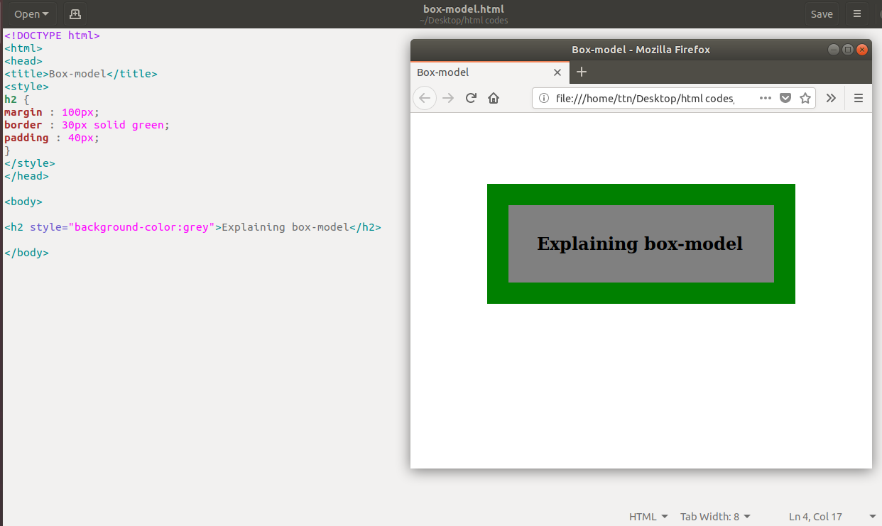

8. What are the different types of CSS Selectors?
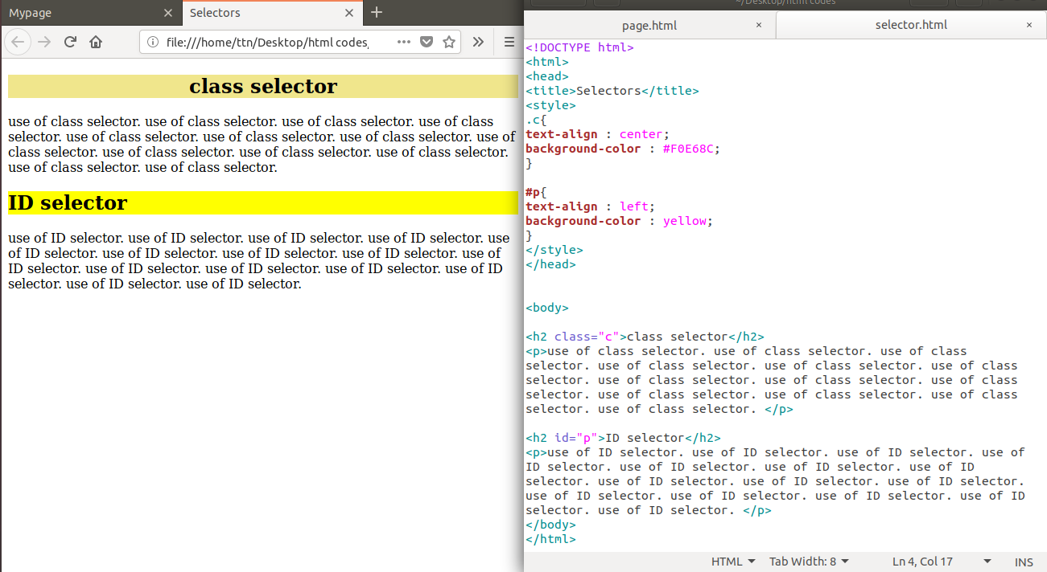

9. Define Doctype.
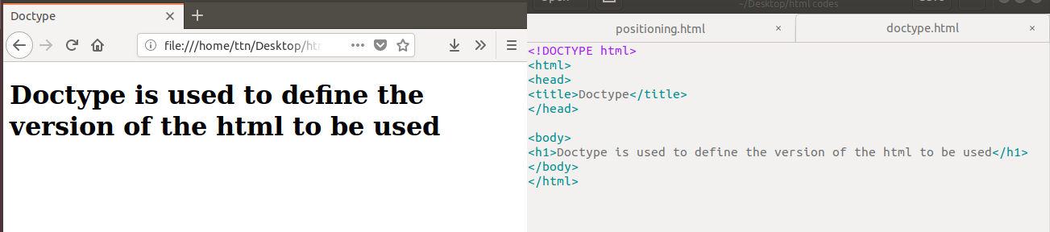

10. Explain 5 HTML5 semantic tags.
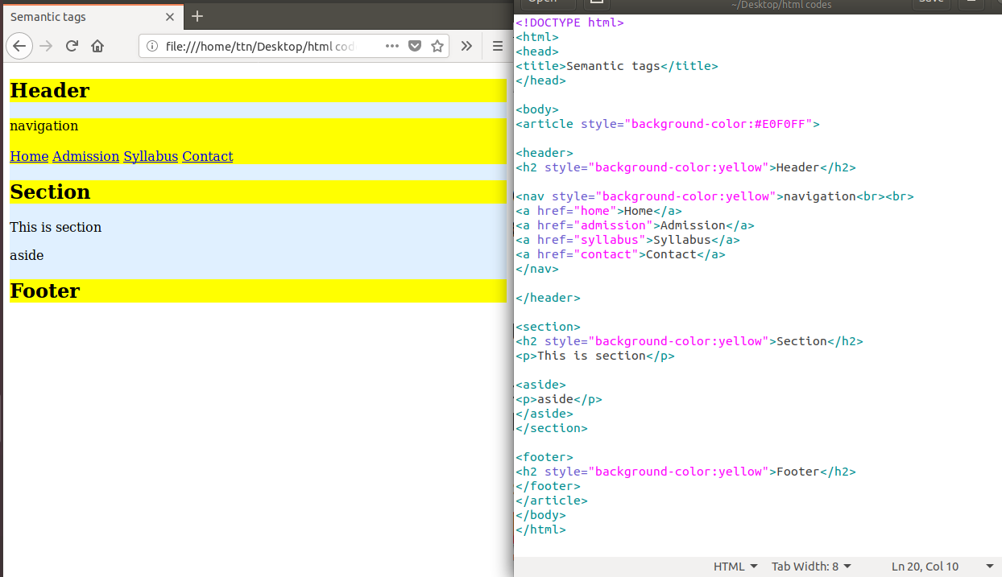

11. Create HTML for web-page.jpg(check resources, highest weightage for answers)
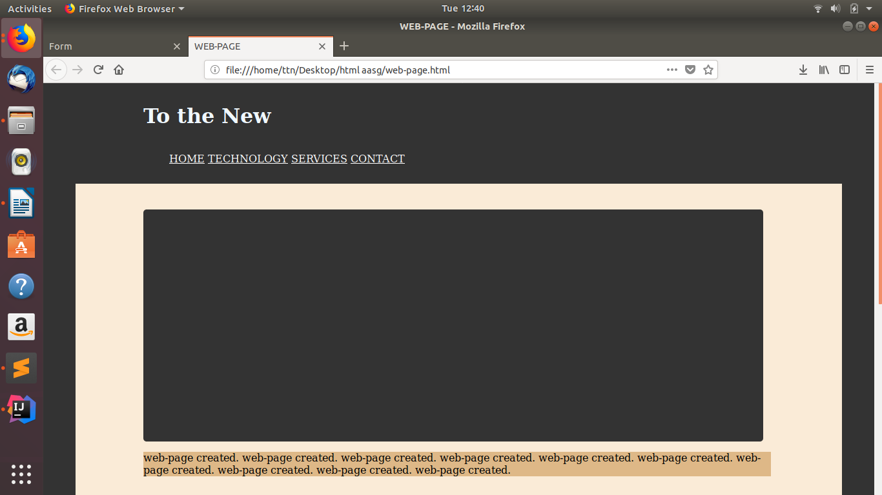
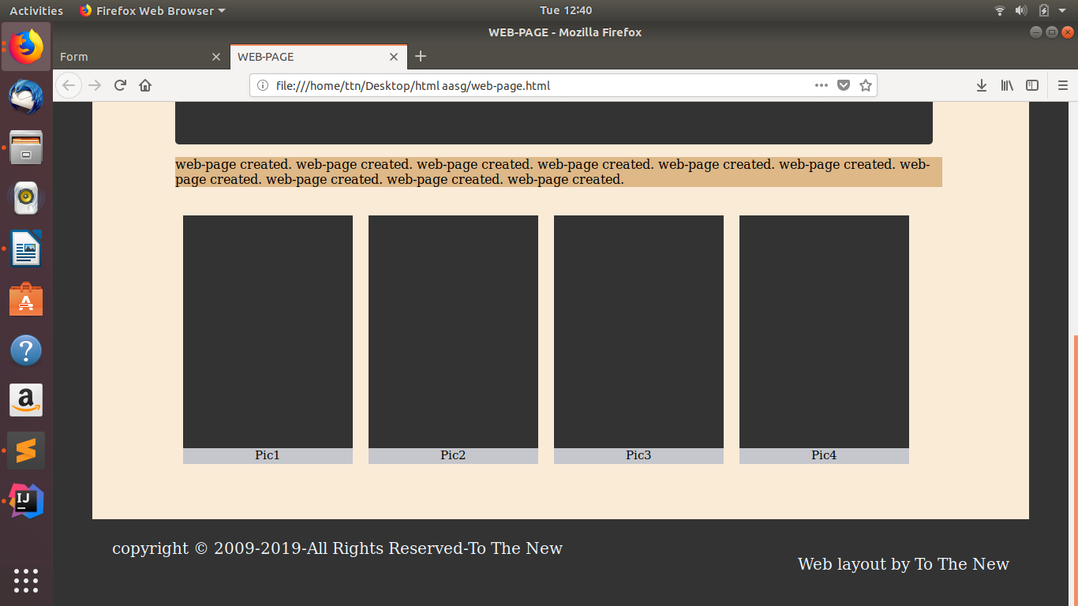

12. Create HTML for form.png (check resources, highest weightage for answers)
