License Key

config/wflicense.key

PM53ZJP3AV3KJV9GTB

Add these variables to webfocus.cfg

***IBI_ADMIN_NAME=admin***

***IBI_ADMIN_PASS=anythingyouwant***

Admin:

User:

jimca no pass

* ~~when scrolling the container under mouse, the replace content icon doesn't move.~~
* ~~Add Remove for easy placeholder  
  pc_menu_bar_title_bar_replace=Replace  
  pc_menu_bar_title_bar_remove=Remove~~
* ~~Localize resources for drag markers context dialog~~
* ~~the marker drop inside should start right at the edge for container inside responsive or inside column.when droping on flex children, don't allow drop on easy selector.~~
* ~~in the page dragdrop handler, reject all containers that are part of a flex.~~
* ~~in the titlebar dragdrop handler, don't reject easy selector placeholders from being dragged, just flex easy selectors.~~

var event = new BiEvent("themechanged");

event.setUserData(BipUtil.THEME_CHANGED_HINT_DIALOG);

application.getThemeManager().dispatchEvent(event);

Useful Information

Edit string resources:

1. Stop Apache
2. Get src/com/ibi/intl
3. Copy the entire dir structure com/ibi/intl (or create com and ibi, and just copy intl) to C:\ibi\WebFOCUS82\webapps\webfocus\WEB-INF\classes
4. Rename com_ibi_intl.jar in C:\ibi\WebFOCUS82\webapps\webfocus\WEB-INF\lib
5. Restart Apache

Generic jira case: BIP-849

#### Treetransf.xml backend file:

CVS: src\com\ibi\portal\templates

Build: C:\ibi\WebFOCUS82\webapps\webfocus\WEB-INF\classes\com\ibi\portal\templates

### Switch to V4 mode or set a default theme

C:\ibi\WebFOCUS82\config\install.cfg

or

C:\ibi\WebFOCUS82\config\webfocus.cfg

IBI_V4_PORTAL=true

IBI_TOOL_THEME=BIPNeutral

After changing, clear cache from the administration console.

#### Import zip package

Copy zip to C:\ibi\WebFOCUS82\cm\import

IBI_V4_PORTAL=TRUE

C:\ibi\WebFOCUS82\webapps\webfocus\WEB-INF\jsp\global\ibigbl.js

#### Isharedemo credentials

User:  \\isharedemo\telu

Password: Isharedemo1

#### Portal startup page:

C:\ibi\WebFOCUS82\webapps\webfocus\WEB-INF\jsp\bip\wfbip_portal\wfbiindex.jsp

XFOCUS

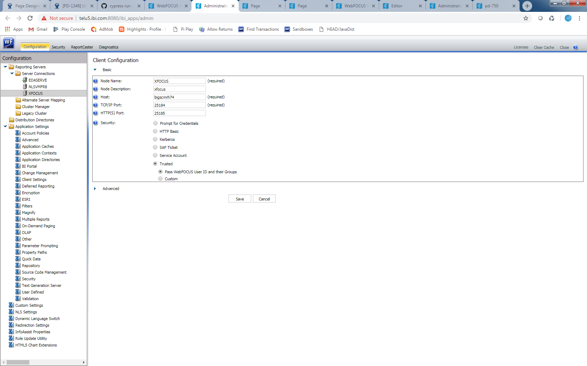

NLS QA server

Credentials: osdqa22/webfoc7

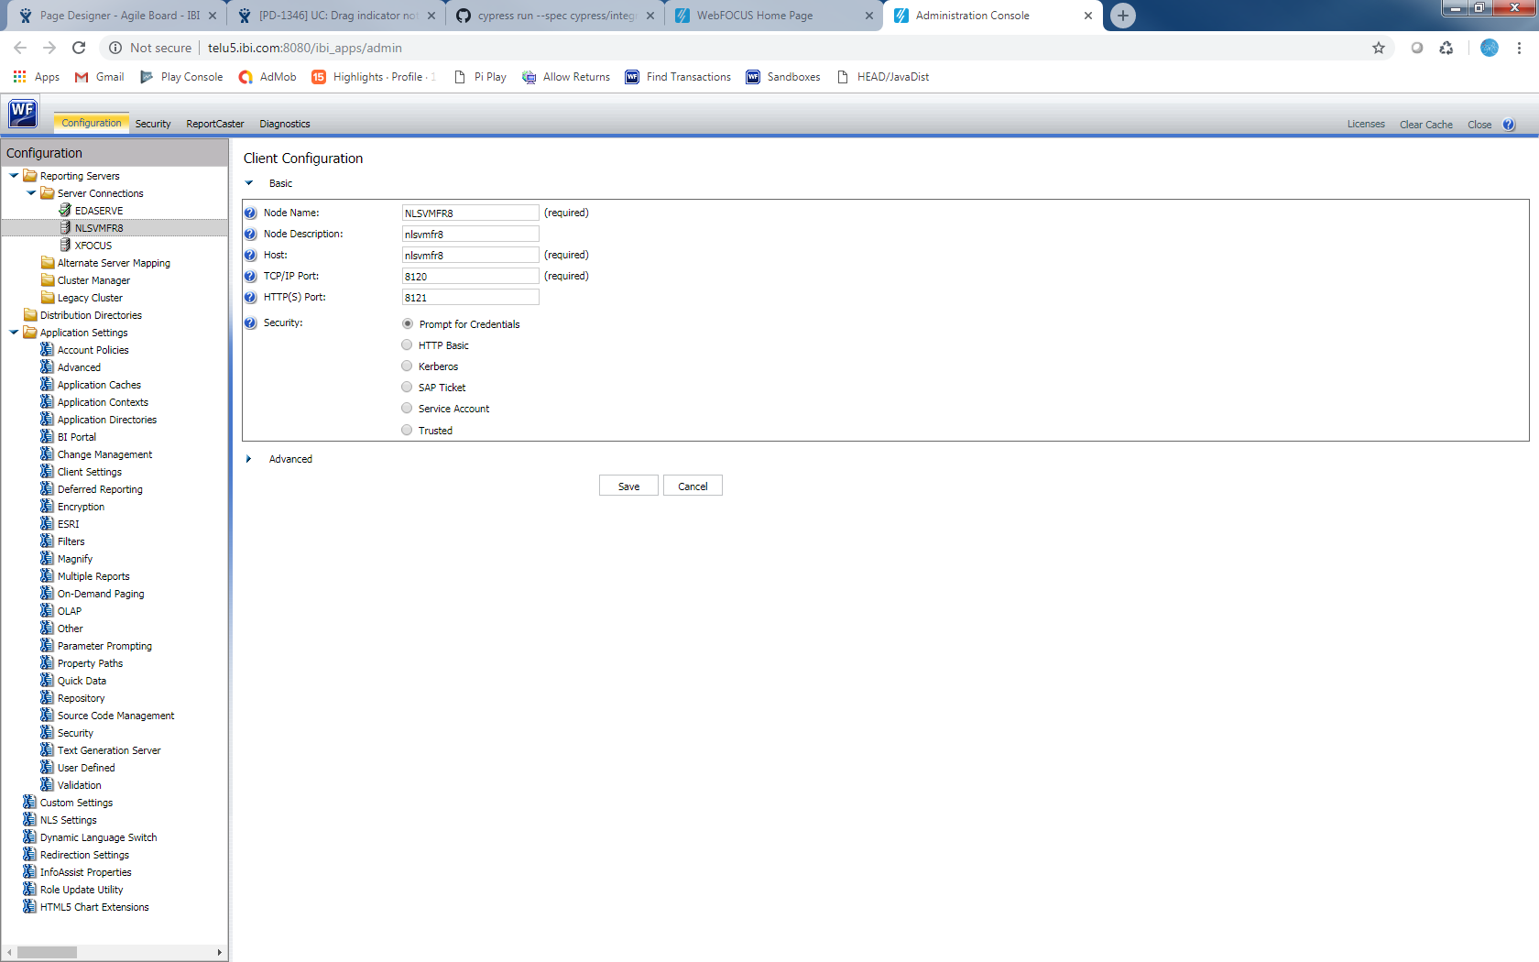

#### Set a property to a IBFS object:

use equivalent url for your own installation

<http://telu5.ibi.com:8080/ibi_apps/wfirs?IBFS_action=TEST>

on that page you will find a putProperty option.

pass it the ibfs path of the focexec and the property you want to set. In your case loadiniframe=no.

#### Modified wfdescribe call:

<http://telu5.ibi.com:8080/ibi_apps/wfirs/ibfs/WFC/Repository/Public/resources/prompt1.fex?IBFS_path=%2FWFC%2FRepository%2FPublic%2Fresources%2Fprompt1.fex&IBFS_action=run2>

#### Replace Derby database

In C:\ibi\WebFOCUS82\config\install.cfg set the new database name

IBI_REPOS_DB_URL=jdbc:derby://127.0.0.1:1527/WebFOCUS8201GA;create=true

Recycle apache server.

# Bootstrap Grid

<http://getbootstrap.com/css/#grid>

<https://scotch.io/tutorials/understanding-the-bootstrap-3-grid-system>

<https://v4-alpha.getbootstrap.com/layout/grid/>

<https://www.bootstrapcdn.com/>

/* Extra small devices (phones, less than 768px) */

/* No media query since this is the default in Bootstrap */

/* Small devices (tablets, 768px and up) */

@media (min-width: @screen-sm-min) { ... }

/* Medium devices (desktops, 992px and up) */

@media (min-width: @screen-md-min) { ... }

/* Large devices (large desktops, 1200px and up) */

@media (min-width: @screen-lg-min) { ... }

.col-xs-$ less than 768

.col-sm-$ between 768 and 992

.col-md-$ between 992 and 1200

.col-lg-$ over 1200

Bootstrap pluging:

Alert

Button

Carousel

Collapse

Dropdown

Modal

Tooltip

Popover

ScrollSpy

Tab

Affix

Page Designer

<http://saebasoft.ddns.net:8080/ibi_apps>

<http://saebasoft.ddns.net:8080/ibi_apps/WFServlet.ibfs?IBFS1_action=RUNFEX&IBFS_path=/WFC/Repository/V5PORTAL/pages/designer.htm>