POOJA K

1BM19CS111

Lab 1

Program 1. Perform the following DB operations using Cassandra.

1. Create a key space by name Employee

2. Create a column family by name Employee-Info with attributes Emp_Id Primary Key, Emp_Name, Designation, Date_of_Joining, Salary, Dept_Name

3. Insert the values into the table in batch

4. Update Employee name and Department of Emp-Id 121

5. Sort the details of Employee records based on salary

6. Alter the schema of the table Employee_Info to add a column Projects which stores a set of Projects done by the corresponding Employee.

7. Update the altered table to add project names.

8 Create a TTL of 15 seconds to display the values of Employees.

1.

CREATE KEYSPACE Employee WITH REPLICATION = { 'class' : 'SimpleStrategy', 'replication_factor': 1 };

cqlsh> DESCRIBE KEYSPACES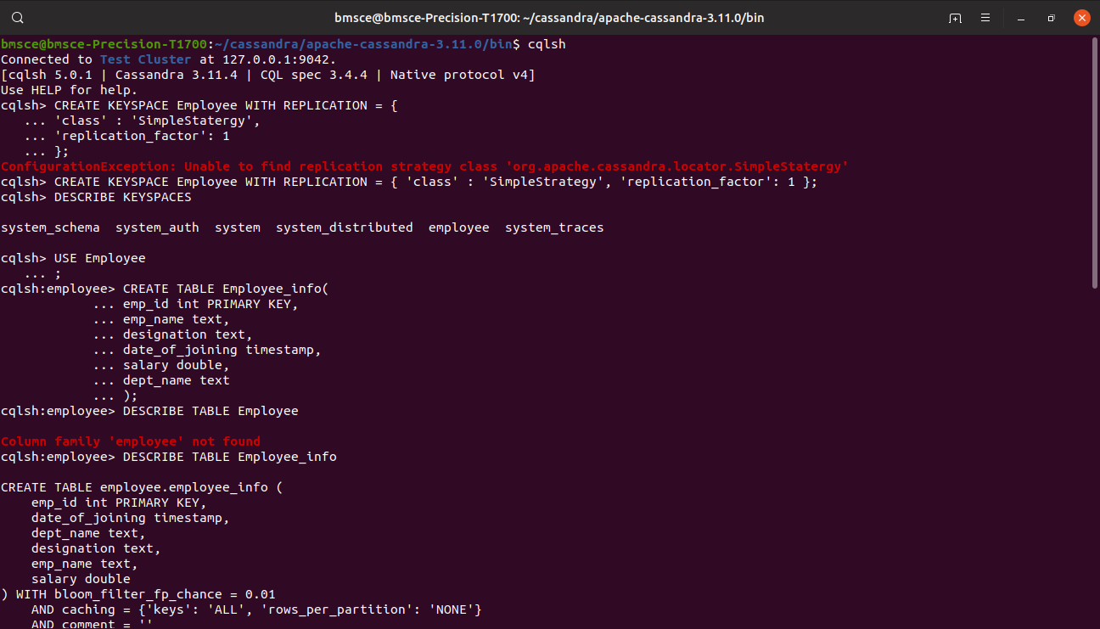

system_schema system_auth system system_distributed employee system_traces

2.CREATE TABLE Employee_info(

... emp_id int PRIMARY KEY,

... emp_name text,

... designation text,

... date_of_joining timestamp,

... salary double,

... dept_name text

... );

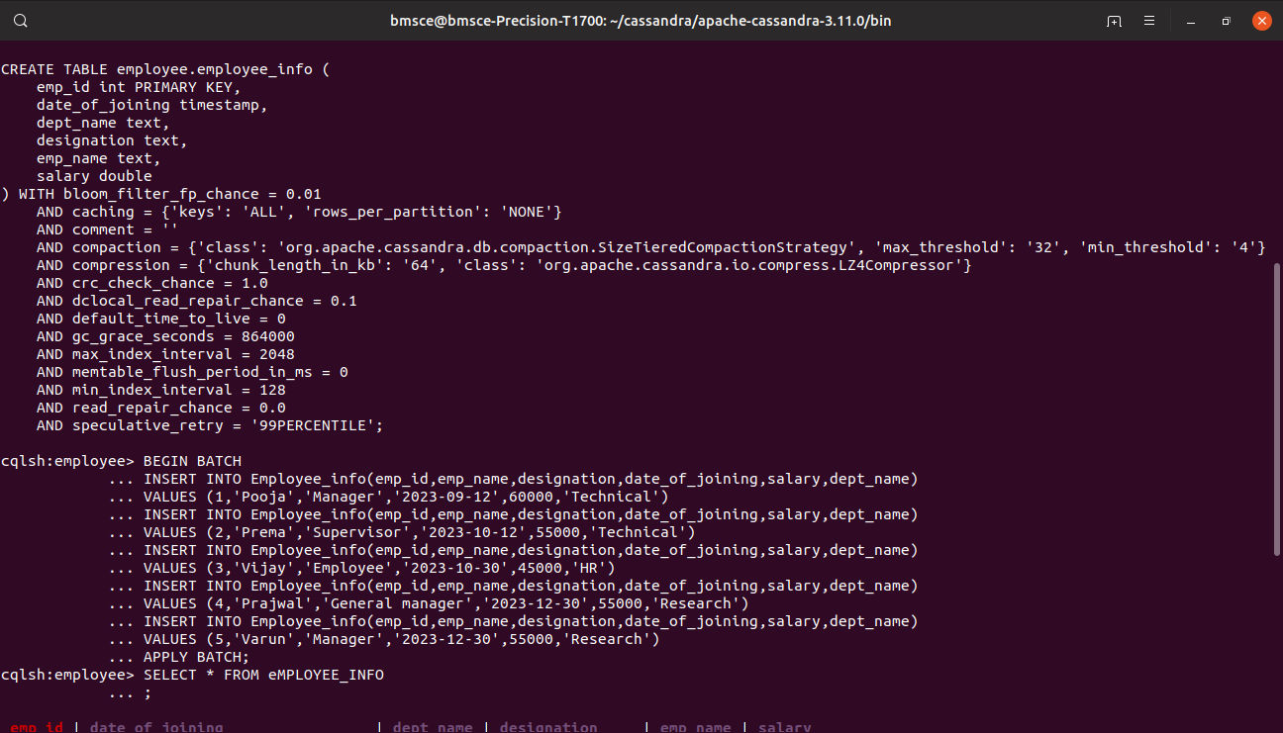

3) BEGIN BATCH

... INSERT INTO Employee_info(emp_id,emp_name,designation,date_of_joining,salary,dept_name)

... VALUES (1,'Pooja','Manager','2023-09-12',60000,'Technical')

... INSERT INTO Employee_info(emp_id,emp_name,designation,date_of_joining,salary,dept_name)

... VALUES (2,'Prema','Supervisor','2023-10-12',55000,'Technical')

... INSERT INTO Employee_info(emp_id,emp_name,designation,date_of_joining,salary,dept_name)

... VALUES (3,'Vijay','Employee','2023-10-30',45000,'HR')

... INSERT INTO Employee_info(emp_id,emp_name,designation,date_of_joining,salary,dept_name)

... VALUES (4,'Prajwal','General manager','2023-12-30',55000,'Research')

... INSERT INTO Employee_info(emp_id,emp_name,designation,date_of_joining,salary,dept_name)

... VALUES (5,'Varun','Manager','2023-12-30',55000,'Research')

... APPLY BATCH;

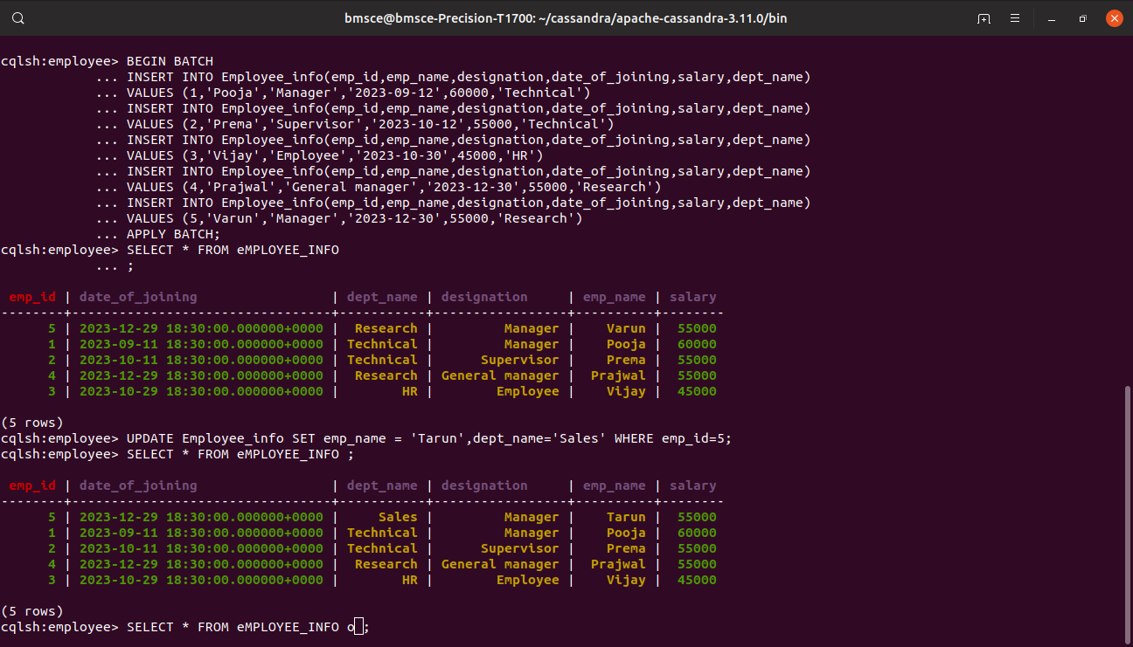

4). SELECT * FROM eMPLOYEE_INFO

... ;

emp_id | date_of_joining | dept_name | designation | emp_name | salary

--------+---------------------------------+-----------+-----------------+----------+--------

5 | 2023-12-29 18:30:00.000000+0000 | Research | Manager | Varun | 55000

1 | 2023-09-11 18:30:00.000000+0000 | Technical | Manager | Pooja | 60000

2 | 2023-10-11 18:30:00.000000+0000 | Technical | Supervisor | Prema | 55000

4 | 2023-12-29 18:30:00.000000+0000 | Research | General manager | Prajwal | 55000

3 | 2023-10-29 18:30:00.000000+0000 | HR | Employee | Vijay | 45000

5.)

UPDATE Employee_info SET emp_name = 'Tarun',dept_name='Sales' WHERE emp_id=5;

cqlsh:employee> SELECT * FROM eMPLOYEE_INFO ;

emp_id | date_of_joining | dept_name | designation | emp_name | salary

--------+---------------------------------+-----------+-----------------+----------+--------

5 | 2023-12-29 18:30:00.000000+0000 | Sales | Manager | Tarun | 55000

1 | 2023-09-11 18:30:00.000000+0000 | Technical | Manager | Pooja | 60000

2 | 2023-10-11 18:30:00.000000+0000 | Technical | Supervisor | Prema | 55000

4 | 2023-12-29 18:30:00.000000+0000 | Research | General manager | Prajwal | 55000

3 | 2023-10-29 18:30:00.000000+0000 | HR | Employee | Vijay | 45000



6)ALTER TABLE Employee_info

... ADD project text;

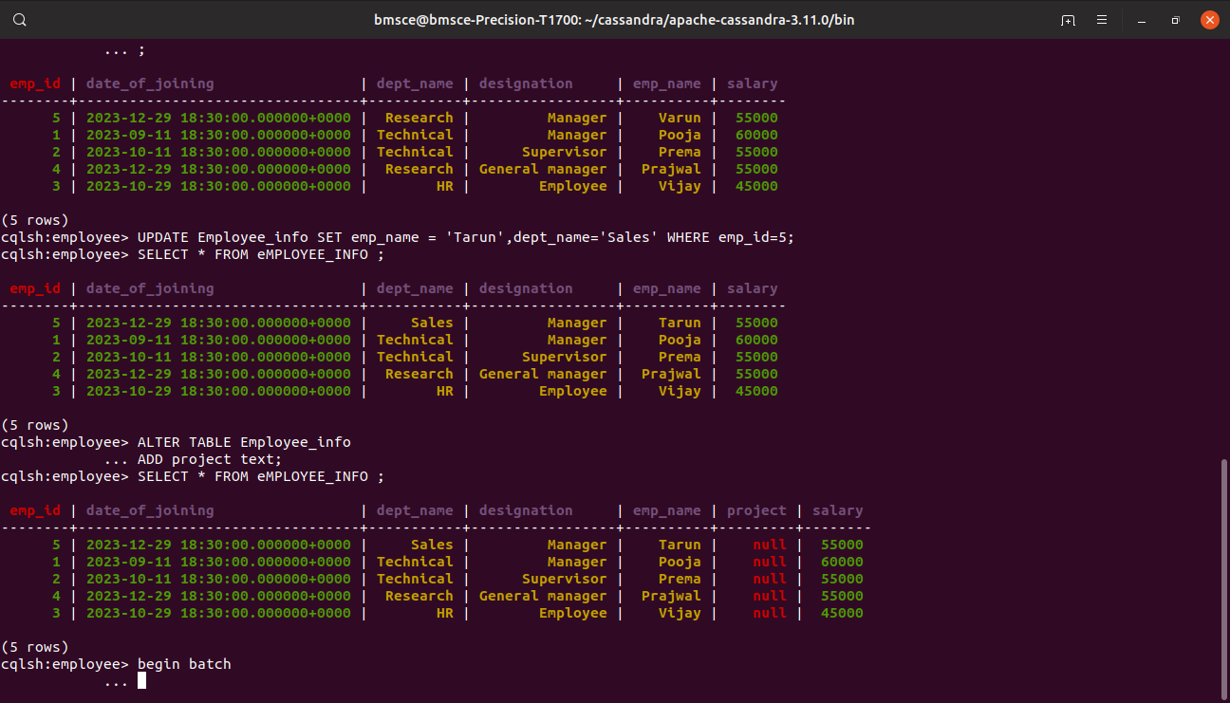

7)

begin batch

... update employee_info set project = 'abc' where emp_id=1

... update employee_info set project = 'dfc' where emp_id=2

... update employee_info set project = 'dfc' where emp_id=3

... update employee_info set project = 'xyz' where emp_id=4

... update employee_info set project = 'rqz' where emp_id=5

... ;

... apply batch;

cqlsh:employee> SELECT * FROM eMPLOYEE_INFO ;

emp_id | date_of_joining | dept_name | designation | emp_name | project | salary

--------+---------------------------------+-----------+-----------------+----------+---------+--------

5 | 2023-12-29 18:30:00.000000+0000 | Sales | Manager | Tarun | rqz | 55000

1 | 2023-09-11 18:30:00.000000+0000 | Technical | Manager | Pooja | abc | 60000

2 | 2023-10-11 18:30:00.000000+0000 | Technical | Supervisor | Prema | dfc | 55000

4 | 2023-12-29 18:30:00.000000+0000 | Research | General manager | Prajwal | xyz | 55000

3 | 2023-10-29 18:30:00.000000+0000 | HR | Employee | Vijay | dfc | 45000

