**Architectural Styles -The styles listed are:**

*1. Layered*

*2. Client Server*

*3. Microservices*

*4. Event-Driven Architecture*

*5. Service -Oriented Architecture*

**Overview of each architectural style listed:**

**1. *Layered Architecture*:**

*- *Description*:* Divides the system into layers, each with specific responsibilities.

*- *Common Uses*:* Enterprise applications, web applications.

*- *Example*:* Presentation layer, business logic layer, data access layer.

**2. *Client-Server Architecture*:**

*- *Description*:* Splits the system into two parts: clients (request services) and servers (provide services).

*- *Common Uses*:* Networked applications, web servers.

*- *Example*:* Web browsers (clients) communicating with web servers.

**3. *Microservices Architecture*:**

*- *Description*:* Decomposes the system into small, independent services that communicate over a network.

*- *Common Uses*:* Scalable and complex applications.

*- *Example*:* E-commerce platforms with separate services for user management, product catalog, and payment processing.

**4. *Event-Driven Architecture*:**

*- *Description*:* Uses events to trigger and communicate between decoupled components.

*- *Common Uses*:* Real-time applications, distributed systems.

*- *Example*:* Financial trading platforms, IoT systems.

**5. *Service-Oriented Architecture (SOA)*:**

*- *Description*:* Organizes the system as a set of services that communicate over a network, often using a common communication protocol.

*- *Common Uses*:* Enterprise applications, complex business processes.

*- *Example*:* Banking systems where different services handle accounts, transactions, and customer information.

**Service-Oriented Architecture (SOA) Case Study: Banking System**

**Scenario:**

A bank needs to integrate various services such as account management, loan processing, and customer support into a unified system. The goal is to improve interoperability, reusability, and maintainability of services.

**Architecture Overview:**

*\*Core Services*:*

1. *Account Service*: Manages user accounts, balances, and transactions.

2. *Loan Service*: Handles loan applications, approvals, and disbursements.

3. *Customer Support Service*: Manages customer inquiries and support tickets.

4. *Notification Service*: Sends notifications (emails, SMS) to customers.

**\****Service Communication*:*

- Services communicate over a standardized protocol like SOAP or REST.

- An ESB (Enterprise Service Bus) is used for managing communication and routing between services.

**Detailed Implementation:**

*1. Account Service*:

- *Functionality*:

- Create, update, and delete accounts.

- Perform balance inquiries and fund transfers.

- Generate account statements.

- *Technology*: Java EE, Spring Boot.

- *Database*: Oracle or MySQL.

*2. Loan Service*:

- *Functionality*:

- Process loan applications.

- Perform credit checks.

- Manage loan disbursements and repayments.

- *Technology*: .NET Core, ASP.NET.

- *Database*: Microsoft SQL Server.

*3. Customer Support Service*:

- *Functionality*:

- Handle customer inquiries through multiple channels (phone, email, chat).

- Track support tickets and their resolutions.

- Provide FAQs and self-service options.

- *Technology*: Python, Django.

- *Database*: PostgreSQL.

*4. Notification Service*:

- *Functionality*:

- Send account alerts, loan status updates, and promotional messages.

- Support for multiple channels (email, SMS, push notifications).

- *Technology*: Node.js, Express.

- *Third-Party Integration*: Twilio for SMS, SendGrid for emails.

*Enterprise Service Bus (ESB)*:

- *Functionality*:

- Manages service communication, routing, and transformation of messages.

- Provides monitoring, logging, and error handling capabilities.

- *Technology*: Apache Camel, Mule ESB.

**Benefits:**

1. *Reusability*: Services are designed to be reusable across different applications and projects within the bank.

2. *Interoperability*: Services can communicate with each other regardless of the underlying technology stack.

3. *Maintainability*: Each service can be developed, deployed, and scaled independently.

4. *Flexibility*: Easy integration with external partners and third-party services.

**Challenges:**

1. *Performance Overhead*: The use of ESB can introduce latency in communication between services.

2. *Complexity*: Managing service contracts, versioning, and service orchestration can be complex.

3. *Security*: Ensuring secure communication between services and protecting sensitive data is critical.

**Implementation Steps:**

1. *Define Service Contracts*:

- Use WSDL (Web Services Description Language) for SOAP services or OpenAPI (Swagger) for REST services.

- Clearly define the input/output formats, error handling, and security requirements.

2. *Develop Services*:

- Implement the core functionality of each service according to the defined contracts.

- Ensure services are stateless to improve scalability and reliability.

3. *Set Up ESB*:

- Configure the ESB to handle service communication, message routing, and transformation.

- Implement monitoring and logging to track service performance and identify issues.

4. *Integrate Services*:

- Ensure services can communicate with each other through the ESB.

- Perform end-to-end testing to validate the integration and overall system functionality.

5. *Deploy and Monitor*:

- Deploy services on a scalable infrastructure (e.g., Kubernetes, Docker).

- Use monitoring tools to track service performance, availability, and usage patterns.

By following these steps and leveraging SOA, the bank can build a robust, flexible, and scalable system that meets its .

**Event-Driven Architecture Case Study: Real-Time Analytics System**

**Scenario:**

A company needs to build a real-time analytics system to process and analyze data from Internet of Things (IoT) devices deployed in a smart city. The devices send various types of data, such as temperature, humidity, air quality, and traffic information. The system must handle high volumes of data, provide real-time insights, and be scalable.

**Architecture Overview:**

*Core Components*:

1. *Event Producers*: IoT devices that generate data events.

2. *Event Broker*: Central system for managing and distributing events (e.g., Apache Kafka).

3. *Event Consumers*: Services that process and analyze the events.

4. *Data Storage*: Databases and data lakes for storing raw and processed data.

5. *Real-Time Dashboard*: User interface to visualize real-time data and insights.

*Communication*:

- Events are published to and consumed from the event broker.

- Event-driven communication ensures decoupling and scalability.

**Detailed Implementation:**

*1. Event Producers (IoT Devices)*:

- *Functionality*:

- Collect data from sensors and publish it as events.

- Example: Temperature sensors, air quality monitors, traffic cameras.

- *Technology*: Embedded systems with MQTT protocol for sending events.

*2. Event Broker*:

- *Functionality*:

- Manage event streams from producers to consumers.

- Ensure reliability, scalability, and fault tolerance.

- *Technology*: Apache Kafka or AWS Kinesis.

- *Features*: Topic-based event channels, partitioning, replication.

*3. Event Consumers*:

- *Data Processing Service*:

- *Functionality*: Ingests raw data, performs initial processing, and enriches data.

- Technology*: Apache Flink, Apache Spark Streaming.

- *Analytics Service*:

- *Functionality*: Performs complex analytics, generates insights, and detects anomalies.

- *Technology*: Python, TensorFlow, Apache Beam.

- *Notification Service*:

- *Functionality*: Sends alerts based on predefined rules (e.g., high pollution levels).

- *Technology*: Node.js, Express, integrated with Twilio or similar services.

*4. Data Storage*:

- *Raw Data Storage*:

- *Functionality*: Store raw event data for historical analysis.

- *Technology*: HDFS, AWS S3.

- *Processed Data Storage*:

- *Functionality*: Store processed and analyzed data for quick access.

- *Technology*: Elasticsearch, Amazon Redshift.

*5. Real-Time Dashboard*:

- *Functionality*:

- Visualize real-time data, trends, and analytics.

- Provide user-friendly interface for end-users to interact with data.

- *Technology*: React.js for frontend, D3.js for data visualization, WebSocket for real-time updates.

**Benefits:**

1. *Scalability*: The system can handle a high volume of events and scale horizontally by adding more event consumers.

2. *Decoupling*: Producers and consumers are decoupled, allowing independent development and scaling.

3. *Real-Time Processing*: Provides real-time insights and alerts, improving responsiveness and decision-making.

4. *Flexibility*: New event consumers can be added without disrupting existing services.

**Challenges:**

1. *Complexity*: Managing event streams, ensuring data consistency, and handling out-of-order events can be complex.

2. *Latency*: Ensuring low-latency processing and delivery of events.

3. *Monitoring and Debugging*: Difficulties in tracking and troubleshooting issues in an asynchronous system.

**Implementation Steps:**

1. *Set Up Event Broker*:

- Deploy Apache Kafka or AWS Kinesis.

- Configure topics, partitions, and replication factors.

2. *Develop Event Producers*:

- Implement data collection and event publishing logic in IoT devices.

- Ensure reliable connectivity and data transmission.

3. *Develop Event Consumers*:

- Implement data processing, analytics, and notification services.

- Ensure services can handle high throughput and scale horizontally.

4. *Set Up Data Storage*:

- Configure raw and processed data storage solutions.

-Implement data ingestion pipelines.

5. *Build Real-Time Dashboard*:

- Develop user interface for data visualization.

- Integrate with WebSocket or similar technology for real-time updates.

6. *Deploy and Monitor*:

- Deploy services using container orchestration platforms (e.g., Kubernetes).

- Use monitoring tools (e.g., Prometheus, Grafana) to track system performance and health.

By leveraging an event-driven architecture, the company can build a robust and scalable real-time analytics system that meets its requirements for processing and analyzing IoT data. This approach ensures high responsiveness, flexibility, and the ability to handle large volumes of data.business needs while allowing for future growth and integration.

**Case Study: Modernizing a Banking System with SOA**

**Introduction**

A major bank, SecureBank, is facing challenges with its current monolithic banking application. The system is struggling with performance issues, particularly during peak transaction periods. Additionally, integrating new services and maintaining the existing codebase has become increasingly difficult. To address these issues, SecureBank decides to modernize its system using Service-Oriented Architecture (SOA).

**Objectives**

**1. *Scalability*:** Ensure the banking system can handle a growing number of transactions and users.

**2. *Integration*:** Simplify the integration process for new financial services and third-party systems.

**3. *Maintainability*:** Improve the maintainability of the codebase by decoupling services.

**Solution: Service-Oriented Architecture (SOA)**

SecureBank adopts an SOA approach, breaking down the monolithic application into a set of discrete, reusable services. Each service performs specific business functions and communicates through well-defined interfaces.

**Identified Services**

**1. *Customer Service*:** Manages customer information, authentication, and profile management.

**2. *Account Service*:** Handles account management, including account creation, updates, and balance inquiries.

**3. *Transaction Service*:** Processes financial transactions, such as deposits, withdrawals, and transfers.

**4. *Loan Service*:** Manages loan applications, approvals, and repayments.

**5. *Notification Service*:** Sends notifications to customers via email, SMS, or push notifications.

**6. *Reporting Service*:** Generates reports for various banking operations and regulatory compliance.

**Detailed Architecture and UML Diagrams**

**Use Case Diagram**

The use case diagram illustrates the interactions between users and the various services within the banking system

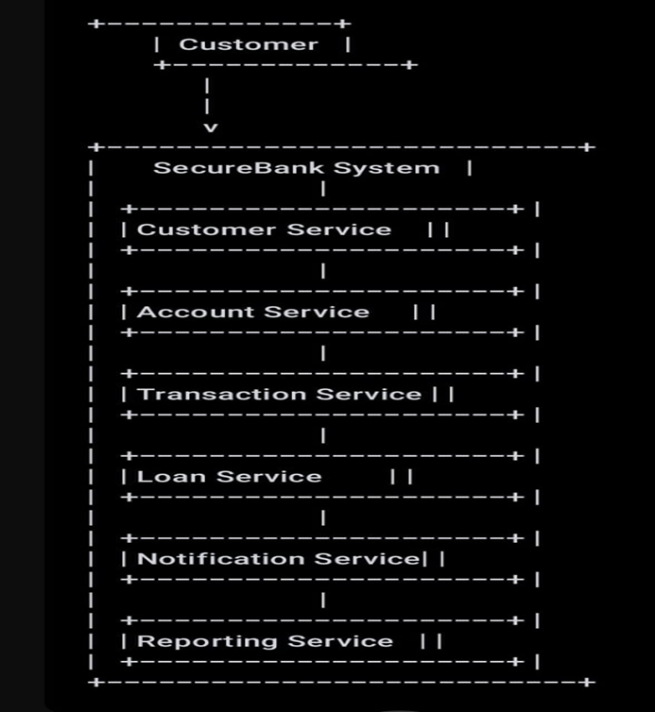

**Component Diagram**

The component diagram shows the internal structure of the system and the dependencies between components.

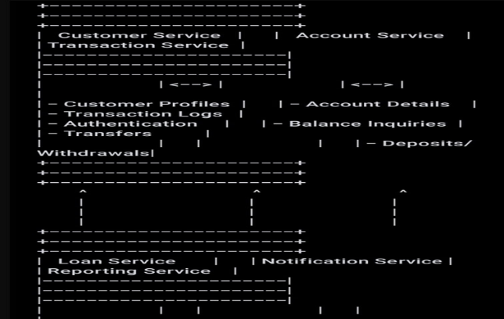

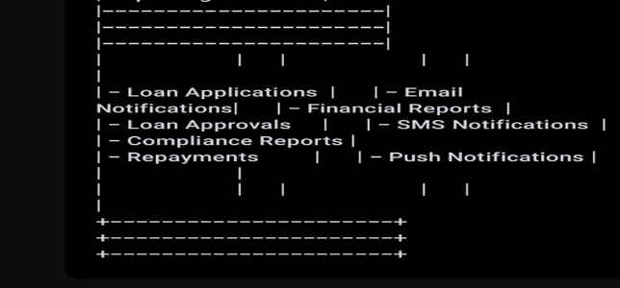

**Sequence Diagram**

The sequence diagram demonstrates the process of a customer making a fund transfer and how the different services interact to complete the transaction.

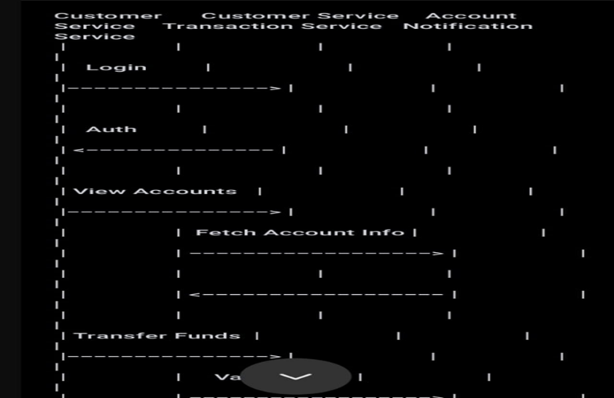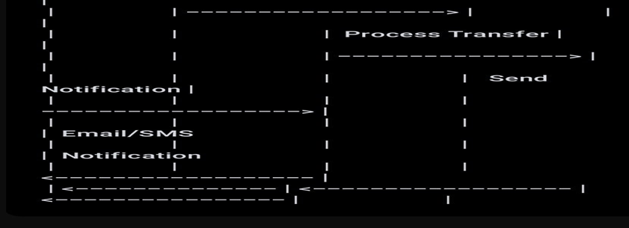

**Detailed Explanation**

**1.Customer Service**

**\*Responsibilities*:**

- Manages customer data, including registration, profile updates, and authentication.

- Ensures secure handling of customer credentials and personal information.

**\*Benefits*:**

- Decoupling customer management from other services simplifies user-related operations.

- Enhances security by isolating authentication logic.

**2.Account Service**

**\*Responsibilities*:**

- Manages account creation, updates, and balance inquiries.

- Provides APIs for querying account information.

**\*Benefits*:**

- Centralizes account-related operations, making it easier to manage and update account data.

- Improves scalability by handling account queries and updates independently.

3.**Transaction Service**

**\*Responsibilities*:**

- Processes financial transactions, such as deposits, withdrawals, and transfers.

- Ensures transaction integrity and maintains transaction logs.

**\*Benefits*:**

- Decouples transaction processing from other operations, enabling independent scaling.

- Simplifies transaction management and improves maintainability.

**4.Loan Service**

**\*Responsibilities*:**

- Manages loan applications, approvals, and repayments.

- Provides APIs for querying loan information.

*Benefits*:

- Centralizes loan-related operations, making it easier to manage and update loan data.

- Improves scalability by handling loan processing independently.

**5.Notification Service**

**\*Responsibilities*:**

- Sends notifications to customers via email, SMS, or push notifications.

- Manages notification templates and delivery schedules.

**\*Benefits*:**

- Enhances customer communication by centralizing notification management.

- Improves scalability by handling notification delivery independently.

**6.Reporting Service**

**\*Responsibilities*:**

- Generates reports for various banking operations and regulatory compliance.

- Provides APIs for querying report data.

**\*Benefits*:**

- Centralizes reporting operations, making it easier to generate and manage reports.

- Improves scalability by handling report generation independently.

**Conclusion**

By adopting SOA, SecureBank achieved significant improvements in scalability, integration, and maintainability. The decoupled services allow for independent development, deployment, and scaling, resulting in faster release cycles and better overall system performance. This modernization effort positions SecureBank to handle future growth and integrate new services with minimal disruption.