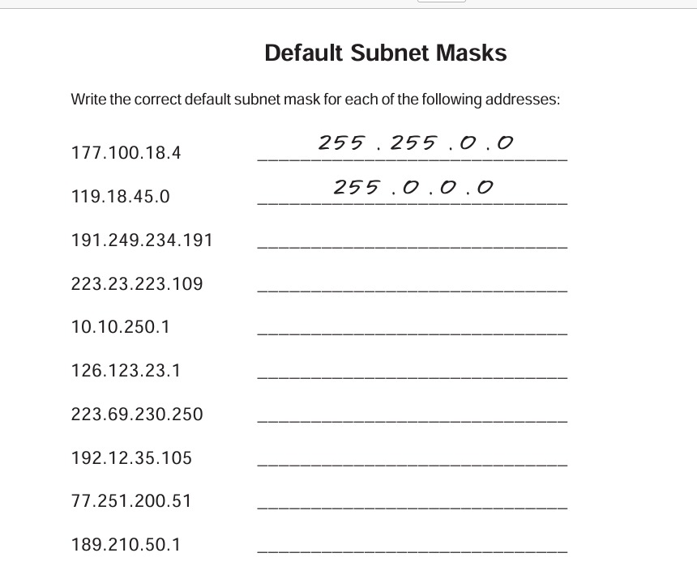

255.255.0.0

255.255.255.0

255.0.0.0

255.0.0.0

255.255.255.0

255.255.255.0

255.0.0.0

255.255.0.0

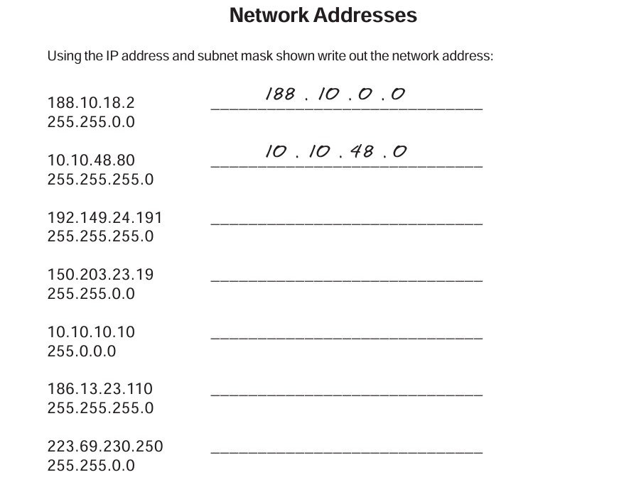

NETWORKDDRESS

188.10.0.0

10.10.48.0

192.149.24.0

150.203.0.0

10.0.0.0

186.13.23.0

223.69.0.0