Vixen Developer Manual
(Apendix X)

User Interface Framework

Author : Jared Herbohn
Date : 03-06-2007
Revision : 0.0.1

COMMERCIAL-IN-CONFIDENCE
The information contained within this document is confidential and must not be made available to any person who has not entered into a non-disclosure agreement with Voiptel Pty Ltd. This document must not be used for any purpose other than the purpose for which it was originally supplied.

Revision History
Author | Date | Revision | Notes

Table of Contents
Revision History 2
1.Introduction 4
2.System Components 5
2.01 Page Link 5
2.02 Ajax Link 5
2.03 Application 5
2.04 Application Template 5
2.05 Application Modules 5
2.06 DBO / DBL 5
2.07 Page Template 5
2.08 Layout Template 6
2.09 HTML Template 6
2.10 HTML Elements 6
2.11 Javascript 7
2.12 CSS 7
3.Files 8
3.01 Application Template 8
3.02 Application Modules 8
3.03 Page Template 8
3.04 HTML Objects 8
3.05 Style Templates 8
3.06 Javascript 8
3.07 Images 8
3.08 Layout Templates 8
3.09 Database Access Files 8
3.10 System Files 9
4.System Diagrams 10
<text> 10
4.01 Page Loading 10
4.02 Ajax Loading 11
4.03 Page Rendering 12

Introduction
<text>

System Components
This section describes the components of the system and what they do.

2.01 Page Link
The page link is the only page in the interface that is accessed directly from a web browser. The page link translates the URL passed by the browser and works out the Application Template and Method to be loaded.

eg. “http://minx/vixen.php/Account/View/” translates into;
Application Template : Account
Method : View

2.02 Ajax Link
<text>

2.03 Application
The Vixen Intranet Application is the framework which the interface is built around. It contains two primary functionalities, loading a page and authentication. Loading a page is performed through either the Load or AjaxLoad methods, which both load into the application any submitted data in the form of GET, POST, cookies or AJAX requests. The application also provides authentication methods in the form of CheckAuth, which gets the user's details if they are logged in, PermissionOrDie, which asks the user to log in if they dont meet the minimum permissions for a particular page, and UserHasPerm, which tests whether the current user has a particular level of permission or not.

2.04 Application Template
Application Templates contain the code which performs any data manipulation required by pages in the interface. This includes checking user authentication, loading data from the database, calculating information from the data, and saving information back to the database.

2.05 Application Modules
Application Modules contain blocks of code which provide additional functionality to many seperate areas of the interface, and as such need to be accessible by multiple application templates.

2.06 DBO / DBL
<text>

2.07 Page Template
Page Templates define how each particular page in the interface will be displayed in the browser. Each page template sets the name of the page (as seen in the title bar), the number of columns on the page, and which html objects appear in each column. Page templates also define the context to use for each html object when the output of the object is required to be customised for a particular page.

2.08 Layout Template
Layout Templates define the different layouts which pages in the interface may utilise. The possible types of layout include:
One Column Two Column Three Column Popup

2.09 HTML Template
Each block of information which is displayed in the interface is defined as a HTML Object, and can be used by any page in any layout. These blocks of information are stored as HTML Templates. Within each HTML Template is a render function which renders the appropriate HTML Elements for this object, depending upon which context is specified. This render function will build up any table structures which are needed, and call the render method of each DBO property which is to be displayed. Here can also be specified additional functionality for tables like row highlighting, additional details and tooltips.

2.10 HTML Elements
Each simple HTML construct is defined within the HTML Elements class as a method which takes an array of parameters and renders a single formatted piece of data to the screen. The current set of HTML Elements which are usable include:
Input Text Input Hidden Text Area Label RenderValue
RenderHiddeen EmailLinkLabel CheckBox RadioButtons ApplyOutputMask
BuildOutputValue ComboBox
The format of the data passed to the methods is built using the following structure:

An example of the $arrParams array that is passed to each of these functions
is as follows. Note that this can have a more complex structure to it if it is
defining a set of radio buttons, or a similar control

Array
(
[Object] => Account
[Property] => Balance
[Context] => 1
[Value] => -50000
[Valid] =>
[Required] =>
[Definition] => Array
(
[ValidationRule] =>
[InputType] => NA
[OutputType] => Label
[Label] => Balance
[OutputLabel] => $<value>
[OutputMask] =>
[Class] => Red
[BaseClass] => Default
)
[Type] => Output
)

A property who's output label is dependent on its value (ie radio buttons), will have the following extended structure:

Array
(
[Object] => Account
[Property] => BillingType
[Context] => 0
[Value] => 3
[Valid] =>
[Required] =>
[Definition] => Array
(
[ValidationRule] =>
[InputType] => Text
[OutputType] => Label
[Label] => Billing Type
[OutputLabel] => Unknown billing type (BillingType = <value>)
[OutputMask] =>
[Class] => Default
[Options] => Array
(
[0] => Array
(
[Value] => -1
[OutputLabel] => Not Assigned Yet
[InputLabel] =>
)
[1] => Array
(
[Value] => 1
[OutputLabel] => Credit Card (<value>)
[InputLabel] =>
)
[2] => Array
(
[Value] => 2
[OutputLabel] => Direct Debit (<value>)
[InputLabel] =>
)
[3] => Array
(
[Value] => 3
[OutputLabel] => Cheque (<value>)
[InputLabel] =>
)
[4] => Array
(
[Value] => 10
[OutputLabel] =>
[InputLabel] =>
)
)
[BaseClass] => Default
)
[Type] => Input
)

2.11 Javascript
All javascript classes exist within the Vixen object. Following is a list of classes which are accessible in any page (listed as default) and those which can be included when needed.
Default:
Vixen Ajax Browser Dhtml Menu Popup
Additional:
Highlight Slide Tooltip

2.12 CSS
All Cascading Style Sheet styles are stored in a single css file. Classes are applied by wrapping elements in “div” or “span” tags and setting the class to the required style. No styling should be applied inline, it should all be kept within the one file.
<link with database definition for input/output styles and masking>

Files
This section describes the location naming and purpose of individual files within the system.

3.01 Application Template
Application Template files are located in the app_template directory. There is a separate Application Template file for each major component of the interface (Account, Service, Contact, etc), each file contains a number of methods (View(), List(), etc). There is also a default Application Template (default.php) for Methods that do not belong to a specific major component. Within the file is a class named AppTemplateName (where Name is the template name), this class extends the ApplicationTemplate class.
The current set of application templates are:
Account Adjustment Contact Default Employee
Invoice Knowledge Base Note Plans Service

3.02 Application Modules
Application Modules are located in the module directory. They are stored in seperate module files named according to the area of functionality the module applies to. Within each module file is a class named ModuleName (where Name is the module name) which contains one or more methods which can be called by application templates.

3.03 Page Template
Page Templates are located in the page_template directory. There is a seperate Page Template for each page of the interface.

3.04 HTML Objects
HTML Objects are located in the html_template directory, with similar templates relating to each major component of the interface stored in a subdirectory together. Generic HTML Templates are stored in the base directory, not in subdirectories.

3.05 Style Templates
<text>

3.06 Javascript
<text>
Javascript files are located in the javascript directory.

3.07 Images
<text>

3.08 Layout Templates
<text>

3.09 Database Access Files
<text>

3.10 System Files
<text>

System Diagrams

<text>

4.01 Page Loading
<text>
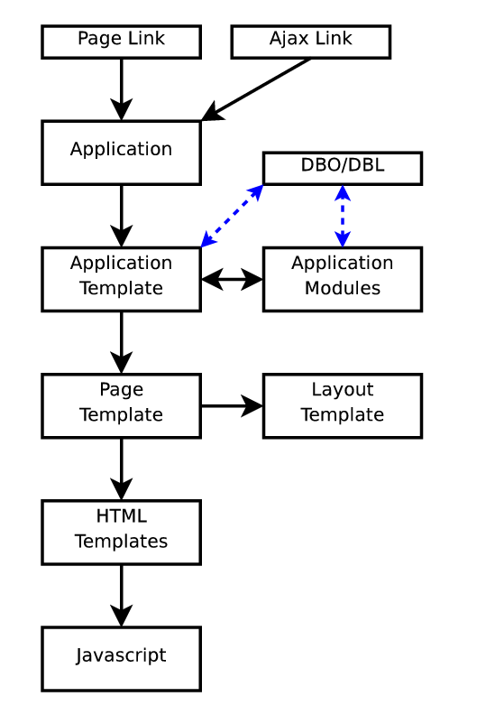

4.02 Ajax Loading
<text>
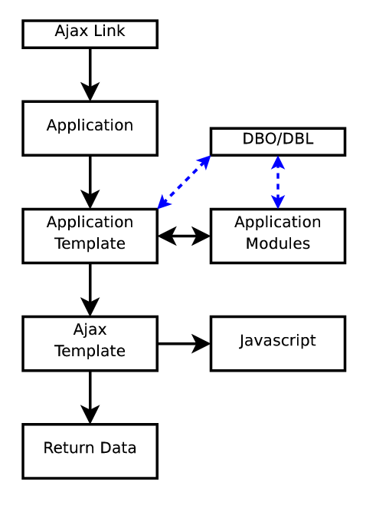

4.03 Page Rendering
<text>

