Accessing the System

--> required URL ot access system both internally and remotely

Login
Access to the vixen Telco Management System requires an employee Username and Password both of which are available from the IT staff (unless already setup). This username and password combination needs to be entered on the login page, however multiple logins from different computers and locations are not allowed if this does inadvertently happen you will be automatically logged out losing all details that have yet to be saved. It is imperative therefore that you do not allow anyone else to see or use your username or password, or attempt to use someone else's.

Logout
You can logout of the system any time by clicking the logout icon, located on the icon bar on the left hand side of the screen. After confirming that you wish to logout, your current session will be ended and you will return to the employee login page.

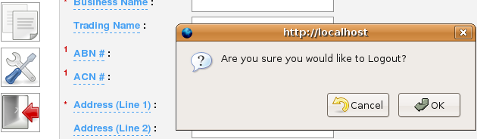

If the system is left idle for 20minutes or more, an automatic logout will occur. Attempting to access a new page or save any details will be unsuccessful and you will be returned to the employee login page.
System Navigation

Throughout the system two types of menus are used, the primary is the icon bar visible on every page running from top to bottom on the left hand side of the screen. This is used for major tasks you wish to accomplish, these include adding Customers, Finding Customers and Viewing available Plans. The other is a text based menu and is visible at the top of the screen on certain pages, this is used for navigation within a page and is referred to as the breadcrumb menu.

BreadCrumb menu
The breadcrumb menu shows you what page you are currently at, and what page you came from previously. If the text is highlighted or of a different colour it is therefore clickable and takes you to that page. For example you may see on the breadcrumb menu the following:

Both Console and Account are of a different colour to Services and are therefore click able, clicking these will take you to the Console and Account pages respectively. Services is not highlighted and so this is your current page, showing you Services for that account.

Icon Bar
The icon bar uses the same icons and has the same actions as those on the employee console screen and hovering over these with the mouse will display a short description of what the button does. This icon bar is visible on every page:

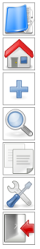
View account specific and service specific tasks (dependant upon the current page)

Takes you to the employee console screen

Add new Customer

Search through existing records to find a customer

View available plans that are already existing in the system

Administrator rights (only visible with administrator privileges)

To log you out of the system

The Account icon also has a sub-menu of actions available depending upon where it has been clicked from, for example if you are viewing Plans for a particular service, and you hover over this with your mouse a service sub-menu is visible from where you can perform numerous tasks including viewing a service, editing a service, adding adjustments and provisioning.

If however you are viewing an account details specific page, then hovering over this icon will only show account specific tasks.

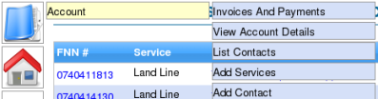
Example: Hovering over the account icon whilst viewing services linked to an account shows further account specific tasks in the sub menu.

Adding a Customer

Clicking on the add new customer icon on the icon bar on the left of the screen will take you to a new page to allow details for this new customer to be entered. When entering customer details you will notice red asterisks and numbers to the left of the description labels, these indicate that this text box has to be filled i.e. it is mandatory or that it is a group of textboxs that requires one or both to be entered. For example you will notice at the bottom of the page, a footnote:
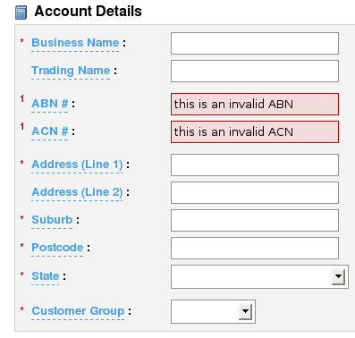
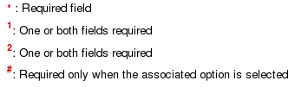

The Mandatory textboxes that have to be filled are Business Name, Address (Line 1), Suburb, Postcode, State and Customer Group because of the red asterisk to the side of the label.

One or both of the ABN #, ACN # has to be filled because of the red number 1 to the side of the label

And Address (Line 2) is optional

Entering Details
On some textboxes you will notice as you are entering details, they will immediately turn red and in some instances will stay red when you begin entering details elsewhere. This shows that the information entered is incorrect, or not in the required format, this feature is found on both the ABN and ACN textboxes. If this is the case check what you have typed and in some instances re-type in the details again. It will turn green when correct.

Billing Details
When entering Billing Details unless the customer has requested to be billed via either direct debit or credit card there is no need to enter in this information. Invoice, Direct Debit from Bank Account and Direct Debit from Credit Card there is a recessed button to the side of each of these, and only one option can be selected at any one time, if for example the customer has requested to be billed via 'Direct Debit – from bank account' then you would select this option, enter in the details and leave 'Direct Debit – from Credit Card' blank. This is also the same if the customer had requested 'Direct Debit – from Credit Card'.

For further information about adding additional billing details see: Add Bank Account Details and Add Credit Card Details.

Primary Contact
Each account has to have a primary contact who will oversee the Account, additional contacts can be added to the account at a later stage, see: Add Contacts.

If you attempt to add the customer before completing all mandatory sections or leaving in errors then the page will indicate the corrections needed before the details can be saved. Only when these errors are corrected will the details be saved. This page will add a new customer, if you wish to add an Account to an existing customer, you will need to use 'Add Associated Account' from the existing account.

Find Customer

Clicking on the find customer icon on the icon bar on the left of the screen will take you to the page where you can specify which criteria you wish to use to search for current customers within the system. The criteria you can use is:

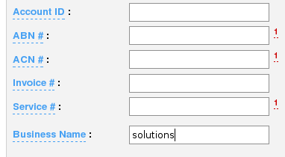
The red number 1 next to the ABN #, ACN# and Service# only allows searches through current accounts only, NOT archived accounts.

You can search for a customer using only one of these details, however if you are searching for a customer using a business name you do not even need to know the full name, infact a partial search on the name will display all matches that have that partial name. For example searching for 'Solutions' as the search criteria will display all customers with the word 'Solutions' in their Business name, you can not however search using partial matches with any of the number textboxes as these require the full number to search.

In addition to the above search criteria you can also search with the Customers First Name AND Last Name, again a partial match will display all customers with a match in their name. It is important to remember that you can either search for a business name, service #, incoice #, ACN#, ABN#, Account ID, or for a first name AND last name you cannot search for both.

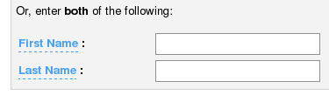

When you have finished specifying what criteria you want to use to search, clicking on the search button found on the lower right of the screen will begin to process.

Narrowing The Search
If you have chosen to search for a partial match in either the Business Name, or First Name and Last Name textboxes there may be more than one customer with those matches in their name, if this is the case the search needs to be narrowed down alittle further.

Example: a search on the Business Name 'solutions' has brought back a list of accounts with 'solutions' matched in their name, this search has to be narrowed further. These steps are exactly the same if you need to narrow down a list of accounts with a match in the First Name and Last Name.
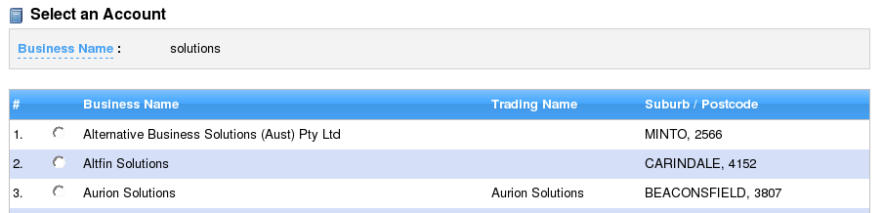
Narrowing The Search (cont...)
To the left of each result in the search list, there is a small recessed button. Once you have found the customer click on this recessed button and click continue in the lower right-hand corner of the screen.

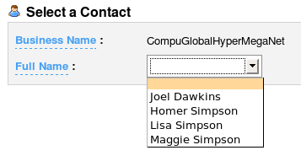
Selecting a Contact
One the search results have been narrowed, and you have clicked continue you will be asked to select a contact that is attached to the account, click on the dropdown list to expland the results, click on the contact and click continue found in the lower righthand of the screen. If however the contact does not appear in the dropdown list, then they are not allowed access to the system.

Customer Verification
A customer can only gain access to their account information once they have been verified by answering correctly a sufficient number of details about themselves or their account. Any of the textboxes can be used to verify a customer, however not all textboxes are necessarily required. Depending on the details for each customer, the verification page will look similar to this:

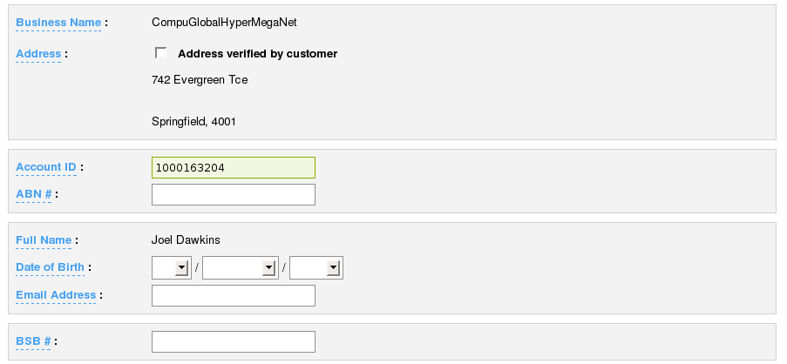
Example: Showing the Account ID has been correctly verified

If the details supplied by the contact are correct the textbox will will turn green and once a sufficient number of correct details have been verified the continue button located on the lower right of the screen will turn green and become enabled. At this point the customer has been successfully verified and can access their account.
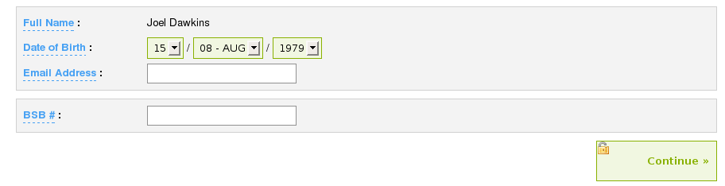
Example: Showing the continue button enabled
Recent Customers
Once a customer or customers has been verified you can refer to these at a later stage using the recent customers icon on the icon task bar. Clicking on this icon will bring up a window that lists the 20 most recently verified customers, the results displayed even allow you to view the contact details for that customer. Clicking anywhere in the table row will close the window and display the details.

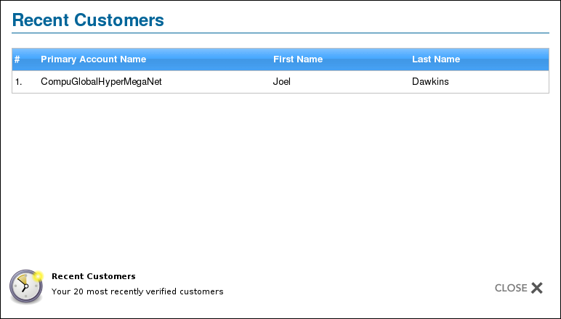
Example: clickable row to display contact details

Clicking close will close this window and return you to where you opened it from. Only customers that you have verified will appear in this list.

Account Overview

This is the primary page for accessing all account specific information, including showing the contact details for each account, the past invoices, services and any notes associated with the account. Below is a typical example of the screen:
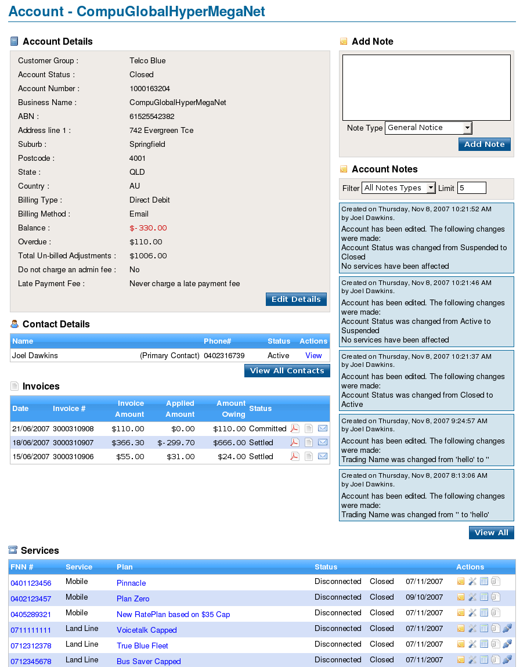
Account Details

This component of the Account Overview shows all details of the account including basic billing information and the current balance, overdue and total un-billed adjustments on the account. To edit any detail shown, click on the 'Edit Details' button on the lower right-hand side of the component from where these labels will change into edittable textboxes. Once clicked, one or many of the textboxes can be altered to new details or the previous stored details can remain, editing is not compulsory and once selected to edit you can always return to the previous display view without saving any changes by clicking the 'Cancel' button, this also being found on the lower right-hand side of the component.
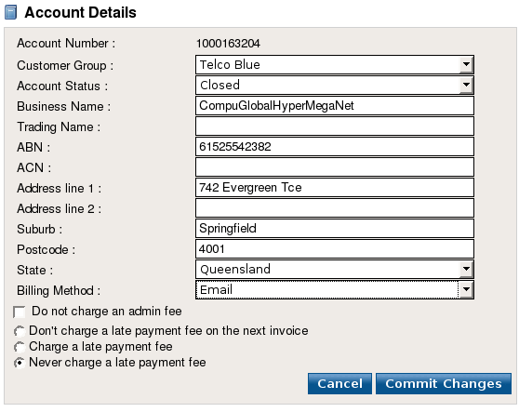
'Customer Group', 'Account Status', 'State' and 'Billing Method' are all drop-down lists that have further hidden selections available and clicking on these displays all further selections available. These lists are mandatory, they must always have a selection.

However the textboxes from 'Business Name' through to 'Postcode' are optional and can have an empty value.

Beneath 'Billing Method' are four options for charging an admin fee and charging a late payment, 'Do not charge an admin fee' is optional and it can either be checked, which is shown by a recessed cross within or unchecked which is how it is displayed in the above screenshot. The three recessed buttons for charging a late payment fee:
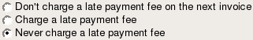

These are grouped together and only one option out of the three can be selected at any one time.

Clicking the 'Commit Changes' button will attempt to save the details to the database, if one or more of the textfields turns red and an alert appears. This means that the detail for that textbox which has changed to red is invalid and you should correct the mistake before attempting to save again.

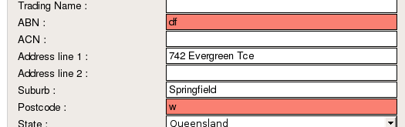
Example: showing both ABN and Postcode as invalid. These two textboxes need to be corrected before any information can be saved.

If the save has been successful, that is no textboxes have changed to red and you have not seen any error message, the view of the component will again change to that of the pre-edit view. But this time reflecting the alterations and changes that have been made.

Contact Details

This component shows all of the contacts attached to this account, listing the name, phone #, the status and any actions available for this contact. In this example the contact 'Joel Dawkins' is shown as 'Active' this means he is currently associated with the account, the only other possible value is 'Archived', where the contact is no longer associated with the account.
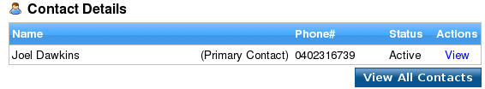

Example: The click able 'View' action

The highlighted 'View' under the actions column is clickable, it allows you to see more detailed information for each contact shown in this list. Clicking on this will display the extra detail within that window, to return to the current view click back on the browser menu-bar.

This list only shows the primary contact within an account, if you wish to see all contacts attached to the account clicking 'View All Contacts' on the lower right of the component will display all contacts in a popup window, these too are displayed in the same style as the primary contact. To the immediate right of each is a 'View' action that allows further detailed information to be shown in a seperate window.

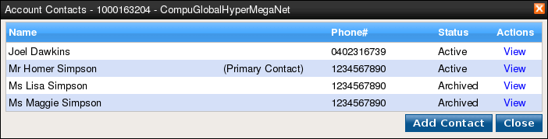
Example: Showing all contacts in a popup window

Within this popup window is the button 'Add Contact' located on the lower right of the component, clicking on this will display the add contact page from where a new contact can be created and attached to the account, clicking on 'Close' with close the window.

Invoices

This component show the last three invoices on this account, listing the date of when the invoice was produced and sent, its unique number, amounts owing and applied, its status and to the immediate right of each row are three small action icons that perform different tasks. You will also notice that each row is highlightable when you move over it with the mouse. Clicking on each row will expand to show further information for that invoice, this being when the payment was due and the total owing. Clicking on any other row will collapse that open row and expand another row, clicking on the original row will collapse the row on itself.

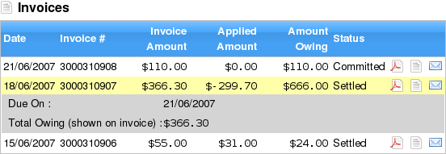
Example: Showing the last 3 invoices and the invoice# 3000310907 being expanded showing extra detail

To the immediate right of each row are three icons that perform three different actions, from left to right these are view PDF invoice, View Invoice Details and Email PDF Invoice. Shown below for greater clarity:

View PDF invoice
Clicking on this icon will open up a PDF file that has the invoice details rendered onto the final bill that the customer will receive, this will open into Adobe Acrobat reader

View Invoice Details
Clicking this icon will open a separate page listing further details for that particular invoice, clicking on the browser back button will return you to the current view.

Email PDF Invoice
Clicking on this icon will open a popup that allows you to send the PDF invoice to one or more contacts listed within this account.

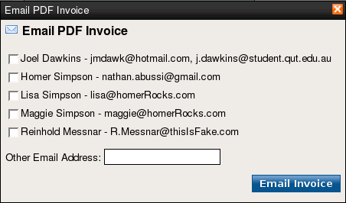
You can also specify an email address that is not included in the account by entering the details in the 'Other Email Address' textbox. Clicking on the recessed square to the immediate left of each contact selects it and this is shown by a recessed cross.

Clicking on 'Email Invoice' will send the invoice in PDF format to any email address that has been selected

Services

This component shows all the services that are associated with the account regardless of their status, listing the Full National Number (FNN), the service and plan and when the service was opened or closed, it is important to note that these rows are not expandable and will not expand and show detailed further information when clicked.

You will notice that in each row, the FNN and the Plan are both highlighted, that is they are different in colour to the other to the text in the other columns. This text is click able, it has an action associated with it. For the FNN clicking on any highlighted number displays the service details and clicking on the highlighted plan name will display the plan details, to return to the current view click back on the browser menu-bar.

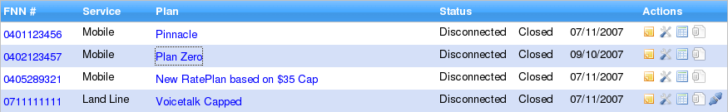
As with the previous Invoices component to the immediate right of each row are four icons that provide further actions for each service, from left to right these are View Service Notes, Edit Service, Change Plan, View Unbilled Charges and Provisioning.

View Service Note
Clicking on this icon will open a popup window that allows you to view all service notes, and also to filter these service notes based on note type, either 'User Notes' or 'System Notes' and to limit the display to a fixed number of notes.

There is also a colour scheme used on the notes, that helps you differentiate between different note types, for example shown below on the main screen capture are three notes. The first two are coloured a pastel shade of green this indicates it is a 'Follow-up required' note, the third is a pastel shade of red this indicates it is 'Attention note'. The full list of available notes and their colours are:
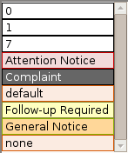
Example: All note types available

However the colour is always secondary to the actual content of the note, and it is good practice to act upon the content and not solely rely on the colour used.
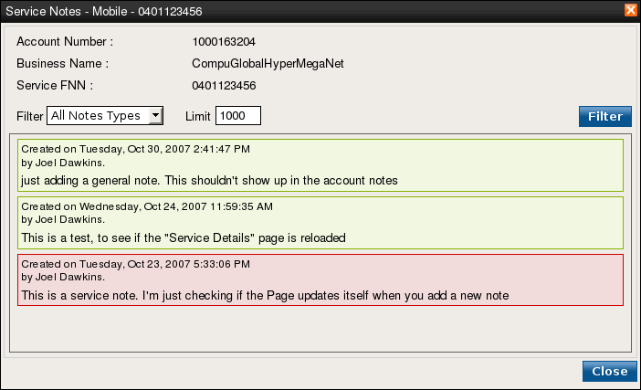
Example: Showing two 'Follow-up required' and one 'Attention' note, the default values for the filtering, is that all Notes are shown and the display is limited to 1000.

To filter the notes to either User or System notes, clicking on the drop-down menu will show all the options available to you, clicking a new option and then clicking on the 'Filter' button will display only notes for that new selection. To the immediate right is the limit textbox where you can restrict the display to as few as 1 or as many as 1000 visible notes.

For example if you want to view only User notes and limit the display to 50 notes, shown:

If you leave the limit textbox empty the limit will default to 10 visible notes, and if you attempt to enter in a value that is greater than 1000, such as 1001 then this will default to 1000 visible notes. As with all popup windows clicking the 'Close' button which is found in the lower right will close that window and return you to the main screen.
Edit Service
Clicking on this icon will open a popup window that allows you to view service specific detail and to alter if necessary this information. Depending on the service that you have selected to edit you may see extra information for Mobile, Inbound 1300/1800, ELB (Enterprise Level Billing) or Cost Centre, this example shows extra detail for mobile specific services:
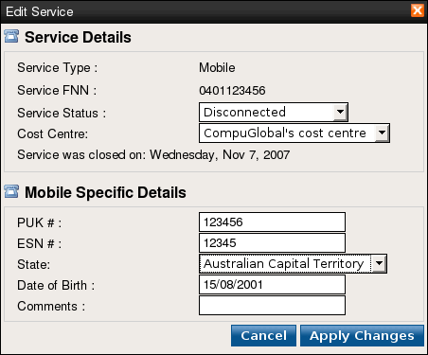
Example: The Service Details section of the popup window is the typical display of what every service shows. In this example, the service type is 'Mobile', the service FNN is '0401123456' and both the Service Status and Cost Centre values are in a drop-down menu which means more than one value exists.

Clicking on these drop-down menus will show all the options available to you, and any changes made by choosing a new Service Status or Cost Centre will only be saved when you have clicked the 'Apply Changes' button on the lower right.

There are three possible Service Status's available Active, Disconnected and Archived, the last being only visible to users who have admin priveledges. If you attempt to select Active on an archived service i.e. to unarchive it. You may encounter the situation where the FNN is currently in use with another service if this is the case, you must first close the other service and only then will unarchiving be successful.

The Mobile Specific Details section is only visible if the service selected is for Mobile, if you have chosen Inbound 1300/1800 then you will see a slightly different section that is related to this type of service. These sections are specific to the type of service and so you will not see the same details for every service, in some cases that are no service specific details at all to be shown.

Editting these details is not compulsory and you can always cancel and return to the previous screen by clicking the 'Cancel' button located on the lower right.

Clicking the 'Apply Changes' button will attempt to save the details to the database, if one or more of the textfields turns red and an alert appears. This means that the detail for that textbox which has changed to red is invalid and you should correct the mistake before attempting to save again.
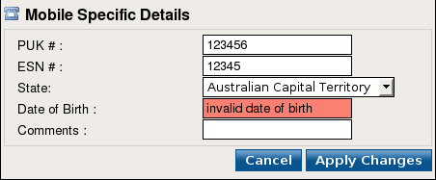
Example: showing the Date of Birth is invalid. This textbox needs to be corrected before any information can be saved.

If the save has been successful, that is no textboxes have changed to red and you have not seen any error message, the popup will close and you will be returned to the familiar view, but this time reflecting the changes that have been made.

Change Plan
Clicking on this icon will open a popup window that allows you to view service and plan specific detail and to alter if necessary this information. The first section of the screen contains the Service Details, these details are static and cannot be altered the second part however shows the plan the service is currently on and has a drop-down list box of all plans you can change the service to. Editting the service's plan is not compulsory clicking the 'Cancel' button allows you to return to the previous screen at anytime.
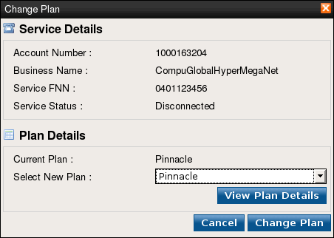
Example: showing the current plan the service is on.

To the immediate right of 'Select New Plan' is a drop-down menu and by clicking on this will show all the options available to you, any changes made by choosing a new Plan will only be saved when you have clicked the 'Change Plan' button on the lower right.

If a new plan is selected and you have clicked the 'Change Plan' button this popup window will close and the changes will be visible on the previous page.

Below the Select New Plan drop-down menu is a further button, this allows the plan currently selected in the drop-down list to be viewed. As can be seen above the plan currently selected in the drop-down list is 'Pinnacle', clicking the 'View Plan Details' button would therefor view the details of that plan within that page. see: View Plan
View Unbilled Charges
Clicking on this icon will open a new page that allows you to view all the unbilled adjustments on that service and to even filter those unbilled calls based on record type. The unbilled adjustments table lists all adjustments, when they were created, by whom, the status, charges and nature of the adjustment. To the immediate right of each row, is a highlighted and underlined 'Details' this is clickable and displays more detail for each adjustment in a popup window, clicking 'Close' found on the lower right will close that window and return you to the previous screen.
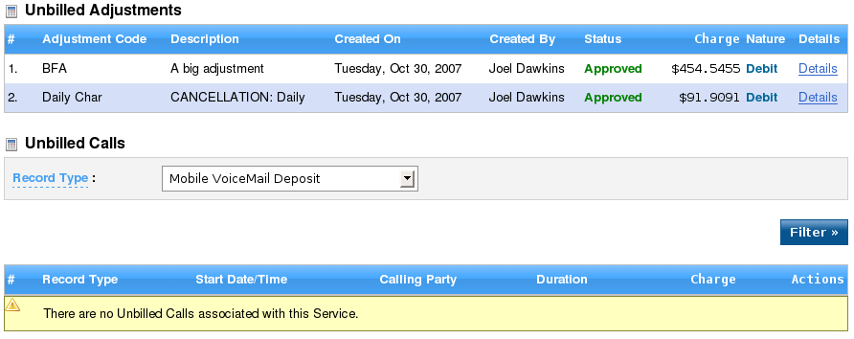
If there have been any unbilled calls on this service, the list below the 'Filter' button will display them. At times it may be necessary to only view certain types of calls this is where you are able to filter the view. Below the Unbilled Calls section is a drop-down list that contains the record types that you can filter the list by. For example you can choose to display only 'Mobile MMS' or 'GPRS', if you have chosen a new option from the drop-down list, clicking on the 'Filter' button will reload the page but this time showing only those calls matching the filter.
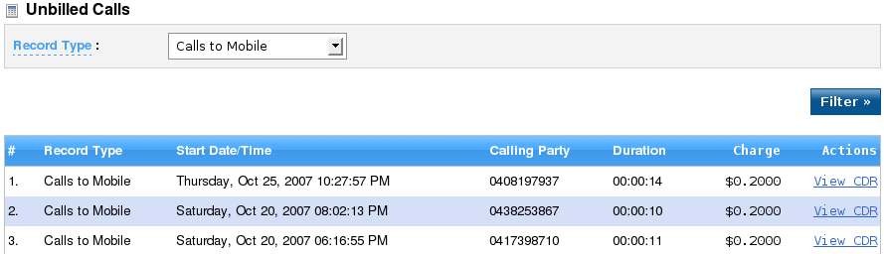
Example: Showing the unbilled calls list filtered to only show 'Calls to Mobile', to the immediate right of each row, is a highlighted and underlined 'View CDR' this is clickable and displays more detail from the CDR file in a popup window, clicking 'Close' found on the lower right will close that window and return you to the previous screen.
Provisioning
Clicking on this icon will open a new page that allows you to view and alter all the details regarding provisioning on a service, see: Provisioning

Add Note

This component allows a user note to be added to this account, it also allows you to specify the type of note to add via the drop-down note type list. Shown Below:

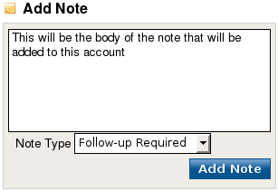
Example: In this example “This will be the body of the note that will be added to this account” is the content of the note and the Note type will be a 'Follow-up Required'.

Once the note and note type have both been chosen clicking on the 'Add Note' button will save this note and refresh the page from where you will see the new note added to the recent notes list.

Account Notes

This component displays the five most recent notes that have been added to this account, they are shown in descending order with the top most note being the most recently added. Although in this example they are all blue in colour (system notes) both user notes and system notes can be shown, either on their own or mixed with each. A limit can be specified to restrict to the display to a minimum of 1 visible note or a maximum of 1000 visible notes, what is important when wanting to filter the notes either in number shown or the type of the note is that after making a change you have to click elsewhere on the screen. This is particularly relevent to the 'Limit' text box else the change in display will not be shown immediately, for example if 25 were entered as a new value in the textbox over-writing a previous value you would then click anywhere on the screen.
Rate Management

Clicking on the Available Plans icon displays all Rate plans that are currently in use within the system they are displayed in descending order sorted by the plan type and plan name. Each row of the list shows the rate and also details the type of rate its name, details concerning the fees associated with the rate and its status. You will also notice that each name and to the immediate right of each row is a highlighted 'New' and highlighted 'Edit' (not visible for all rates) these are clickable.
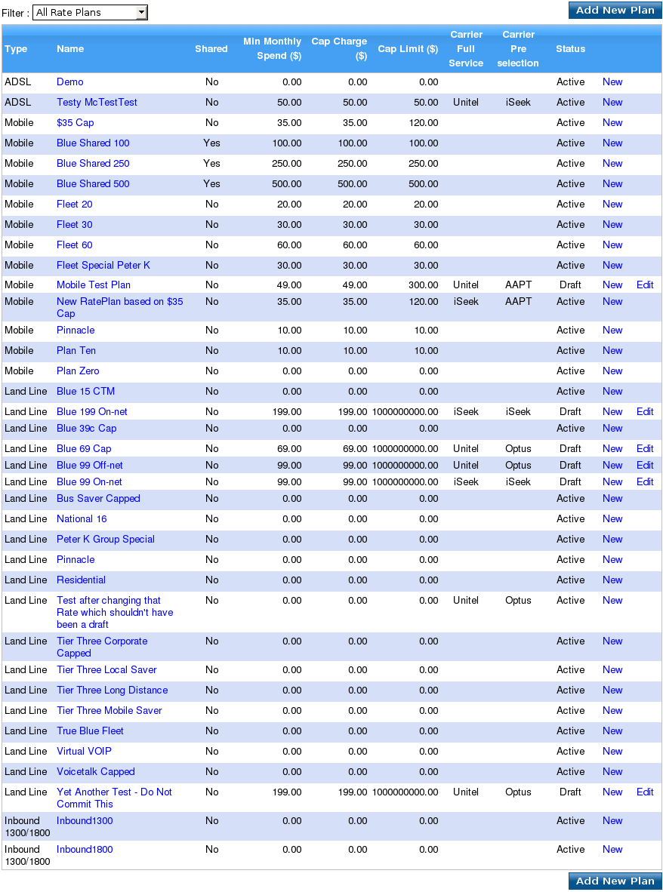

The default display is to show all available plans on all services that are in the system, however this list can be filtered to show plans for a specific service. To filter this list, on the top left is a filter drop-down menu clicking on this and slecting a new option will filter the display to that new selection. For example if you wanted to display all plans for inbound 1300/1800 services:
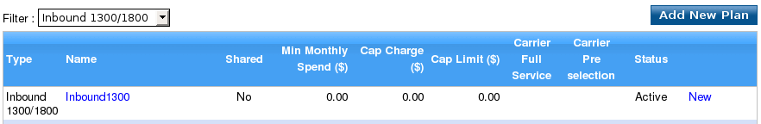
Example: The list filtered to show only Inbound 1300/1800 plans

Under each Name column is the name of the plan that the service is on, in the above example the service inbound 1300/1800 has a plan named inbound1300 attached to it. This name is also a different colour and is therefor clickable, clicking this will display the View Rate Plan Details. see View Rate Plan Details

The immediate right of each row has the words 'New' and 'Edit' both are also clickable due to their different colouring, and allow you to create a new Rate based on an existing rate or edit an existing Rate (if the rate is shown to be a draft in the status column), there is also a third action which is accessible from the Add new Plan button found at the top-right of the screen, this creates a totally new plan which is not based on an existing plan. Note, if the Plan is not a draft then you will not see the Edit link.
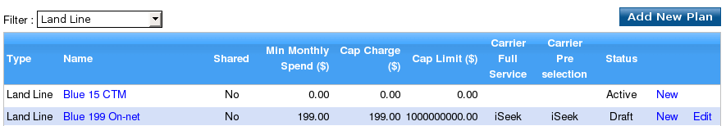
Example: Blue 199 On-net Plan for the landline service, a draft plan shown by the status column it can be editted, hence the Edit link is visible, also shown is the 'Add New Plan' button to a add a totally new plan that is not based on an existing plan.

Create a new plan based on one

Clicking the highlighted 'New' allows a new rate to be created that is based on the current rate on that immediate row. For example if you wish to create a new plan but have it retain certain feratures of a pre-existing plan, for example a handful of rategroups, or a patricular service type or cap charges you would specify these features through this link that takes you to the Add Rate Plan page. see New Plan Based on One

Edit a Draft Plan

Clicking the highlighted 'Edit' allows a plan that is in draft mode to be editted and altered before it is made active, any property of the plan can be changed including adding or removing rategroups, its Name and description. This editted rate can be saved again as a draft or made active through use of the commit button. see Edit Draft Rate Plan

Add New Plan

Clicking the 'Add New Plan' button above and below the list on the right, allows a new plan to be created from scratch. It shares all of the same options as the editting a draft plan page but there is no pre-existing plan that is shown. see Add New Plan
Edit a Draft Plan

The Add Rate Plan component of the 'Add new plan based on one' shows all the details that are currently entered for the plan you are wishing to edit, editing is not compulsory and once selected to edit you can always return to the previous display view without saving any changes by clicking the 'Cancel' button, this being found on the lower right-hand side of the component. To the immediate left of each label is a red asterisk, this indicates that this is mandatory and cannot be left blank, Service Type, Carrier Full Service and Carrier Preselection are all drop-down lists that have further hidden selections available.
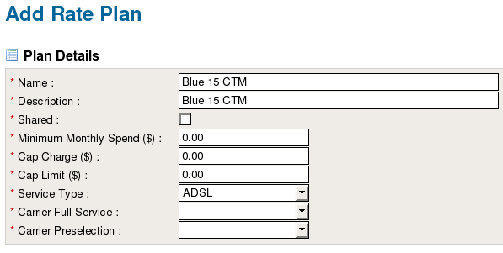
Example: The 'Add Rate Plan' component of the Add Rate Plan page Showing the asterisks beside each label therefore these are mandatory, and the three drop-down lists with ADSL pre-selected in the Service Type.

Selecting a service type also displays the rategroup list, for example if you were to select 'ADSL' as a service type from the drop-down list, this would subsequently show only those rategroups that are attached to the ADSL service.

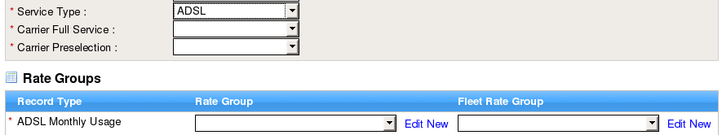
Example: Showing the Service Type as ADSL and the only rategroup for that service type is shown

To the lower right of the components are three buttons, 'Cancel', 'Save as Draft' and 'Commit'. Clicking the 'Cancel' button discards any changes you may have made and returns you to the previous screen, Clicking on the 'Commit' button, validates what you have selected and if correct adds this rate and marks it as active whereas clicking on the 'Save as Draft' button also validates what has been selected but marks the rate as draft, allowing you to add to or alter details at a later stage.

It is important to note, that if you have not entered in a mandatory option you will be notified of this and as such it will not allow you to save the rate before continuing. For example if you had not selected a service type and have then attempted to save the rate by clicking the 'Commit' button, you would encounter this following message:

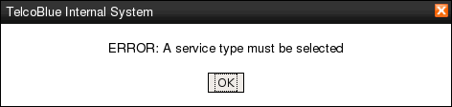
Example: showing that corrections have to be made before the saving of the rateplan can be successfully completed.

Create a new plan based on an existing Plan / Add New Plan

Both 'create a new plan based on an existing plan' and 'add new plan' are functionaly similar to each other so will be explained together, where the difference is apparent further indepth details will be shown concerning that individual option.

This component of the Add new plan based on one shows all the details that are currently entered for the plan you are wishing to base a new plan upon, editing is not compulsory and once selected to edit you can always return to the previous display view without saving any changes by clicking the 'Cancel' button, this being found on the lower right-hand side of the component. To the immediate left of each label is a red asterisk, this indicates that this is mandatory and cannot be left blank, Service Type, Carrier Full Service and Carrier Preselection are all drop-down lists that have further hidden selections available.

Example: The 'Add Rate Plan' component of the Add Rate Plan page Showing the asterisks beside each label therefor these are mandatory, and the three drop-down lists with ADSL pre-selected in the Service Type.

The 'Add New Plan' page only differs in that no stored information is shown, as a new plan is being added.

The RateGroups component lists all the rategroups that are currently in use by the Plan named in the Plan Details component. Changing the Service Type will subsequently change all rategroups shown, this is a dynamic option and the list of visible rategroups will change whenever a new service type is selected.

The RateGroup component lists all the rategroups that apply to that rateplan, if the service type were Mobile the only recordtypes shown are ones that specifically apply to this such as GPRS Data and mobile specific calls. To the immediate right of recordtype is a drop-down list that contains more than one option, clicking on this will display all the rategroups available to you, for example clicking on the GPRS-20 drop-down menu shows four rategroups:
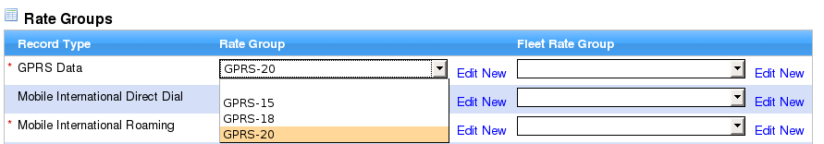
Example: four RateGroups shown for the GRPS Data recordtype, the first being blank

To the immediate right of this drop-down list are two highlighed links 'Edit' and 'New', these allow the rategroup that you have selected in the drop-down list to be Editted (if the rategroup is a draft) or to create a new Rategroup that is based on the selected one already.

To the right is another column headed Fleet Rate Group this allows you to select a fleet rategroup that overrides a normal rategroup for a given recordtype. It includes the same Edit and New highlghted links to alter the rategroups as before but this is solely for Fleet Rate Groups.

Adding a new RateGroup

Clicking on the highlighted New will display a popup that allows you to create a new rate group using pre-existing details from the rategroup selected in the drop-down list, shown on the previous screen. The Rate Group Details component of this popup allows you to enter a new name and description, however the options
for making this a fleet rate, specifying the service type and record type are disable as these are preset.
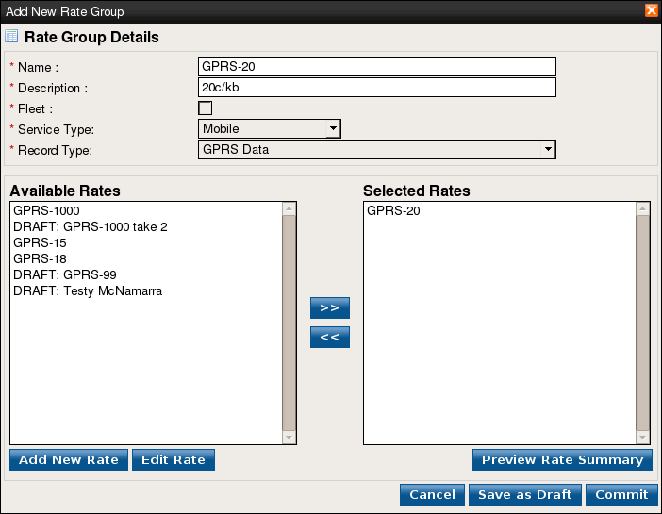

Example: The Rate Group Details component of the add new rate group popup, showing Fleet, Service Type and Record Type all disabled <explain more>

The available Rates component show all Rates that can be added to the new rate group, to the right of this is the Selected Rates this shows rates that have been selected for inclusion. To add an available Rate to the selected rates box is as simple as clicking on a rate and then clicking on the >> chevron, to add more than one rate click and hold the mouse button down and drag over the rates you want and then click the >> chevron as before.

To remove a selected Rate click or click and drag over the rates you wish to remove, and click the << chevron, this will return the selection to the available rates.

Each rategroup can be saved as either a Draft or an active Rategroup by using the buttons found on the lower right of the popup 'Save as Draft' and 'Commit'. If a rategroup is saved as a draft this can still retain the same name as an existing active rategroup, however if you attempt to save using the commit button and there is already a rategroup using the same name then you will encounter an error message and the rategroup will not be saved until this has been corrected.

Any rate in the Selected Rates box can be previewed to show its summary and whether there are conflicts with others rates and where these conflicts occue. Clicking on 'Preview Rate Summary' displays a further popup window from where the days of the week are shown in descending order on the left handside while the hours go across the top of the screen.

Add New Rate/Edit Rate
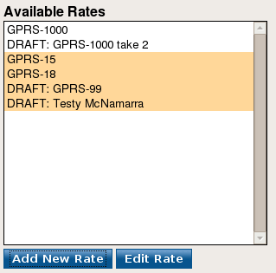
Below the available rates box are two further buttons 'Add New Rate' and 'Edit Rate' these allow you to add a new rate and edit a rate respectively.

However these buttons also support the adding a new rate that is based upon an already existing rate, while the procedure for adding a rate isnt complicated it does require alittle understanding:

Example: The Add New Rate and Edit Rate buttons below the Available Rates box

Adding a new Rate
You have to deselect any rate that may be currently selected in the available rates box, if a rate is highlighted press and hold down the 'ctrl' key whilst clicking the highlighted rate with the mouse cursor, this then deselects this rate. Clicking on the 'Add New Rate' button will display the add new rate popup multiple rates are selected this too will open up the add new rate popup to create a blank rate.

Adding a new Rate that is based upon an already existing rate
This is the reverse of the above, you have to select a rate in the available rates box, if no rate is highlighted click on a rate which you wish to base the new rate on and then follow by clicking on the 'Add New Rate' button which will display the add new rate popup.

Editting a Rate
This is similar to above, you have to select a rate in the available rates box, if no rate is highlighted click on a rate with which wish to base the new rate on and then follow by clicking on the 'Add New Rate' button which will display the add new rate popup.

Rate Details

The Add New Rate popup is where all properties of a new rate or an existing rate can be created or altered, it allows you to specify standard charges, excess charges and any caps associated with the new rate. You can also visually set when the rate begins and ends throughout the week by use of a moveable timebar. As the popup is quite thorough it is best to split it into individual parts and explain those:

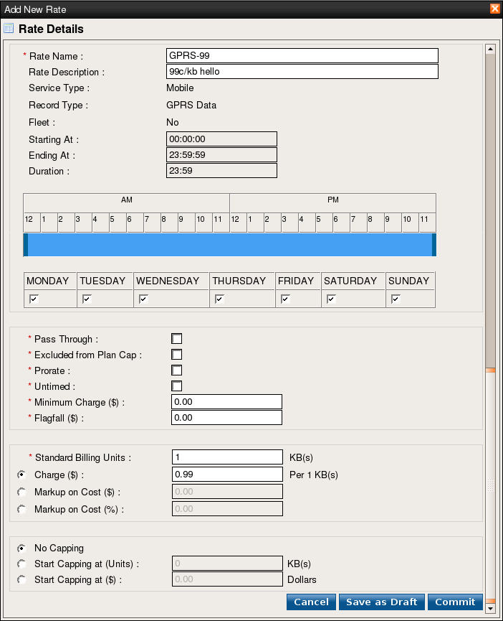

section one

duration component

week component

section two

section three

section four

Example: The initial view of the add new rate popup showing the three distinct visible sections and the three buttons on the lower right. This view is scrollable and so the whole view is not visible at one time, this shows the adding of a new rate based upon a pre-existing rate.

As you work through adding a rate, certain details may become visible depending on choices made, for example specifying a start cap in either units or dollars will show the receiprocal end cap details, and consequently specifying an end capping of units or dollars will also show the excess charges. You will also notice that the days available are all defaulted to the whole week, and the begin and end time of the rate is set for 23 hours and 59 minutes duration, all of which can be altered.
Rate details cont...

The first section specifically deals with the rate name, the description and when you want the rate to apply and for which days. You will notice that there is only one textbox that has a red asterisk to its immediate left, this indicates that this text box has to be filled i.e. it is mandatory. The textbox for 'Rate Description' has no asterisk therefor it is optional, beneath these two textboxes are 'Service Type Record Type and Fleet' and these are preset options that cannot be editted. What then follows are three textboxes 'Starting At', 'Ending At' and 'Duration' these are display textboxes only, that is they cannot be altered and you cannot enter new values into them.

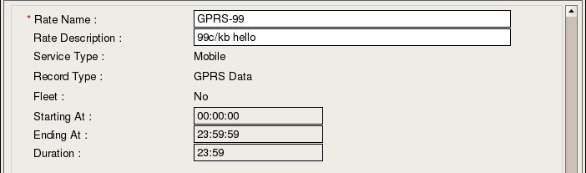

preset options

display textboxes

Example: The first section of the add new rate popup, showing the two textboxes 'Rate Name', and 'Rate Description', 'Rate Name' being a mandatory textbox due to the red asterisk to its immediate left. The details 'Service Type, Record Type and Fleet' are preset, whereas the details for the rate start and end and duration although disabled are dynamic, upon moving the timebar these will change accordingly.

The duration component is divided into AM and PM components, the AM component having twelve blocks numbered from 12 to 11 representing the hours from midnight to 11am and the PM component having twelve blocks numbered from 12 to 11 representing the hours from 12pm until 11pm. Each hour shown is divided into four blocks each of 15minutes in length and a duration can contain any number of hours and minutes.

To set a time frame for when this rate begins and ends you use the movable timebar that is represented by the shaded blue bar. On either end of this bar are darker blue bars, these are clickable point where the bar can be resized or positioned, the smallest time frame that can be represented is a duration of 1hour the greatest being 23hours and 59minutes.

In its default state the moveable time bar is set for the maximum duration of 23hours and 59minutes, for example if you wished to set a duration of 4hours and have the rate begin at 5am, you would click on the right most dark blue bar (the mouse cursor will change) and whilst still holding the left mouse button drag the mouse back to resize the timebar and reduce the duration. Whilst dragging the mouse you will see the hours and minutes in the duration textbox are decreasing when they have reached the four hour mark, release the left mouse button. The above principle is also used when you want to move the timebar so the rate begins at a later time, click on the left most dark blue bar (the mouse cursor will change to a clenched fist) and whilst still holding the left mouse button drag the mouse forward to move the timebar and increase the starting at time of the rate. Whilst dragging the mouse you will see the hours and minutes in the 'Starting At' textbox are increasing when they have reached the 5AM mark, release the left mouse button.

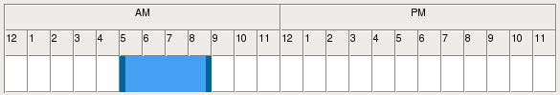
Example: The duration component showing the immediate left and right of the moveable timebar.

Increasing or descreasing the minutes of a duration is as simple as clicking and dragging the right most dark blue bar and watching the duration textbox, when reached release the left mouse button.
Rate details continued...

Below the duration component are the days of the week that you can select to apply to the rate, underneath each day label is a checkbox in its default state it is on, that is the checkbox has a tick in it. To make a rate apply or not apply for that day click on the tick within that checkbox, on is represented by a tick off is represented by no tick.

Example: The week component with MONDAY through to WEDNESDAY and the weekend selected yet THURSDAY and FRIDAY are not selected as they have no tick in their respective checkboxes.

Section Two

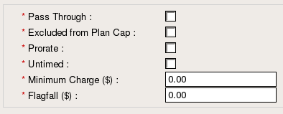
Example: Everything in section 2 is mandatory it contains details that apply to all rates regardless, to the immediate left of each label is a red asterisk this denotes that it is a mandatory. From 'Pass Through' to 'Untimed' are checkboxes and a selected state in any of these is represented by a tick, unselected is when there is no tick.

Section Three

This section displays all the details for standard units and standard charges, not all rates can have a standard charge, a standard markup on cost and a percentage markup on cost and this is reflected here with only one of the three options being able to be chosen. The three recessed buttons are for specifying a charge per number of units, a markup on cost and a percentage markup on cost:

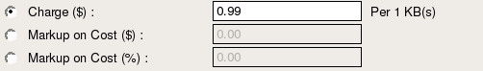
Example: Showing the 'Charge ($)' is enabled whilst the two other textboxes are disabled

These are grouped together and only one option out of the three can be selected at any one time, when changing an option the input box to the immediate right will become enabled, whilst the other two remain disabled.

Section Four

This section displays all details for the starting of caps, the ending of caps and any cap excesses associated with a new rate. In its default state, that is when the popup is displayed no ending capping details or excess details are displayed as the no capping button is the default selection.

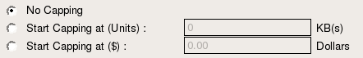
Example: Showing the default 'No Capping' option selected and no further cap or excess details are shown

However if either the 'Start Capping at (Units)' button or the 'Start Capping at ($)' is clicked both found to the immediate left of their respective labels then further capping details are shown, these being 'No Cap Limit, Stopping Capping at (units) and Stop Capping at ($)', whilst there is no red asterisk to the immediate left of each of the options, they are manadatory if you have selected to either begin or end a cap, then you will need to enter in a value.

Section 4 continued...

If you have selected to begin capping at units or capping at dollars, then you will see a further hidden section be displayed, this hidden section has three optional recessed buttons which correspond to either 'No Cap Limit, Stop Capping at (Units) or Stop Capping at ($)', clicking on either of the recessed buttons will enable the greyed out textbox to its immediate right, clicking on another option disables the textbox once more.

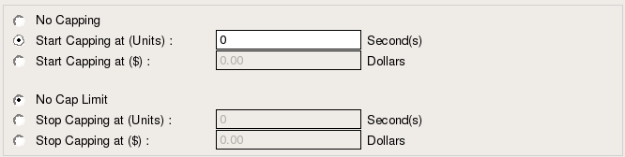
visible section
hidden section

Example: clicking on either option in the dotted square will show the hidden section

Selecting either 'Stop Capping at (Units)' or 'Stop Capping at ($)' are two options that display further hidden sections that are not immediatelyaccessible or shown by default. Clicking on the recessed button that is to the immediate left of the 'Stop Capping at (Units)' label will display excess charge section, only one text box is mandatory and that is 'Excess Billing Units' as a red asterisk is found to its immediate left. The remaining text boxes are grouped together and only one option out of the three can be selected at any one time, when changing an option the input box to the immediate right will become enabled, whilst the other two remain disabled.

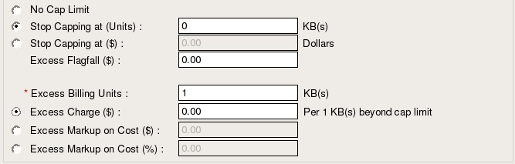
visible section
hidden section

Example: clicking on the 'Stop Capping at (Units)' recessed button in the dotted square will show the hidden Excess section

Clicking on the recess button that is to the immediate left of the 'Stop Capping at ($)' will display the excess flagfall textbox only.

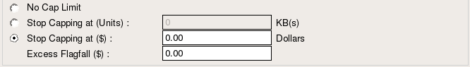
visible section
hidden section

Example: clicking on the 'Stop Capping at ($)' recessed button in the dotted square will show the hidden Excess Flagfall ($) text box.

Section 4 continued...

When a rate has been created it can either be saved as a draft, where it can retain the same name as a rate that is already active or saved as active where the rate is available and able to be used as soon as possible. There are two buttons that accomplish both these

