Vixen Developer Manual
(Apendix X)

User Interface Framework

Author : Jared Herbohn
Date : 03-06-2007
Revision : 0.0.1

COMMERCIAL-IN-CONFIDENCE
The information contained within this document is confidential and must not be made available to any person who has not entered into a non-disclosure agreement with Voiptel Pty Ltd. This document must not be used for any purpose other than the purpose for which it was originally supplied.

Revision History
Author | Date | Revision | Notes

Table of Contents
Revision History 2
1.0 Introduction 4
2.0 System Components 4
2.01 Page Link 4
2.02 Ajax Link 4
2.03 Application 4
2.04 Application Template 4
2.05 Application Modules 4
2.06 DBO / DBL 4
2.07 Page Template 4
2.08 Layout Template 5
2.09 HTML Template 5
2.10 HTML Elements 5
2.11 Javascript 5
2.12 CSS 5
3.0 Files 5
3.01 Application Template 5
3.02 Application Modules 5
3.03 Page Template 5
3.04 HTML Objects 6
3.05 Style Templates 6
3.06 Javascript 6
3.07 Images 6
3.08 Layout Templates 6
3.09 Database Access Files 6
3.10 System Files 6
4.0 System Diagrams 6
4.01 Page Loading 7
4.02 Ajax Loading 8
4.03 Page Rendering 9

1.0 Introduction
<text>

2.0 System Components
This section describes the components of the system and what they do.

2.01 Page Link
The page link is the only page in the interface that is accessed directly from a web browser. The page link translates the URL passed by the browser and works out the Application Template and Method to be loaded.

eg. “http://minx/vixen.php/Account/View/” translates into;
Application Template : Account
Method : View

2.02 Ajax Link
<text>

2.03 Application
<text>

2.04 Application Template
<text>

2.05 Application Modules
<text>

2.06 DBO / DBL
<text>

2.07 Page Template
<text>

2.08 Layout Template
<text>

2.09 HTML Template
<text>

2.10 HTML Elements
<text>

2.11 Javascript
<text>

2.12 CSS
<text>

3.0 Files
This section describes the location naming and purpose of individual files within the system.

3.01 Application Template
Application Template files are located in the app_template directory. There is a separate Application Template file for each major component of the interface (Account, Service, Contact, etc), each file contains a number of methods (View(), List(), etc). There is also a default Application Template (default.php) for Methods that do not belong to a specific major component. Within the file is a class named AppTemplateName (where Name is the template name), this class extends the ApplicationTemplate class.

3.02 Application Modules
<text>

3.03 Page Template
<text>

3.04 HTML Objects
<text>

3.05 Style Templates
<text>

3.06 Javascript
<text>

3.07 Images
<text>

3.08 Layout Templates
<text>

3.09 Database Access Files
<text>

3.10 System Files
<text>

4.0 System Diagrams
<text>

4.01 Page Loading
<text>
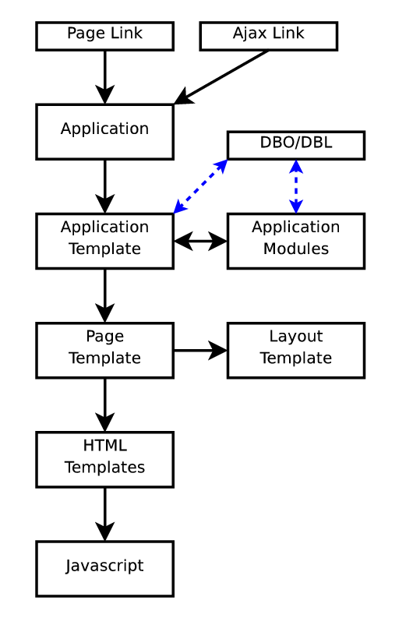

4.02 Ajax Loading
<text>
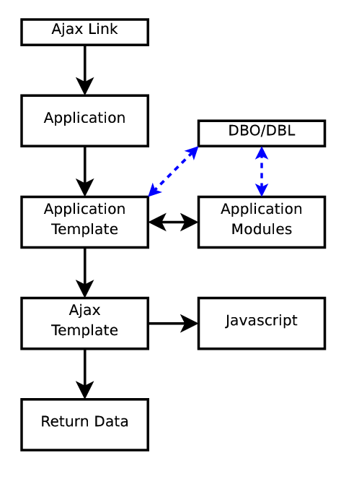

4.03 Page Rendering
<text>

