StreamFlix
Architecture

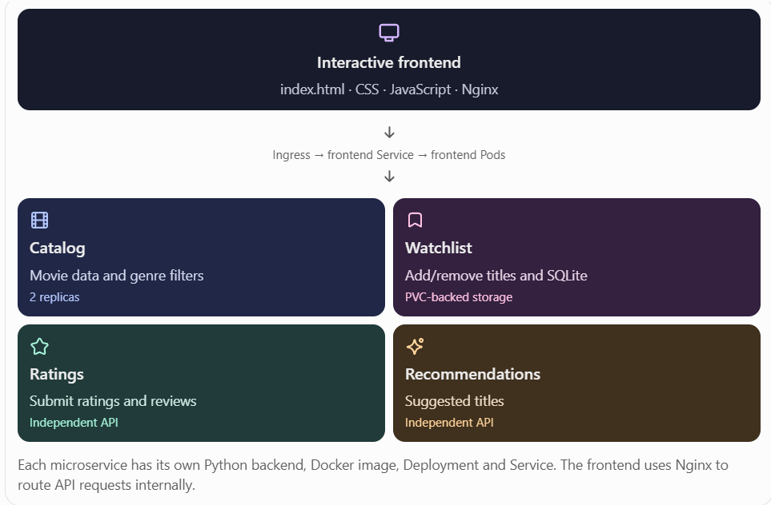
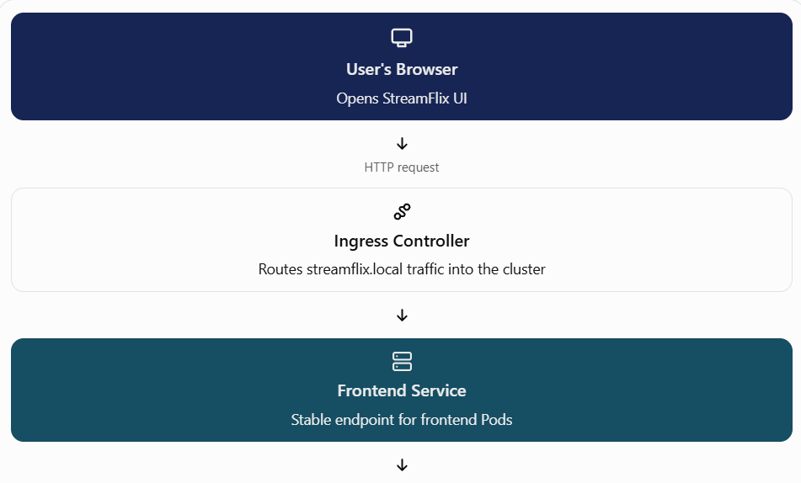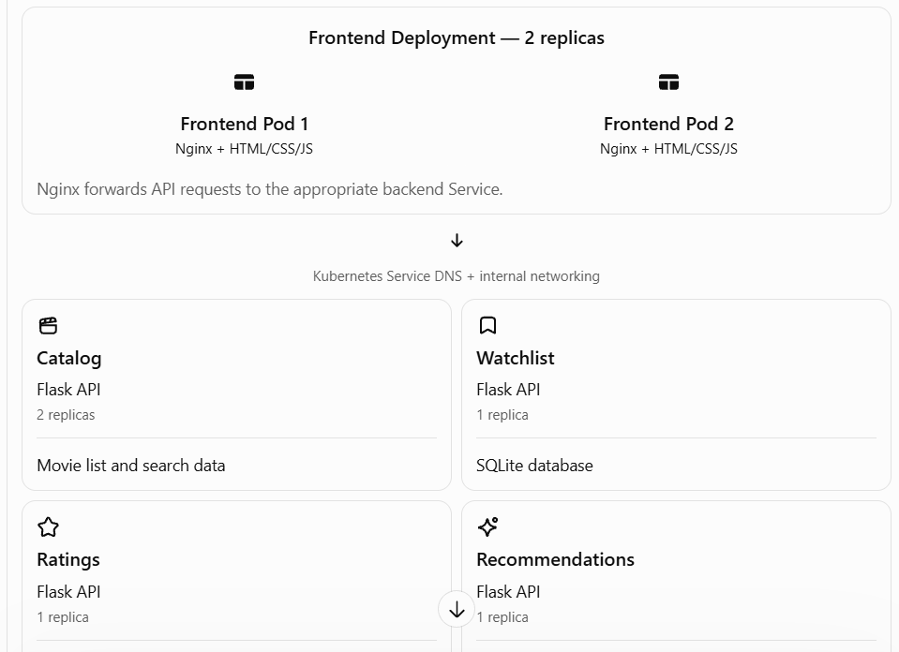
2. What each component does
Component | Responsibility
Browser | Displays the UI and sends user actions
Ingress | Accepts incoming HTTP traffic for streamflix.local and routes it to the frontend Service
Frontend Deployment | Maintains two frontend Pods
Nginx | Serves the website and proxies /api/... requests to backend Services
Catalog microservice | Returns the movie catalog
Watchlist microservice | Adds, lists, and removes watchlist entries
Ratings microservice | Accepts and returns movie ratings
Recommendations microservice | Returns suggested movies
Kubernetes Service | Provides a stable internal name and routes traffic to matching Pods
Deployment | Maintains the desired number of Pod replicas and replaces failed Pods
ConfigMap | Supplies non-secret configuration through environment variables
PVC | Requests persistent storage for the watchlist database
NetworkPolicy | Restricts allowed network traffic to selected backend Pods, if the cluster's networking supports enforcement
HPA | Can adjust the catalog Deployment's replica count based on CPU utilization

3. How the application works — step by step
Let's follow a real user action: opening StreamFlix and adding a movie to the watchlist.
1 The user opens the website
The browser visits http://streamflix.local. The request reaches the Ingress Controller, which routes it to the frontend Service.
2 Kubernetes selects a frontend Pod
The frontend Service forwards the request to one of the ready frontend Pods. Nginx serves index.html, which contains the user interface.
3 The browser requests movie data
JavaScript calls /api/catalog. Nginx recognizes the path and forwards the request to catalog-service:5000, which routes it to a ready Catalog Pod.
4 The Catalog API returns movies
The Flask application returns movie information as JSON. Nginx sends the response back to the browser, and JavaScript displays the movie cards.
5 The user adds a movie to the watchlist
The browser sends a POST request to /api/watchlist. Nginx forwards it to watchlist-service:5000. Flask receives the request and stores the movie in the SQLite database at /data/watchlist.db.
6 The UI updates
The API responds to the browser. JavaScript updates the watchlist display. The user sees the result without having to reload the whole website.
4. How Kubernetes networking works
This is the important part to explain to students.
Imagine the Catalog Deployment has two Pods:
- Catalog Pod 1 — Pod IP 10.244.0.10
- Catalog Pod 2 — Pod IP 10.244.0.11
- Catalog Service — stable ClusterIP, for example 10.96.0.20
These IPs are illustrative; Kubernetes assigns the actual addresses.
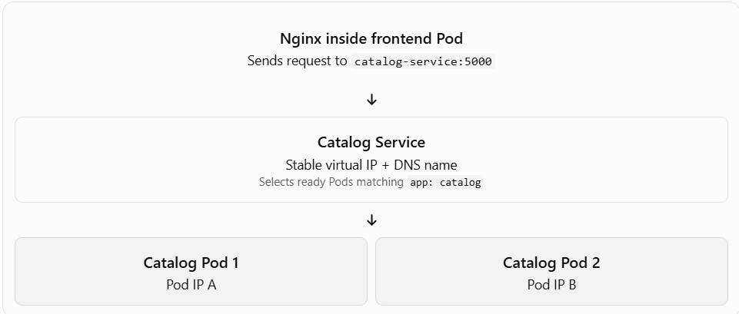
The key difference:
- Pod IP: belongs to an individual Pod and can change when that Pod is replaced.
- Service IP: is a stable virtual IP for the lifetime of that Service.
- Service DNS: lets the frontend use a name such as catalog-service rather than hardcoding Pod IPs.
- Node IP: belongs to the Kubernetes node that runs Pods. It is not the same as a Pod IP.
The frontend does not need to know which Catalog Pod handles its request. It sends the request to the Service name, and Kubernetes networking directs traffic to an eligible backend Pod.

5. How the Kubernetes features are used
Feature | What happens in this project
Namespace | Keeps StreamFlix resources grouped in streamflix
Deployment and replicas | Keeps the desired number of Pods running; for example, two Catalog Pods
Rolling update | Replaces old Pods with new ones during an image update
Readiness probe | Checks whether a Pod is ready to receive traffic
Liveness probe | Helps Kubernetes identify an unhealthy container and restart it
Startup probe | Allows the application time to start before regular health checks take over
PVC | Keeps watchlist database files on persistent storage beyond the life of an individual container
ConfigMap | Provides configuration such as APP_ENV and DB_PATH
Ingress | Routes incoming HTTP traffic to the frontend Service
NetworkPolicy | Allows frontend Pods to connect to selected backend Pods on TCP port 5000
HPA | Can scale the Catalog Deployment from 2 to 5 replicas based on CPU utilization
6. YAML files and their purpose
The numeric prefixes define a convenient deployment order.
Files | Purpose
00-namespace.yaml, 01-configmap.yaml | Create the namespace and configuration
02-pvc.yaml | Request persistent storage
03–10 | Create the four backend Deployments and Services
11-frontend-deployment.yaml, 12-frontend-service.yaml | Run and expose the frontend internally
13-ingress.yaml | Route external HTTP requests to the frontend
14-network-policy.yaml | Restrict backend ingress traffic
15-hpa.yaml | Configure autoscaling for Catalog
7. Demonstrate the architecture live
Run these commands in PowerShell after deploying the project:
kubectl get pods -n streamflix -o wide
kubectl get deployments -n streamflix
kubectl get services -n streamflix
kubectl get ingress -n streamflix
kubectl get pvc -n streamflix
kubectl get hpa -n streamflix
difference between the two YAML kinds.
Deployment | Service
Manages Pods and replicas | Provides a stable network endpoint
Recreates failed Pods | Routes traffic to selected ready Pods
Defines the container image | Defines the service port and target port
Supports scaling and rollouts | Uses labels to find its backend Pods

