Assessment Tool 1 – Constraint-Based Problem Solving
CSA07 – Computer Networks | CO5 Articulation Assessment

Q1 — DNS Resolution (Google)
Wireshark Filter | dns.qry.name == "www.google.com"
Packet Number | 17922
Answer | DNS response (Type A) resolving www.google.com to 142.251.153.119 (and additional A records: 142.251.157.119, 142.251.156.119, 142.251.152.119, 142.251.151.x)
Justification | The base 'dns' filter was applied first per the constraint of inspecting only DNS packets. The query name filter was then used to isolate responses specific to www.google.com from related Google service lookups (ogs.google.com, gstatic.com) also seen in the capture. Packet 17922 is the Type A response, which is the standard record that resolves a hostname to an IPv4 address.

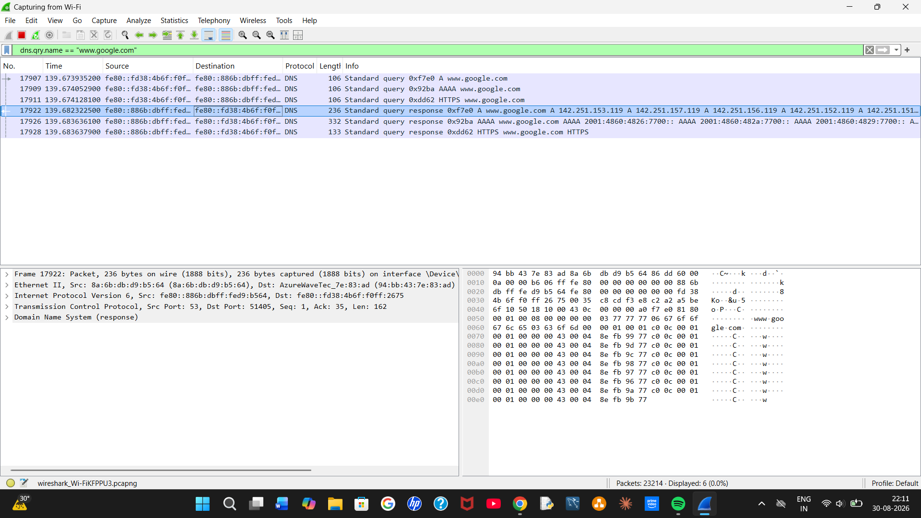

Q2 — HTTPS Web Access (Wikipedia)
Wireshark Filter | tls.handshake.extensions_server_name contains "wikipedia"
Packet Number | 41137
Correct Answer | TCP
Justification | Wikipedia's connection initially used QUIC (HTTP/3 over UDP) by default in Chrome, which meant standard TCP port-443 filters returned no results. QUIC was disabled via chrome://flags to force the browser to fall back to the traditional TCP + TLS connection. The Client Hello packet (No. 41137) confirms Server Name Indication = www.wikipedia.org over a TCP connection (Src Port 53730, Dst Port 443), with TLS 1.3 handling the encryption layer on top of TCP.

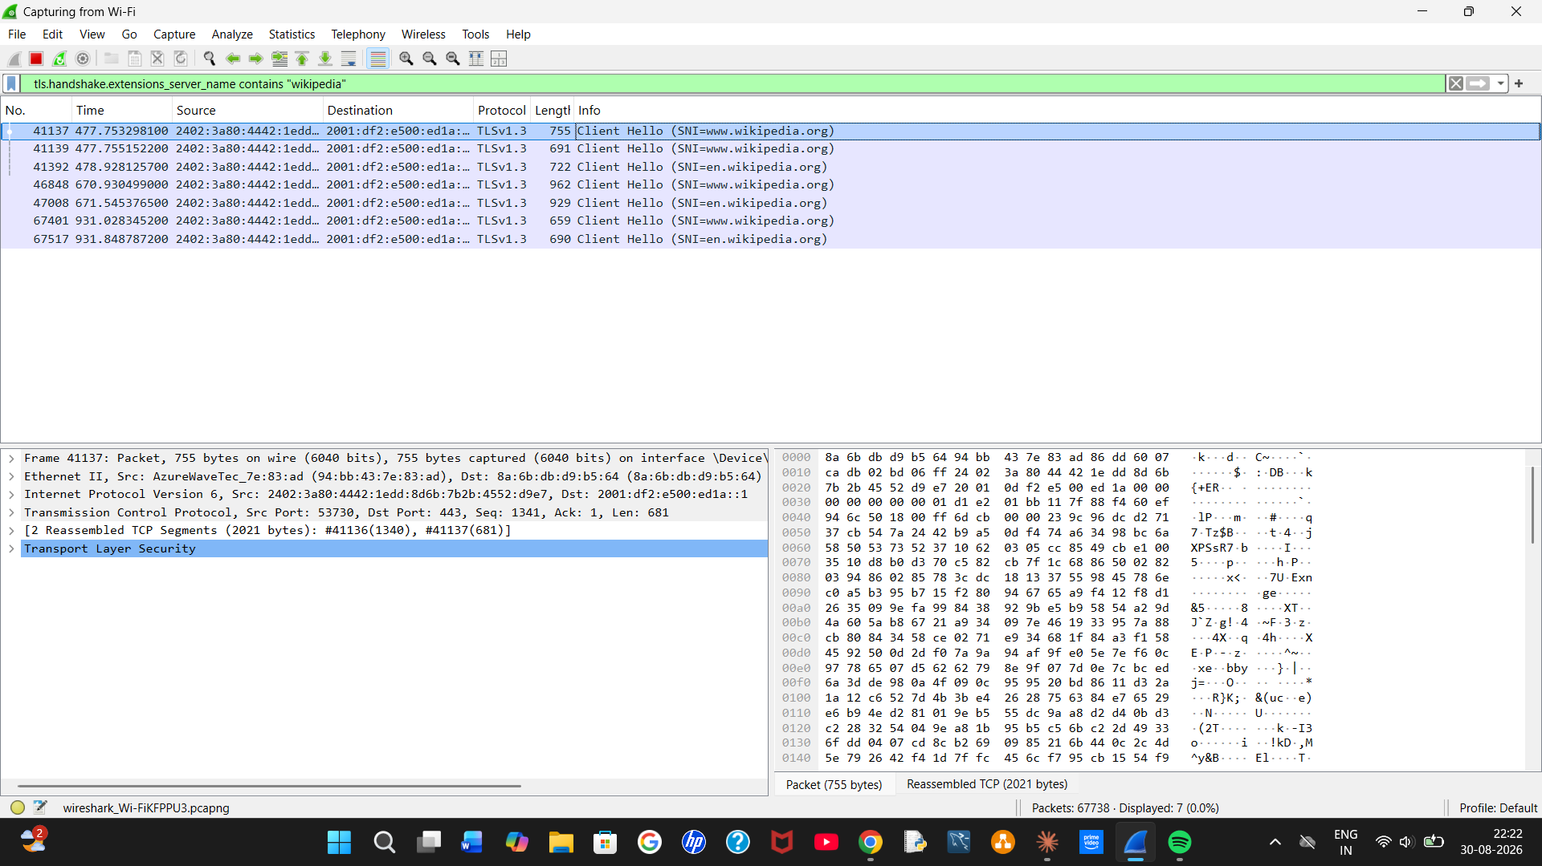

Q3 — FTP Traffic (Rebex FTP Test Server)
Wireshark Filter | tcp.port==21
Correct Answer | Port 21
Packet Number | 71272 (TCP SYN opening the control connection); full FTP command exchange visible from packet 71305 onward
Justification | Connecting to test.rebex.net with the Windows command-line FTP client established a control connection on port 21, confirmed by the TCP three-way handshake (packets 71272–71286) followed by the FTP server banner, USER/PASS command exchange, and server responses, all addressed to/from port 21. Note: the PASS command (packet 73190) shows the password sent in plaintext, illustrating a well-known security weakness of the FTP protocol.

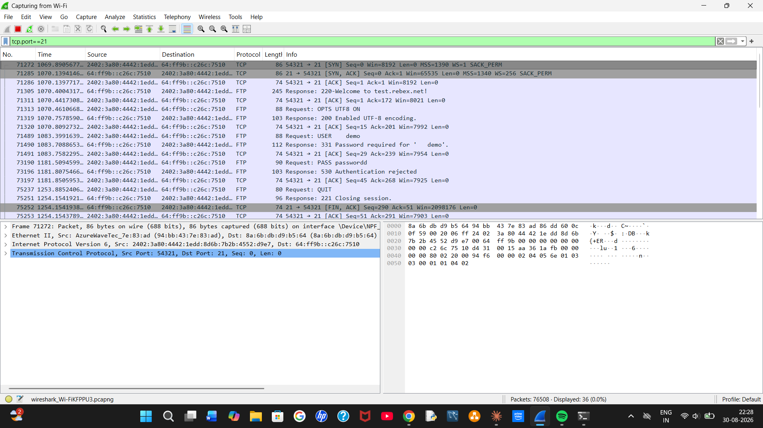

Q4 — SMTP Traffic Identification (Mailtrap Sandbox)
Status | Not completed
Note | This task was not attempted in this session.

Supporting Evidence — Additional Screenshots
The following screenshots, captured during the live Wireshark session, are included in the accompanying submission folder as supporting process evidence:
Task 1: task1_wireshark_open.png, task1_dns_filtered.png, task1_dns_narrowed.png, task1_dns_packet_17922_answer.png
Task 2: task2_dns_wikipedia_lookup.png, task2_ip_filter_empty.png, task2_quic_disabled_tcp.png, task2_tcp443_filtered.png, task2_tcp_traffic_captured.png, task2_sni_packet_41137_answer.png
Task 3: task3_ftp_password_prompt.png, task3_ftp_login_failed.png, task3_ftp_retry.png, task3_ftp_full_session_answer.png

