SIMATS ENGINEERING (SAVEETHA SCHOOL OF ENGINEERING)
Department of Computer Science and Engineering
Assessment Tool 2 – Pseudocode Writing Task (Algorithm Design) | Answer Key
Course Code: | CSA07 – Computer Networks
CO Assessed: | CO5 – K3 - Articulation
CO Statement: | Measure network performance using key metrics with simulation tools (BL4, BL5)

Question 1: P2P File Sharing Algorithm
Topic: | P2P Communication

Scenario
- A student wants to download a file from another computer in a peer-to-peer network.
- The system must connect to an available peer, check whether the peer has the requested file, download the file if available, display a failure message if the file is unavailable, and end the process.

Answer – Arranged Pseudocode
START
CONNECT TO PEER
IF FILE IS AVAILABLE THEN
DOWNLOAD FILE
ENDIF
DISPLAY "File not available"
END

Corresponding Flowchart
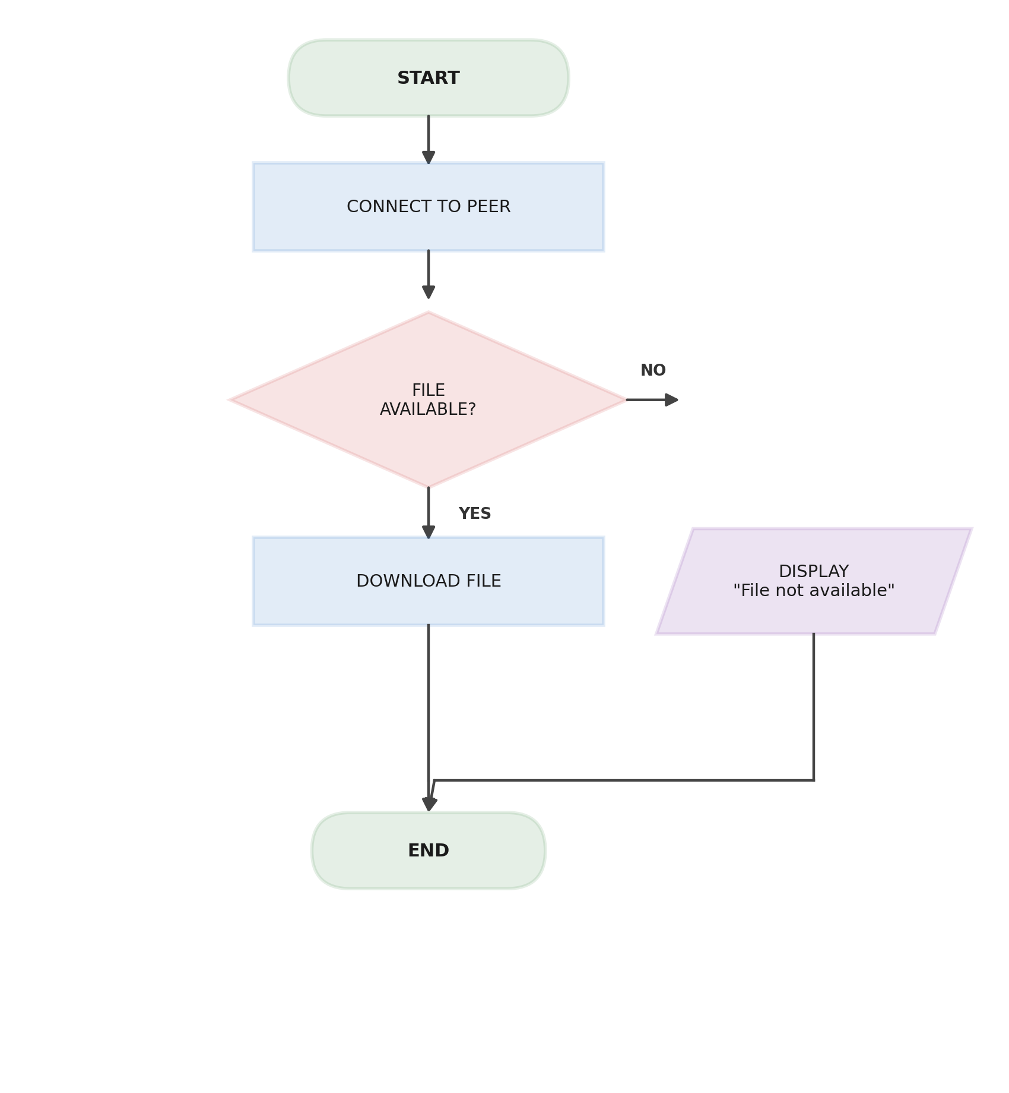

Question 2: VoIP Call Connection Algorithm
Topic: | VoIP Communication

Scenario
- A user starts a voice call using a VoIP application.
- The application must check whether an internet connection is available, connect the call and start voice communication if available, display an error if no internet connection is available, and end the process.

Answer – Arranged Pseudocode
START
CHECK INTERNET CONNECTION
IF INTERNET IS AVAILABLE THEN
CONNECT CALL
START VOICE COMMUNICATION
ELSE
DISPLAY "No Internet Connection"
ENDIF
END

Corresponding Flowchart
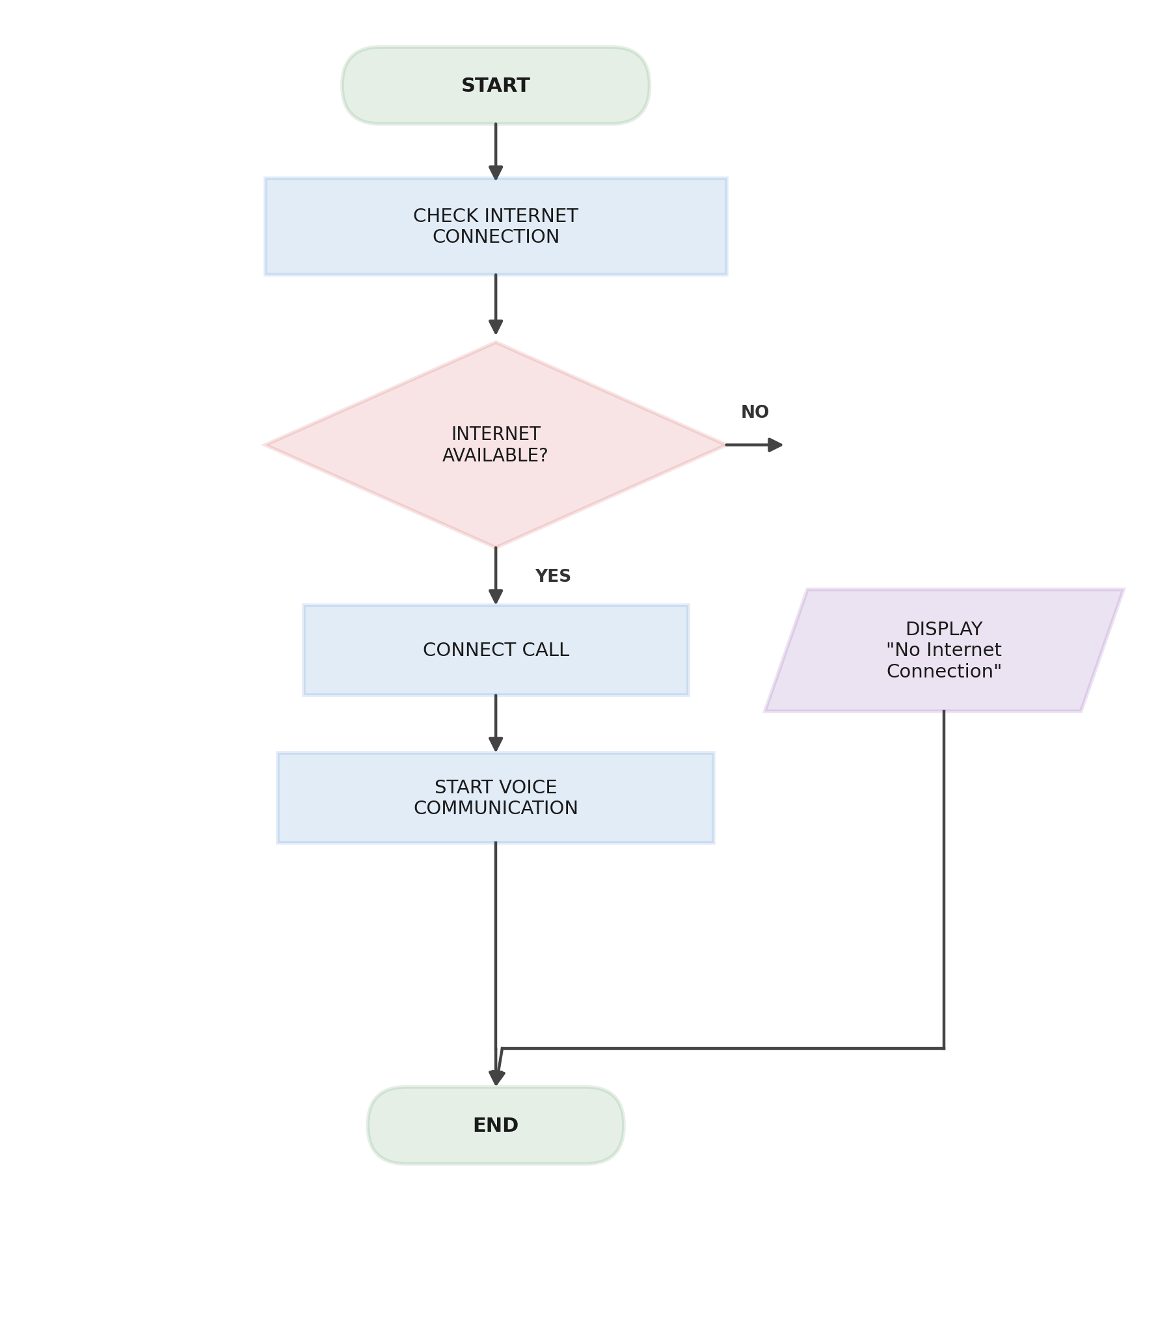

Question 3: Overlay Network Message Routing Algorithm
Topic: | Overlay Networks

Scenario
- A user wants to send a message to another node in an overlay network.
- The system must check whether the destination node is available, send the message directly if the node is available, otherwise forward the message through another available node, confirm that the message has been sent, and end the process.

Answer – Arranged Pseudocode
START
CHECK DESTINATION NODE
IF DESTINATION NODE IS AVAILABLE THEN
SEND MESSAGE DIRECTLY
ELSE
FORWARD MESSAGE THROUGH ANOTHER NODE
ENDIF
DISPLAY "MESSAGE SENT"
END

Corresponding Flowchart
