1. The home page of the application.

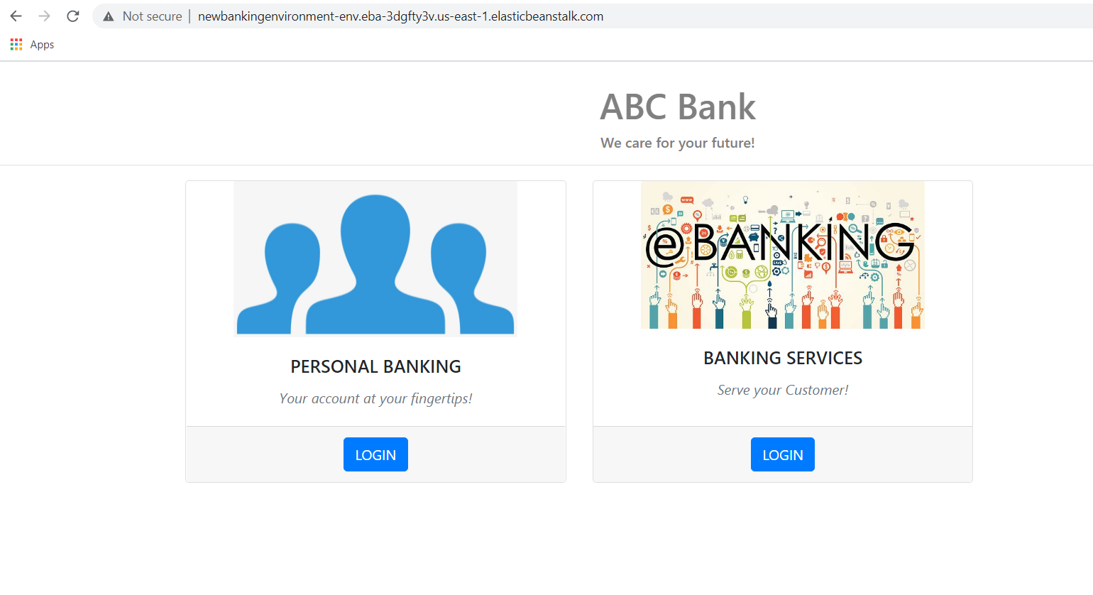

1. List of registered customer.

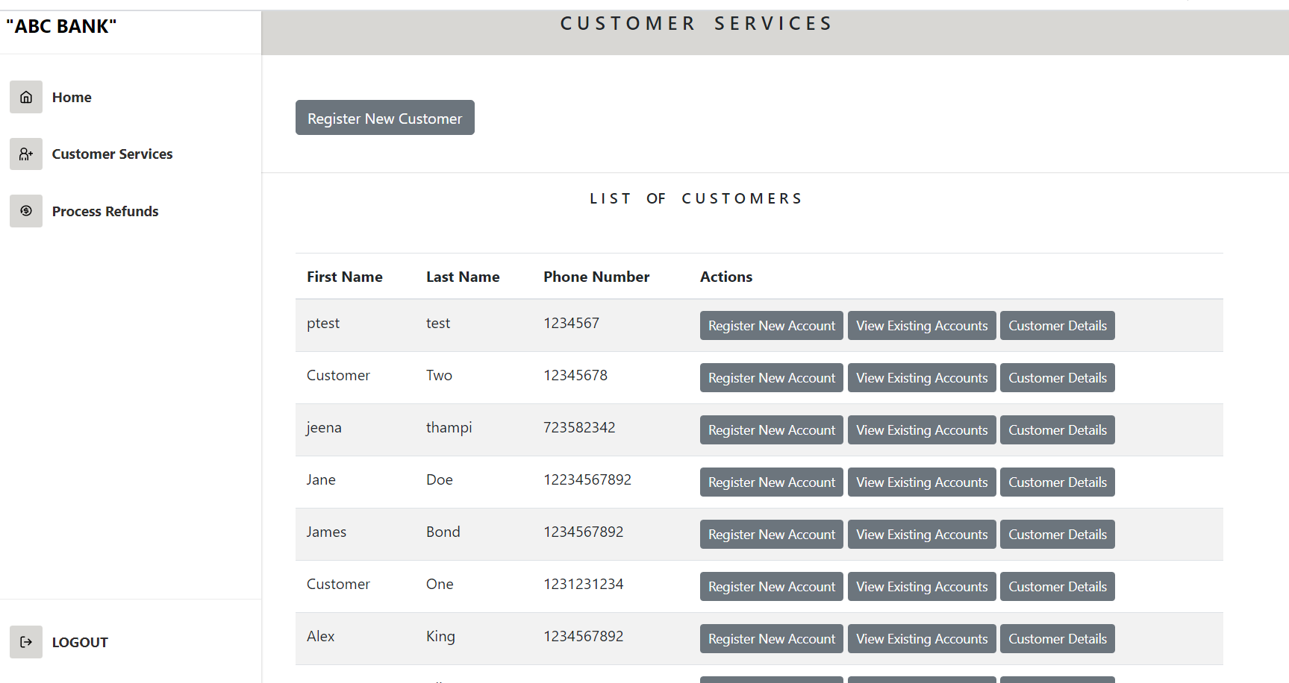

1. Customer details screen in the admin view

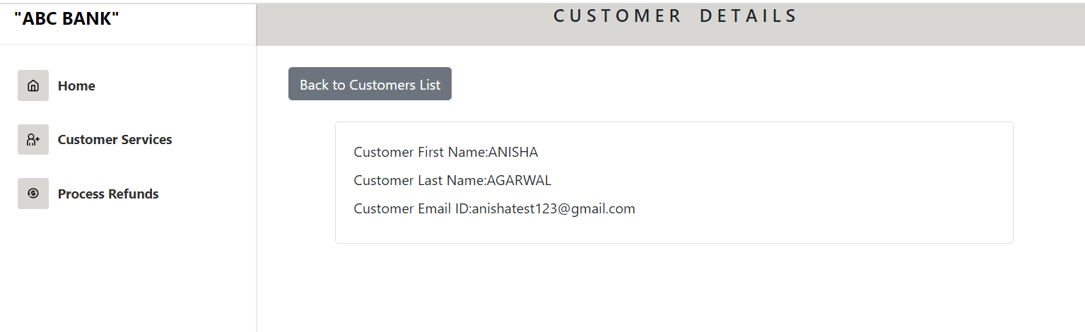

1. Customer profile details in customer view.

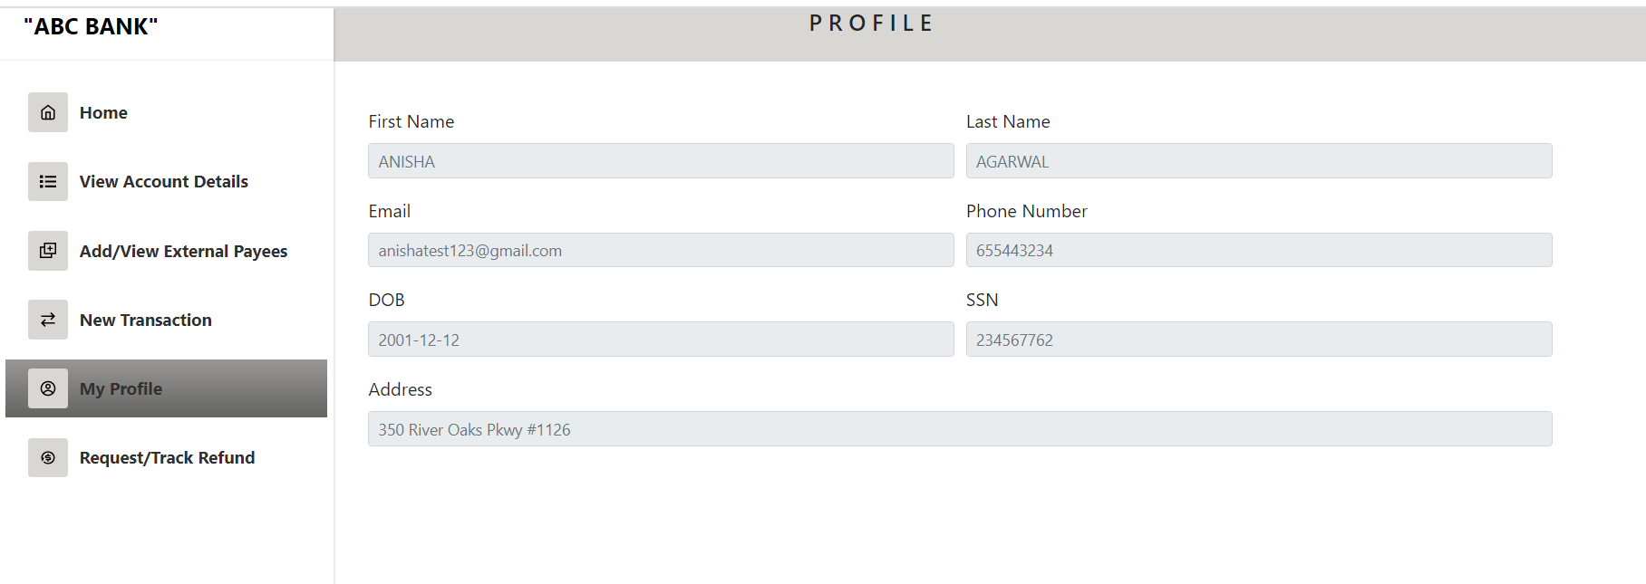

1. Active accounts of the Customer.

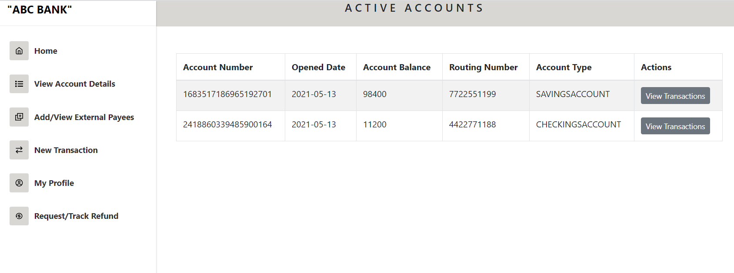

1. Internal Transaction for the customer with the dropdown list of the account number.

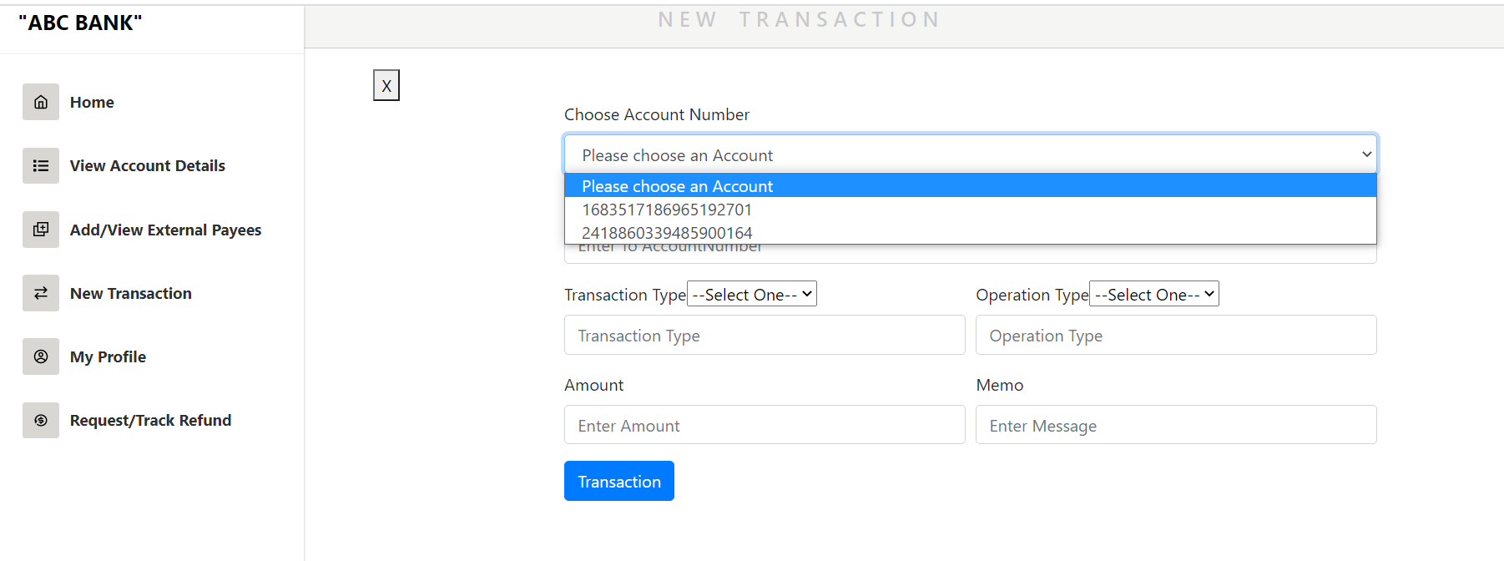

1. External transaction for the customer with the dropdown of the external payee.

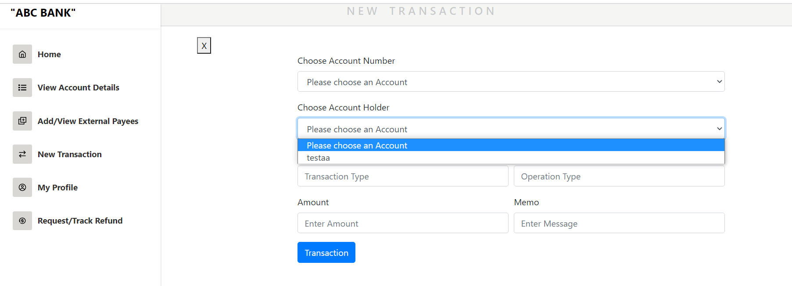

1. View transaction details of the customer savings account.

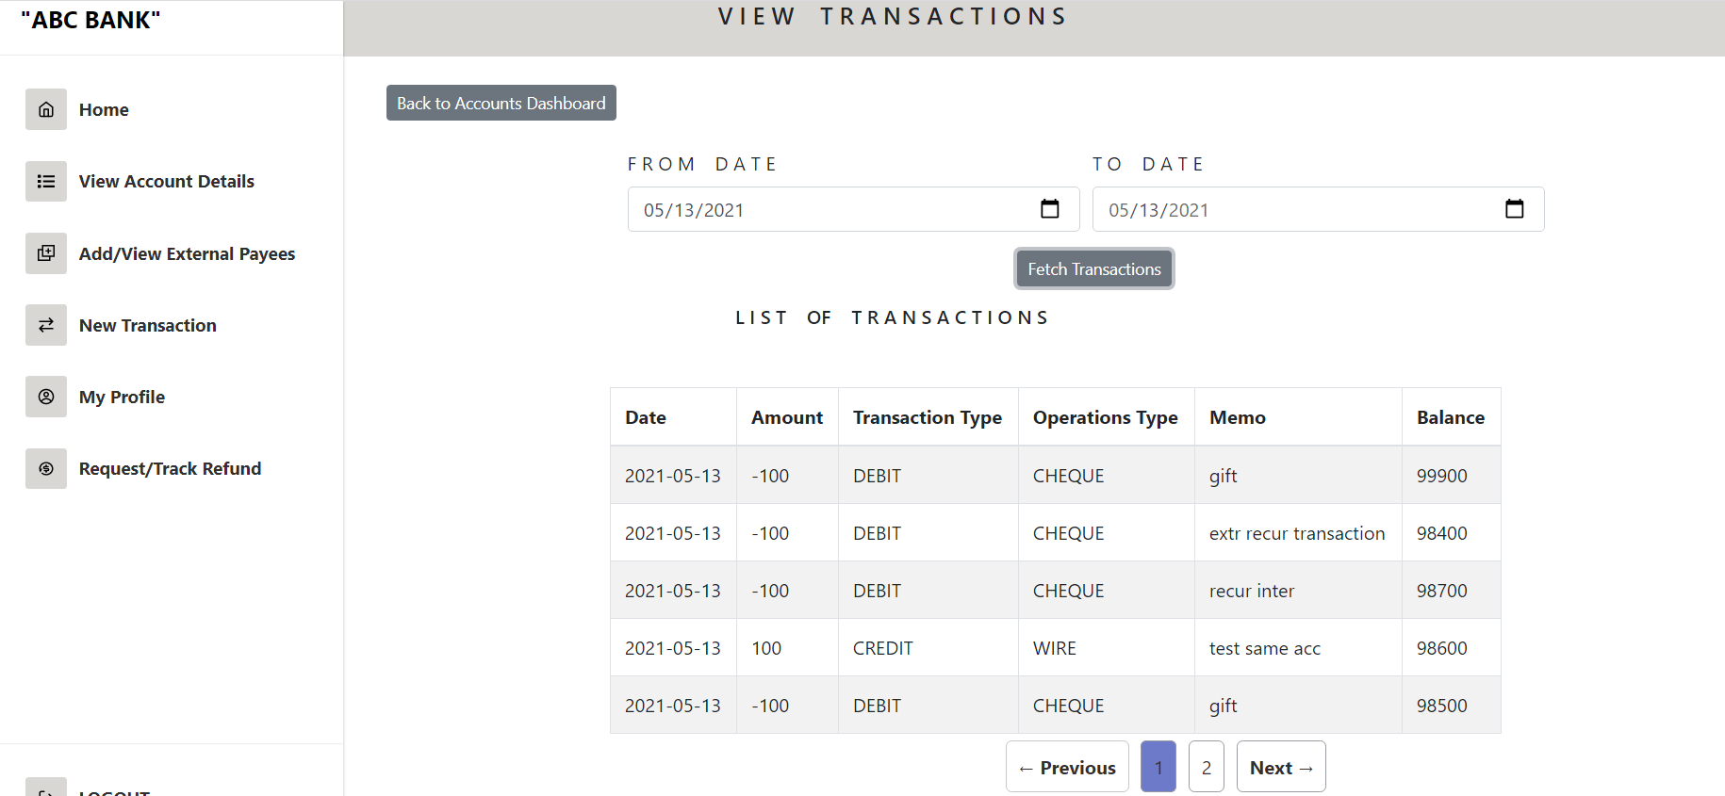

1. View transaction details of the customer checking account.

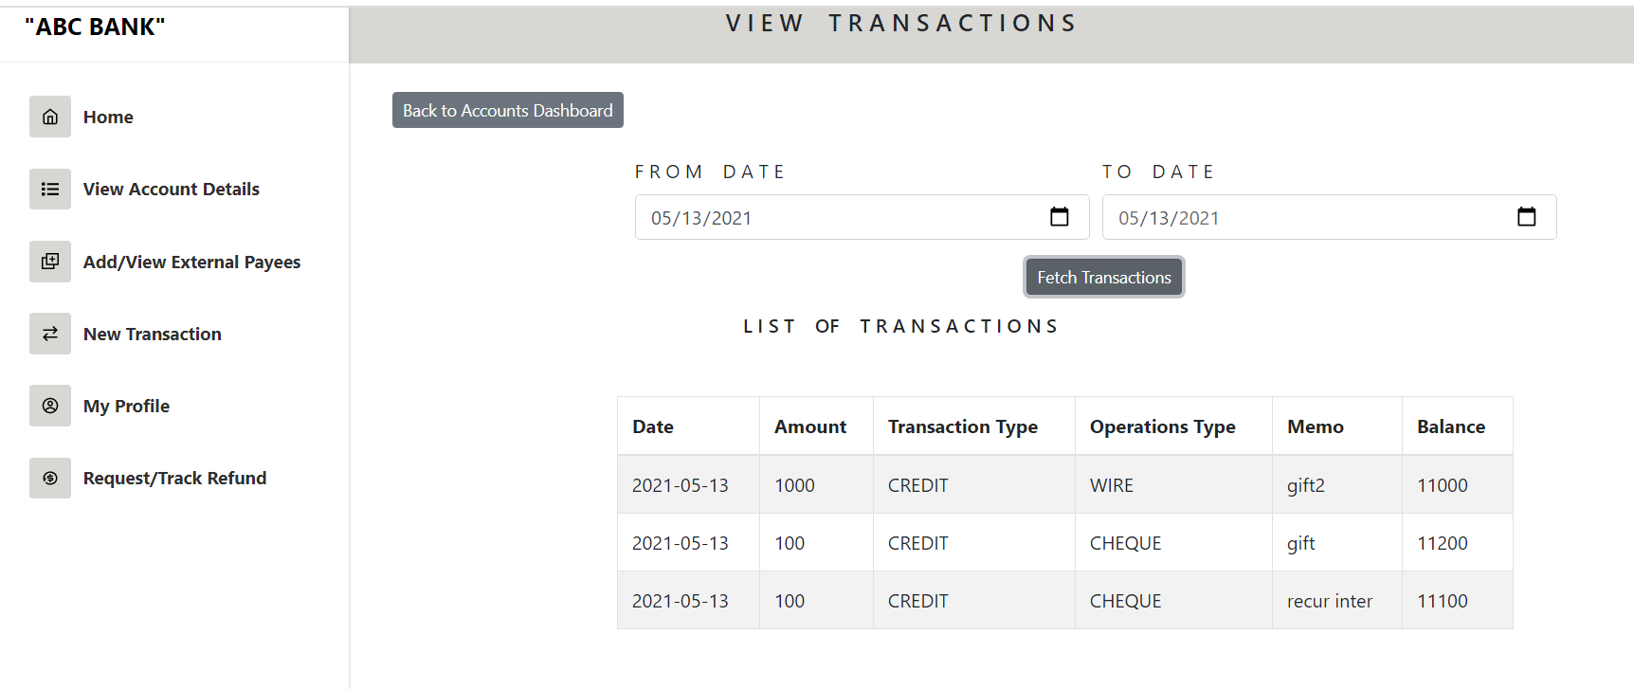

1. Add external Payee screen

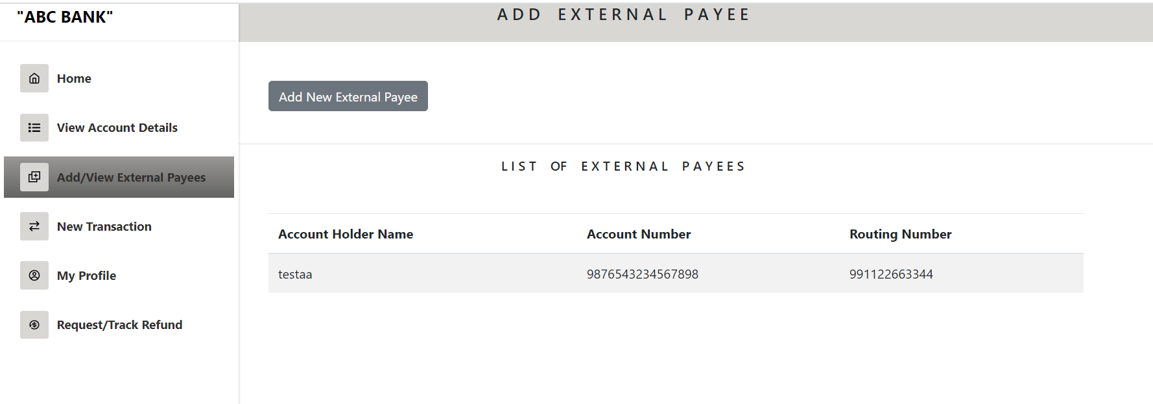

1. Accounts UI details in admin section.

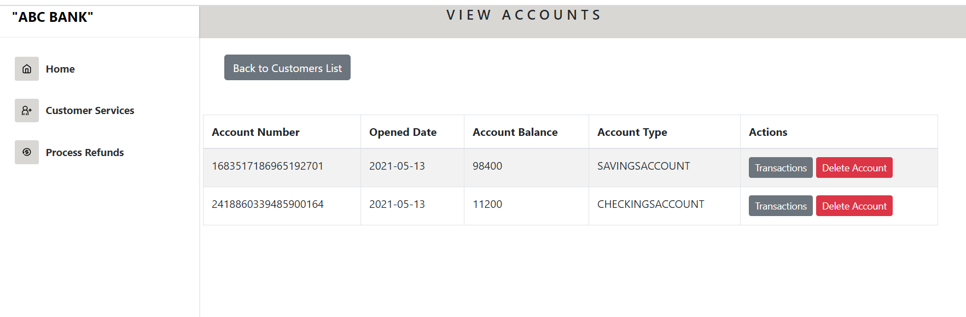

1. View transactions of the savings account of customer from the Admin Section

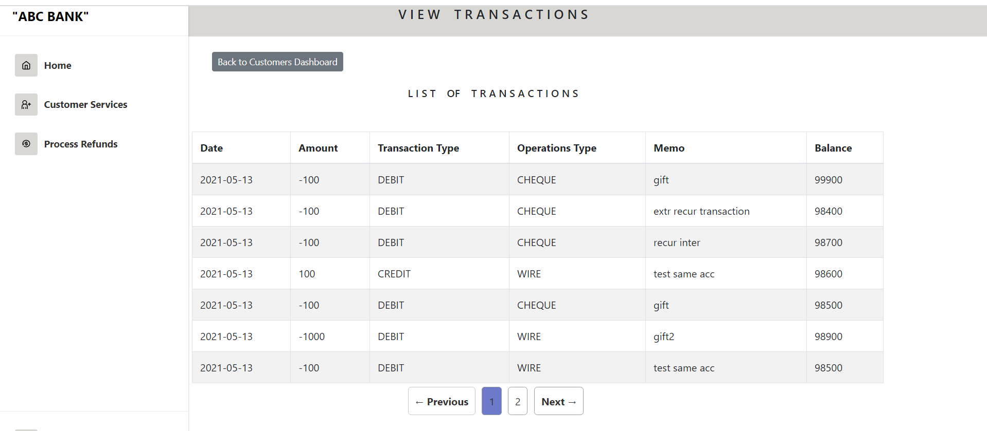

1. View transactions of the checking account of customer from the Admin Section

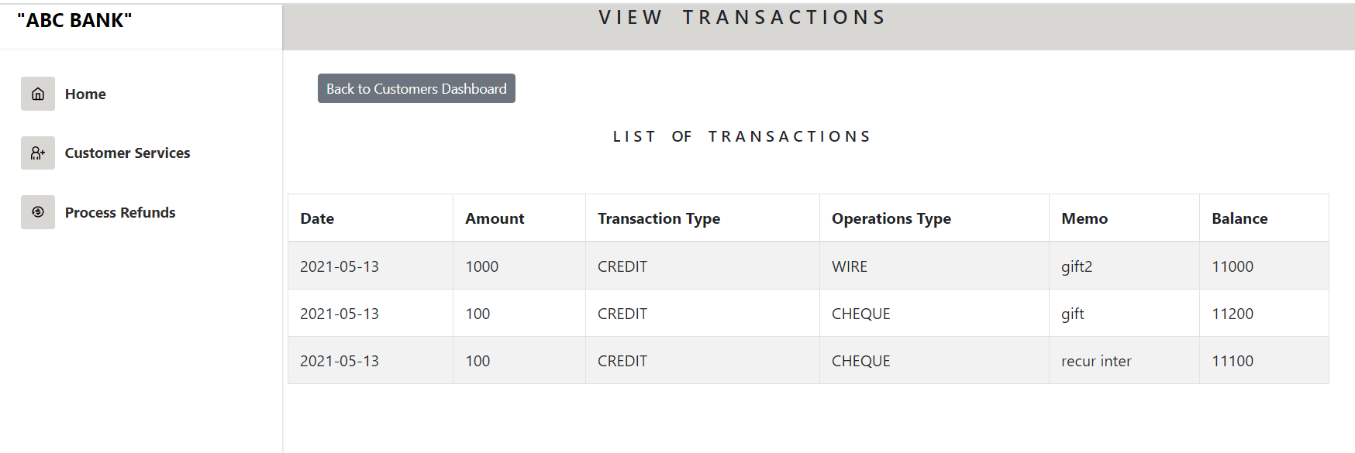

1. Request refund OPEN status from the customer section.

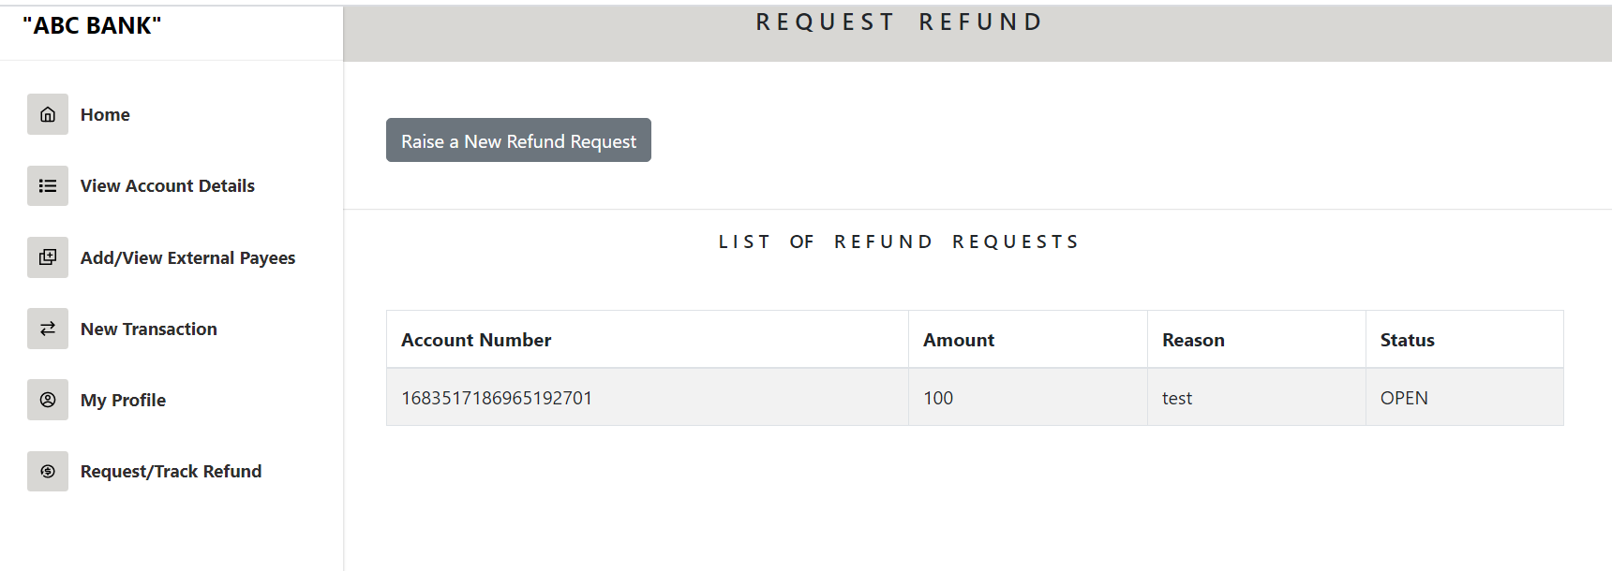

1. Open refund request from the admin section.

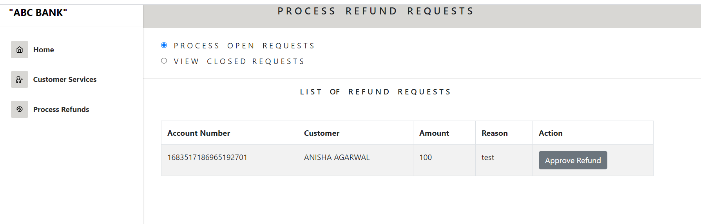

1. Closed refund request from the customer section.

