JDBC Assignment :

Create Table

Code :

package com.student.packages;

import java.sql.Connection;

import java.sql.DriverManager;

import java.sql.Statement;

public class CreateTable {

public static void main(String[] args) {

try {

Class.forName("com.mysql.cj.jdbc.Driver");

Connection con = DriverManager.getConnection("jdbc:mysql://localhost:3306/mydatabase", "root", "Sp940@*&");

Statement st = con.createStatement();

int x = st.executeUpdate("CREATE TABLE employee1 (eid INT, ename VARCHAR(40), dept VARCHAR(40), sal DECIMAL(10,2))");

System.out.println(x);

System.out.println("New Table created successfully");

} catch (Exception e) {

e.printStackTrace();

}

}

}

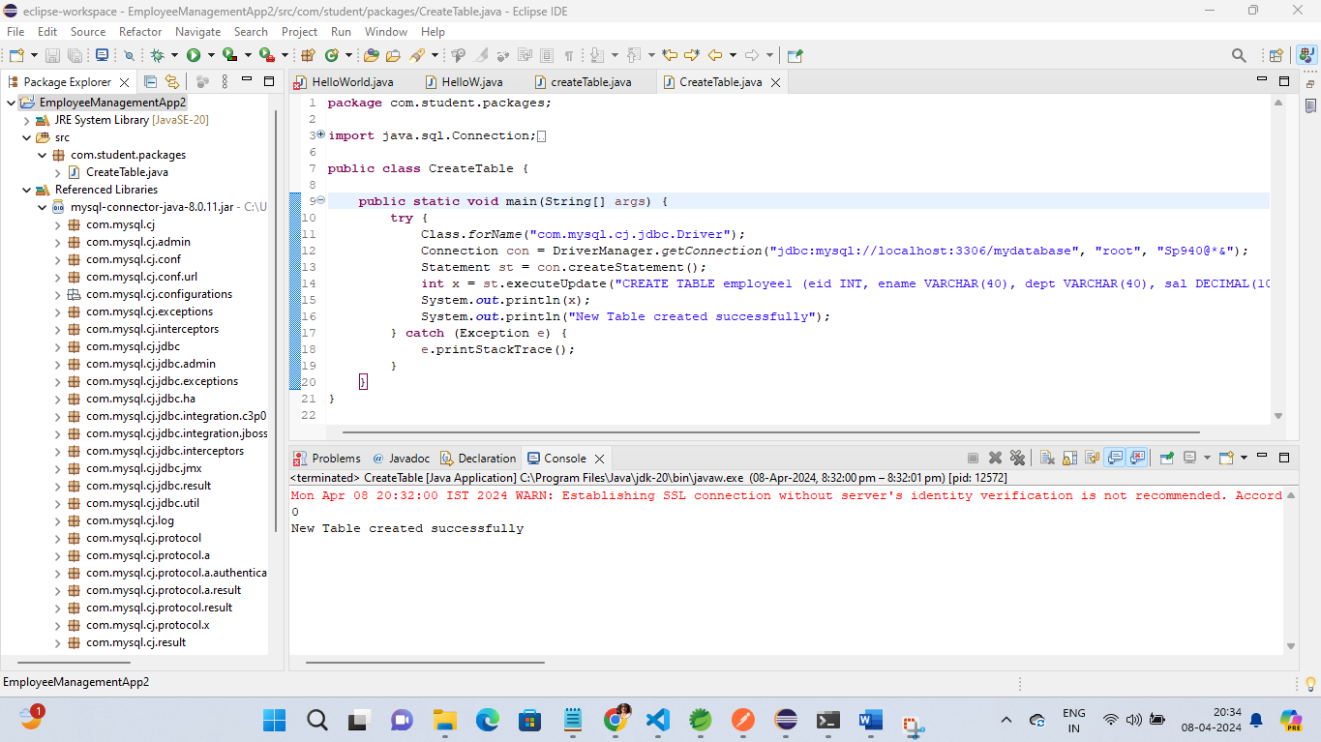

Output :

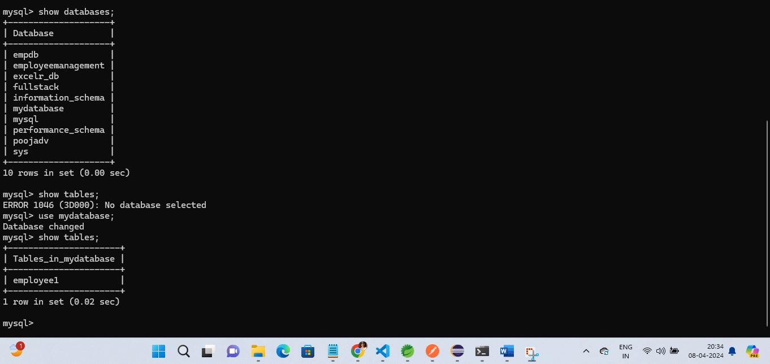

InsertRecord :

Code :

**package** com.student.packages;

**import** java.sql.Connection;

**import** java.sql.DriverManager;

**import** java.sql.Statement;

**public** **class** InsertRecord {

**public** **static** **void** main(String[] args)

{

**try**{

Class.*forName*("com.mysql.cj.jdbc.Driver");

Connection con = DriverManager.*getConnection*("jdbc:mysql://localhost:3306/mydatabase", "root", "Sp940@*&");

Statement st=con.createStatement();

**int** i=st.executeUpdate("insert into employee1 values(1001,'Pooja','IT',13500.00)");

**int** j=st.executeUpdate("insert into employee1 values(1002,'Pari','IT1',135001.00)");

System.***out***.println(i + j+" New Record has been inserted successfully");

}

**catch**(Exception e)

{

e.printStackTrace();

}

}

}

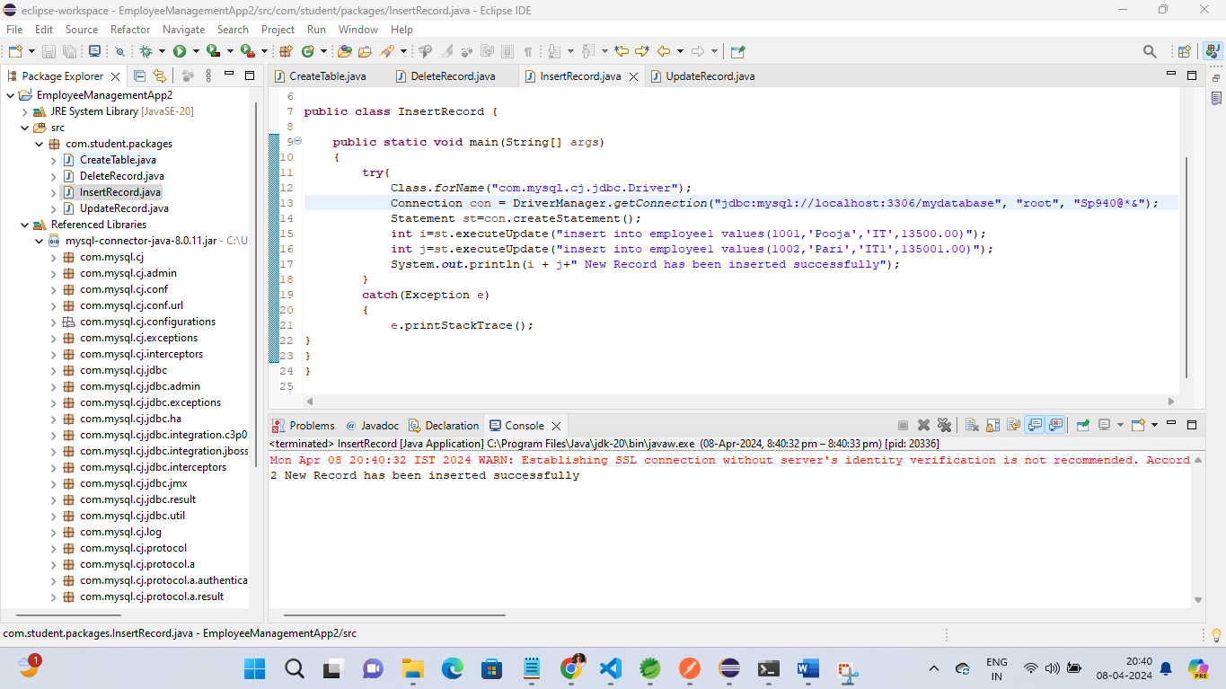

Output :

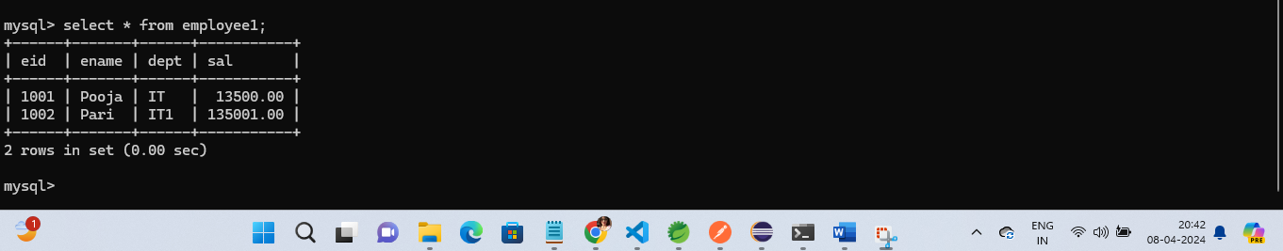

Update Record :

Code :

**package** com.student.packages;

**import** java.sql.Connection;

**import** java.sql.DriverManager;

**import** java.sql.Statement;

**public** **class** UpdateRecord {

**public** **static** **void** main(String[] args)

{

**try**{

Class.*forName*("com.mysql.cj.jdbc.Driver");

Connection con = DriverManager.*getConnection*("jdbc:mysql://localhost:3306/mydatabase", "root", "Sp940@*&");

Statement st=con.createStatement();

**int** i=st.executeUpdate("update employee1 set ename='Pooja_updated',dept='CS', sal=25000.00 where eid=1002");

System.***out***.println(i+"Record Updated successfully");

}

**catch**(Exception e)

{

e.printStackTrace();

}

}

}

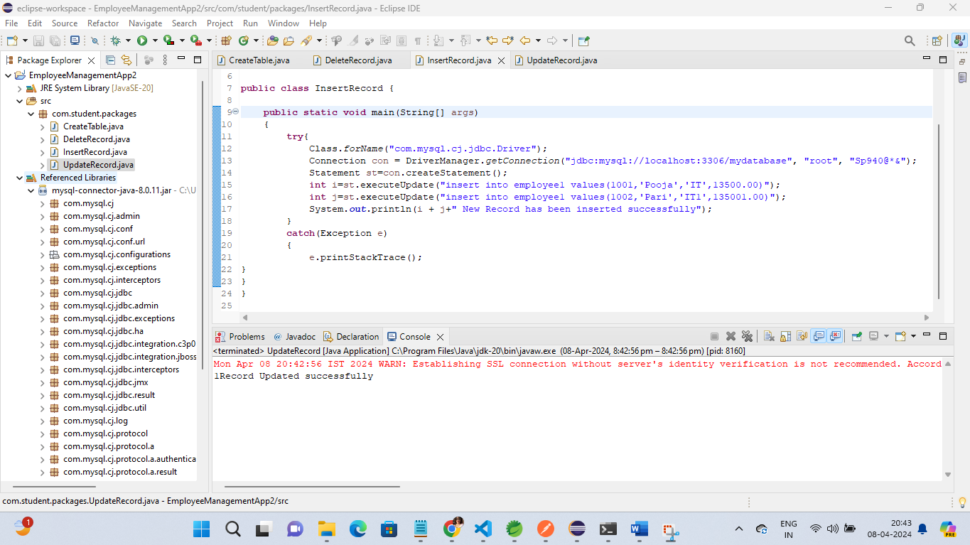

Output :

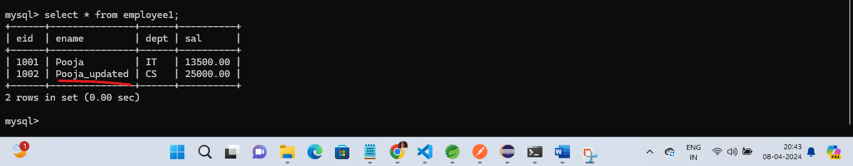

Delete Record :

Code :

**package** com.student.packages;

**import** java.sql.Connection;

**import** java.sql.DriverManager;

**import** java.sql.Statement;

**public** **class** DeleteRecord {

**public** **static** **void** main(String[] args)

{

**try**{

Class.*forName*("com.mysql.cj.jdbc.Driver");

Connection con = DriverManager.*getConnection*("jdbc:mysql://localhost:3306/mydatabase", "root", "Sp940@*&");

Statement st=con.createStatement();

**int** i=st.executeUpdate("delete from employee1 where eid=1001");

System.***out***.println(i+"Record Deleted successfully");

}

**catch**(Exception e)

{

e.printStackTrace();

}

}

}

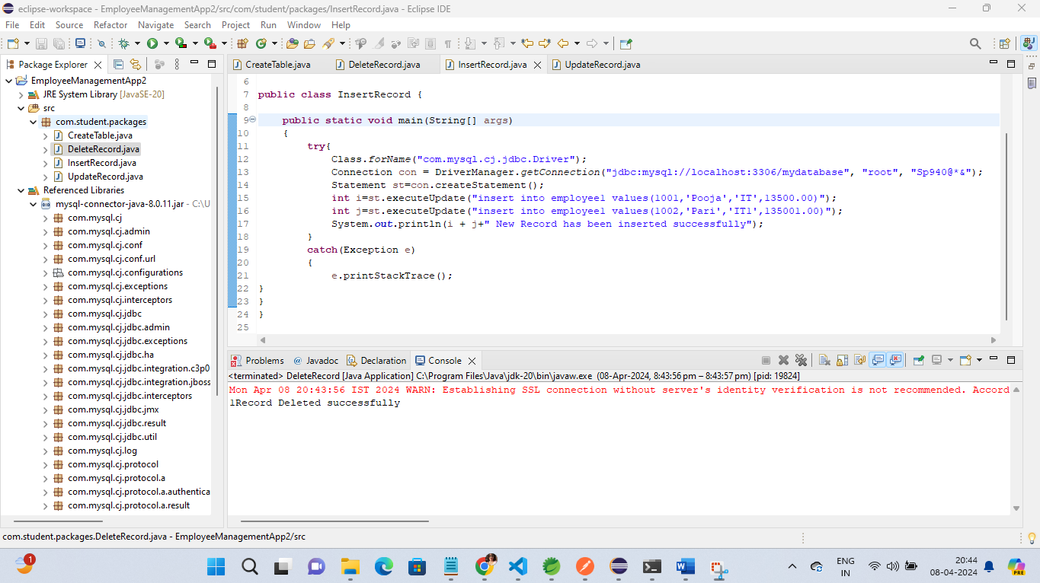

Output :

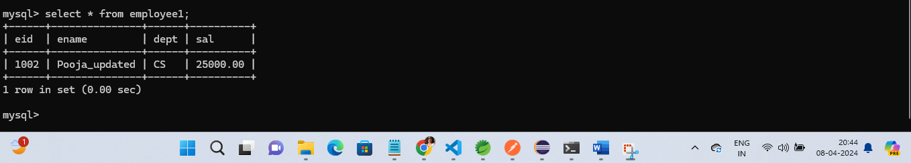

Select all records:

**package** com.student.packages;

**import** java.sql.Connection;

**import** java.sql.DriverManager;

**import** java.sql.ResultSet;

**import** java.sql.Statement;

**public** **class** selectAllRecord {

**public** **static** **void** main(String[] args) {

**try** {

Class.*forName*("com.mysql.cj.jdbc.Driver");

Connection con = DriverManager.*getConnection*("jdbc:mysql://localhost:3306/mydatabase", "root", "Sp940@*&");

Statement st = con.createStatement();

String q="select * from employee1";

ResultSet set=st.executeQuery(q);

**while**(set.next()) {

**int** eid=set.getInt(1);

String ename=set.getString(2);

String dept=set.getString(3);

**double** salary=set.getDouble(4);

System.***out***.println("Eid :"+eid);

System.***out***.println("Ename :"+ename);

System.***out***.println("Department :"+dept);

System.***out***.println("salary :"+salary);

}

} **catch** (Exception e) {

e.printStackTrace();

}

}

}

